H2 Structured Questions by Topic (9173 P1 Sec A, P2 Sec B) — v0.12
Topics follow the SEAB syllabus: H1 Geography 8834 (2026) and H2 Geography 9173 (2026).

Cluster 1: Development, Economy and Environment

1.1 Environment and Resources

ACJC 2025 — H2 Paper 1 (9173/01), Q1 [30 marks]
Syllabus: 1.1.3c Managing Resources – Extractive industries; 1.1.2b Environment and Resources – Supply of provisioning services (reserves); 1.1.1b Understanding Sustainable Development – Measuring progress (SDGs, indicators)
Section A — Cluster 1: Global Development and Natural Resources
Resource 1 shows the global oil production and consumption. Resource 2 shows an oil rig. Resource 3 shows historical oil prices relative to Organisation of the Petroleum Exporting Countries (OPEC) nations’ Gross Domestic Product (GDP). Resource 4 shows the Human Development Index formula.
(a) Describe the pattern of global oil production and consumption as shown in Resource 1. [5]
(b) Using Resource 2, explain the impacts of extractive industries on the host economies. [6]
(c) Using Resource 3, describe the relationship between historical oil prices and the OPEC nations’ GDP. [4]
(d) Explain how countries can manage the impacts of extractive industries. [6]
(e) Using Resource 4, explain the issues in measuring sustainable development. [4]
(f) Explain how variations over time and space of a provisioning service are influenced by demand and technology. [5]

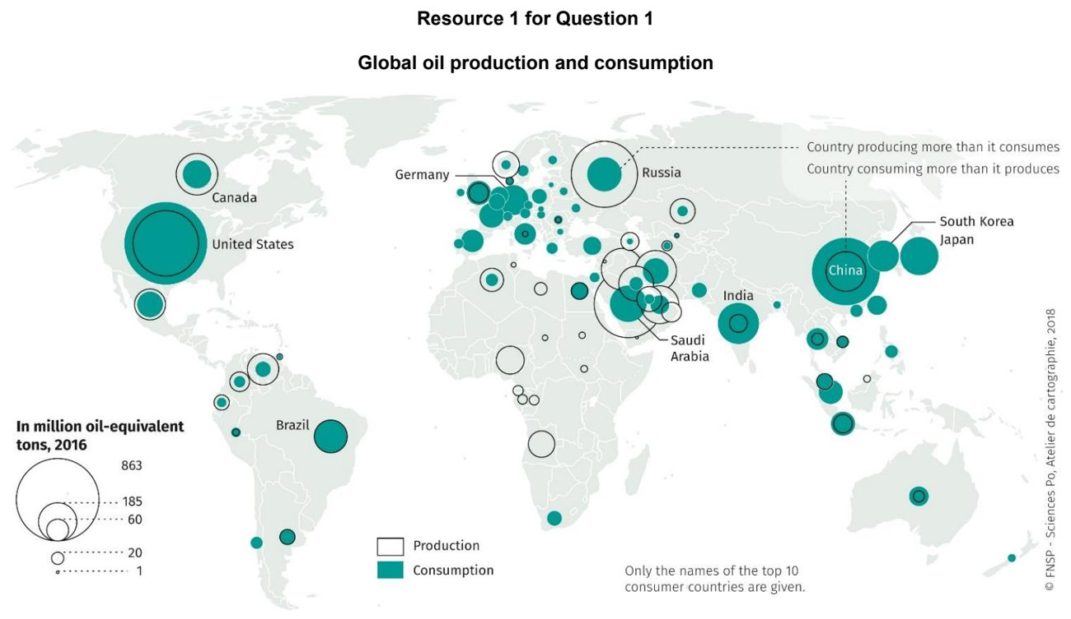

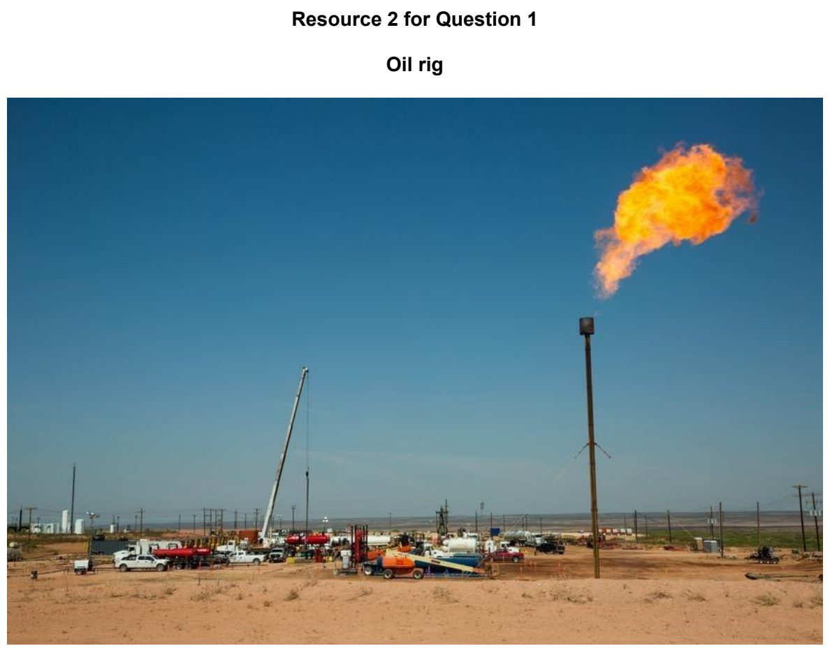

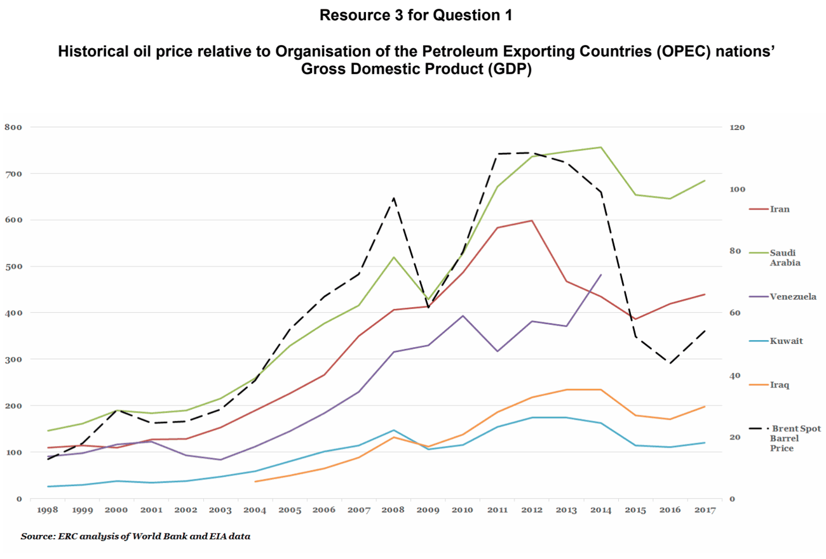

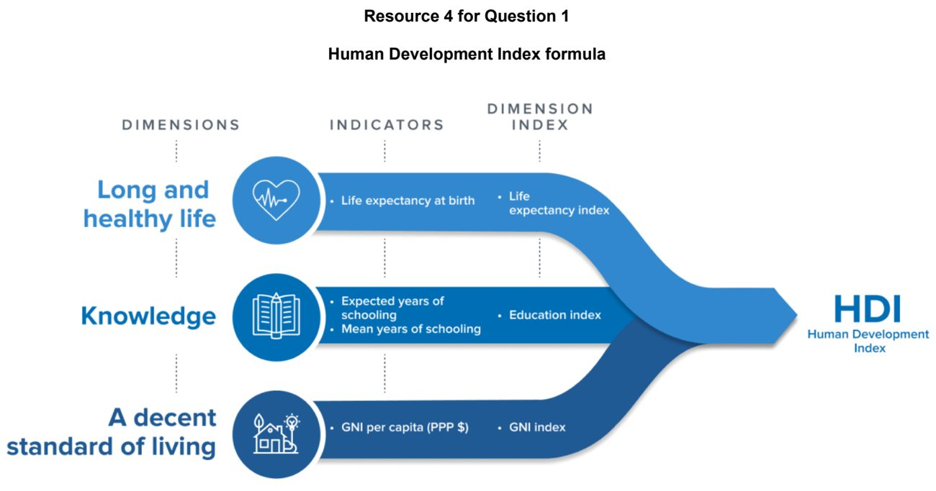

ASRJC 2024 — H2 Paper 1 (9173/01), Q1 [30 marks]
Syllabus: 1.1.3b Managing Resources – Transboundary water conflicts; 1.1.3a Managing Resources – Renewable energy (solar, hydropower)
Section A — Cluster 1: Global Development and Natural Resources
Resource 1 depicts world electricity generation from 2000 to 2020. Resource 2 shows the distribution of water from the Nile River Basin and rate of dependence on the water flow of the Nile River Basin by country. Resource 3 is a map of the Nile River Basin and its riparian states. Of the 11 riparian states of the Nile River Basin, Egypt and Sudan are considered as downstream riparian states. Resource 4 shows the climate classification of countries in the Nile River Basin. Resource 5 is an article about the usage of the Nile River water by Ethiopia and Egypt.
(a) With reference to Resource 1, describe the trends in world electricity generation from 2000 to 2020. [5]
(b) Explain the trade-offs associated with the use of hydropower. [6]
(c) With reference to Resource 2, compare the distribution of water from the Nile River Basin and the rate of dependence on the water flow for the Nile Basin for Egypt and Ethiopia. [4]
(d) With reference to Resource 3, describe the distribution of dams on the Nile River Basin. [4]
(e) Using information from Resources 3, 4, and 5, explain why the construction of the Grand Ethiopian Renaissance Dam might result in conflict between Egypt and Ethiopia. [7]
(f) Suggest two ways in which countries like Egypt and Ethiopia could manage conflicts due to transboundary water resources. [4]

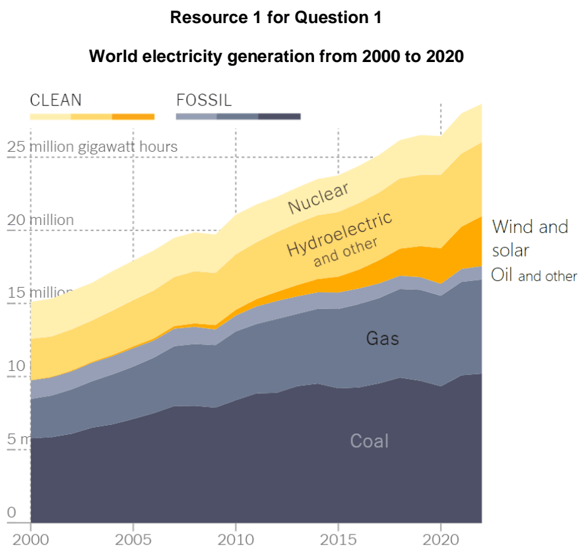

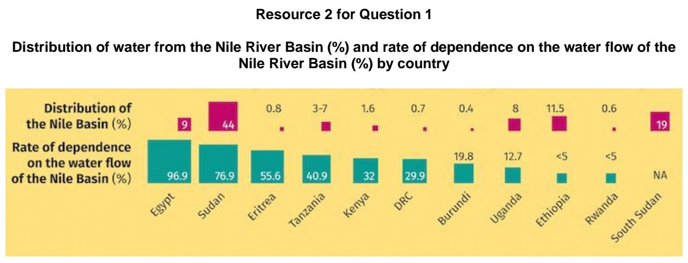

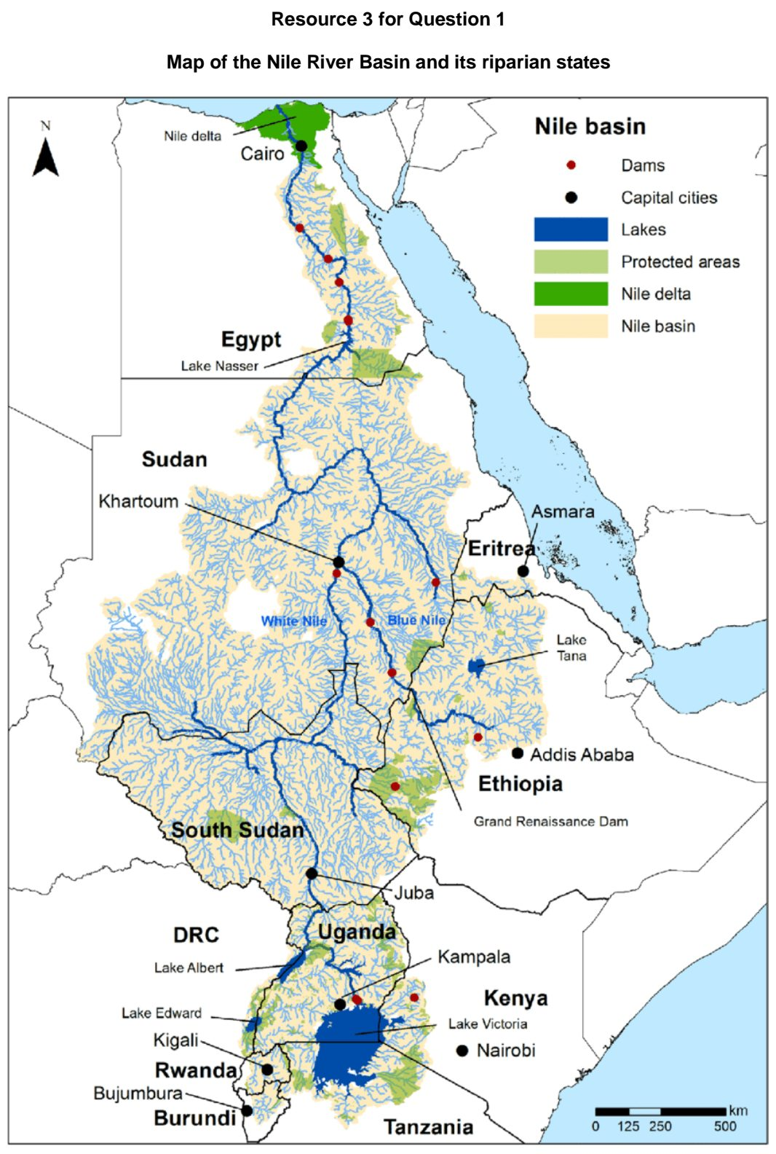

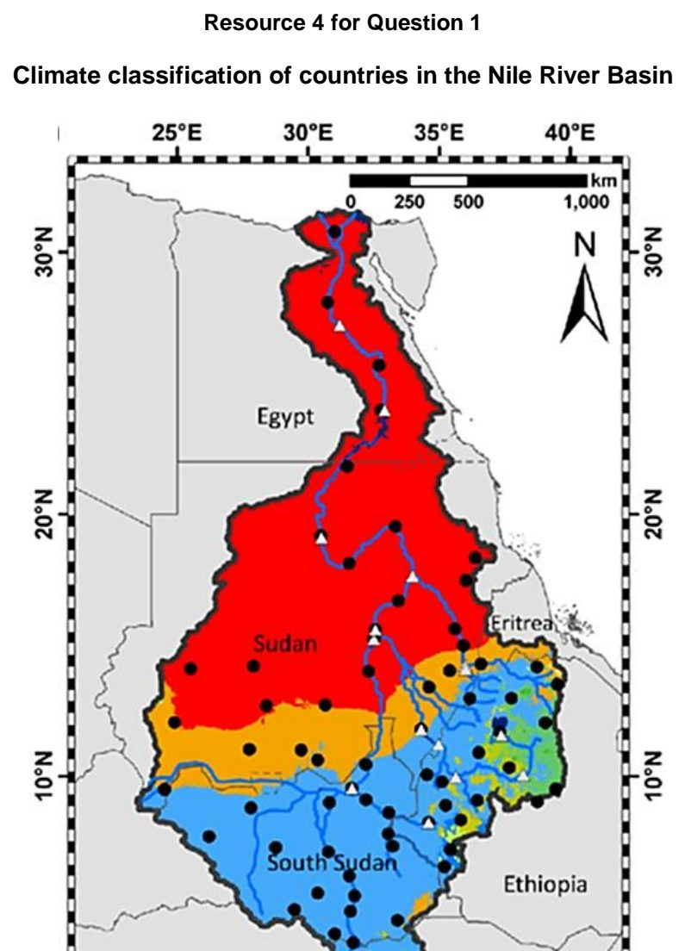
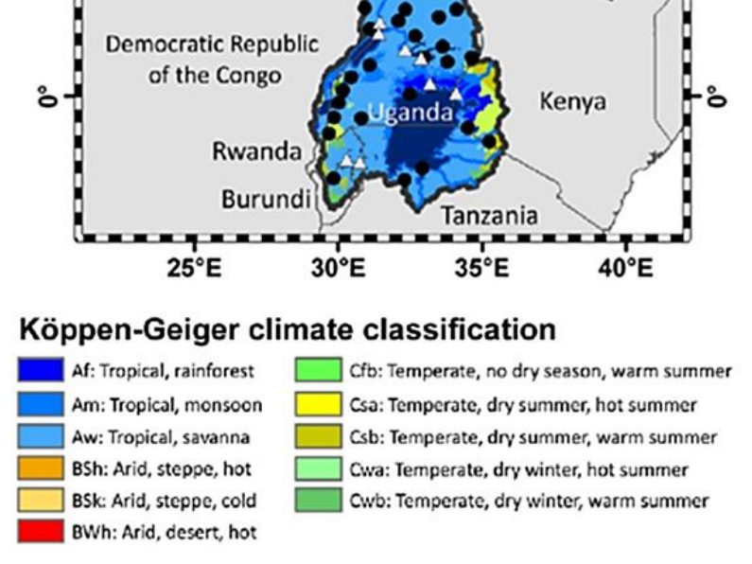

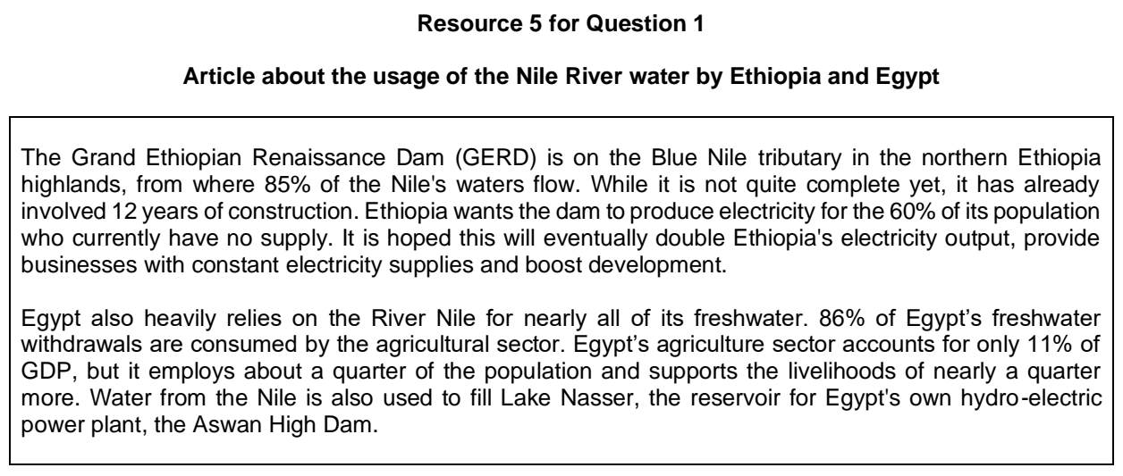

ASRJC 2026 — H2 Paper 1 (9173/01), Q1 [30 marks]
Syllabus: 1.1.1b Understanding Sustainable Development – Measuring progress (SDGs, indicators); 1.1.2c Environment and Resources – Population & resources (Malthus, Boserup); 1.1.3b Managing Resources – Transboundary water conflicts; 1.2.1c Development – Shifts in economic structure; 1.1.1c Understanding Sustainable Development – Challenges limiting SD
Section A — Cluster 1: Global Development and Natural Resources
Resource 1 shows progress assessment for the 17 Sustainable Development Goals (SDGs) based on assessed targets. Resource 2A shows the proportion of national-level governments who partner with city-level governments to collect data on progress towards the Sustainable Development Goals in 2023. Resource 2B shows the proportion of countries with fully-funded strategies to collect data under implementation in 2023.
The Brahmaputra River is a transboundary river shared by China, India, and Bangladesh. Resource 3 shows the share of employment per economic sector for India from 2000 to 2022. Resource 4A is a map showing the Brahmaputra River and its riparian states. Resource 4B is an article on the proposed construction of the Yarlung Tsangpo Grand Dam on the Brahmaputra River.
(a) With reference to Resource 1, compare progress in SDG Goal 4 and Goal 8. [5]
(b) Using Resources 2A and 2B, explain why there might be variations in data collection capacity across countries when measuring progress towards sustainable development. [4]
(c) Explain the political challenges faced by developed countries that limit progress towards sustainable development. [4]
(d) Explain the limitations of Thomas Malthus’ and Ester Boserup’s views on the relationship between population growth and resources. [6]
(e) Describe the changes in share of employment per economic sector for India from 2000 to 2022 shown in Resource 3. [5]
(f) With reference to Resources 3 and 4, explain why there might be conflicts between riparian states on the Brahmaputra River Basin. [6]

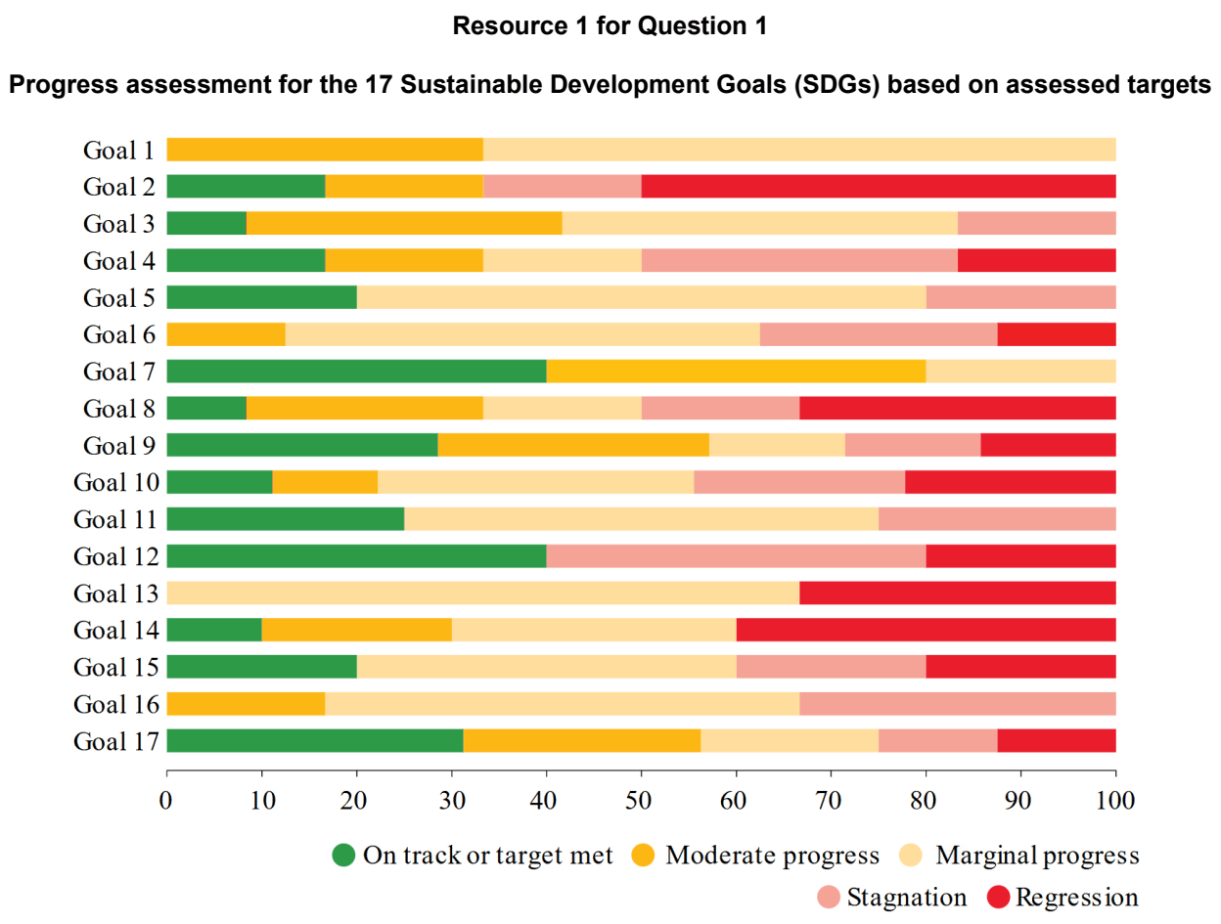

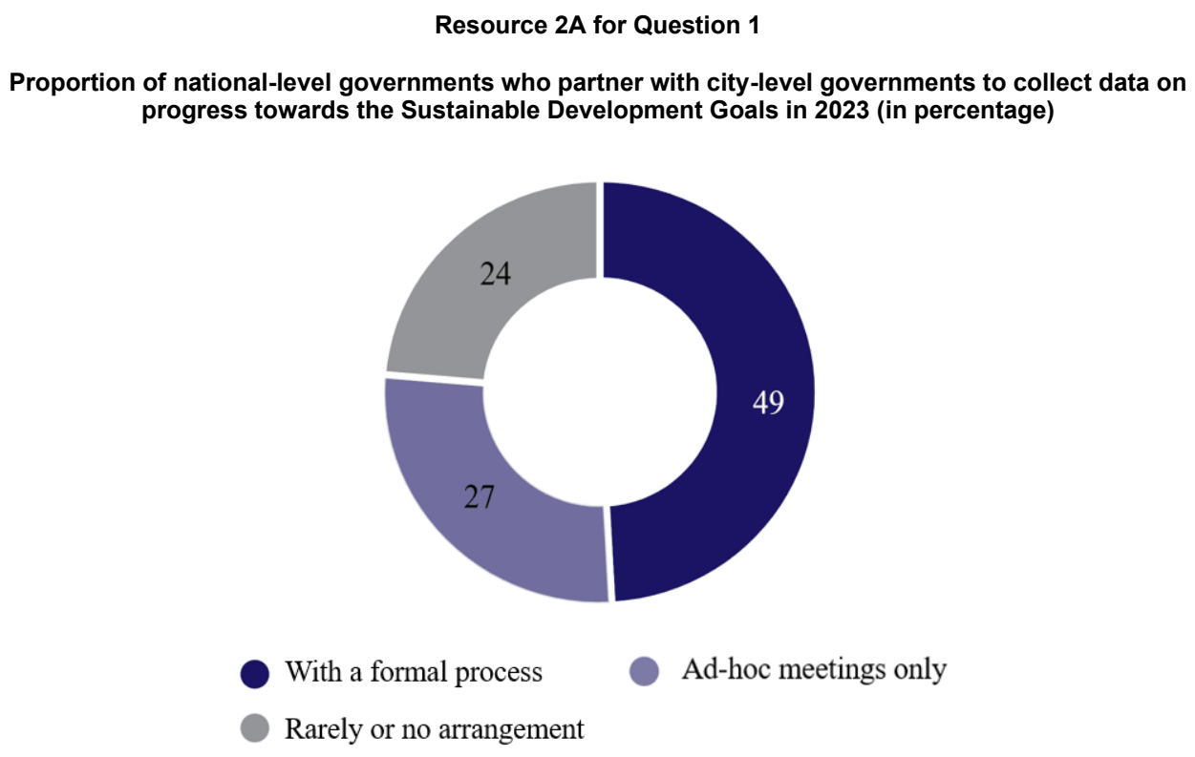

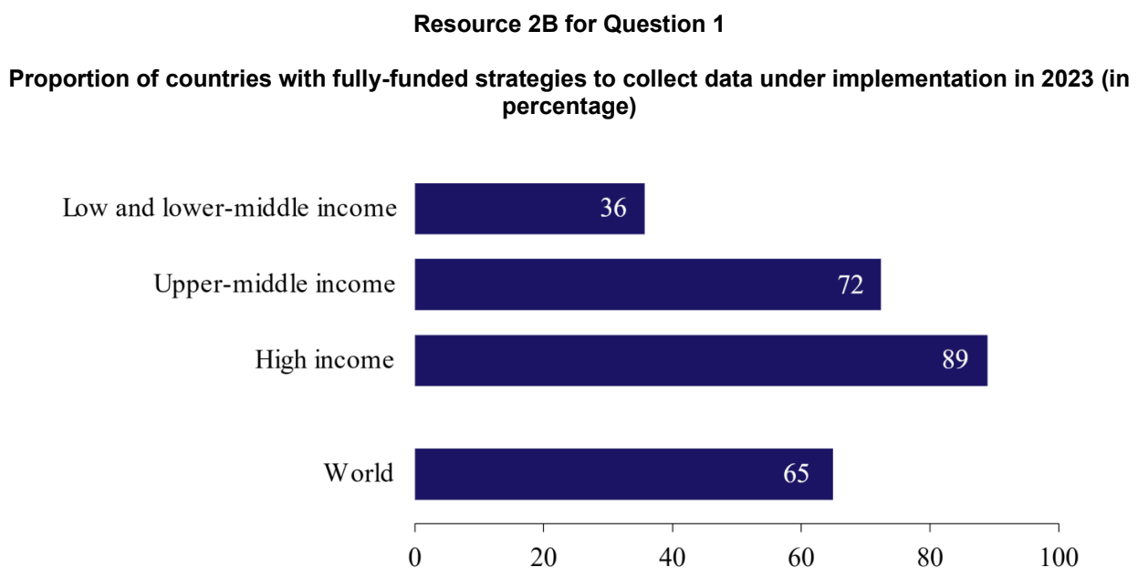

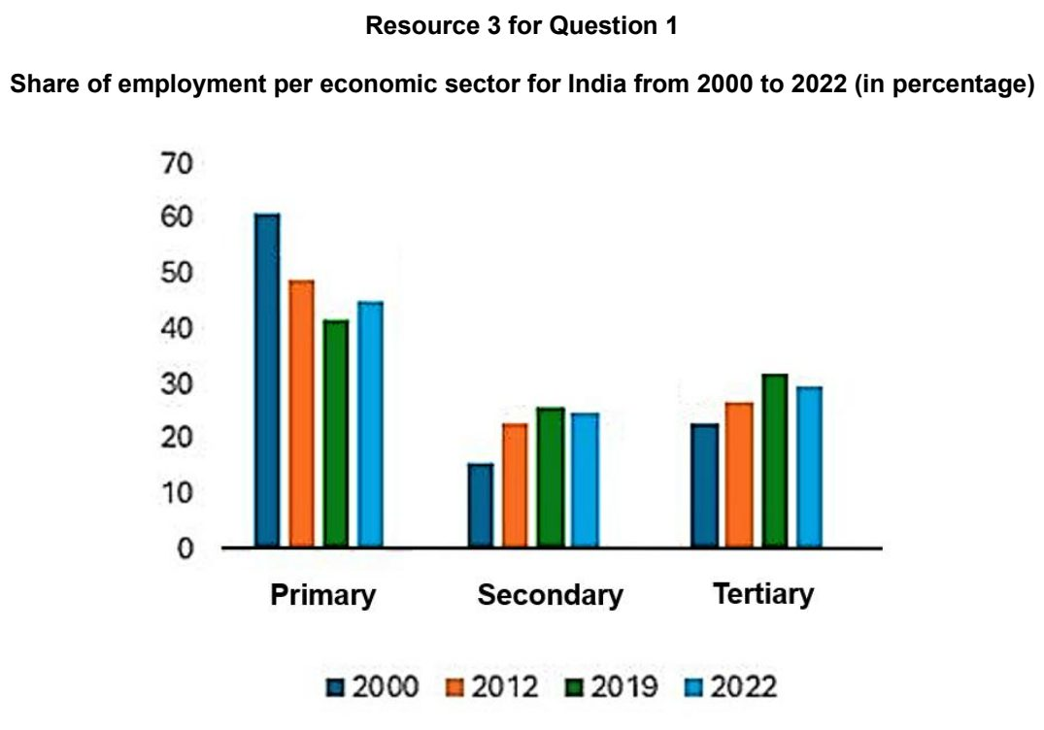

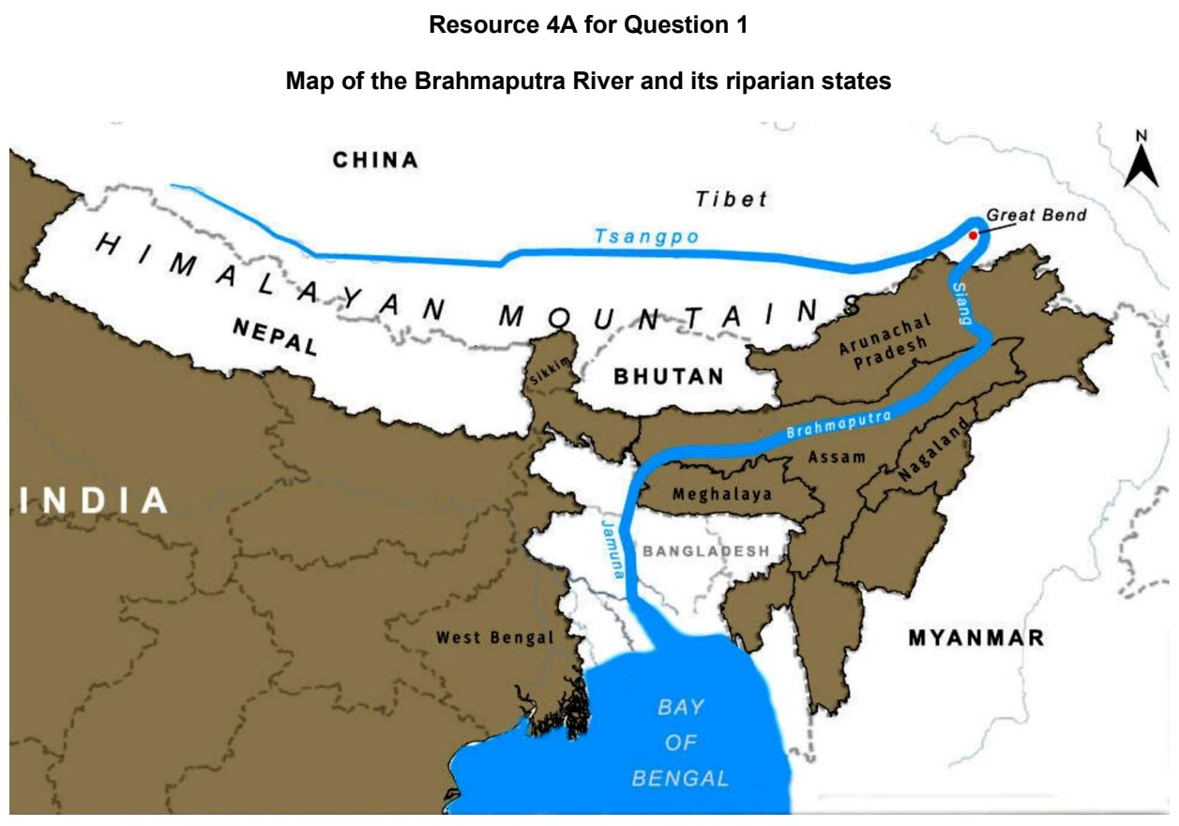

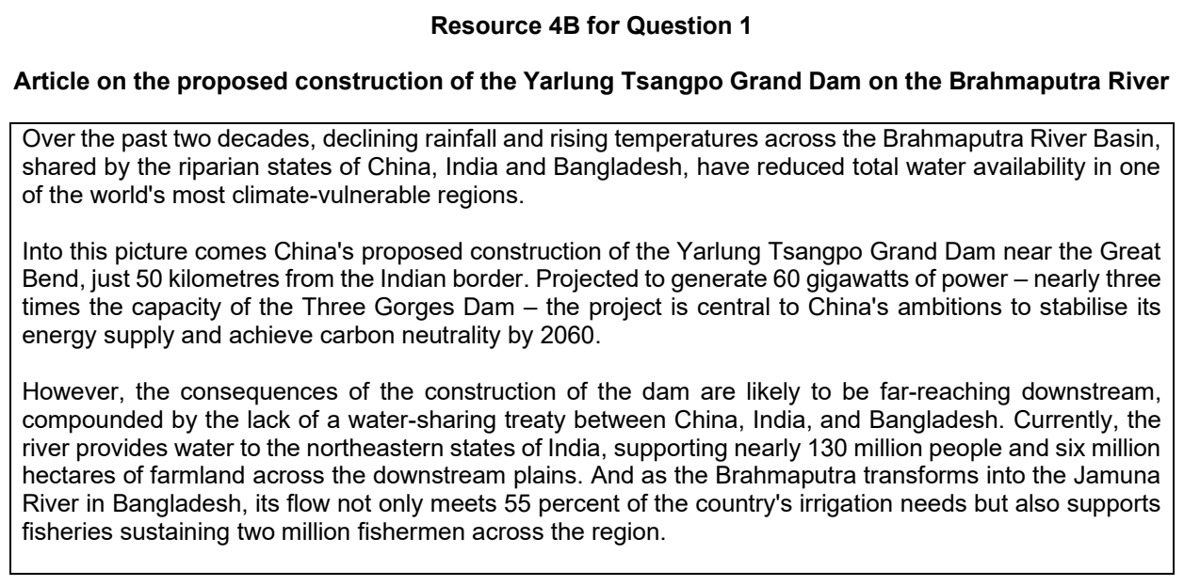

CJC 2024 — H2 Paper 1 (9173/01), Q1 [30 marks]
Syllabus: 1.1.3c Managing Resources – Extractive industries; 1.1.2c Environment and Resources – Population & resources (Malthus, Boserup); 1.2.3b Relative Influence of Actors in Shaping the Global Economy – Labour; 1.1.2a Environment and Resources – Ecosystem services
Section A — Cluster 1: Global Development and Natural Resources
Resource 1 is a map of copper reserves worldwide, in millions of metric tonnes, in 2022 and shows the copper exports of Peru and Chile in that same year. Resource 2 is a map of global consumption of copper in 2021. Resource 3 is a graph of the price of copper between 2013 and 2017, showing the impact of a labour strike in February 2017 on the price of copper. Resource 4 is a photo of Escondida mine, the world’s largest producer of copper, located in Chile.
(a) Cite data from Resource 1 to describe the flow of copper from Chile and Peru. [5]
(b) Describe the consumption of copper shown in Resource 2. [5]
(c) With reference to Resources 1 and 2, suggest reasons for copper exports from Chile and Peru in 2022. [5]
(d) Referring to Resource 3, explain how labour can impact extractive industries. [5]
(e) Explain how extractive industries may impact ecosystem services of their immediate environment. [4]
(f) Explain population-resource relationships according to Malthus and. Boserup. [6]

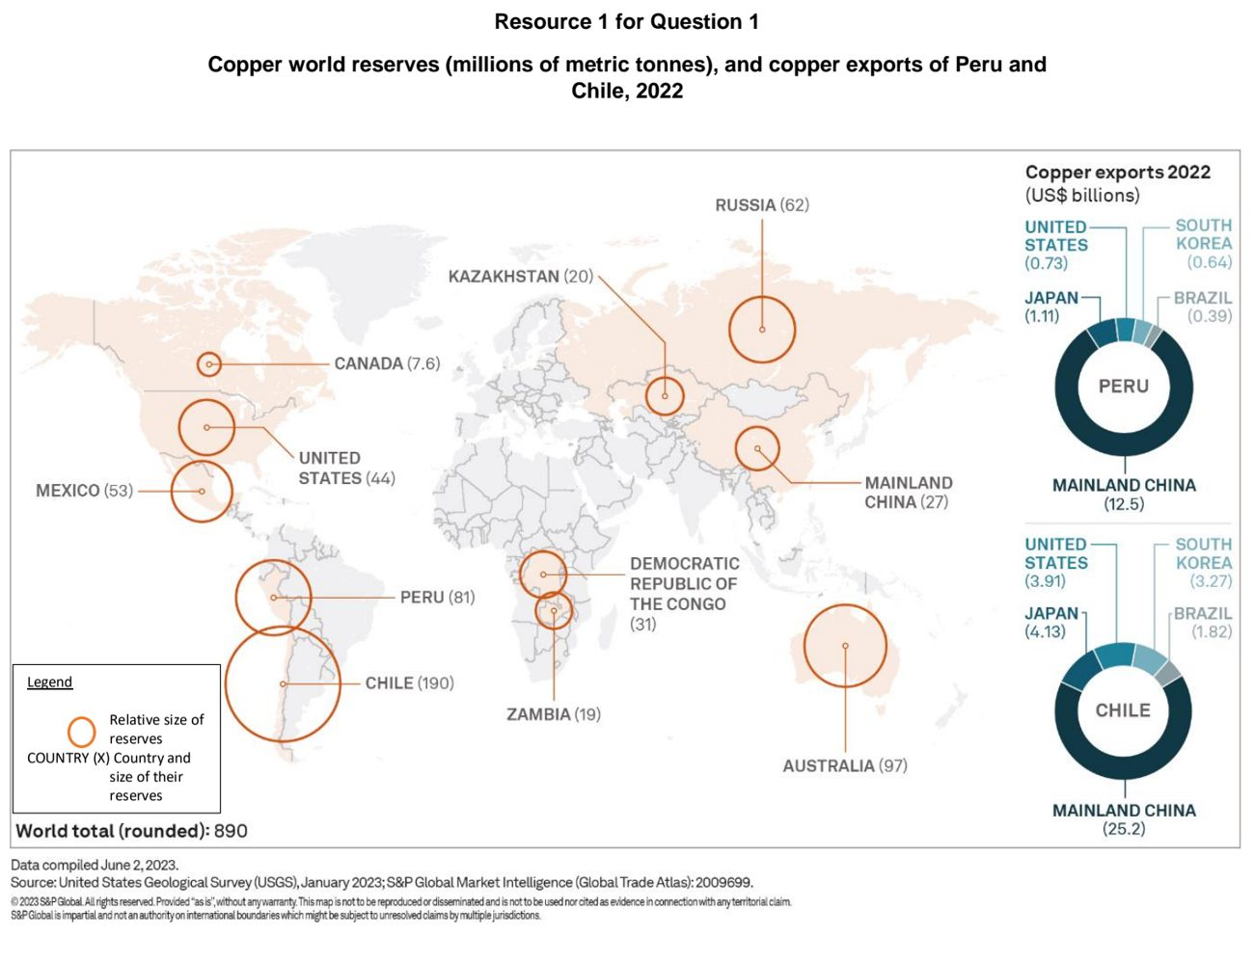

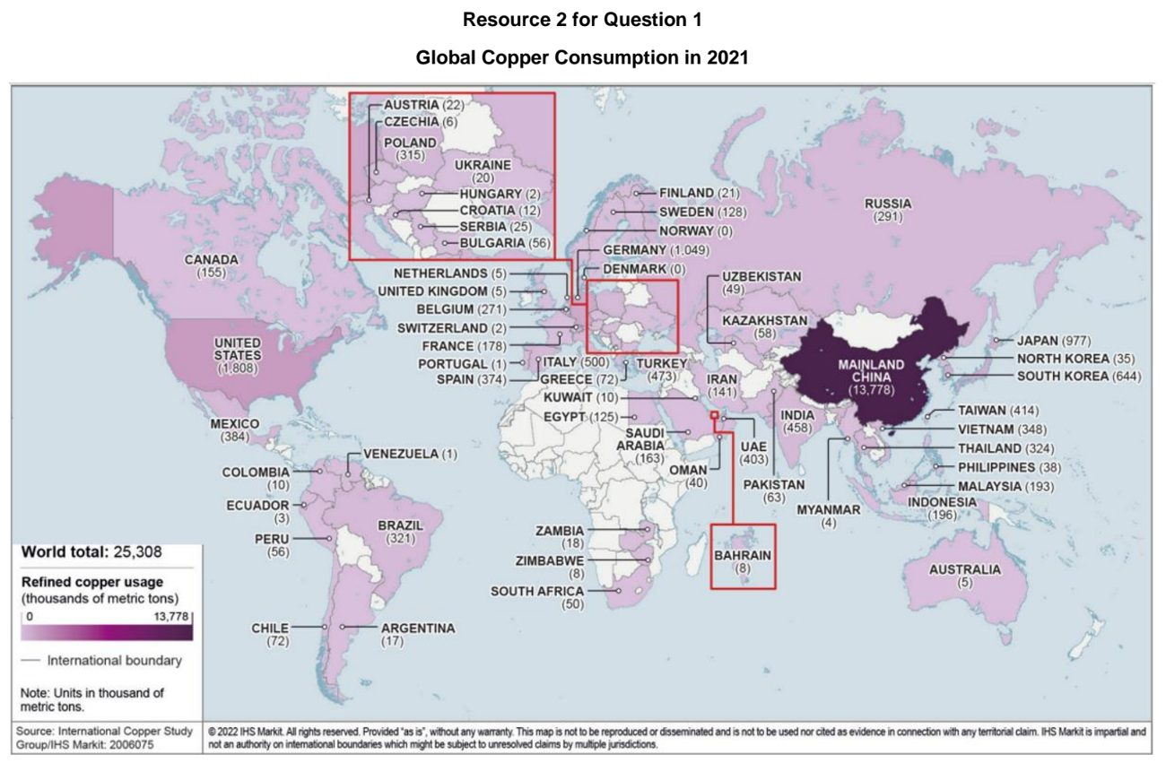

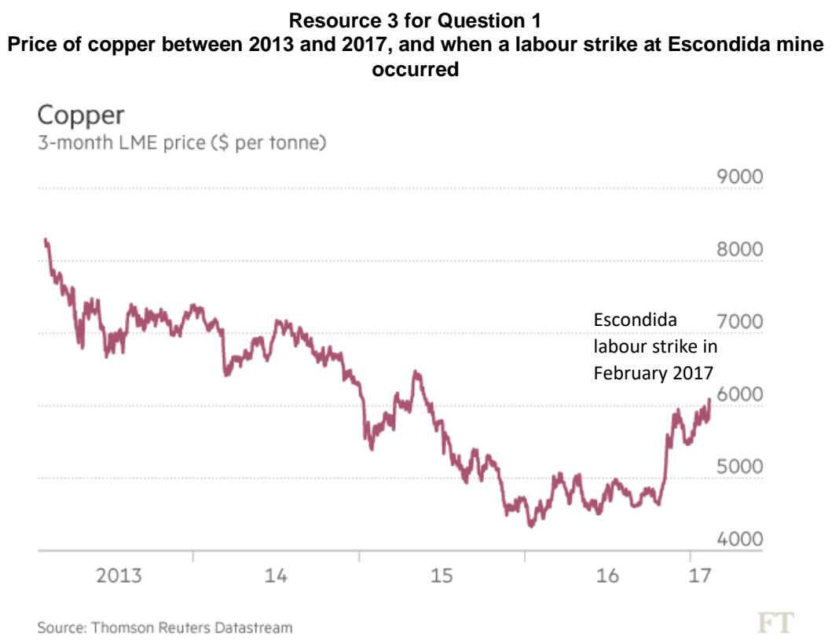

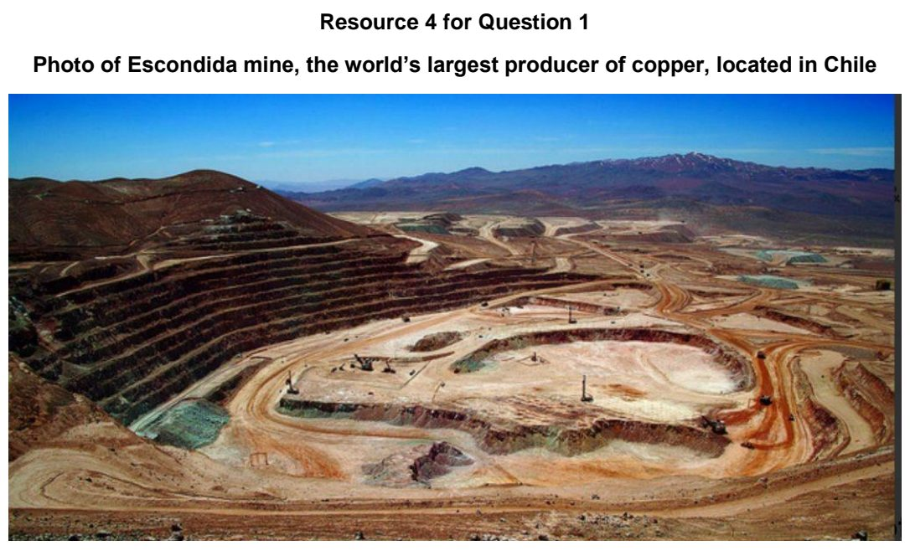

DHS 2024 — H2 Paper 1 (9173/01), Q1 [30 marks]
Syllabus: 1.1.3a Managing Resources – Renewable energy (solar, hydropower); 1.1.2b Environment and Resources – Supply of provisioning services (reserves); 1.1.1a Understanding Sustainable Development – Concept of SD & trade-offs; 1.1.2c Environment and Resources – Population & resources (Malthus, Boserup)
Section A — Cluster 1: Global Development and Natural Resources
Resource 1 shows palm oil production by country in 1992 and 2022. Resource 2 shows a fact file on Indonesia and Malaysia in 2022. Resource 3 shows solar and hydroelectric generation in USA from 2019 to 2024. Resource 4 is a schematic diagram of population-resource relationship in the Sahel region in Africa.
(a) Using an example for each, explain what is meant by conditional reserves and hypothetical reserves. [4]
(b) Compare the distribution of palm oil production between 1992 and 2022 shown in Resource 1. [4]
(c) With reference to Resource 2, explain how palm oil production influences progress towards sustainable development in Indonesia and Malaysia. [6]
(d) Contrast the solar and hydroelectric generation in USA from 2019 to 2024 shown in Resource 3. [4]
(e) Suggest why solar generation in USA is likely to increase in the future as shown in Resource 3. [6]
(f) Explain how the schematic diagram in Resource 4 shows Thomas Malthus’ views on population and resources. [6]

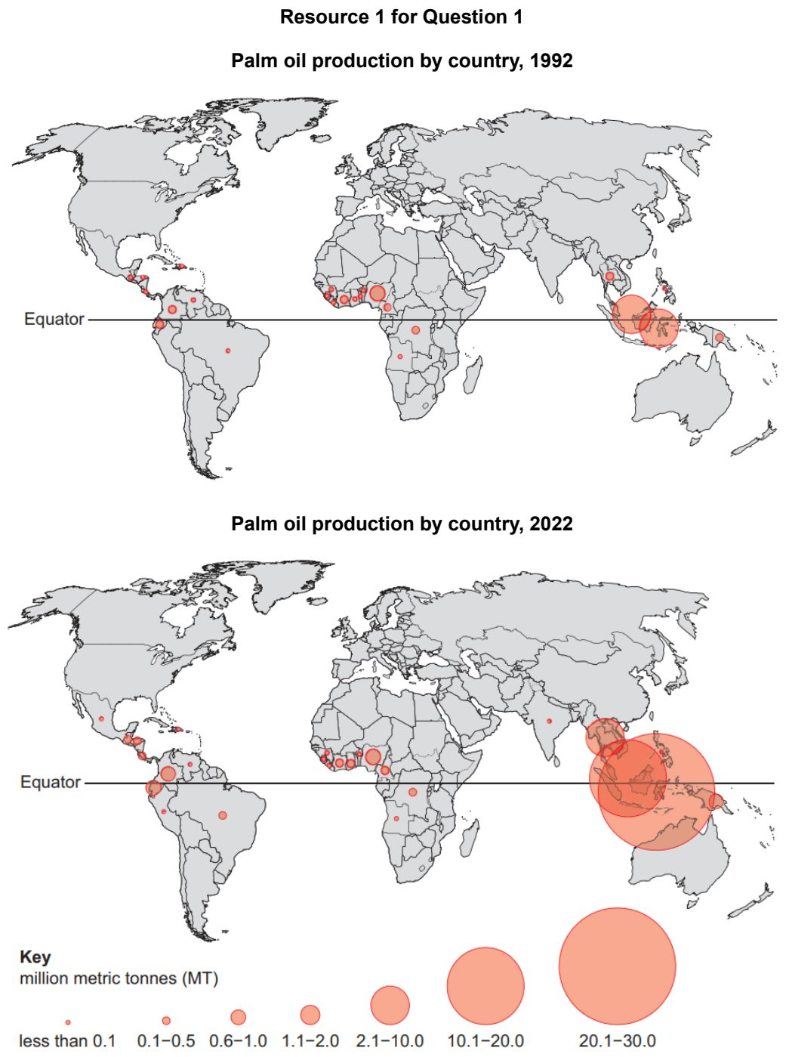

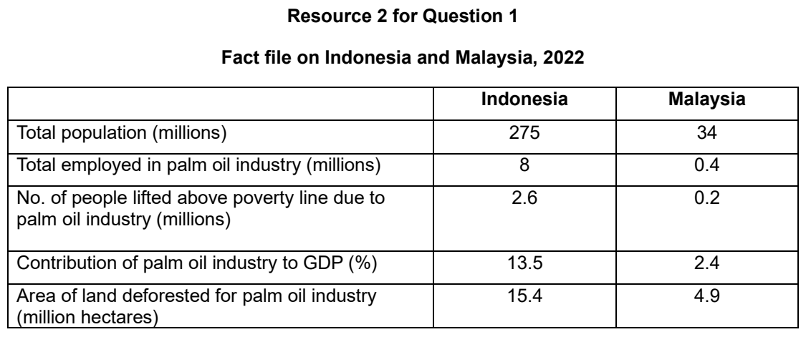

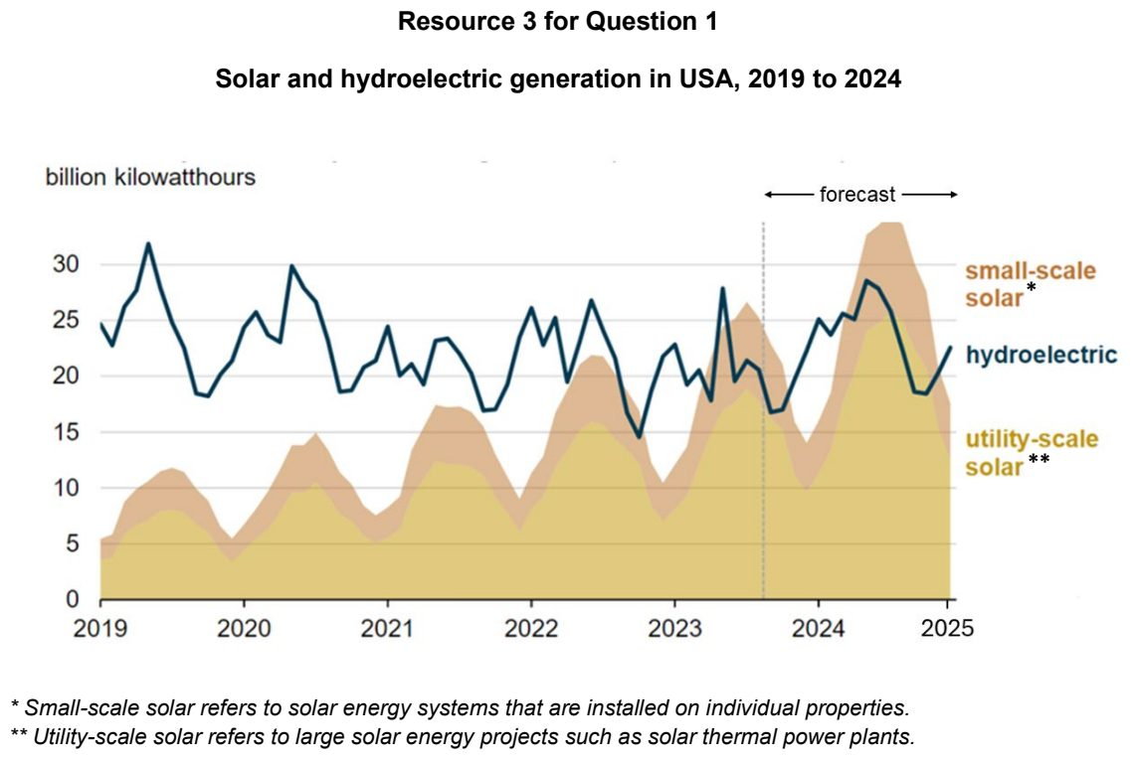

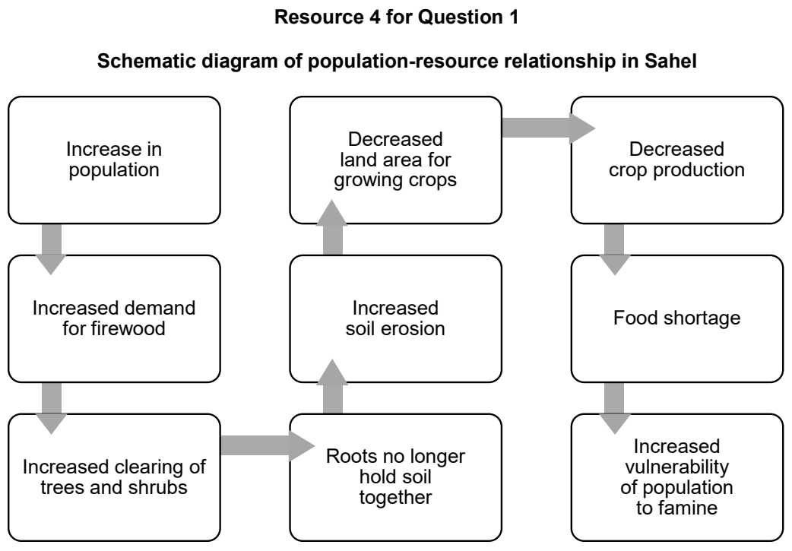

DHS 2025 — H2 Paper 1 (9173/01), Q1 [30 marks]
Syllabus: 1.1.3c Managing Resources – Extractive industries; 1.2.1b Development – Trade, capital & labour flows; 1.2.3c Relative Influence of Actors in Shaping the Global Economy – Multilateral institutions
Section A — Cluster 1: Global Development and Natural Resources
Resource 1 shows the Mineral Contribution Index by country in 2018. Resource 2 shows the global price of lithium carbonate and cobalt from 2016 to 2023. Resource 3 shows the landscape of an area after mining took place in Australia. Resource 4 shows intra-ASEAN trade as a share of total trade for six ASEAN member states between 2004 and 2023.
(a) Explain the characteristics of extractive industries. [5]
(b) Describe the patterns of Mineral Contribution Index (MCI) shown in Resource 1. [4]
(c) With reference to Resources 1 and 2, suggest why the economic impacts of extractive industries vary between countries. [6]
(d) With reference to Resource 3, explain how mining may harm the environment. [5]
(e) With reference to Resource 4, describe the changes in intra-ASEAN trade as a share of total trade for ASEAN member states between 2004 and 2023. [5]
(f) Explain the influence of the Association of Southeast Asian Nations (ASEAN) on TNCs and states. [5]

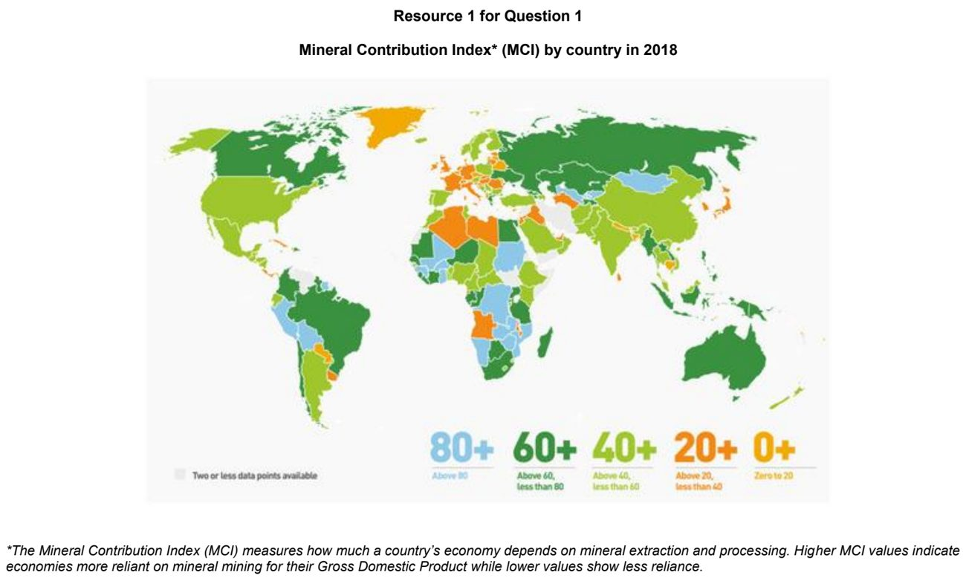

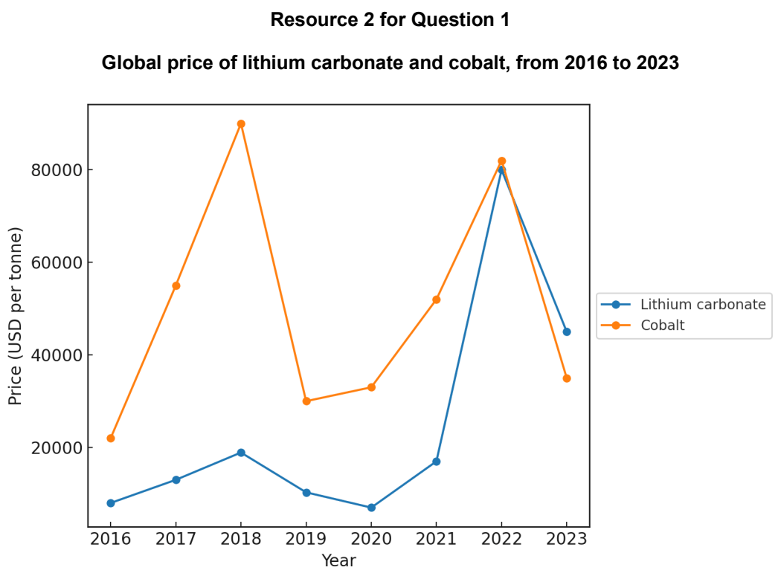

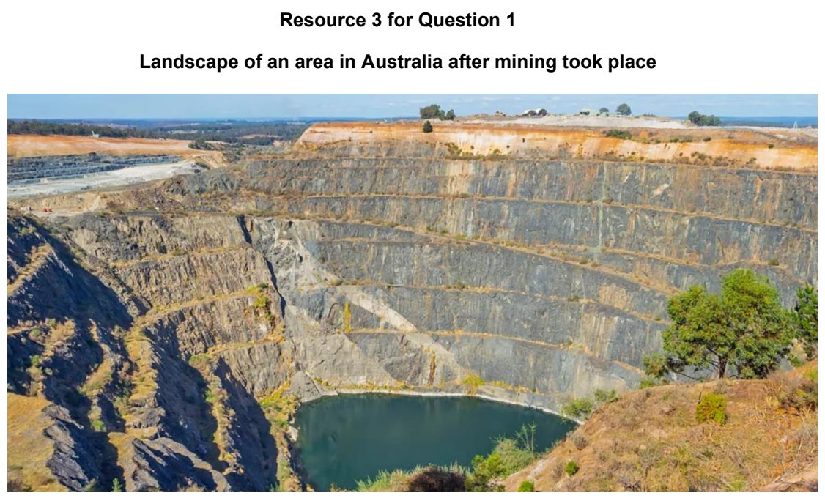

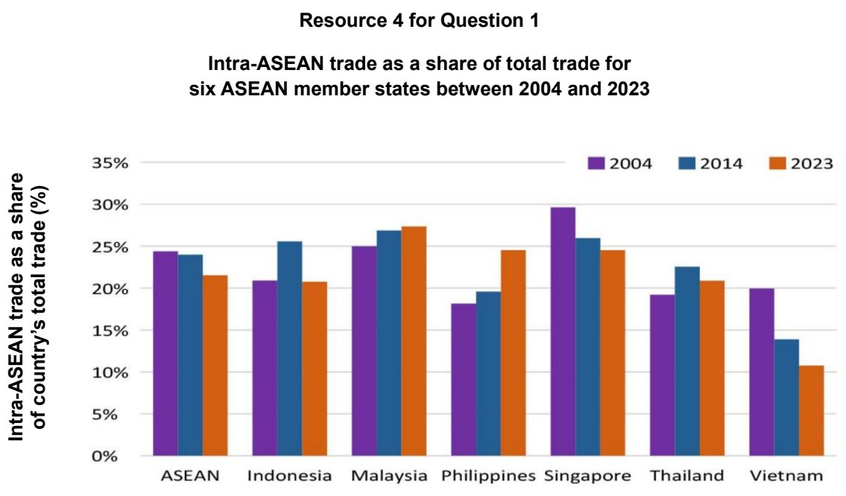

DHS 2026 — H2 Paper 1 (9173/01), Q1 [30 marks]
Syllabus: 1.1.3a Managing Resources – Renewable energy (solar, hydropower); 1.2.2b Geography of the Global Economy and TNCs – GPNs connecting places; 1.2.2c Geography of the Global Economy and TNCs – Impacts of GPNs on home & host; 1.1.2b Environment and Resources – Supply of provisioning services (reserves)
Section A — Cluster 1: Global Development and Natural Resources
Resource 1 shows the distribution of hydroelectric power stations in Scotland, UK. Resource 2 shows sources of electricity generation in Scotland, UK, from 2010 to 2020. Resource 3 shows the Global Production Network (GPN) of DJI, a TNC, in 2006 and 2025. Headquartered in Shenzhen, China, DJI designs, manufactures and sells drones. Resource 4 shows the impact of DJI’s GPN on USA in 2023.
(a) Describe the classification of provisioning services based on their availability. [4]
(b) With reference to Resource 1, suggest reasons for the concentration of hydroelectric power stations in some parts of Scotland. [4]
(c) Compare the change in the use of coal for electricity generation in Scotland with the use of renewables between 2010 and 2020 shown in Resource 2. [5]
(d) Explain why hydropower may not fully replace fossil fuels in developed countries such as Scotland. [5]
(e) With reference to Resource 3, suggest reasons for the continuity and changes in DJI’s GPN between 2006 and 2025. [6]
(f) With reference to Resource 4, explain the impact of DJI’s GPN on USA, a host economy. [6]

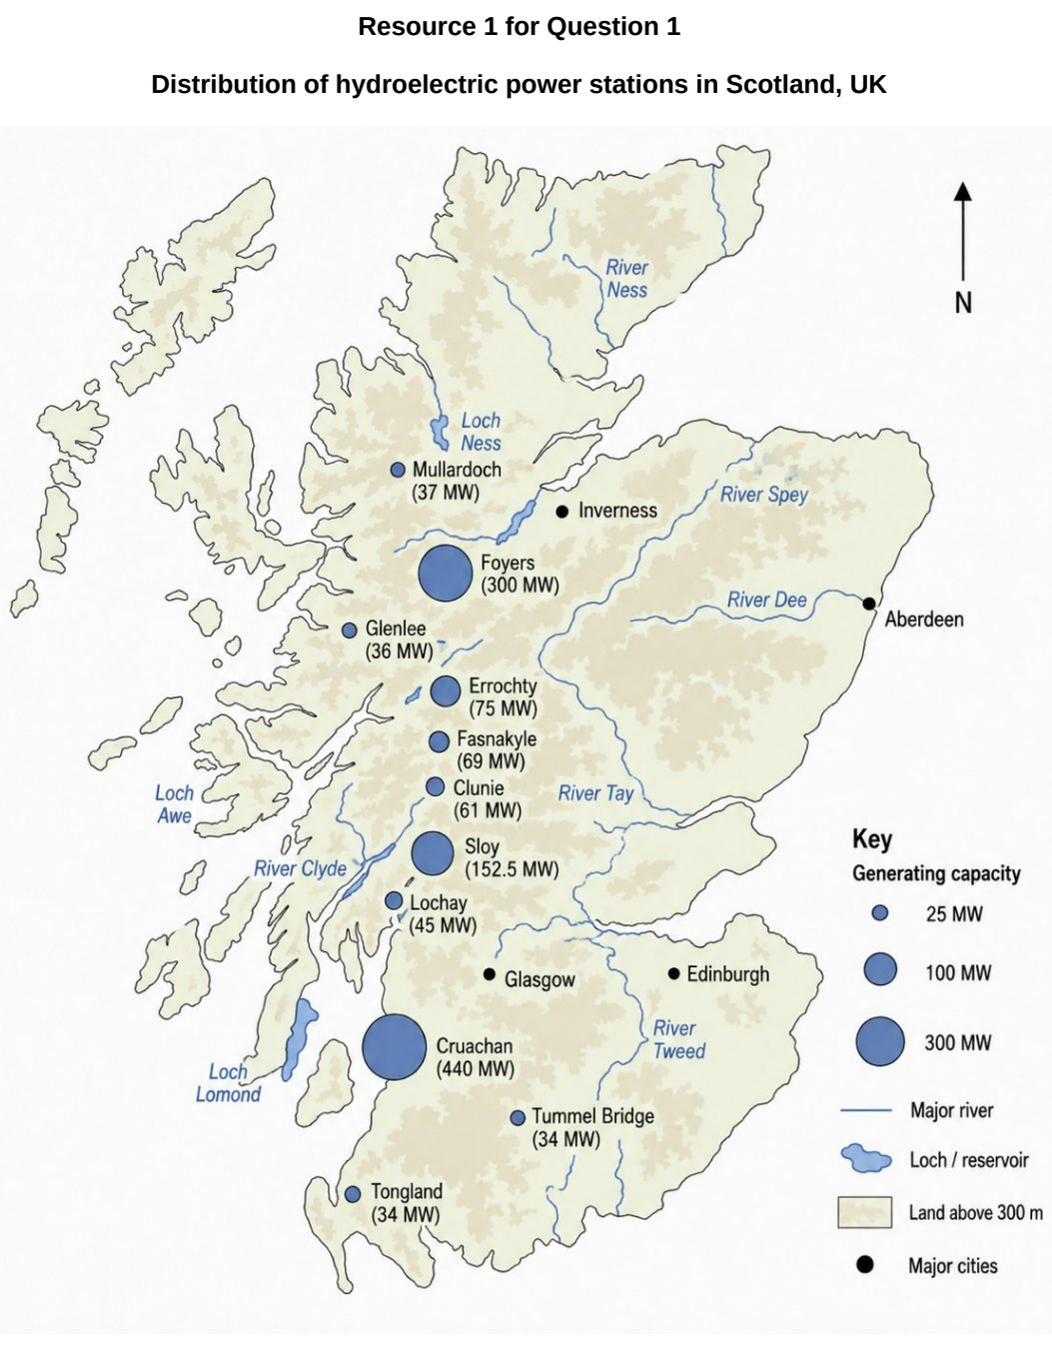

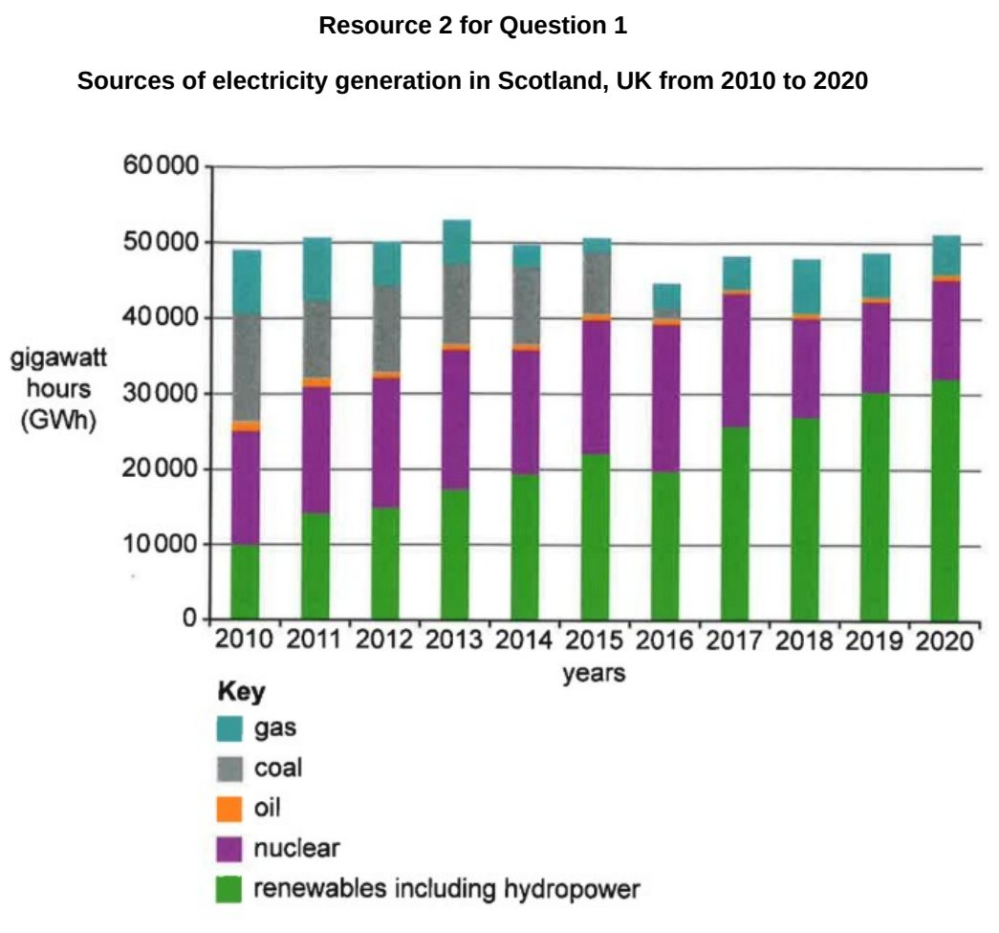

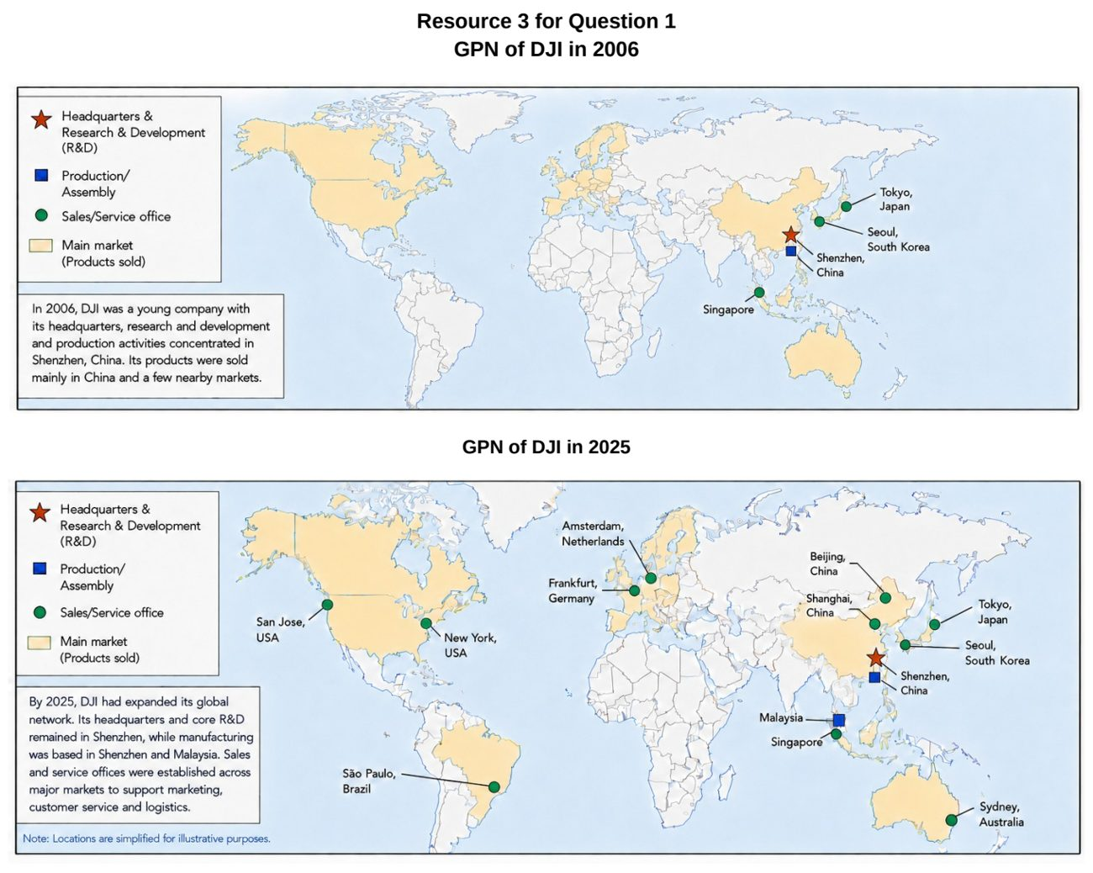

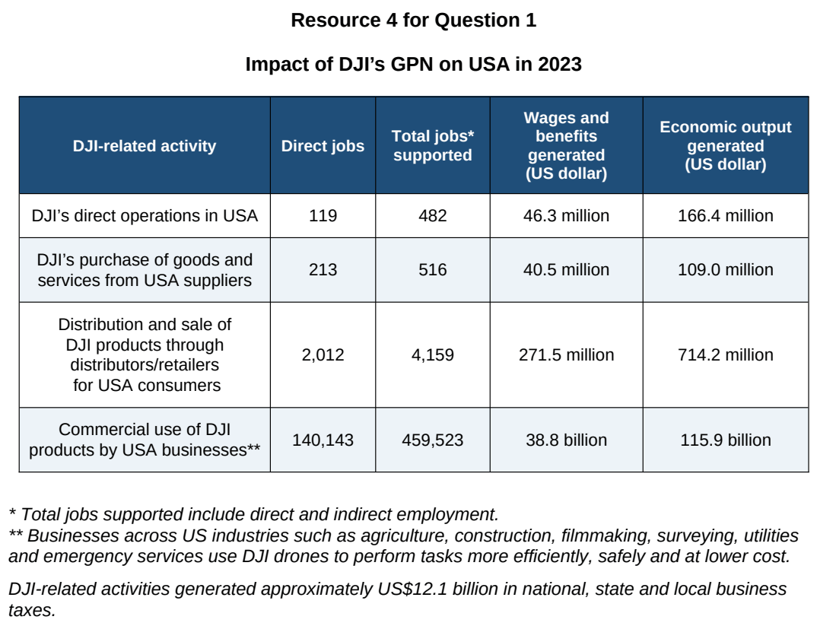

EJC 2024 — H2 Paper 1 (9173/01), Q1 [30 marks]
Syllabus: 1.1.3a Managing Resources – Renewable energy (solar, hydropower); 1.1.3b Managing Resources – Transboundary water conflicts
Section A — Cluster 1: Global Development and Natural Resources
Resource 1 is a map depicting the Nile River Basin, its riparian states and the location of the Grand Ethiopian Renaissance Dam (GERD) along the Blue Nile. Resource 2 shows the estimated changes in annual water flow from the Blue Nile and Nile River before and after the construction of the GERD. Resource 3 shows two satellite photographs of the GERD and its immediate vicinity in 2020, when the GERD was undergoing construction, and 2023, when the GERD was in operation. Resources 4A and 4B show the power and water needs of Ethiopia and Egypt respectively. Resource 5 shows the changes in solar installations in India from 2009 to 2019.
(a) Describe the estimated changes in the annual water flow from the Blue Nile and Nile River before and after the construction of the Grand Ethiopian Renaissance Dam (GERD) as shown in Resource 2. [4]
(b) Use Resource 3 to explain the environmental impacts of the Grand Ethiopian Renaissance Dam (GERD) when it is in operation. [4]
(c) With reference to Resources 1, 2, 3, 4A and 4B, suggest reasons for potential conflicts across the riparian states in the Nile River Basin. [6]
(d) Suggest two ways in which potential conflicts over transboundary water resources such as the Nile River could be managed. [4]
(e) Cite data from Resource 5 to describe the changes in annual and cumulative solar installations in India from 2009 to 2019. [6]
(f) Explain three limitations of solar power in providing energy security in countries at lower levels of development such as India. [6]

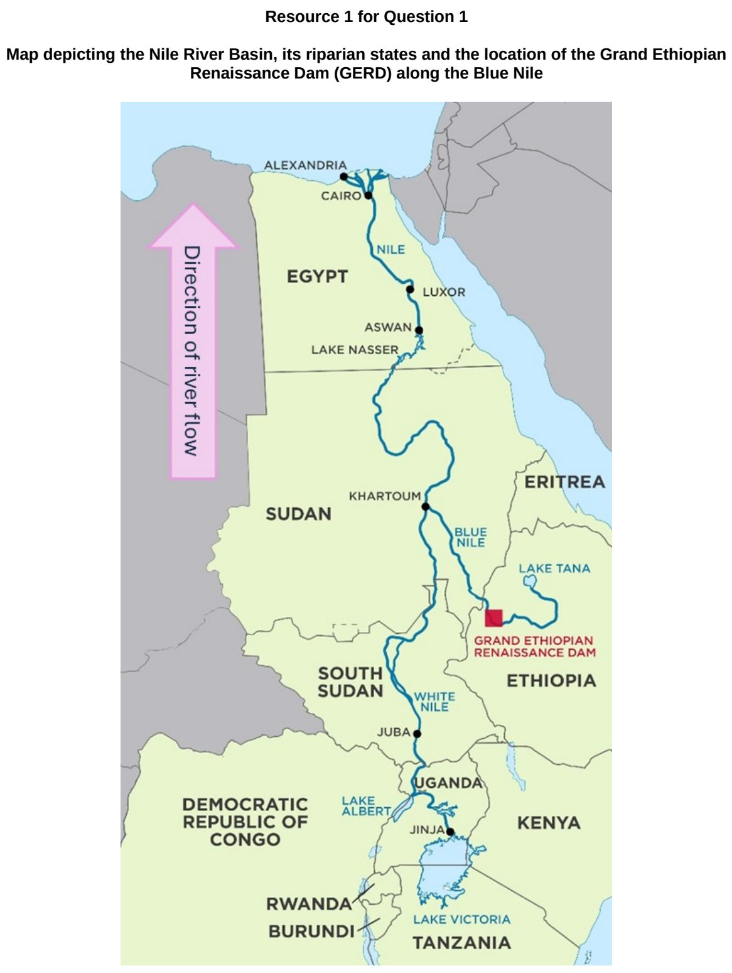

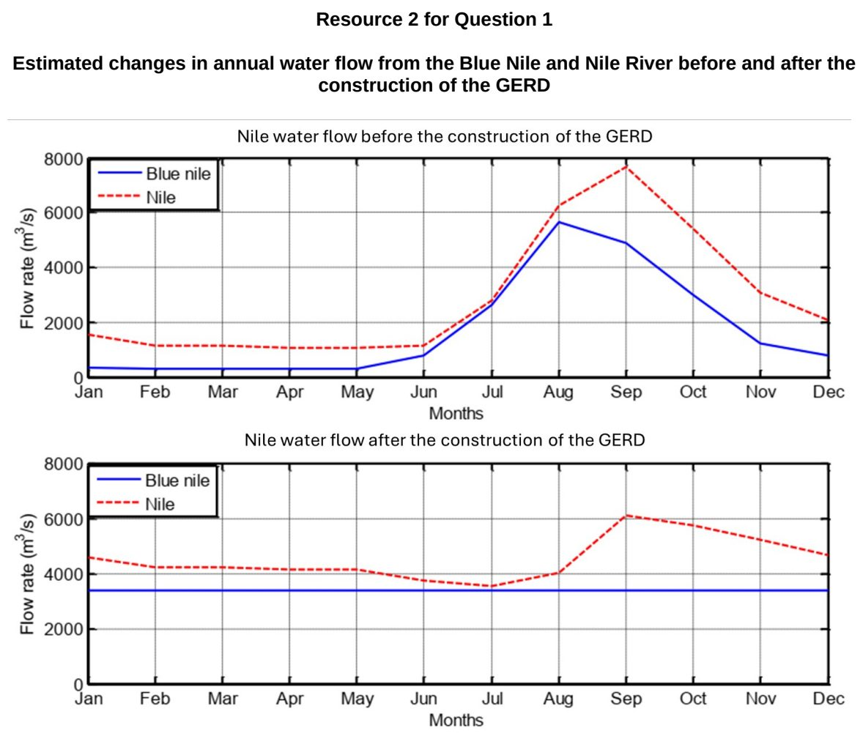

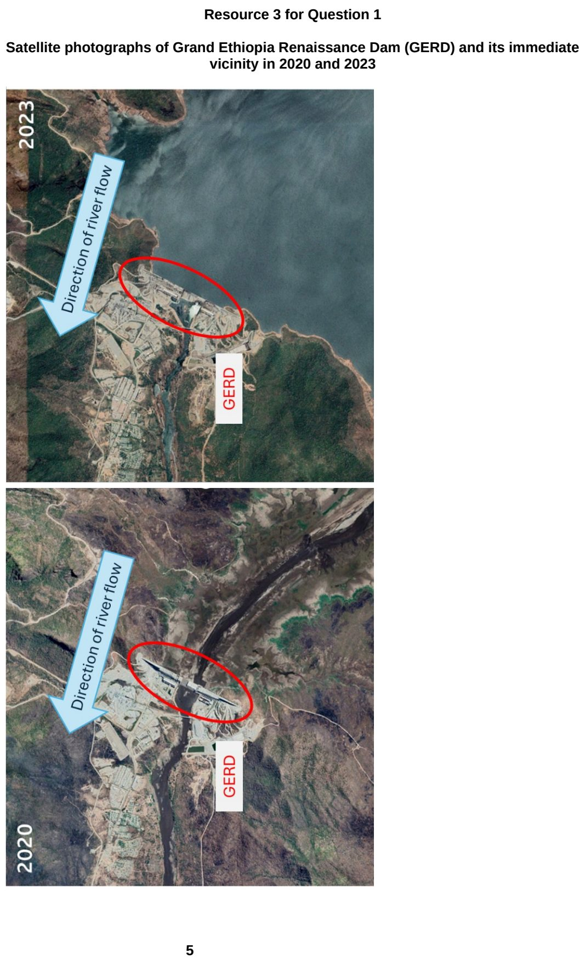

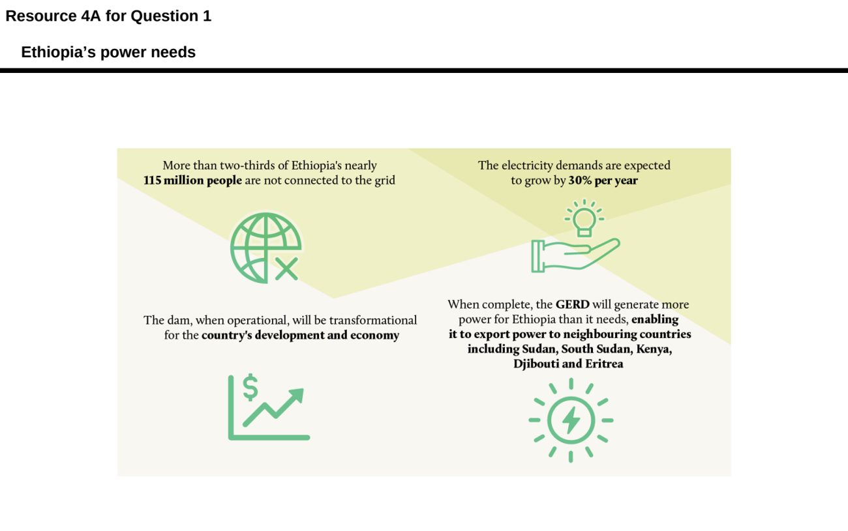

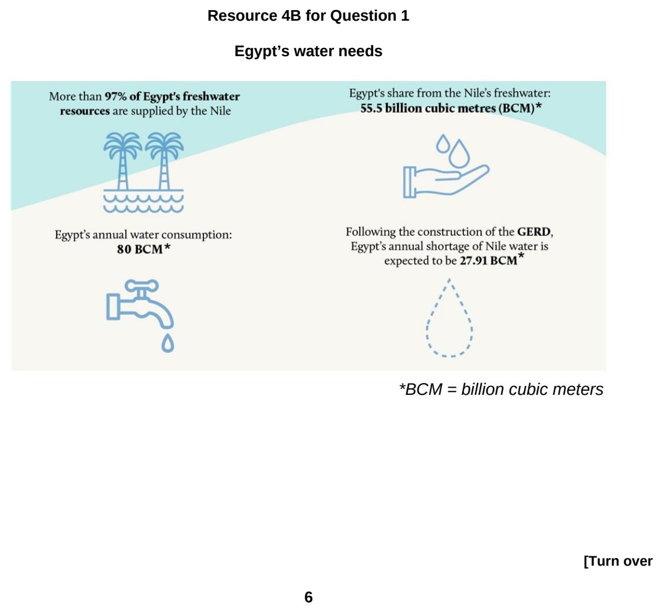

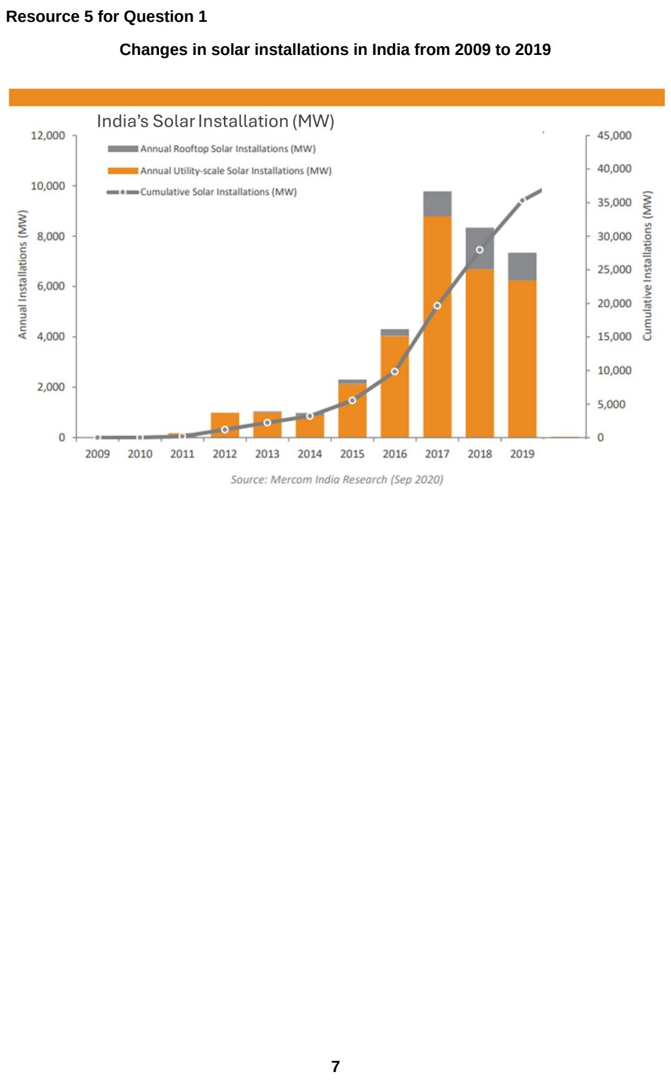

HCI 2025 — H2 Paper 1 (9173/01), Q1 [30 marks]
Syllabus: 1.1.3b Managing Resources – Transboundary water conflicts; 1.1.3a Managing Resources – Renewable energy (solar, hydropower); 2.2.3c Fluvial Landforms in the Humid Tropics – Delta ecosystem services
Section A — Cluster 1: Global Development and Natural Resources
Resource 1 shows the locations of dams along the Yarlung Tsangpo (China)-Brahmaputra River (India and Bangladesh), and associated tributaries. China’s proposed Medog Dam is also shown. Resource 2 shows the share of countries’ electricity production that came from hydropower in 2022. Resource 3 is a fact file on China, India and Bangladesh.
(a) Explain how hydropower can help China achieve sustainable development. [3]
(b) With reference to Resource 1, describe the distribution of dams along the Yarlung Tsangpo-Brahmaputra River. [4]
(c) With reference to Resource 1, explain how the proposed Medog Dam may negatively impact the Ganges-Brahmaputra Delta. [5]
(d) With reference to Resources 1 and 2, suggest reasons for the differences in the countries’ share of electricity production that came from hydropower. [6]
(e) With reference to Resources 1 and 3, outline possible conflicts between China, India and Bangladesh due to the proposed Medog Dam. [6]
(f) Explain the strategies used to manage conflicts over transboundary water resources. [6]

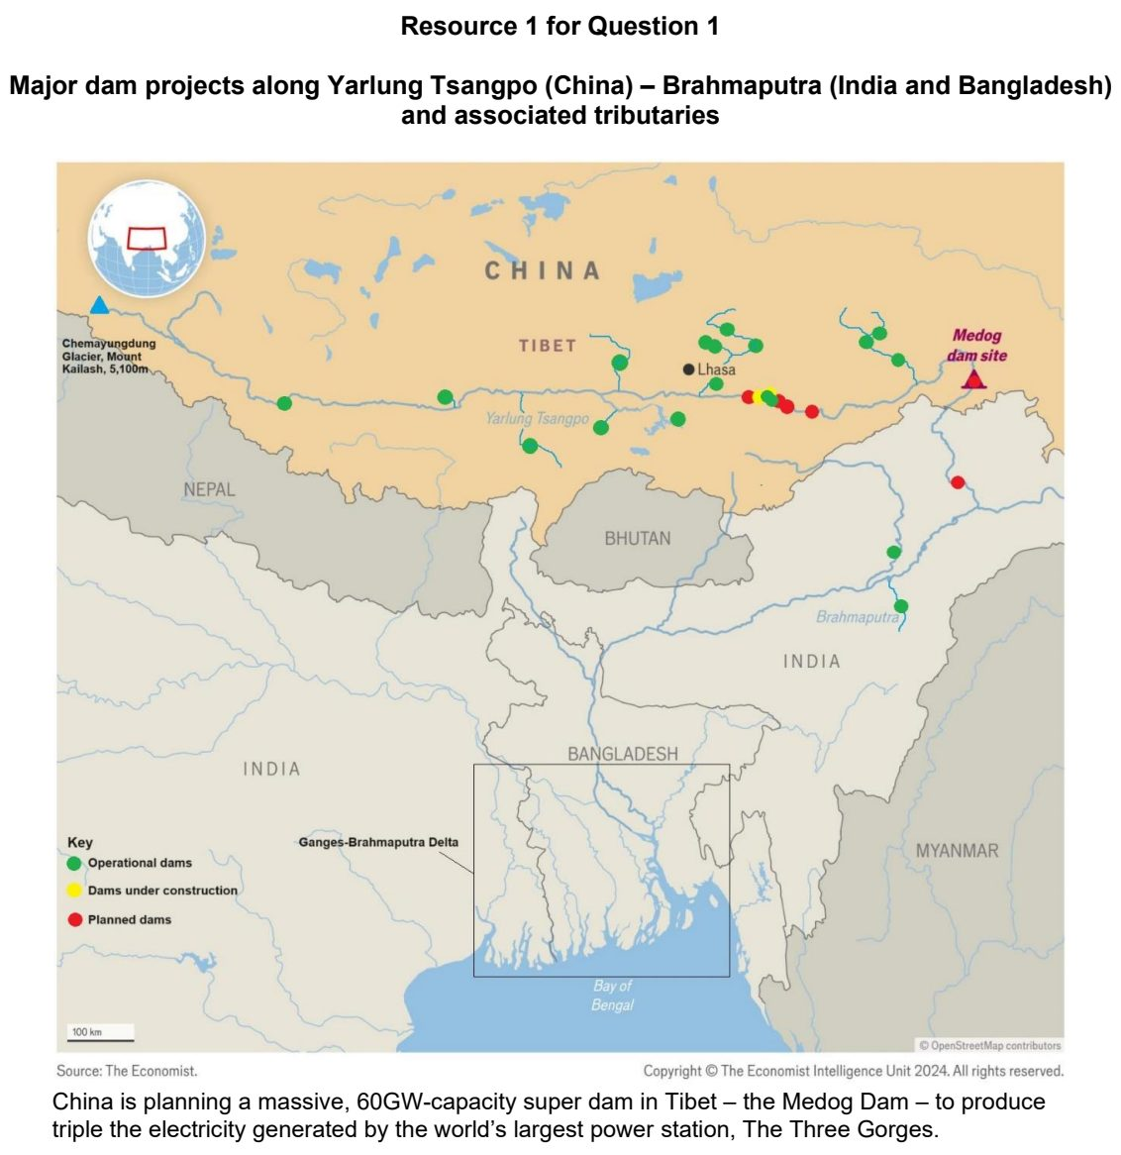

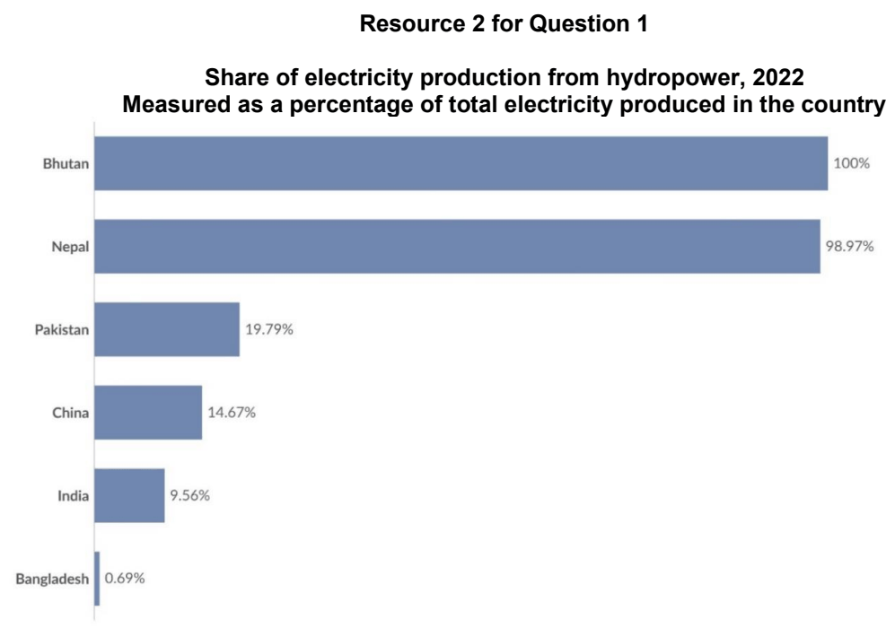

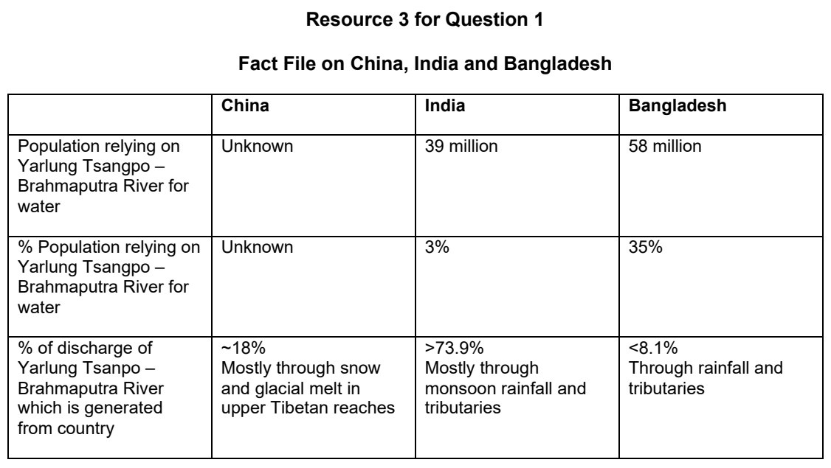

JPJC 2024 — H2 Paper 1 (9173/01), Q1 [30 marks]
Syllabus: 1.1.1b Understanding Sustainable Development – Measuring progress (SDGs, indicators); 1.1.2b Environment and Resources – Supply of provisioning services (reserves); 1.1.1a Understanding Sustainable Development – Concept of SD & trade-offs; 1.1.1c Understanding Sustainable Development – Challenges limiting SD
Section A — Cluster 1: Global Development and Natural Resources
Resource 1 shows the distribution of global proven oil reserves globally. Resources 2A and 2B show the Sustainable Development Goals performance of two top oil exporting countries, Saudi Arabia and Canada in 2021. Resource 3 shows Saudi Arabia’s share of GDP by economic activity in 2021.
(a) Using an example for each, explain what is meant by proven and hypothetical reserves. [4]
(b) Describe the distribution of global proven oil reserves shown in Resource 1. [4]
(c) Compare the performance of Saudi Arabia and Canada in the Sustainable Development Goals as shown in Resources 2A and 2B. [5]
(d) Suggest why the performance of both countries as shown in Resources 2A and 2B may vary. [5]
(e) Describe the difficulties of measuring progress towards sustainable development. [6]
(f) With the aid of Resource 3, explain the possible trade-offs that Saudi Arabia may face in achieving sustainable development. [6]

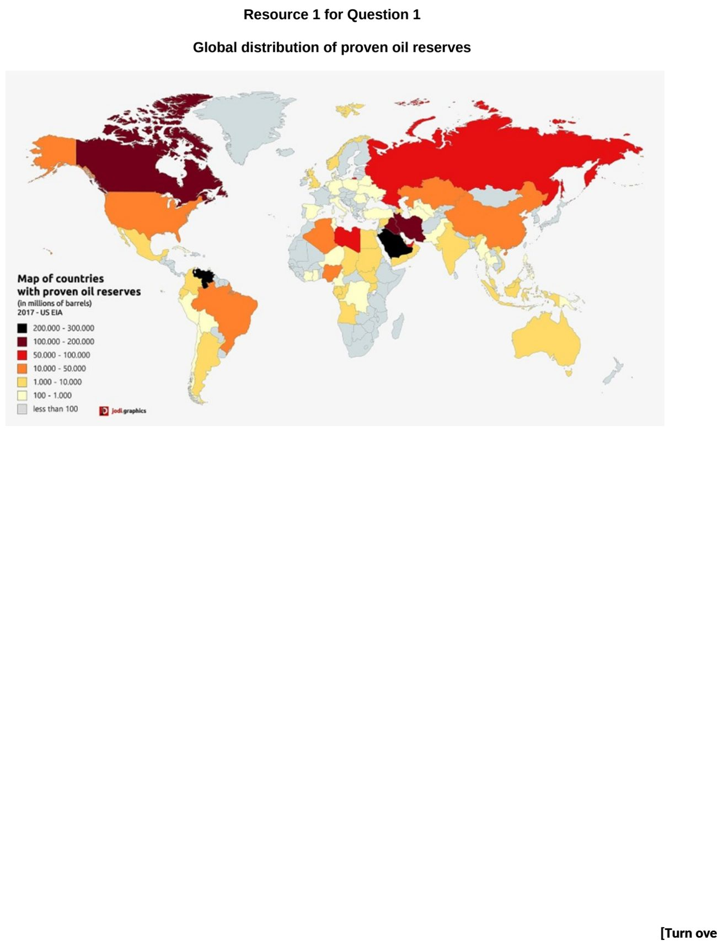

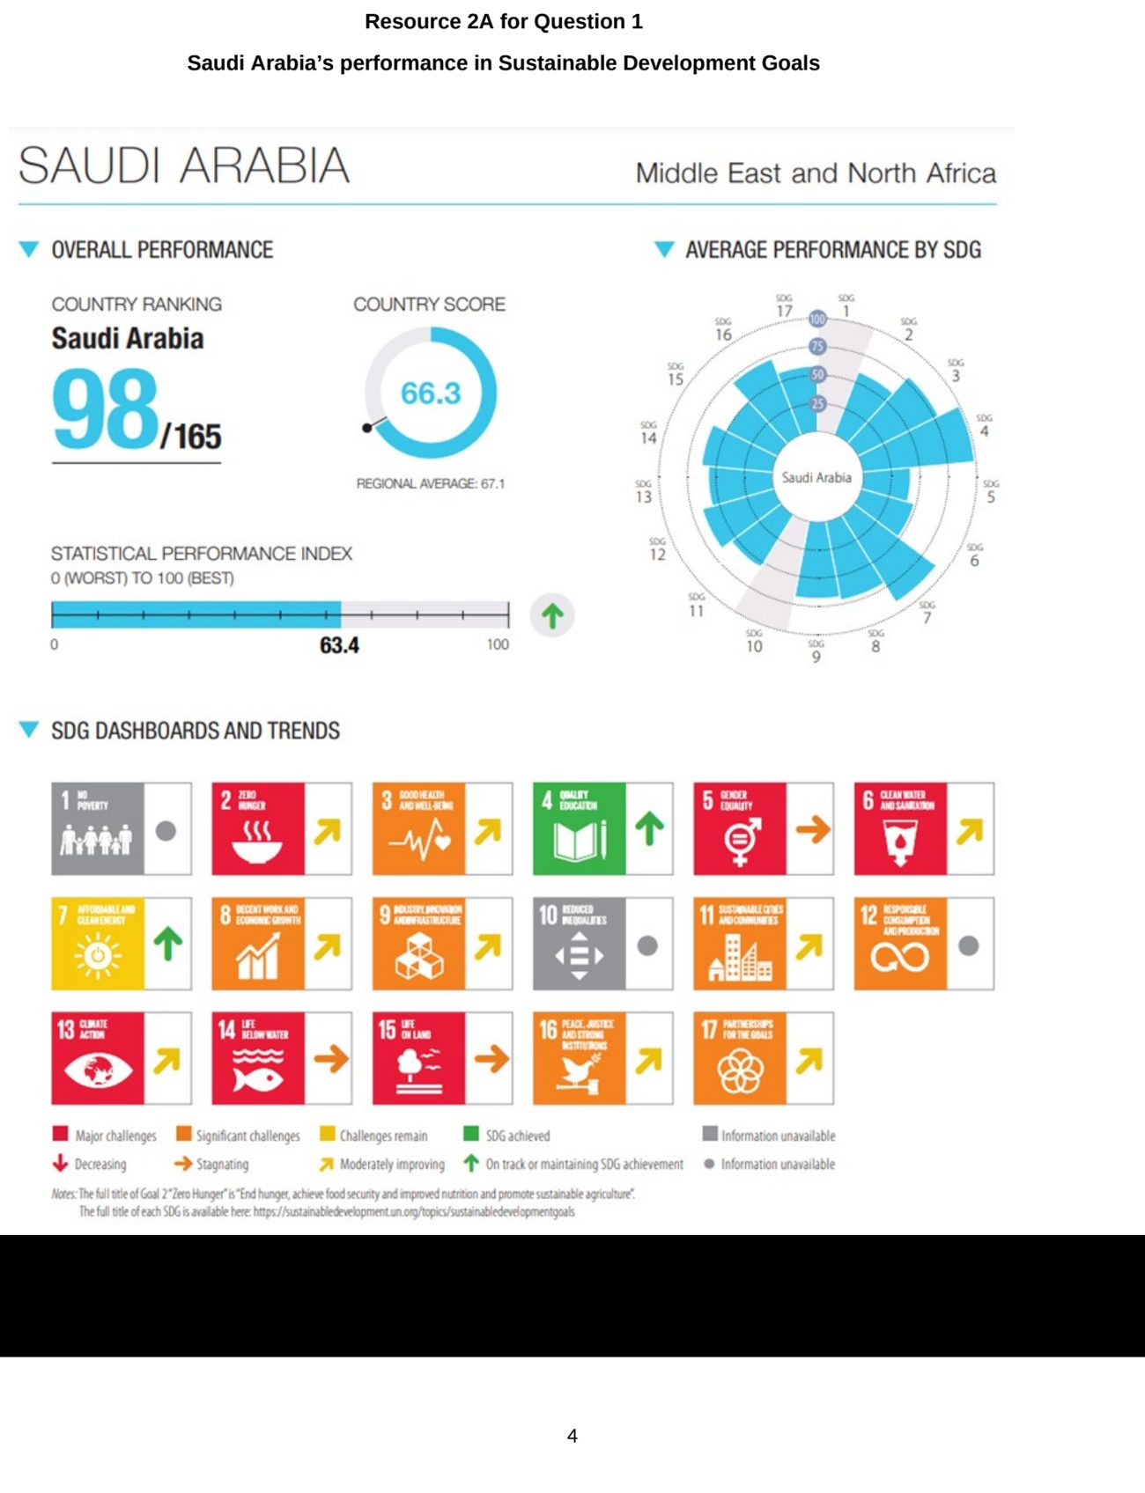

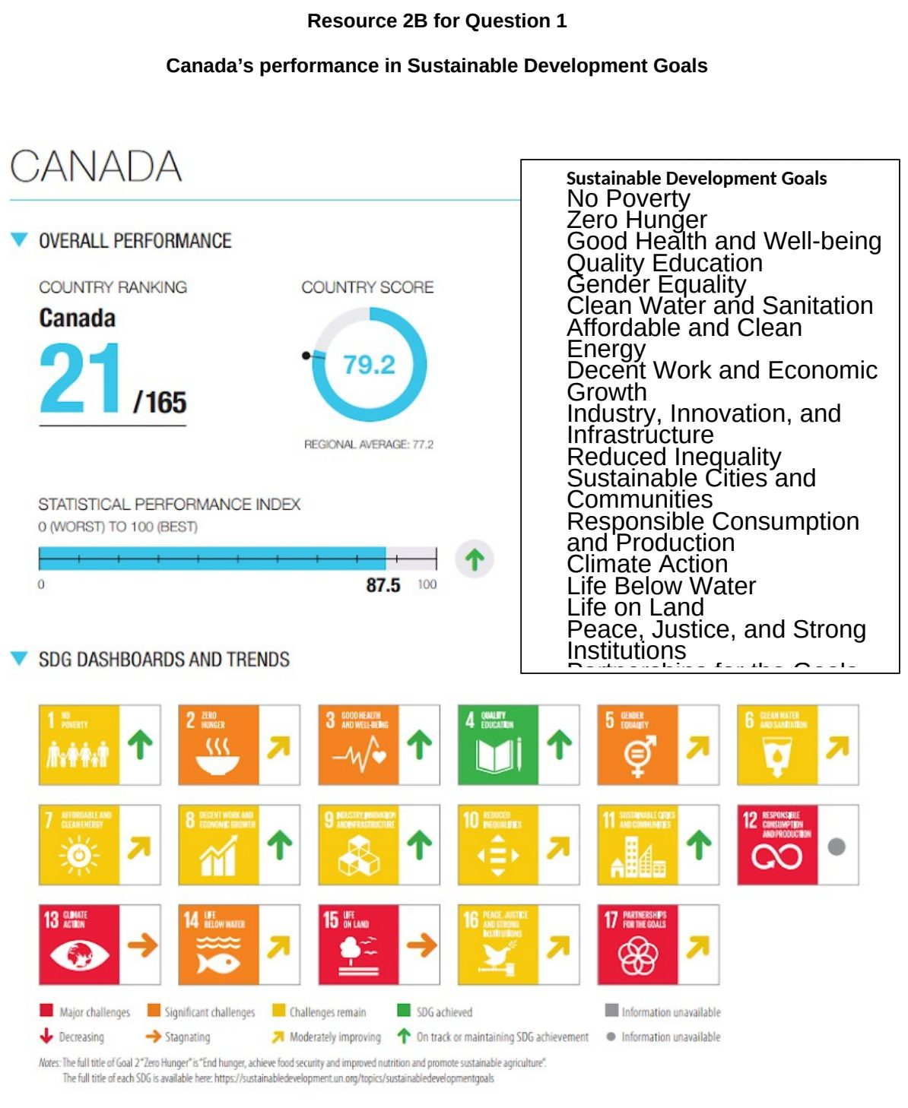

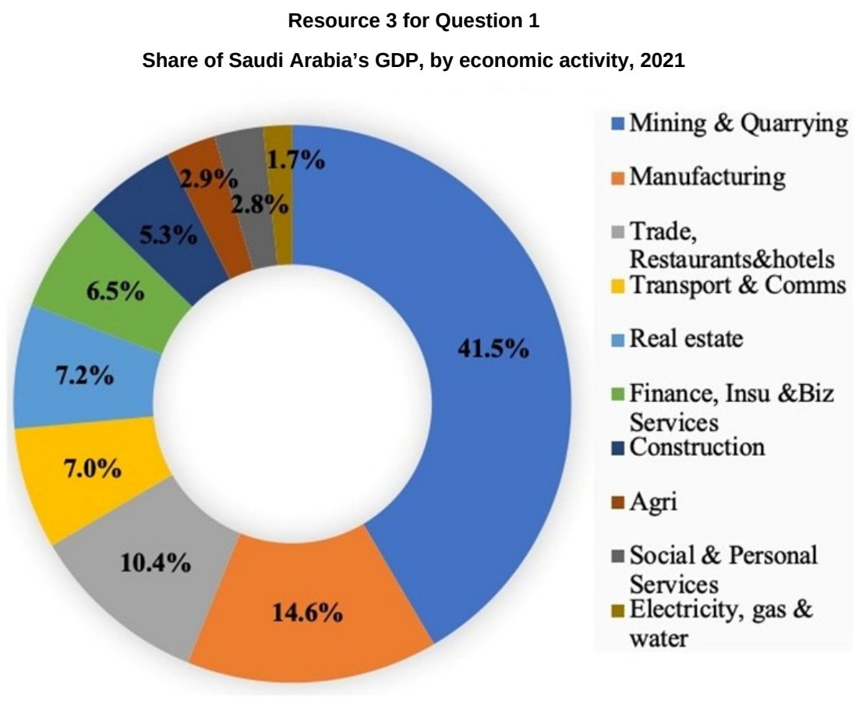

NJC 2024 — H2 Paper 1 (9173/01), Q1 [30 marks]
Syllabus: 1.1.3a Managing Resources – Renewable energy (solar, hydropower); 1.1.3b Managing Resources – Transboundary water conflicts; 1.1.2b Environment and Resources – Supply of provisioning services (reserves)
Section A — Cluster 1: Global Development and Natural Resources
Resource 1 shows the distribution of states in India with solar power projects in 2017. Resource 2 is an article on use of solar energy in India. Resource 3 shows China’s plans for a ‘super dam’ with existing dams on the rivers. Resource 4 shows Sustainable Development Goal (SDG) indicator 7.2.1 on share of final energy use that comes from renewable sources in 2020.
(a) Explain how provisioning services can be classified based on their renewability. [4]
(b) With reference to Resource 1, describe the distribution of solar power projects in India in 2017. [4]
(c) With reference to Resource 2, explain the trade-offs associated with the use of solar power. [4]
(d) With reference to Resource 3, explain how China’s super dam in Tibet can cause conflict between China and India. [6]
(e) Explain the strategies that can be implemented to mitigate potential conflict over transboundary water resources as seen in Resource 3. [6]
(f) With reference to Resource 4, suggest possible reasons for the global variation in the share of energy use that comes from renewable sources. [6]

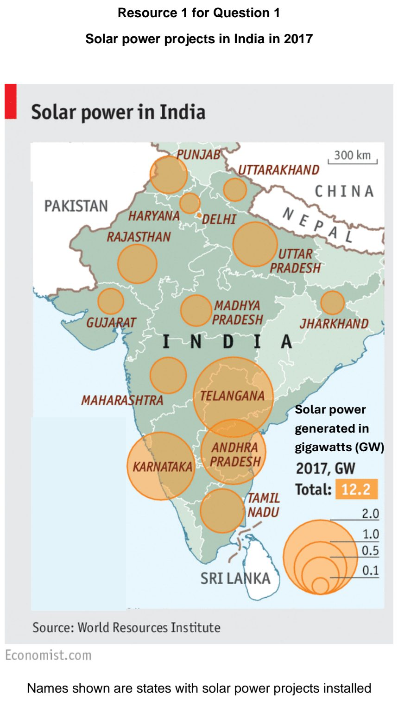

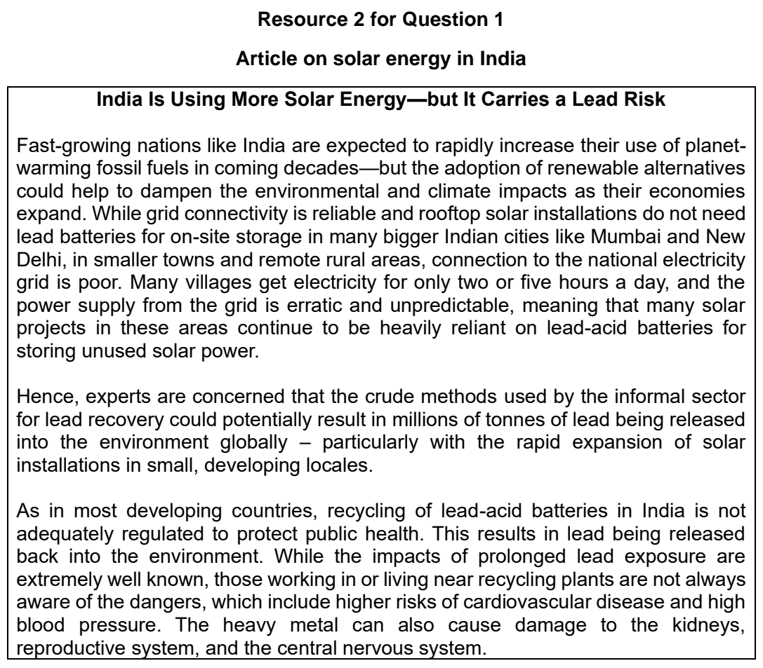

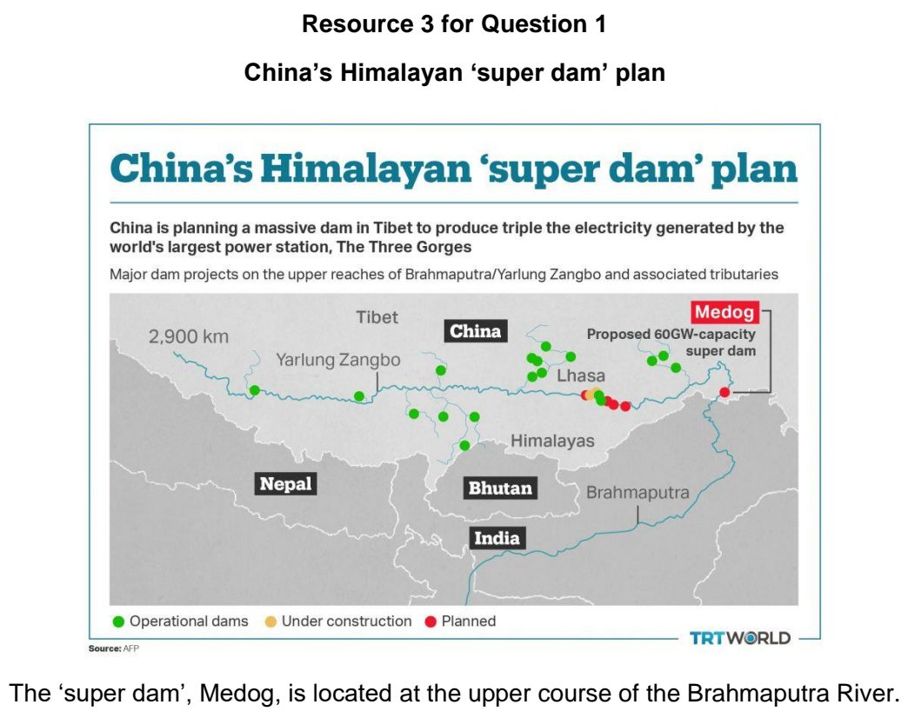

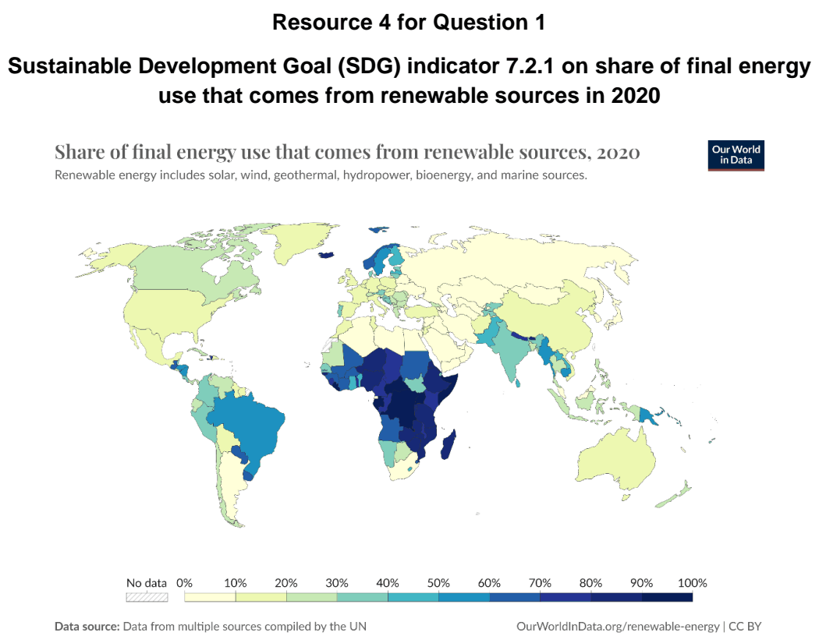

NJC 2025 — H2 Paper 1 (9173/01), Q1 [30 marks]
Syllabus: 1.1.3a Managing Resources – Renewable energy (solar, hydropower); 1.1.1c Understanding Sustainable Development – Challenges limiting SD; 1.1.2b Environment and Resources – Supply of provisioning services (reserves)
Section A — Cluster 1: Global Development and Natural Resources
Resource 1 shows the global energy consumption by source. Resource 2 shows the hydropower projects in the world in 2020. Resource 3 shows a hydropower dam in China. Resource 4 shows China’s installed generation capacity of different energy sources and its energy progress report towards achieving Sustainable Development Goal (SDG) 7: Affordable and Clean Energy.
(a) Using an example for each, explain what is meant by renewable and non-renewable resources. [4]
(b) Cite data from Resource 1 to compare the actual and projected global energy consumption in 2010 and 2050. [4]
(c) Suggest reasons for the trends described in (b). [6]
(d) Describe the spatial distribution of the hydropower projects in the world shown in Resource 2. [5]
(e) With reference to Resource 3, explain the social, economic and environmental trade-offs of using hydropower to achieve energy security. [6]
(f) With reference to Resource 4, describe the challenges associated with China’s attainment of SDG 7 by 2030. [5]

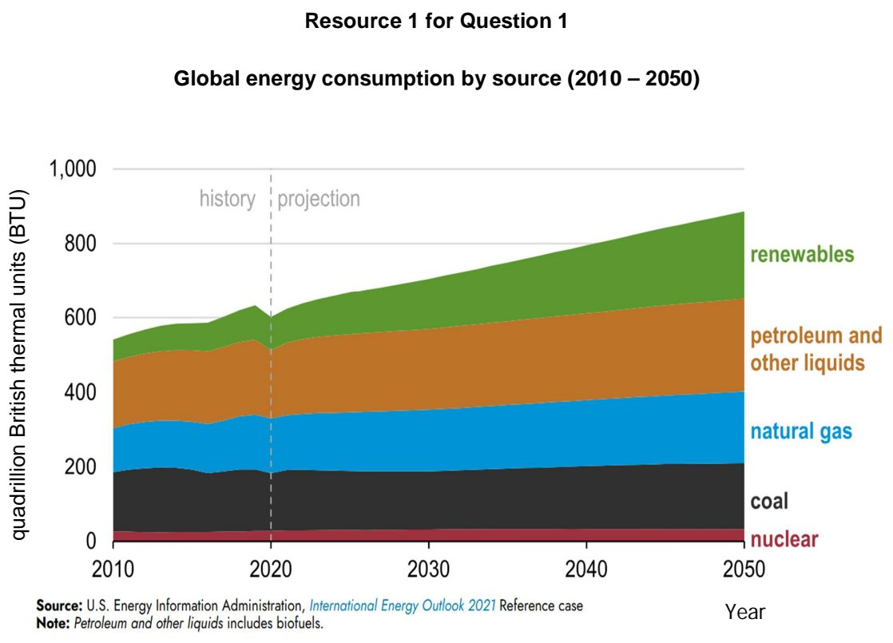

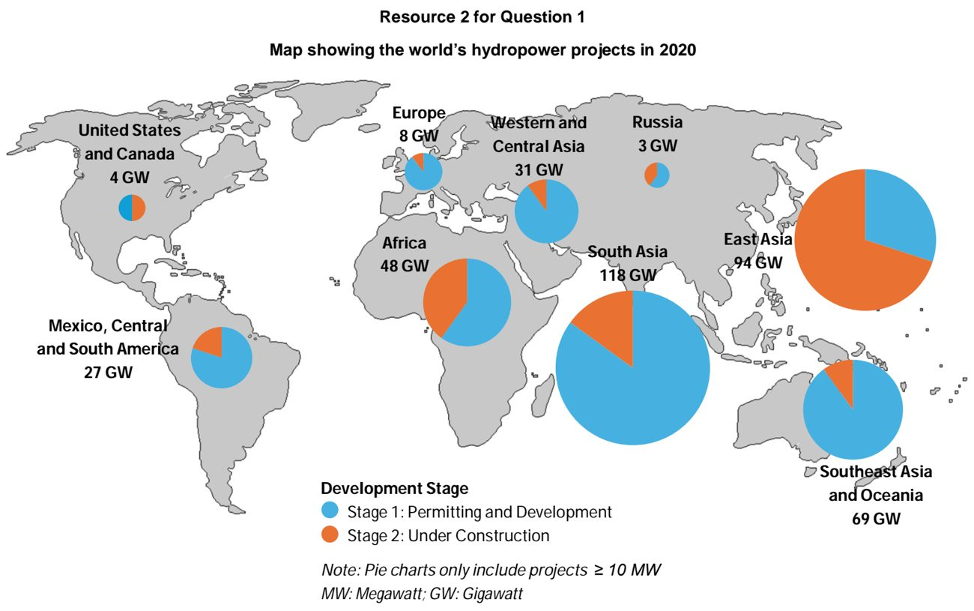

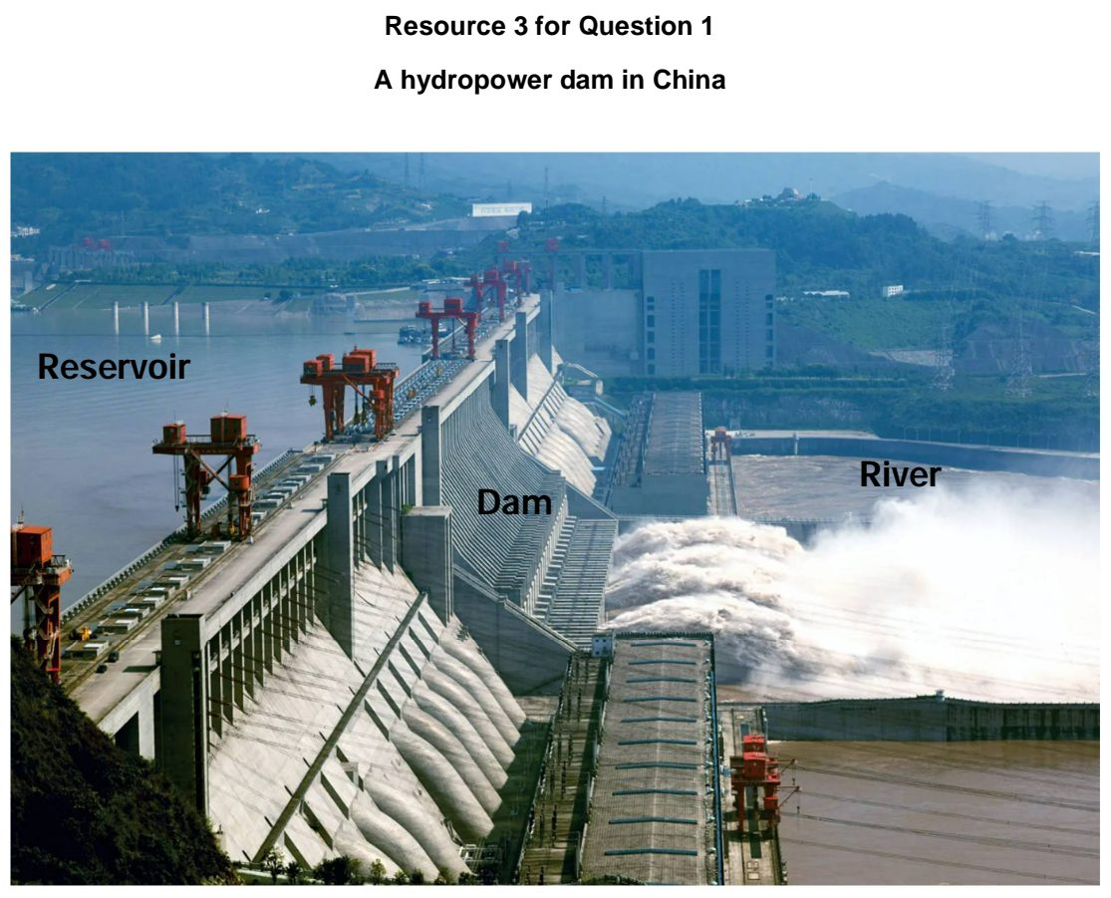

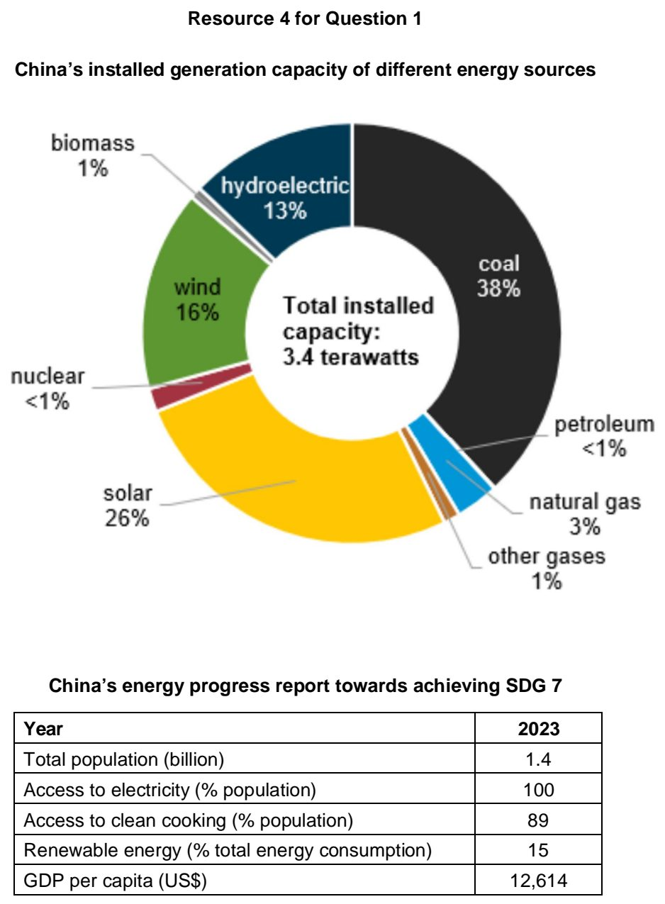

NYJC 2024 — H2 Paper 1 (9173/01), Q1 [30 marks]
Syllabus: 1.1.3a Managing Resources – Renewable energy (solar, hydropower); 1.1.2a Environment and Resources – Ecosystem services
Section A — Cluster 1: Global Development and Natural Resources
Resource 1 shows the growth in solar installed capacity In India from 2008 to June 2023 (in megawatts). Resource 2A is a satellite image of Kanmai 2 in Kamuthi, Tamil Nadu, before the construction of Kamuthi solar power plant in 2009. Resource 2B is a satellite image of Kanmai 2 in Kamuthi, Tamil Nadu, after the construction of Kamuthi solar power plant in 2020. Resource 3 is an excerpt taken from an article titled ‘Adani's Kamuthi solar power plant casts shadow on livelihood of locals’.
(a) Cite data from Resource 1 to describe the growth in India’s solar installed capacity from 2008 to June 2023. [3]
(b) Suggest possible reasons to explain the growth in India’s solar installed capacity shown in Resource 1. [5]
(c) Describe the differences in land use in Kamuthi between 2009 and 2020 shown in Resources 2A and 2B respectively. [4]
(d) Explain how solar power plants can impact the environment in India. [6]
(e) With reference to Resources 2A and 3, describe the ecosystem services that Kamuthi can provide prior to the construction of the solar power plant. [6]
(f) With reference to Resource 3, explain the socio-economic trade-offs associated with solar power. [6]

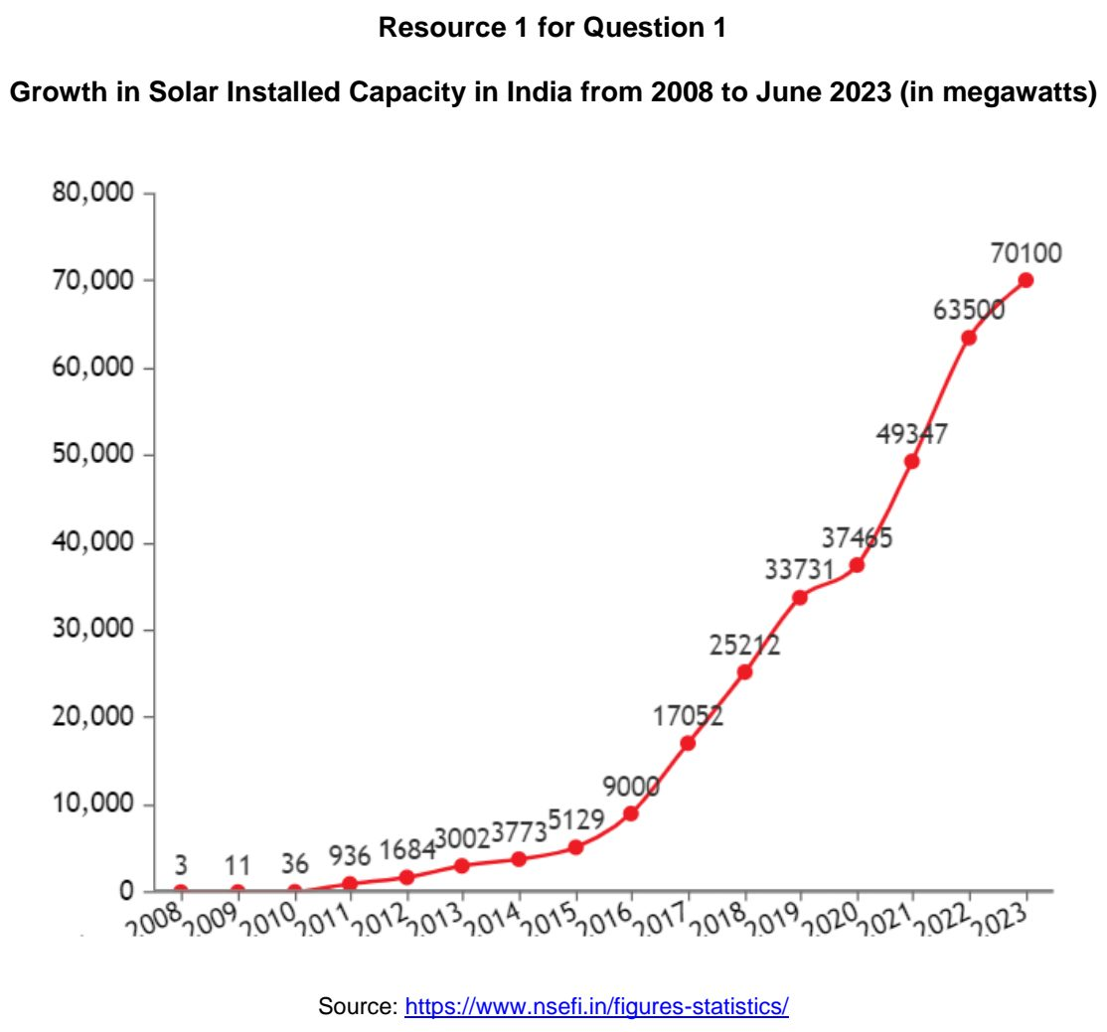

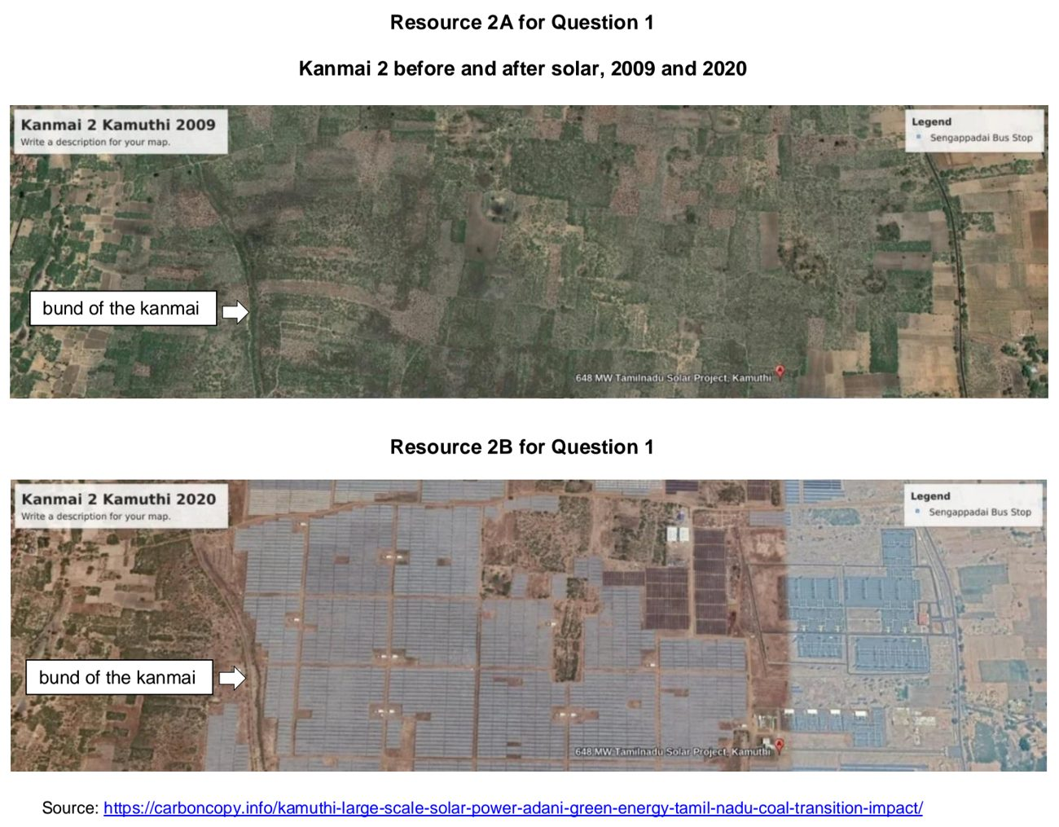

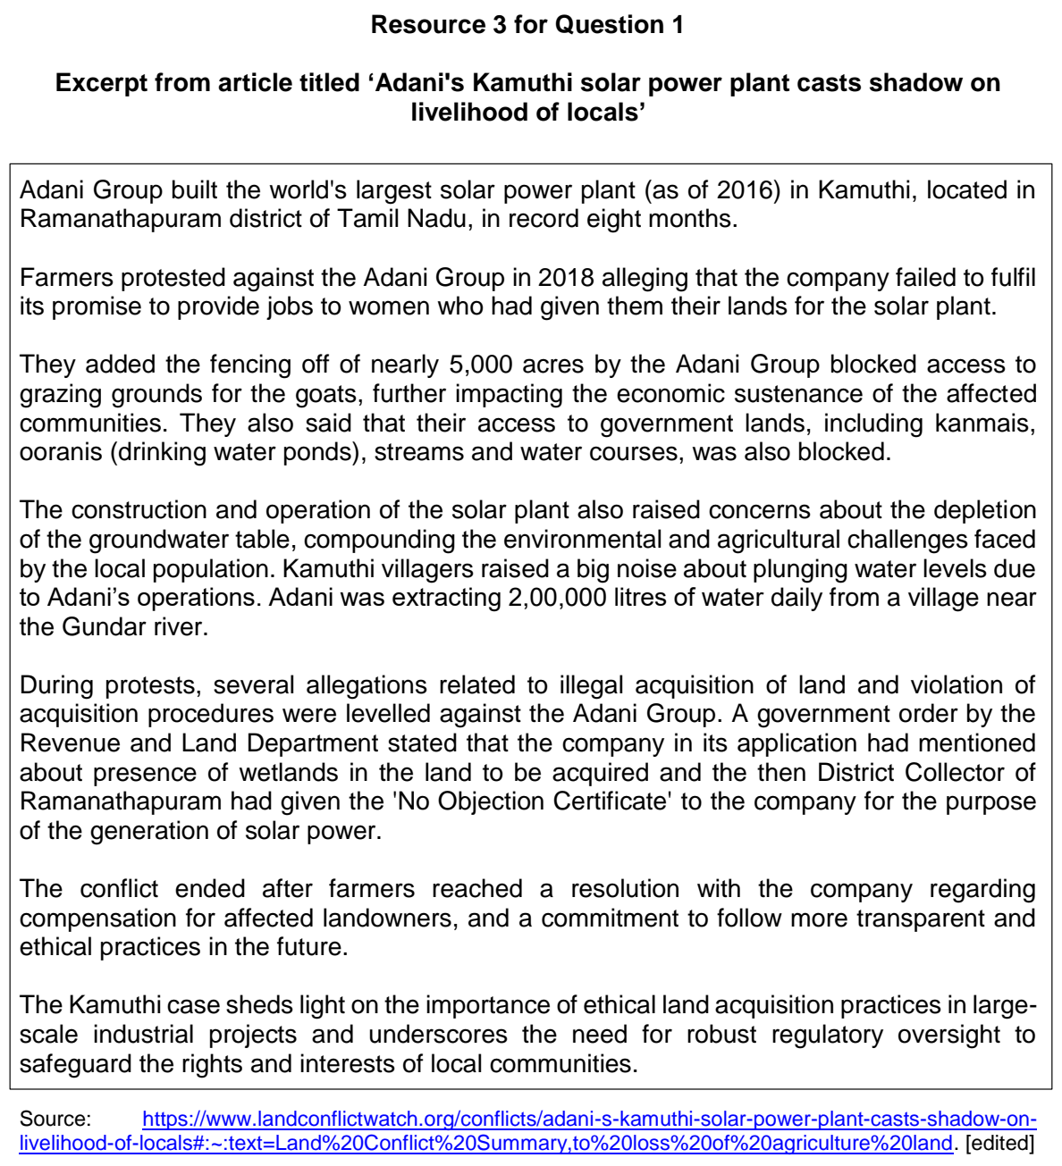

NYJC 2025 — H2 Paper 1 (9173/01), Q1 [30 marks]
Syllabus: 1.1.3c Managing Resources – Extractive industries; 1.2.2a Geography of the Global Economy and TNCs – Interconnectedness through flows; 1.2.2b Geography of the Global Economy and TNCs – GPNs connecting places
Section A — Cluster 1: Global Development and Natural Resources
Resource 1 shows a map of the cobalt supply chains. Resource 2 shows the distribution of mineral deposits in the Democratic Republic of Congo (DRC), Africa. Resource 3 shows the area of land cover classes of interest (km2) and global price of cobalt (USD/T) from 2009 to 2021 in DRC. Resource 4 shows a photograph of a cobalt artisanal small-scale mining (ASM) site in DRC.
(a) With reference to Resource 1, describe the main global flows in the cobalt supply chain. [4]
(b) With reference to Resource 1, explain how the cobalt supply chain demonstrates interdependence between countries and regions through trade flows. [6]
(c) Describe the distribution of mineral deposits in the Democratic Republic of Congo as shown in Resource 2. [4]
(d) Cite data from Resource 3 to describe the trend in the global price of cobalt (USD/T) between 2009 and 2021 in the Democratic Republic of Congo. [4]
(e) With reference to Resources 3 and 4, explain the challenges that extractive industries pose to the sustainable development of the Democratic Republic of Congo. [6]
(f) Suggest three ways in which the Democratic Republic of Congo could promote economic diversification to reduce dependence on extractive industries. [6]

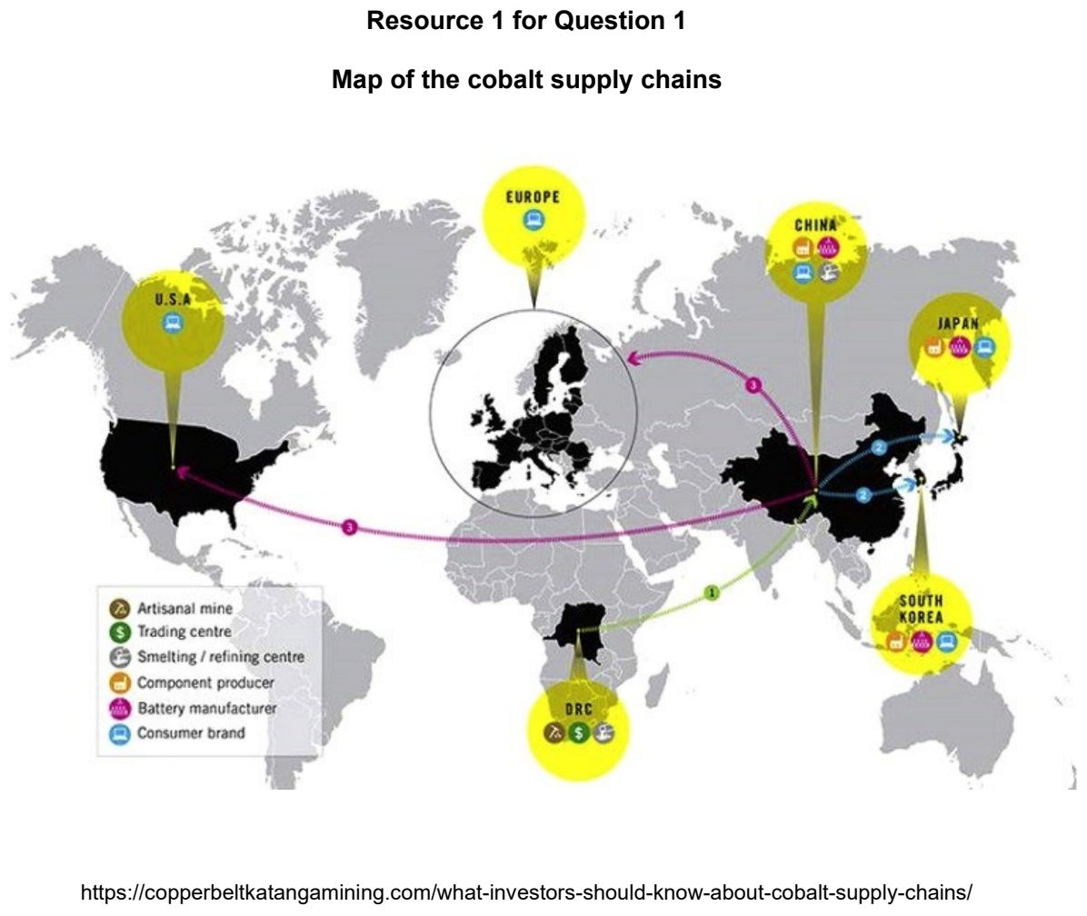

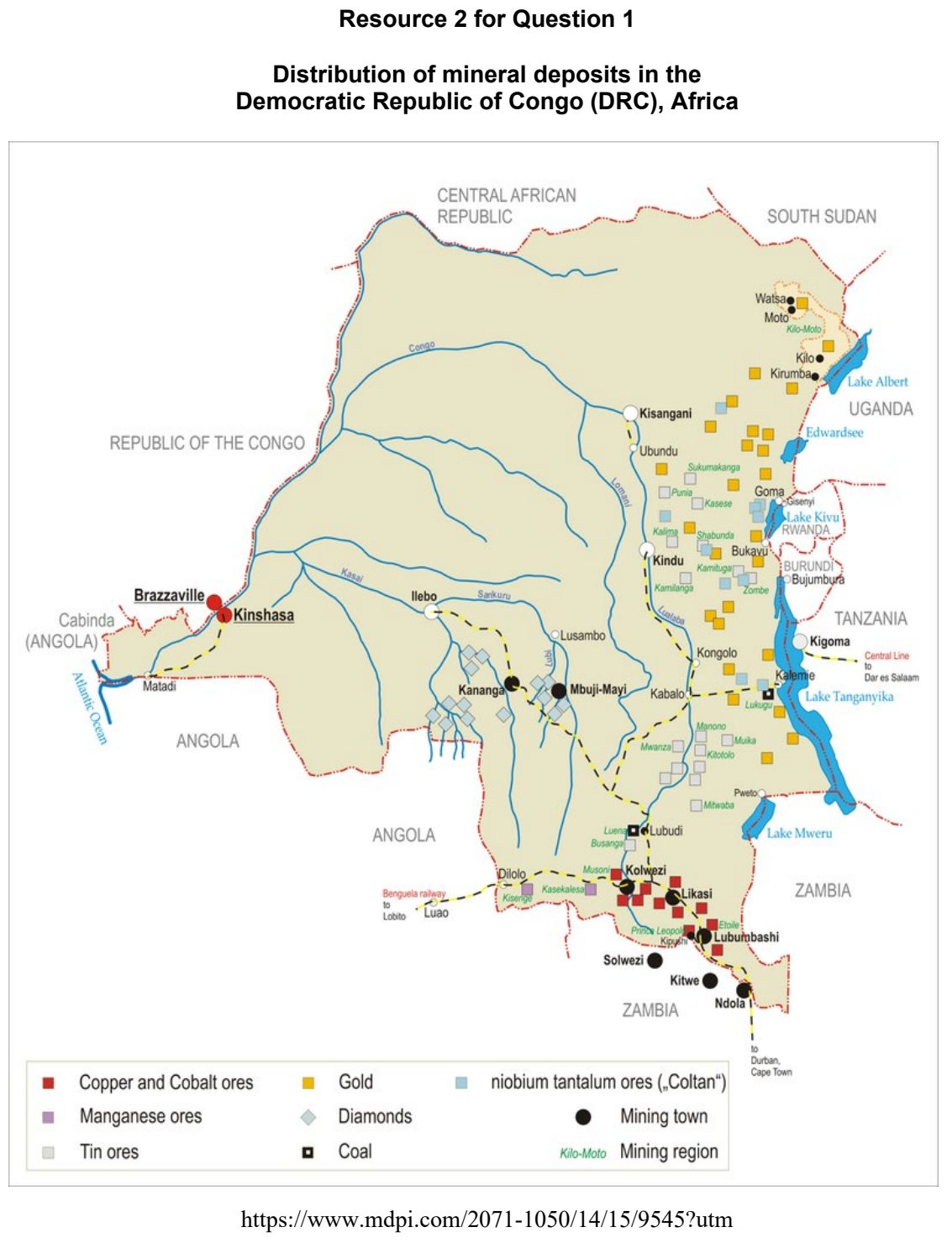

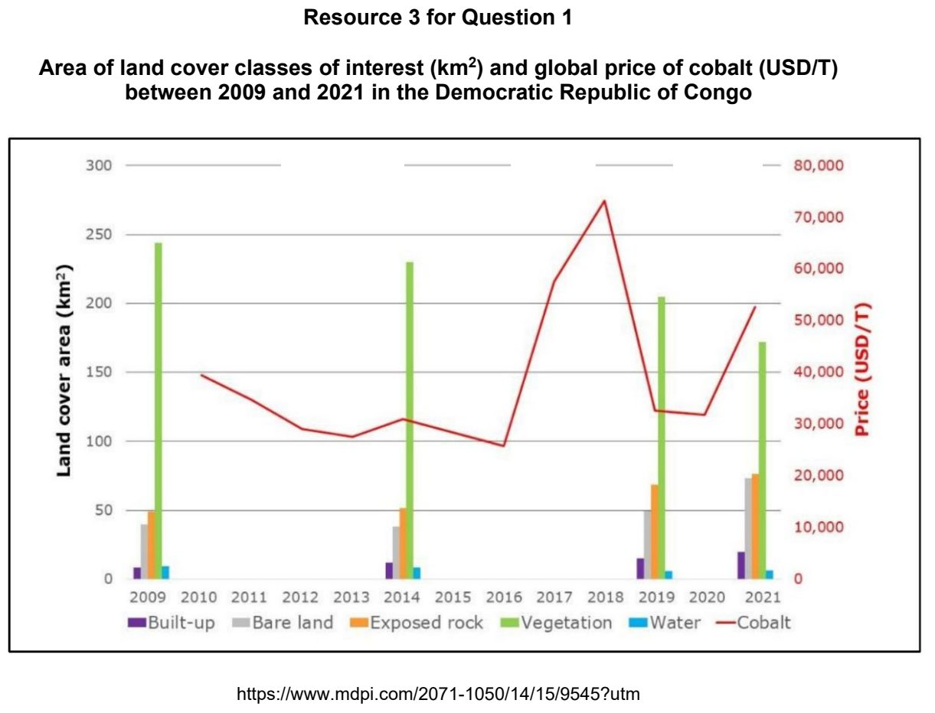

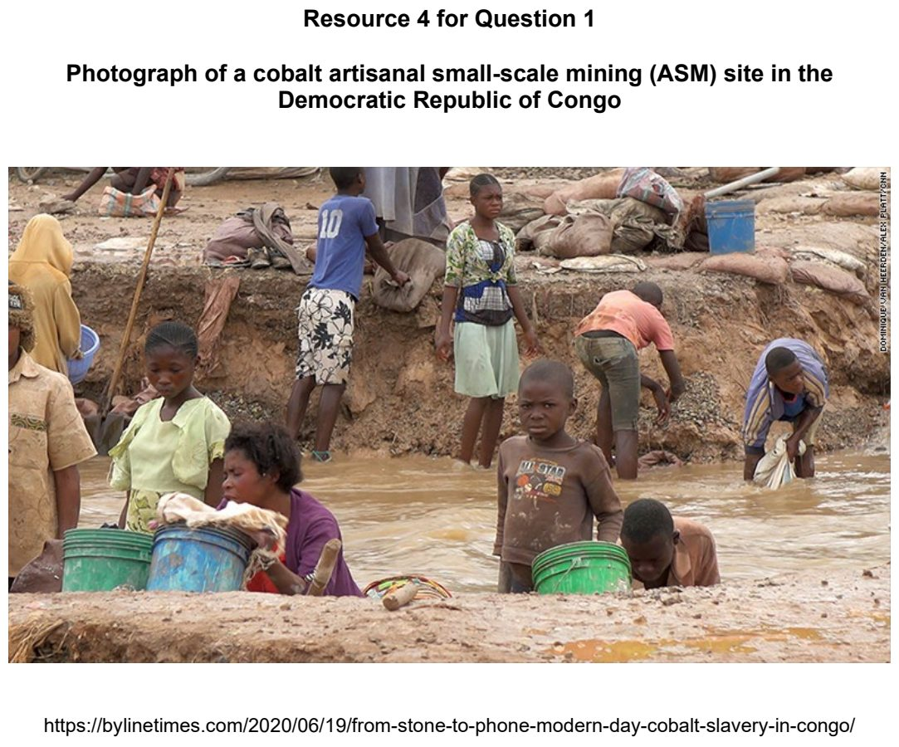

RVHS 2024 — H2 Paper 1 (9173/01), Q1 [30 marks]
Syllabus: 1.1.3c Managing Resources – Extractive industries; 1.1.2b Environment and Resources – Supply of provisioning services (reserves); 1.1.1b Understanding Sustainable Development – Measuring progress (SDGs, indicators)
Section A — Cluster 1: Global Development and Natural Resources
Resource 1 shows the location and amount of economically viable oil reserves at different oil prices in 2016. Resource 2 shows information produced by the Canadian government about the impacts of tar sand developments. Resource 3 shows a tar sand oil production area in Alberta, Canada. Resource 4 shows minerals and the associated geology found in part of northwest England.
(a) Citing data from Resource 1, describe the relationship between oil prices and the location and amount of economically viable oil reserves shown in Resource 1. [4]
(b) Explain the differences between proven reserves, conditional reserves, and speculative reserves. [4]
(c) With reference to Resources 2 and 3, explain how the expansion of tar sand developments can impact Canada’s progress towards sustainable development. [7]
(d) Explain the indicators that can be used to measure the level of economic growth and the degree of social inclusion in a country respectively. [4]
(e) Cite data from Resource 4 to describe the relationship(s) between mineral mining sites and rock types. [4]
(f) Explain the characteristics of extractive industries such as that of mineral mining. [7]

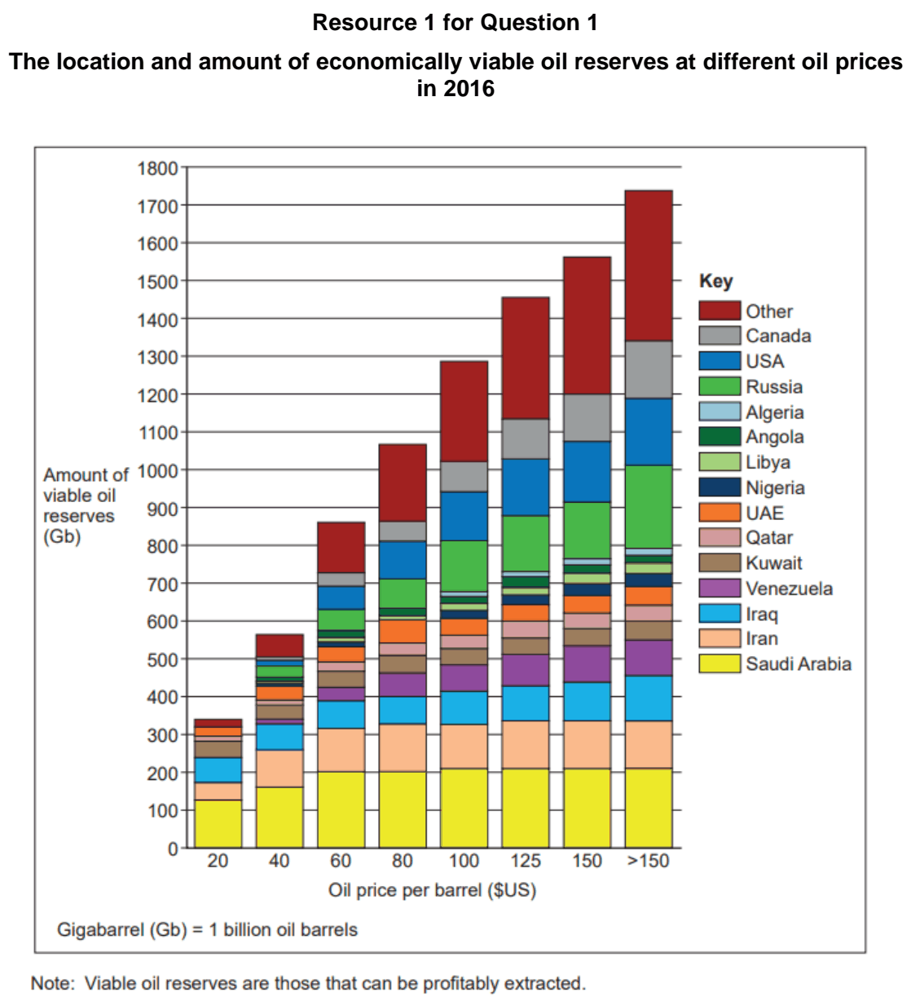

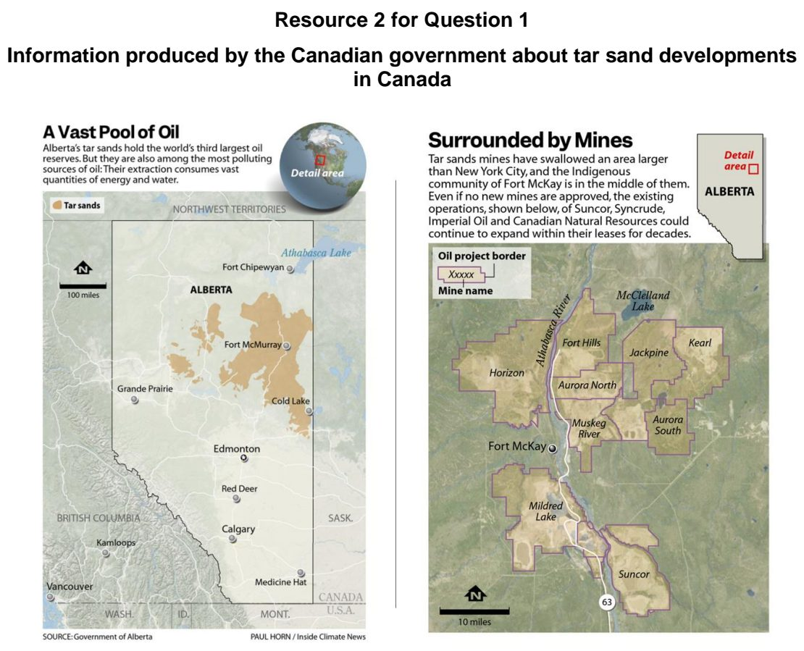

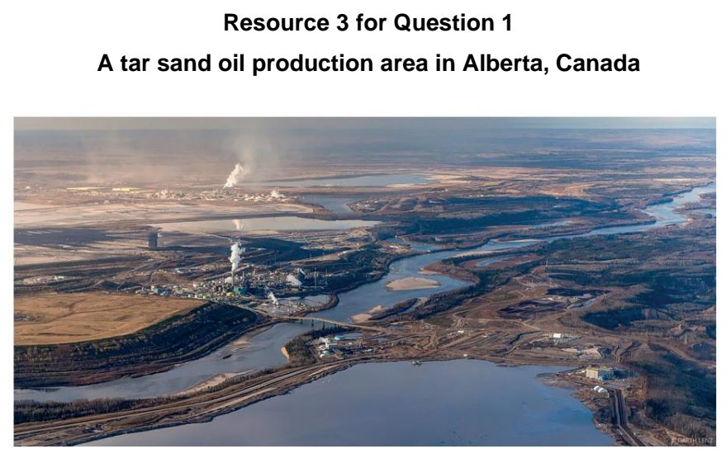

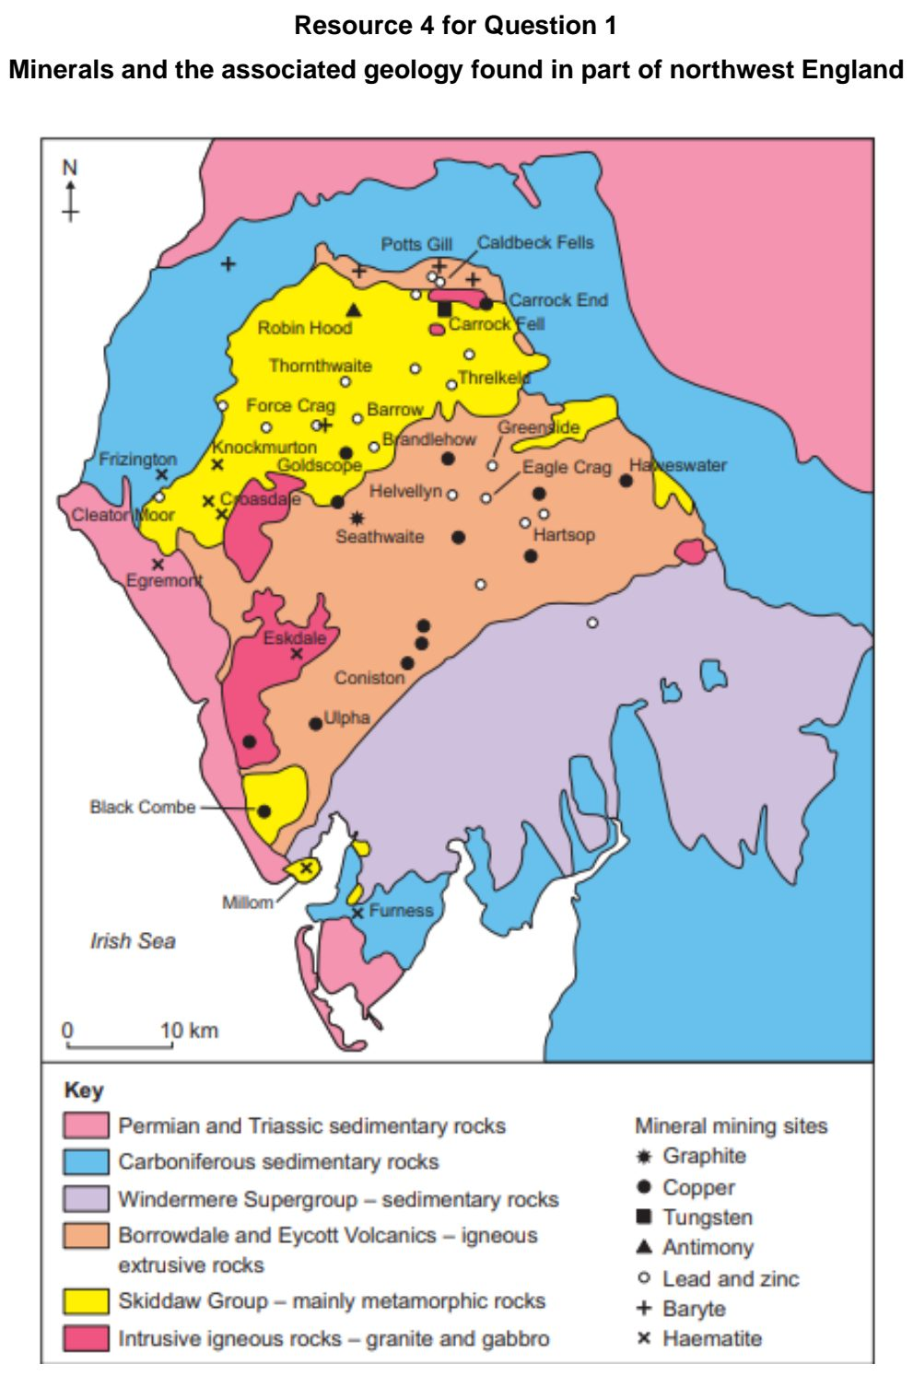

SAJC 2024 — H2 Paper 1 (9173/01), Q1 [30 marks]
Syllabus: 1.1.2b Environment and Resources – Supply of provisioning services (reserves); 1.1.3a Managing Resources – Renewable energy (solar, hydropower); 1.1.3c Managing Resources – Extractive industries
Section A — Cluster 1: Global Development and Natural Resources
Resource 1 shows crude oil reserves in billion barrels (Gbbl) in 2019. Resource 2A shows the location of the proposed Luang Prabang dam along the Mekong River Delta. Resource 2B shows the land use and land cover along the Mekong River Delta.
(a) Describe the distribution of crude oil reserves in billion barrels shown in Resource 1. [4]
(b) Explain the strengths and limitations of the data representation in Resource 1. [4]
(c) Explain impact of technology on provisioning resources. [4]
(d) Citing data from Resource 2A, describe the distribution of hydropower dams along the Mekong River. [4]
(e) With reference to Resources 2A and 2B, explain the impacts of developing hydropower along the Mekong River [8]
(f) Explain the characteristics of extractive industries. [6]

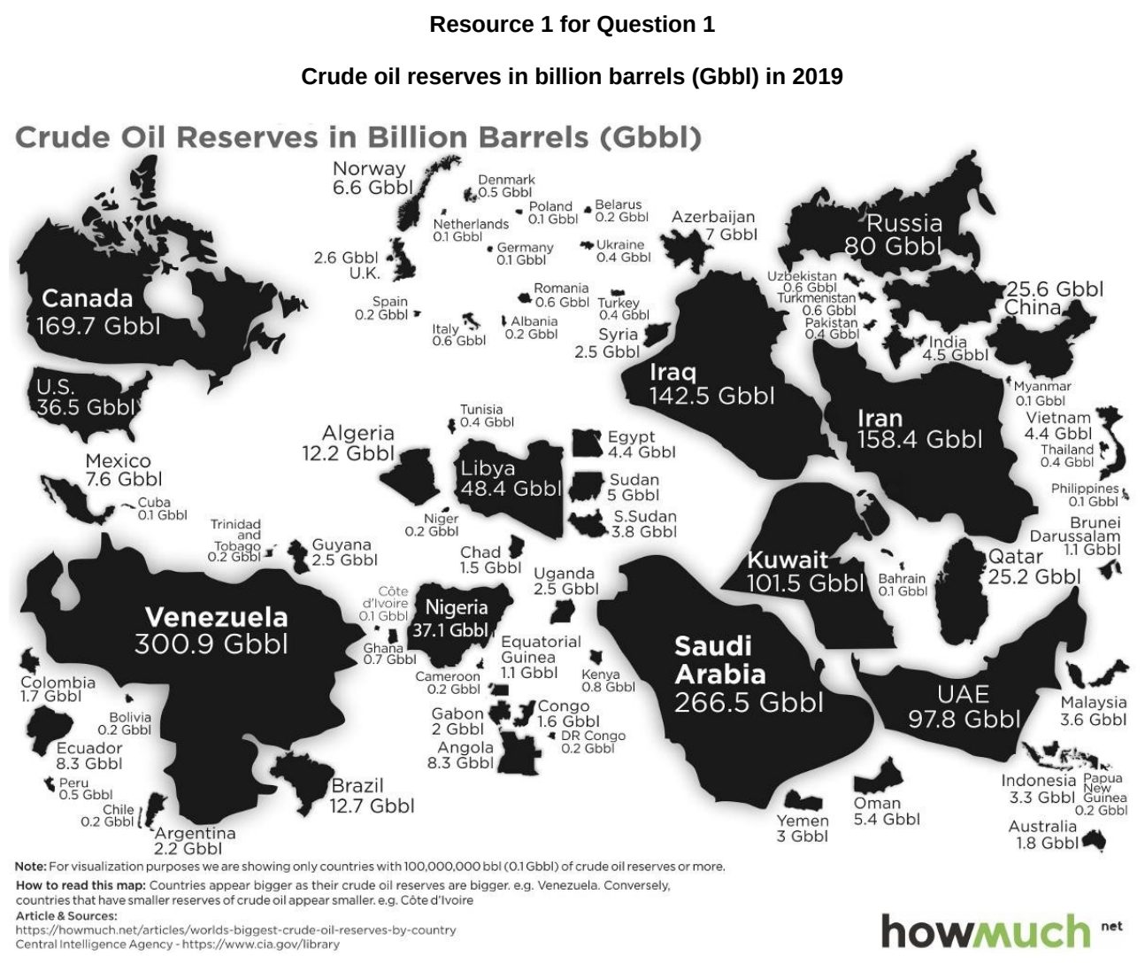

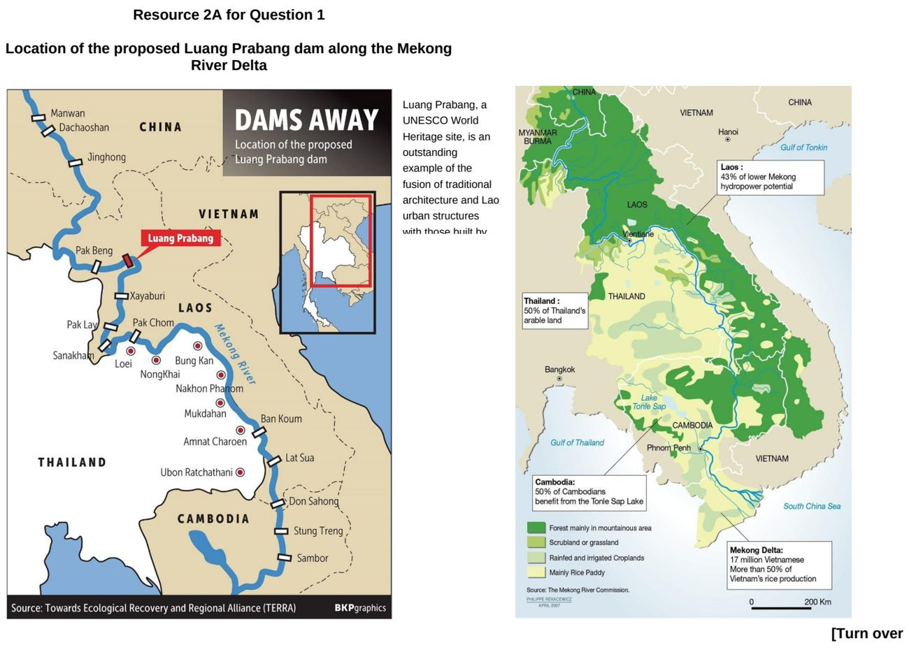

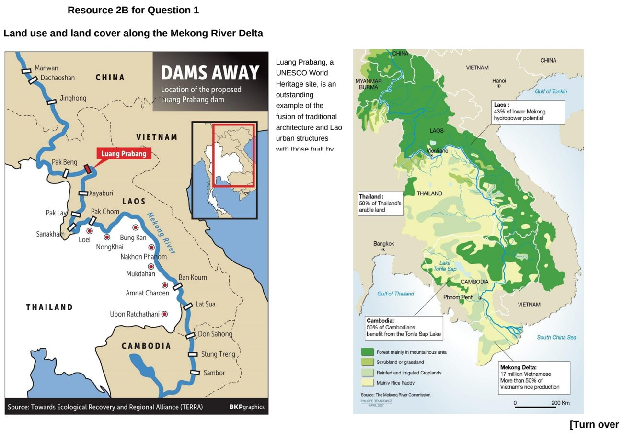

TJC 2024 — H2 Paper 1 (9173/01), Q1 [30 marks]
Syllabus: 1.1.3a Managing Resources – Renewable energy (solar, hydropower); 1.1.1c Understanding Sustainable Development – Challenges limiting SD; 1.1.1b Understanding Sustainable Development – Measuring progress (SDGs, indicators); 1.1.3c Managing Resources – Extractive industries
Section A — Cluster 1: Global Development and Natural Resources
Resource 1 shows the progress of Sustainable Development Goal 7 (SDG7) "affordable and clean energy". Resource 2 shows the energy sources for Germany in 2013 and 2023. Resource 3 shows the site of a proposed dam and hydroelectric power (HEP) station in Gambia, a least developed country in Africa. Resource 4 is a fact file about solar canopies in Singapore.
(a) Using Resource 1, describe the pattern of progress towards SDG7. [4]
(b) Explain possible challenges limiting the progress of countries towards achieving SDG7 as shown in Resource 1. [6]
(c) Citing data from Resource 2, compare the energy sources for Germany between 2013 and 2023. [4]
(d) Using Resource 3, explain possible trade-offs Gambia will need to consider should the proposed dam and HEP station be constructed. [6]
(e) Study Resource 4. Explain the potential and limitations of solar energy in providing energy security to Singapore. [6]
(f) Suggest reasons to explain why extractive industries are often dominated by large private and state-owned firms. [4]

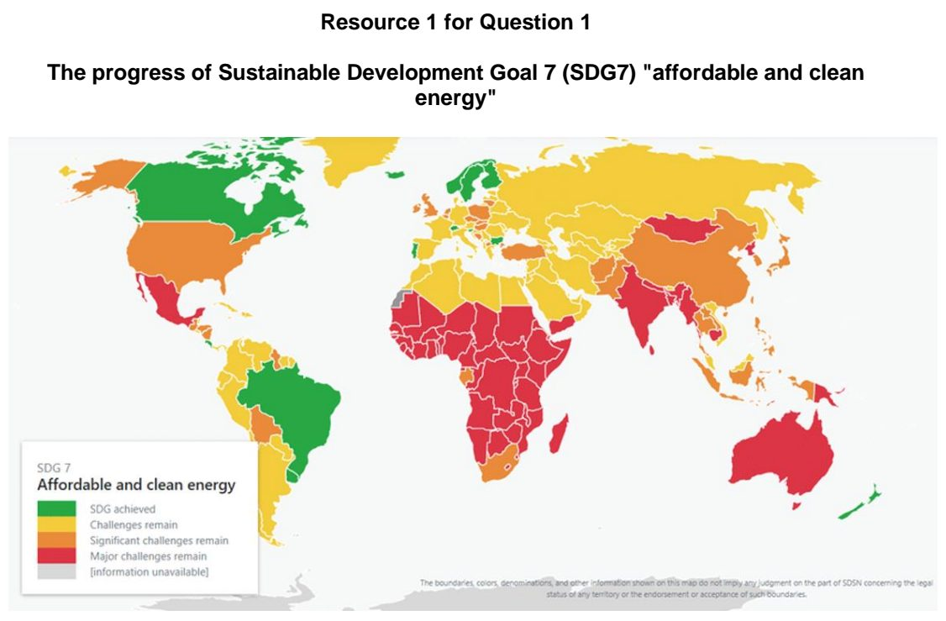

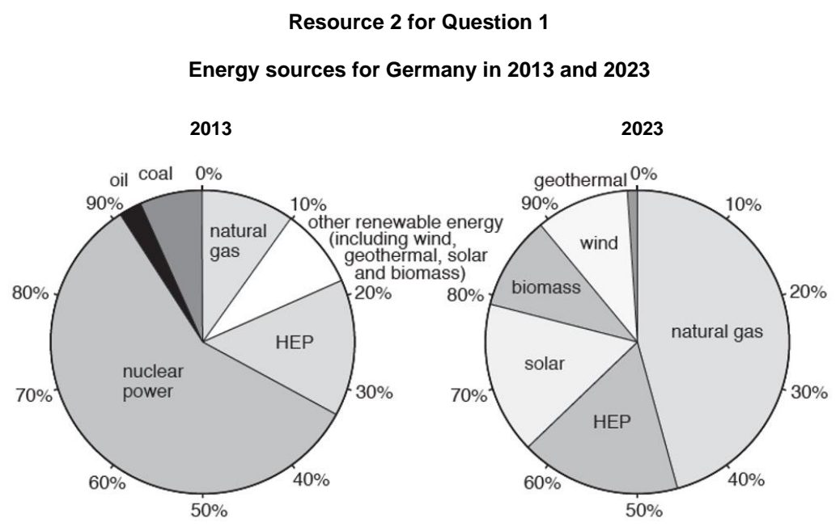

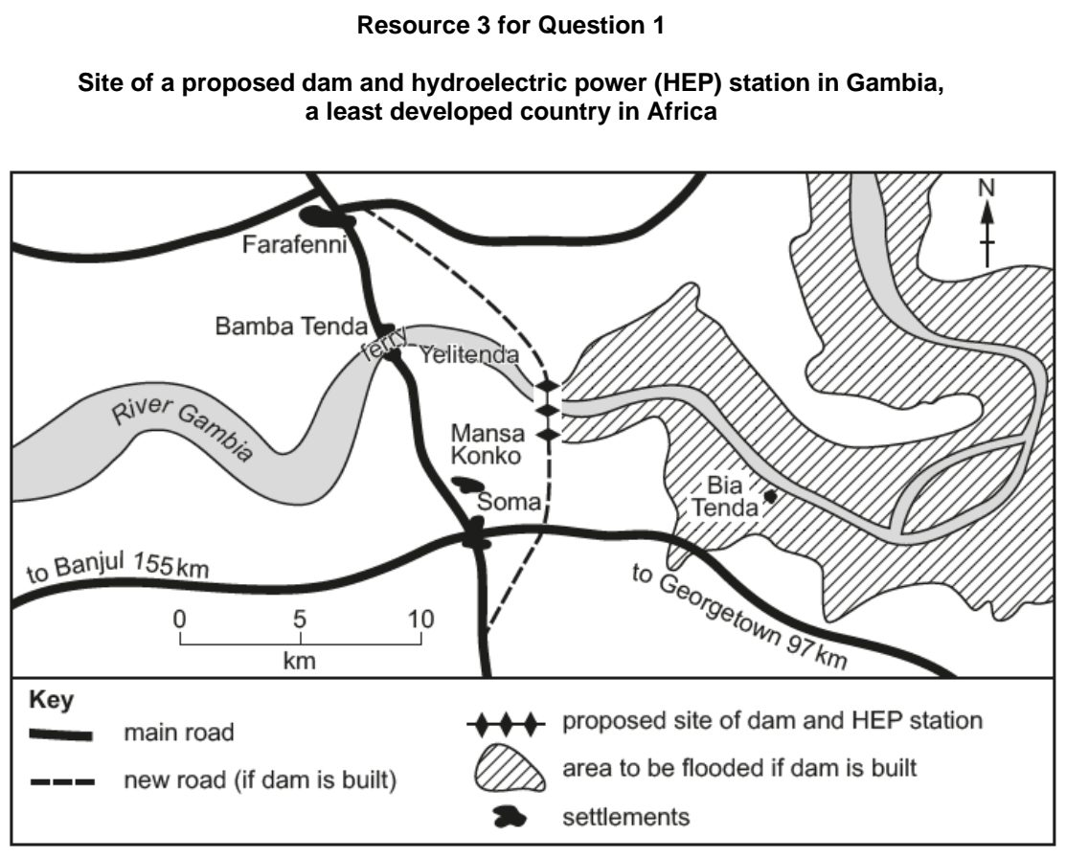

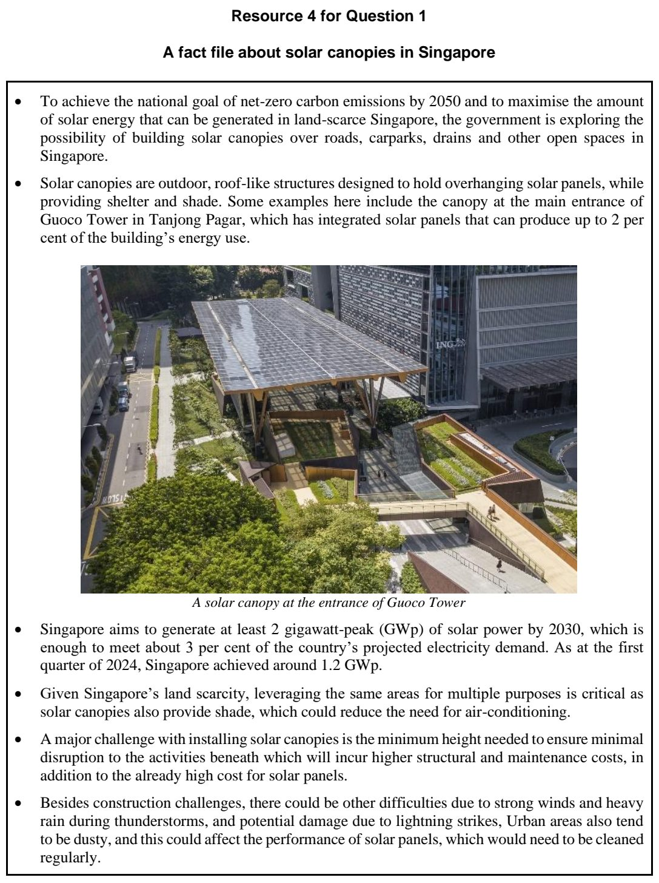

TJC 2025 — H2 Paper 1 (9173/01), Q1 [30 marks]
Syllabus: 1.1.1b Understanding Sustainable Development – Measuring progress (SDGs, indicators); 1.1.1c Understanding Sustainable Development – Challenges limiting SD; 1.2.1b Development – Trade, capital & labour flows; 1.2.2b Geography of the Global Economy and TNCs – GPNs connecting places; 1.2.2a Geography of the Global Economy and TNCs – Interconnectedness through flows
Section A — Cluster 1: Global Development and Natural Resources
Resource 1 shows India’s performance in selected Sustainable Development Goals (SDGs) in 2020 and 2024. Resource 2 shows India’s top trading partners for imports and exports in 2013. Resource 3 shows UK’s car and engine production network in 2019.
(a) Using Resource 1, describe how India’s performance across the various Sustainable Development Goals (SDGs) has changed between 2020 and 2024. [4]
(b) With reference to Resource 1, suggest possible reasons for India’s change in performance for SDG 9 (Industry, Innovation and Infrastructure) between 2020 and 2024. [6]
(c) Explain the difficulties that countries with fast growing populations have in measuring progress towards achieving economic sustainability. [5]
(d) Using Resource 2, compare the top trading partners for India’s imports and exports in 2013. [5]
(e) Describe UK’s car and engine production network in 2019 as shown in Resource 3. [5]
(f) Explain the benefits of economic interdependence between countries. [5]

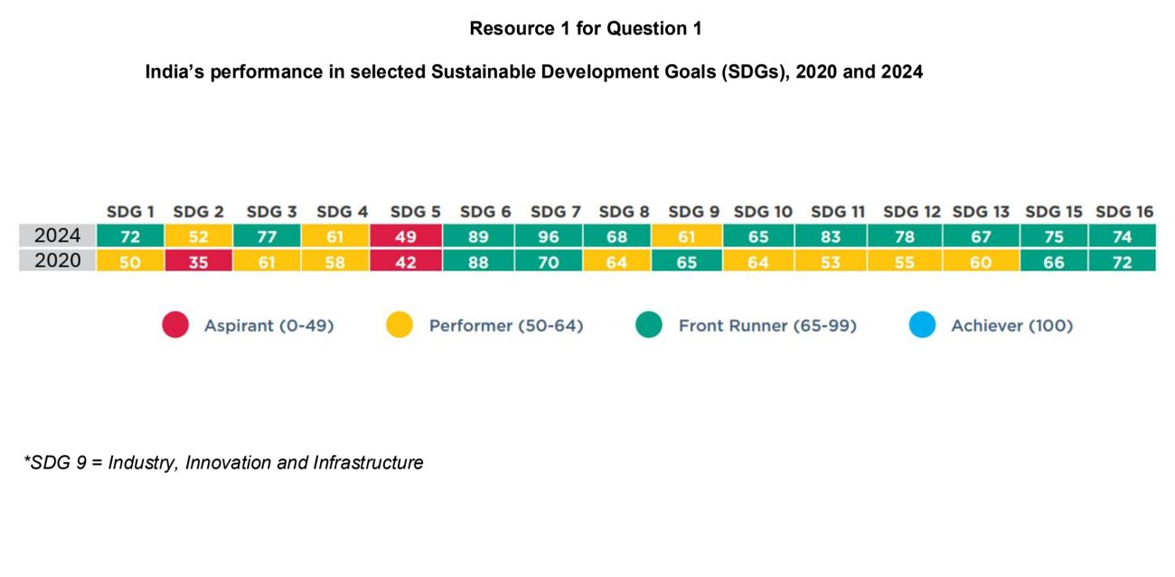

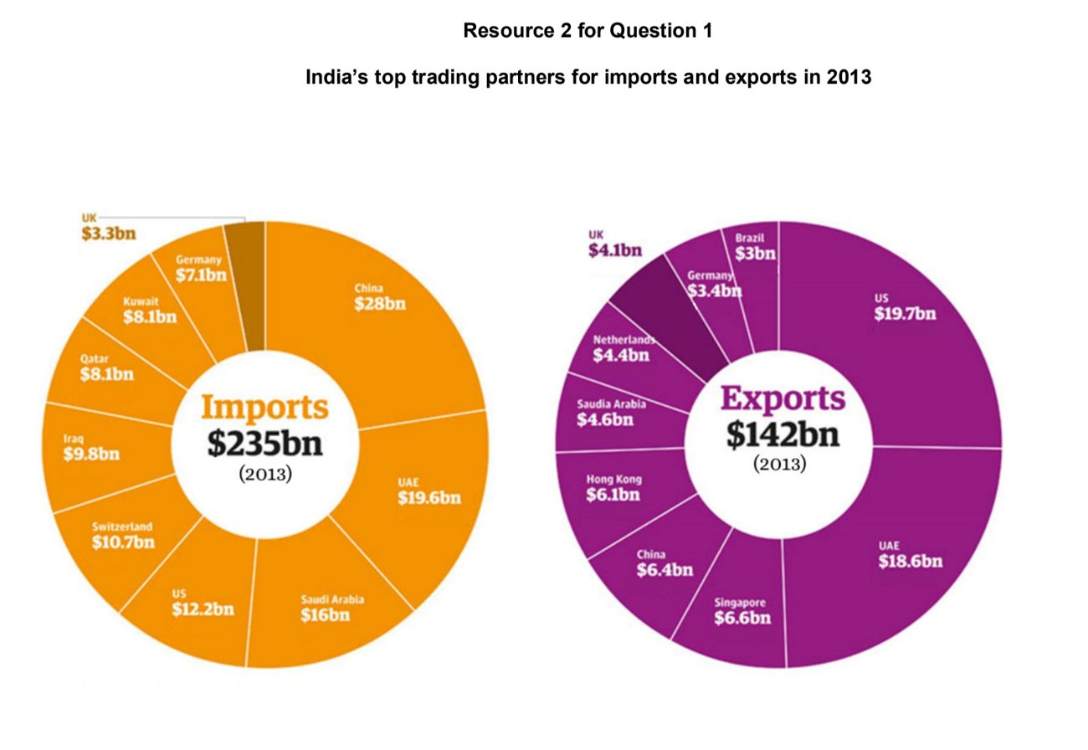

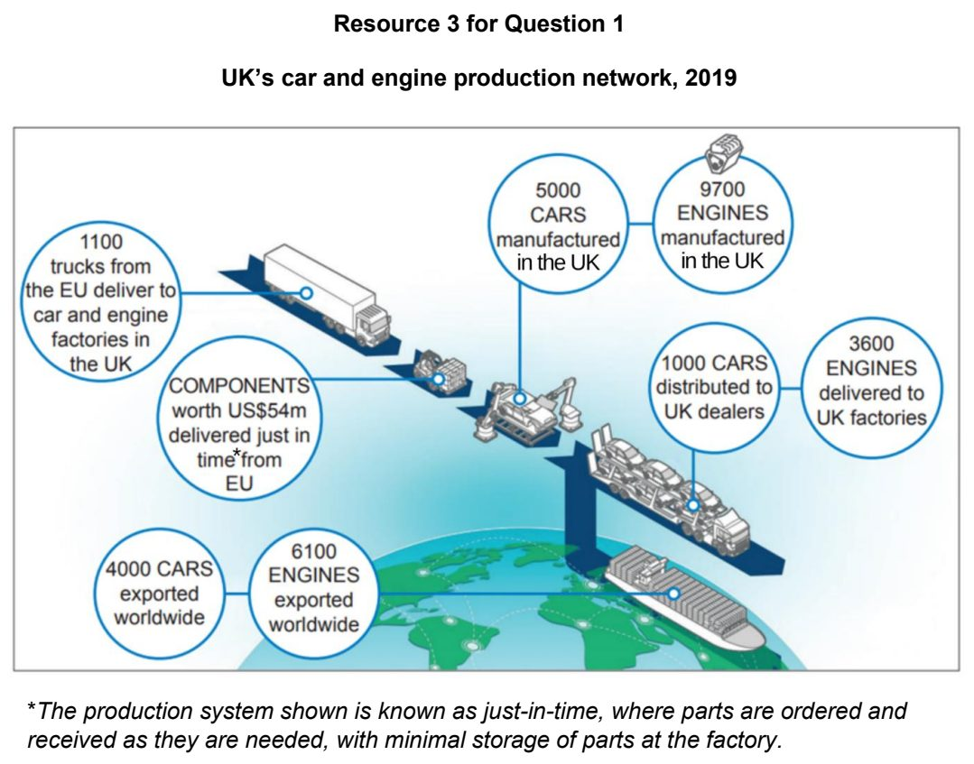

TMJC 2024 — H2 Paper 1 (9173/01), Q1 [30 marks]
Syllabus: 1.1.3a Managing Resources – Renewable energy (solar, hydropower); 1.2.1c Development – Shifts in economic structure; 1.2.3c Relative Influence of Actors in Shaping the Global Economy – Multilateral institutions
Section A — Cluster 1: Global Development and Natural Resources
Resource 1 shows the types of energy resources used for electricity generation in selected countries, 2017. Resource 2 shows the global distribution of solar power energy plants. Resource 3 shows the distribution of employment by sector for LICs and HICs, 1991 and 2018.
(a) Describe the variations in the types of energy resources used for energy generation for the countries shown in Resource 1. [5]
(b) Using Resource 1 and your own knowledge, explain the limitations of hydroelectric power (HEP) as an alternative to fossil fuel. [4]
(c) Using Resource 2, describe the distribution of solar power plants globally. [3]
(d) Account for the pattern of distribution as seen in Resource 2. [4]
(e) Compare the changes in employment for LICs and HICs shown in Resource 3. [4]
(f) Using Resource 3, explain the distribution of employment by sector for LICs and HICs in 2018. [4]
(g) Explain how multilateral institutions can affect economic activities for countries at lower levels of development. [6]

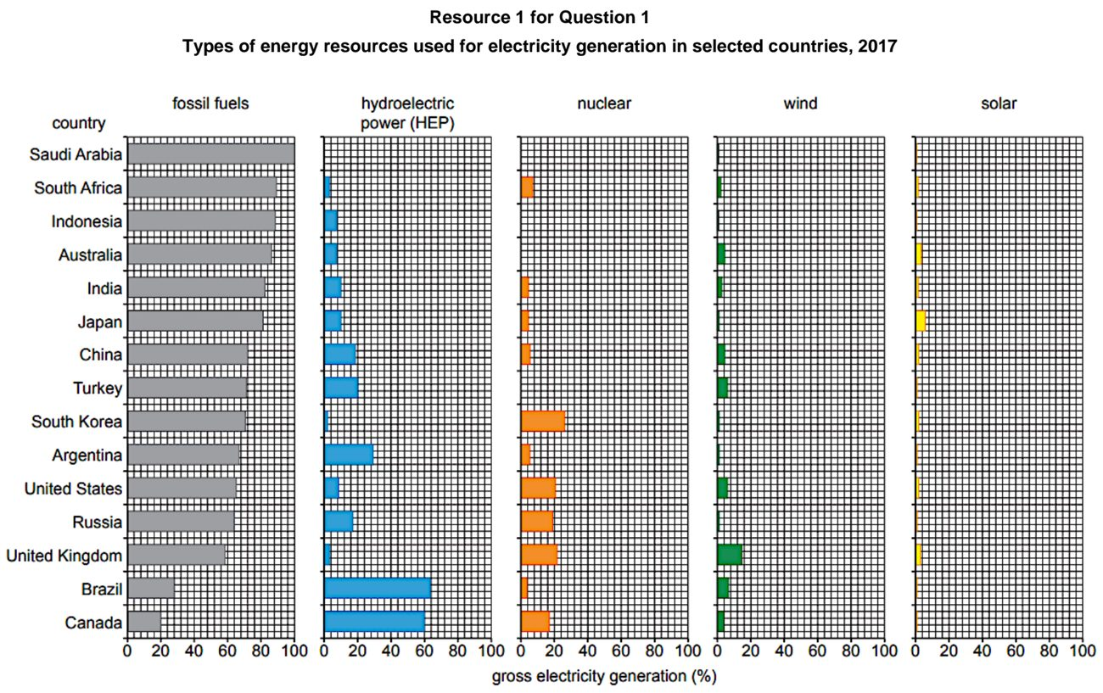

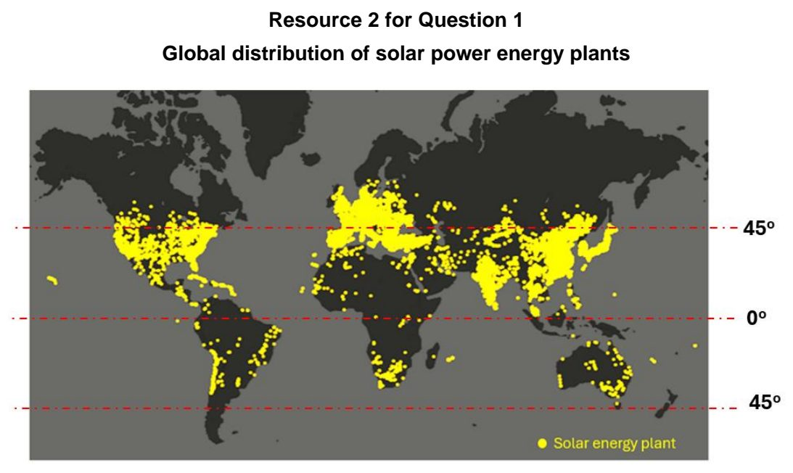

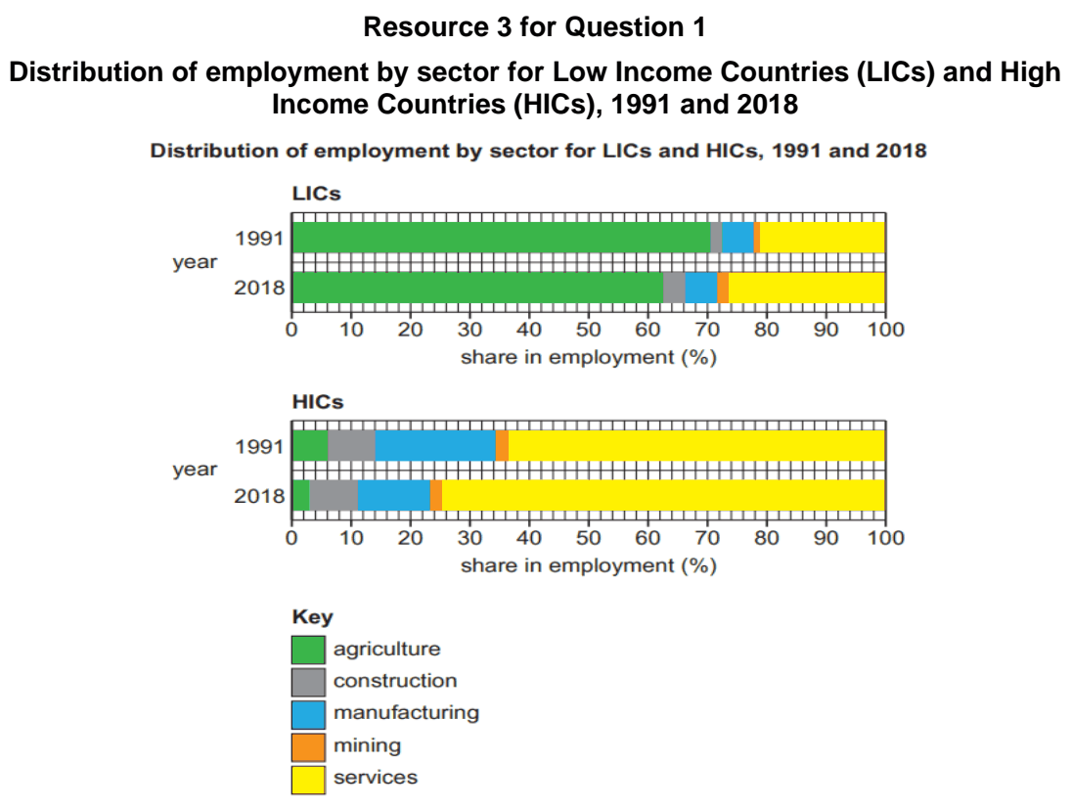

VJC 2025 — H2 Paper 1 (9173/01), Q1 [30 marks]
Syllabus: 1.1.2b Environment and Resources – Supply of provisioning services (reserves); 1.2.3a Relative Influence of Actors in Shaping the Global Economy – States; 1.2.3c Relative Influence of Actors in Shaping the Global Economy – Multilateral institutions; 1.2.2a Geography of the Global Economy and TNCs – Interconnectedness through flows
Section A — Cluster 1: Global Development and Natural Resources
Resource 1 shows the global distribution of rare earth reserves and volume of rare earth metals extracted in 2020. Resource 2 shows trends in global demand for rare earth metals. Resource 3 is a news article highlighting the global rare earth metals shortage.
(a) Illustrate interconnectedness in the global economy. [3]
(b) Describe the global distribution of rare earth reserves and volume of rare earth metals extracted in 2020 in Resource 1. [5]
(c) Explain the gap between reserves available and volume of rare earth metals extracted in Resource 1. [6]
(d) Describe the trends in global demand for rare earth metals in Resource 2. [4]
(e) With reference to Resource 3, explain three ways in which governments may influence the global car industry. [6]
(f) Explain how a multilateral organisation like the World Trade Organisation (WTO) may intervene in Resource 3. [6]

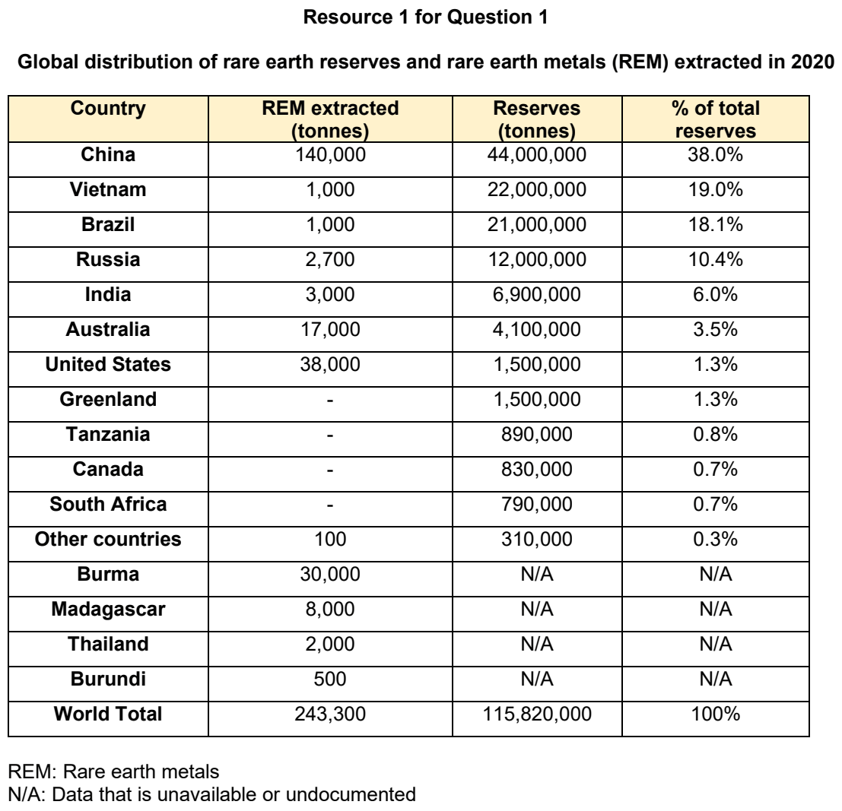

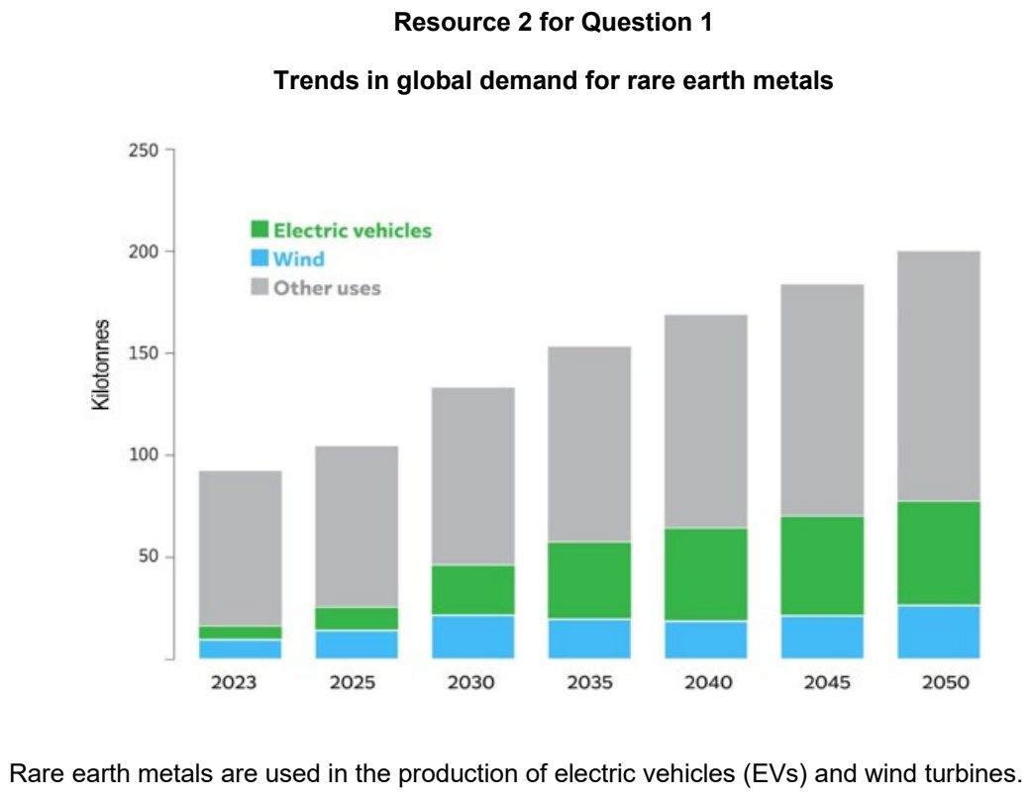

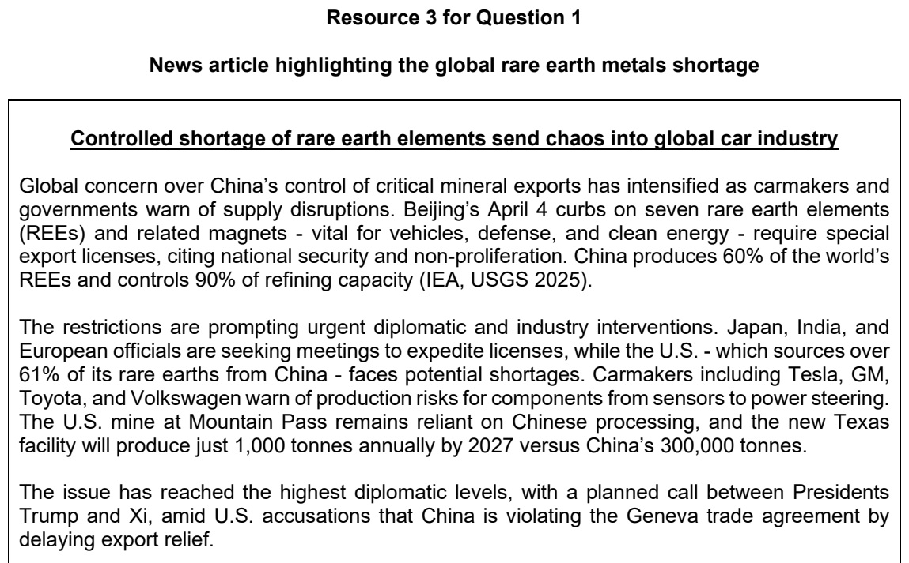

YIJC 2024 — H2 Paper 1 (9173/01), Q1 [30 marks]
Syllabus: 1.1.3a Managing Resources – Renewable energy (solar, hydropower); 1.1.2b Environment and Resources – Supply of provisioning services (reserves); 1.1.1b Understanding Sustainable Development – Measuring progress (SDGs, indicators)
Section A — Cluster 1: Global Development and Natural Resources
Resource 1 shows e-waste collection rate in the world. Resource 2 shows the reliance on the use of fossil fuels. Resource 3 shows the growth of renewable energy between 2013 and 2022. Resource 4 shows the variations in the growth of specific renewable energy in 2022.
*E-waste refers to electrical and electronic equipment that has been discarded. It includes items like desktop, laptop and tablet computers, mobile phones, TVs, refrigerators, air conditioners, washing machines, batteries, electronic toys, sports and leisure equipment.
(a) Cite data from Resource 1 to describe the global e-waste collection rate. [3]
(b) With reference to Resource 1, suggest ways to curb e-waste in different parts of the world. [5]
(c) Despite efforts to reduce carbon emissions, there is still reliance on the use of fossil fuels. Suggest reasons for this trend using Resource 2. [5]
(d) With reference to Resource 3, account for the spatial and temporal variation of the usage of renewable energy. [6]
(e) Explain the trade-offs associated with the use of renewable energy shown in Resource 4. [5]
(f) With reference to all Resources, explain if sustainable development efforts by countries have been successful. [6]

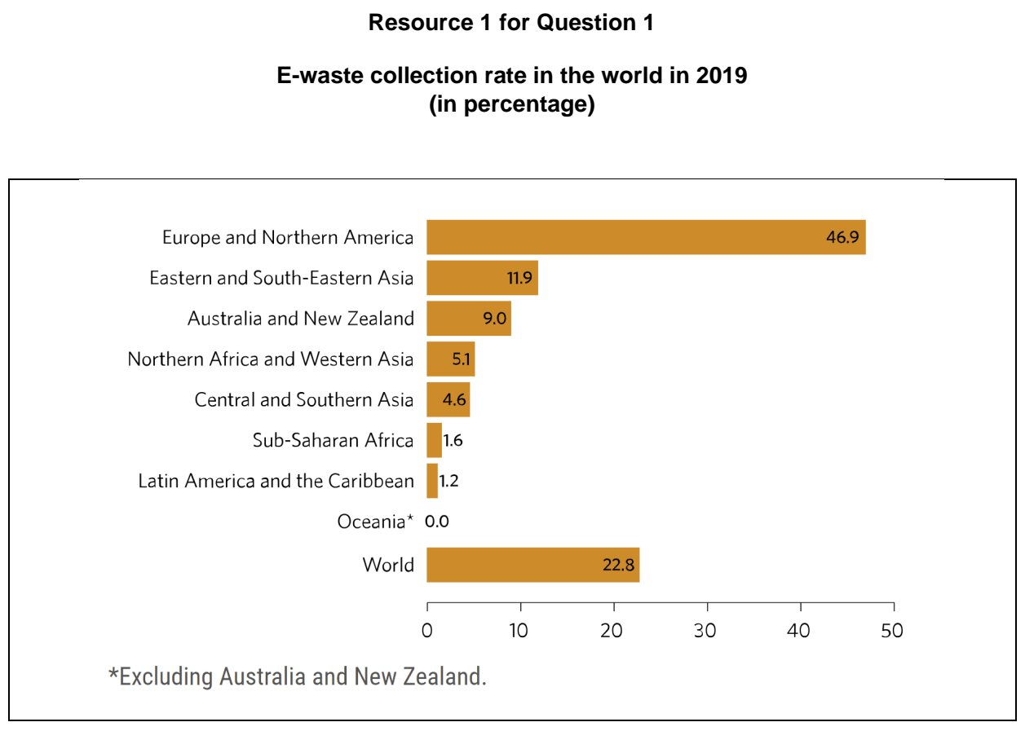

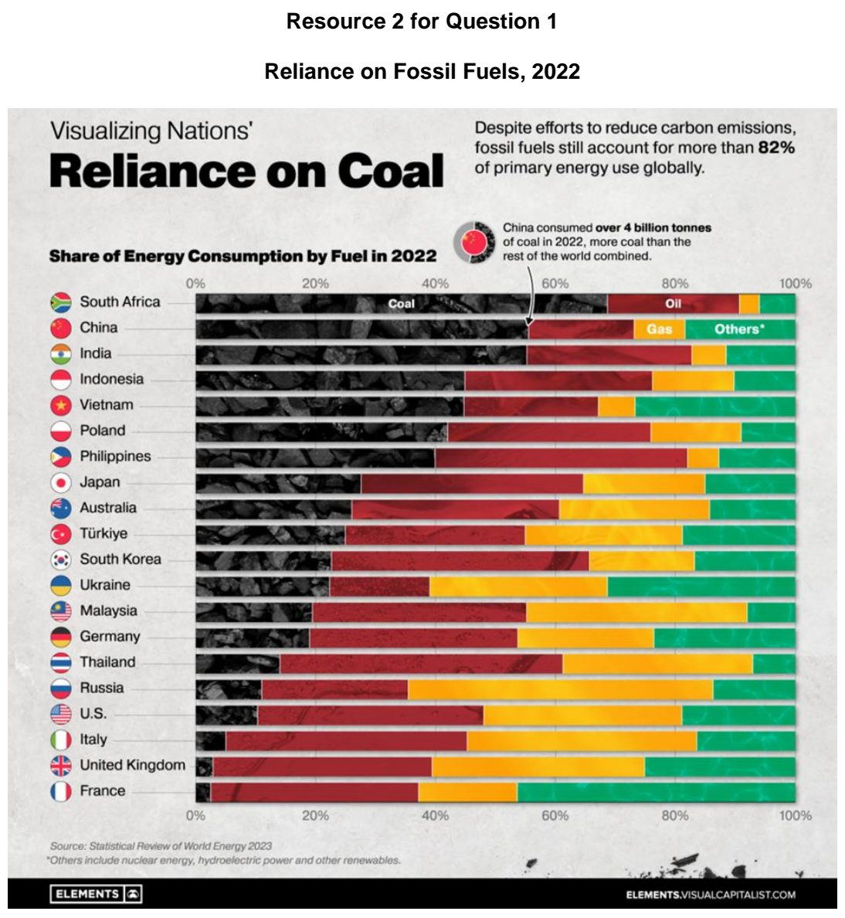

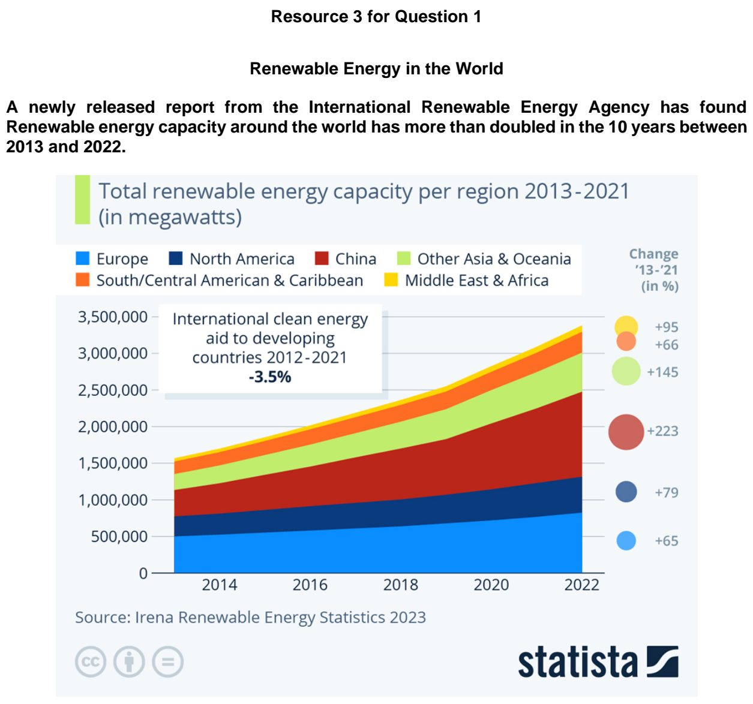

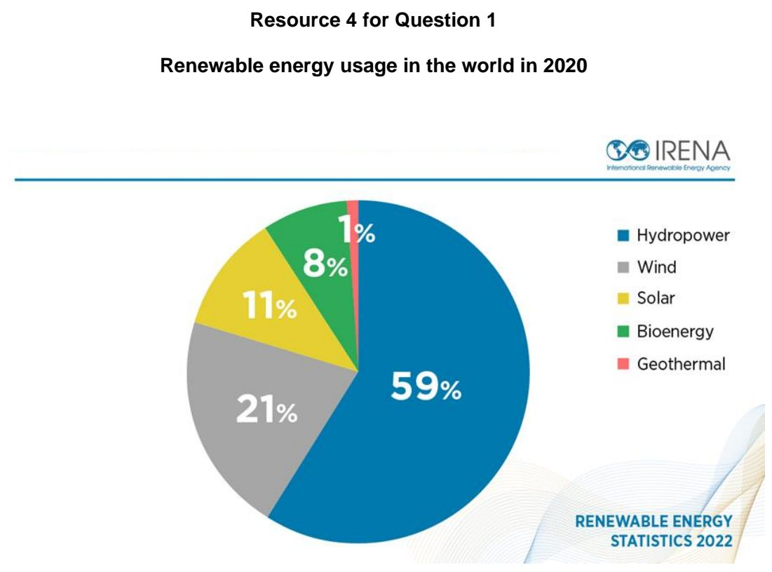

YIJC 2026 — H2 Paper 1 (9173/01), Q1 [30 marks]
Syllabus: 1.2.1a Development – Variations in development; 1.1.2b Environment and Resources – Supply of provisioning services (reserves); 1.1.3c Managing Resources – Extractive industries; 1.2.1c Development – Shifts in economic structure
Section A — Cluster 1: Global Development and Natural Resources
Resource 1 shows the GDP per capita across the Middle East. Resource 2 shows the proven natural gas and natural gas export by countries in 2025.
(a) Using Resource 1, describe the variations in GDP per capita across the Middle East. [5]
(b) Compare proven and conditional reserves. [3]
(c) With reference to Resource 2, describe the relationship between proven natural gas reserves and natural gas exports by country. [4]
(d) Using Resource 2, suggest why Iran, despite its large proven natural gas reserves, is not a major exporter of natural gas. [6]
(e) With reference to Resources 1 and 2, explain why resource rich countries such as Qatar and Iraq have experienced different levels of economic development. [6]
(f) Explain why the growth of service sector may bring both benefits and costs to countries. [6]

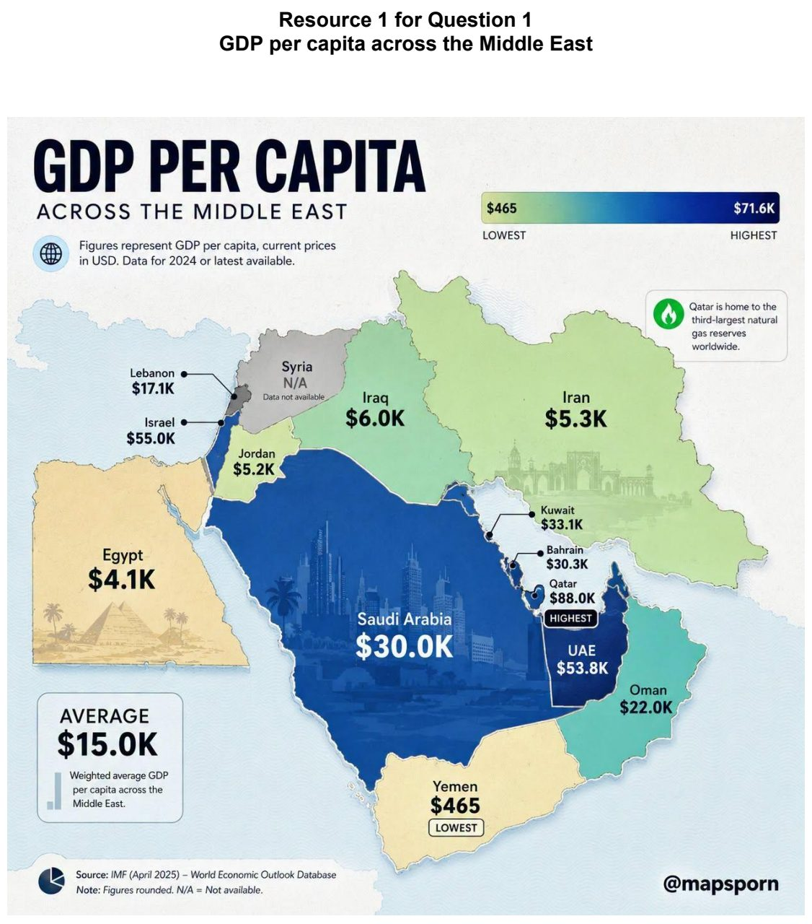

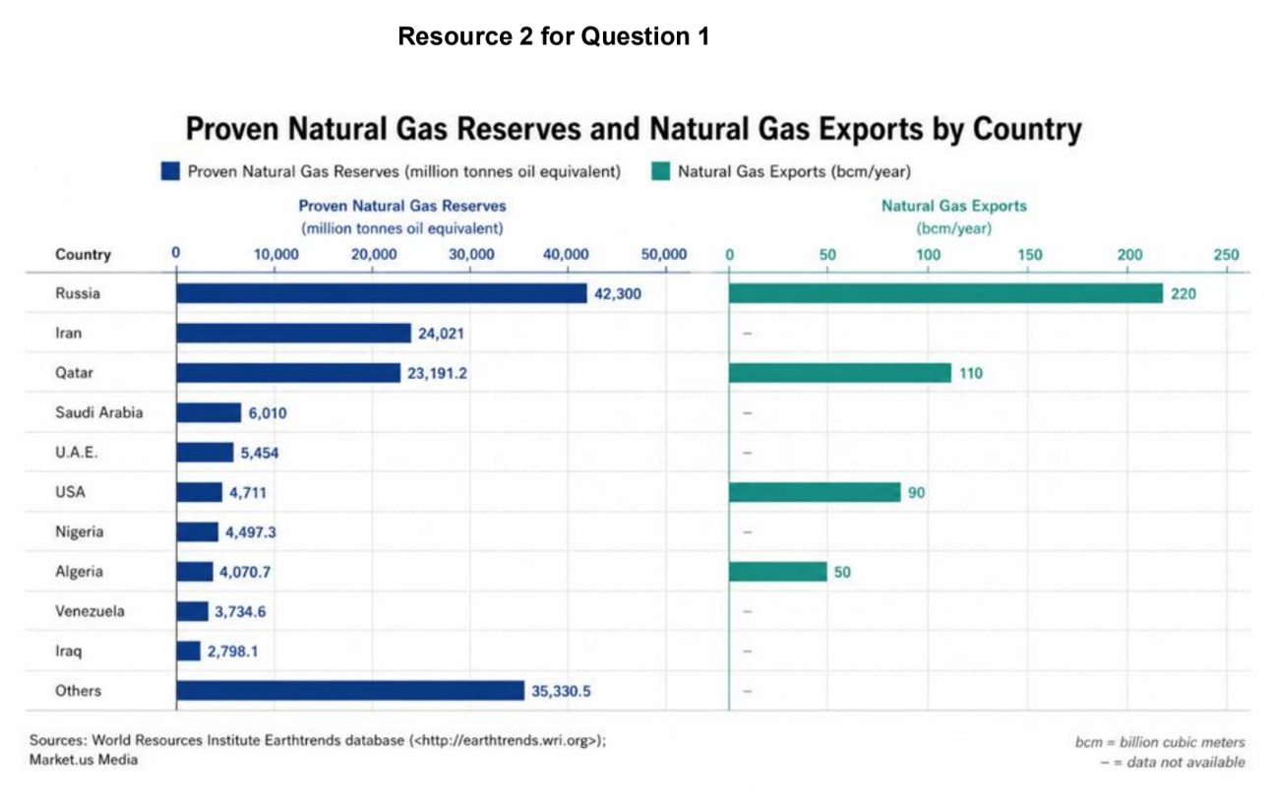

1.2 Development and the Global Economy

ACJC 2024 — H2 Paper 1 (9173/01), Q1 [30 marks]
Syllabus: 1.2.2b Geography of the Global Economy and TNCs – GPNs connecting places; 1.2.2c Geography of the Global Economy and TNCs – Impacts of GPNs on home & host; 1.2.3b Relative Influence of Actors in Shaping the Global Economy – Labour; 1.2.1c Development – Shifts in economic structure
Section A — Cluster 1: Global Development and Natural Resources
Resource 1 shows the map of Nike production factories. Resource 2 shows the Nike commodity chain. Resource 3 shows the factors affecting Nike’s global production network. Resource 4 shows Nike’s sustainability score based on the Sustainable Development Goals (SDGs).
(a) Describe the global distribution of Nike factories shown in Resource 1. [4]
(b) Using Resource 2, explain how Nike’s commodity chain shows the interconnectedness within the global economy. [6]
(c) Explain the impact of labour unions on transnational companies (TNCs). [4]
(d) Using Resource 3, explain the factors that affect Nike’s regional headquarters locations. [6]
(e) Explain the impacts of Nike on the host economy as seen in Resource 4. [6]
(f) Describe how the structure of a less developed country’s economy will be affected by shifts in global manufacturing. [4]

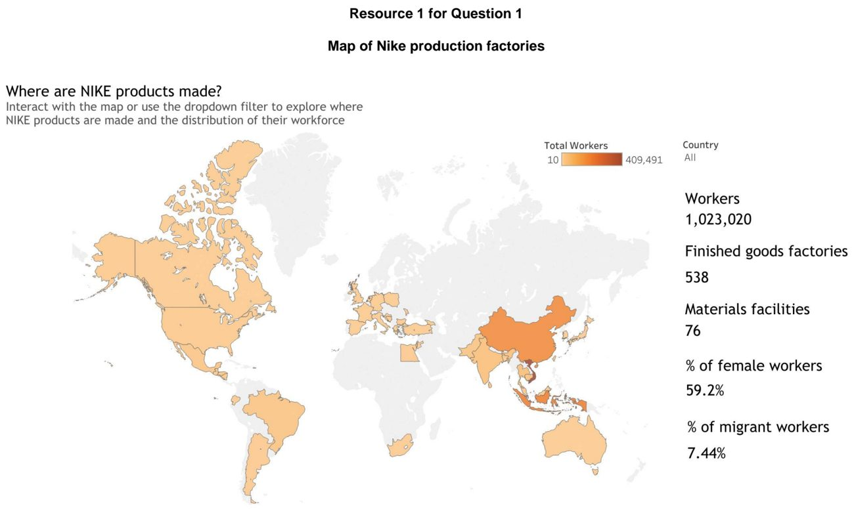

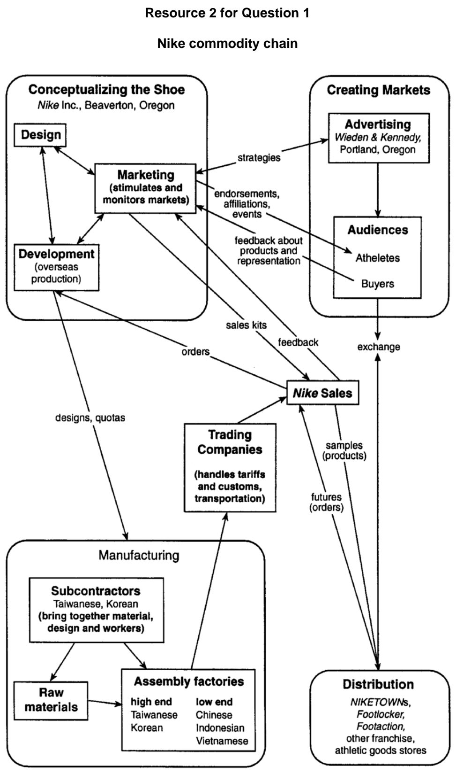

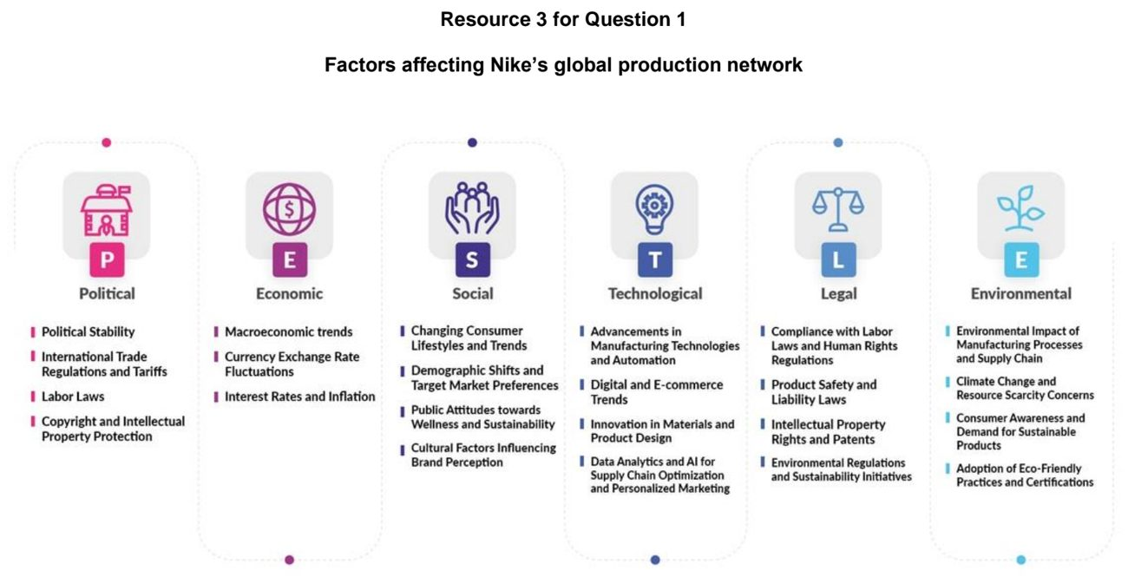

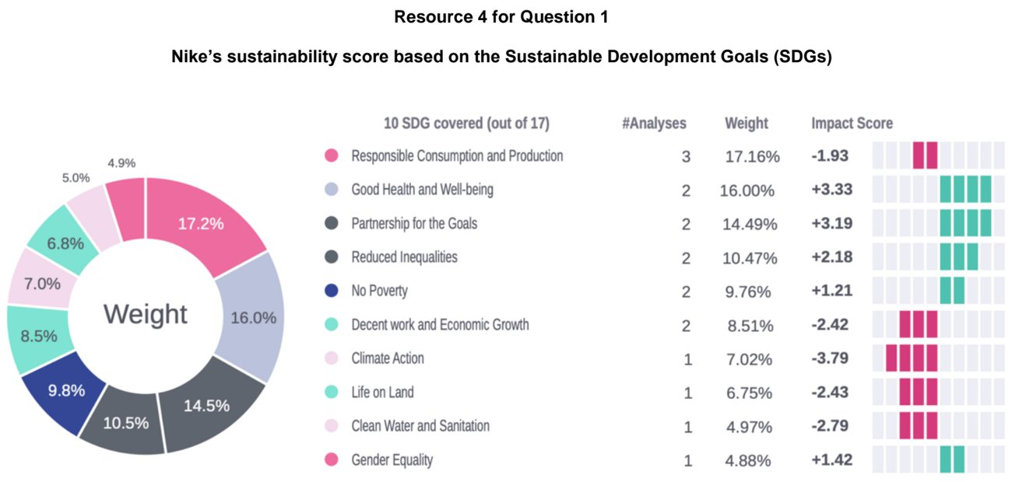

ACJC 2026 — H2 Paper 1 (9173/01), Q1 [30 marks]
Syllabus: 1.2.1b Development – Trade, capital & labour flows; 1.2.1c Development – Shifts in economic structure; 1.2.2b Geography of the Global Economy and TNCs – GPNs connecting places; 1.2.1a Development – Variations in development; 1.2.3c Relative Influence of Actors in Shaping the Global Economy – Multilateral institutions
Section A — Cluster 1: Global Development and Natural Resources
Resource 1 shows the international labour flows by continent in 2020. Resource 2 shows the manufacturing employment as a percent of total employment from 1980 to 2019. Resource 3 shows the countries classified by income in 2023. Resource 4 shows the Apple iPhone Global Production Network (GPN).
(a) Using Resource 1, describe the pattern of global labour flows in 2020. [5]
(b) With reference to Resource 1, explain how labour flows lead to variations in levels of development across space. [6]
(c) Account for the changes in manufacturing employment for the countries shown in Resource 2. [6]
(d) Using Resource 3, describe the global distribution of countries by income in 2023. [4]
(e) Using Resource 4, explain how the Global Production Networks (GPNs) of Transnational Corporations (TNCs) like Apple connect places within the global economy. [5]
(f) Explain how the World Bank can influence Transnational Corporations’ (TNCs) locational decisions. [4]

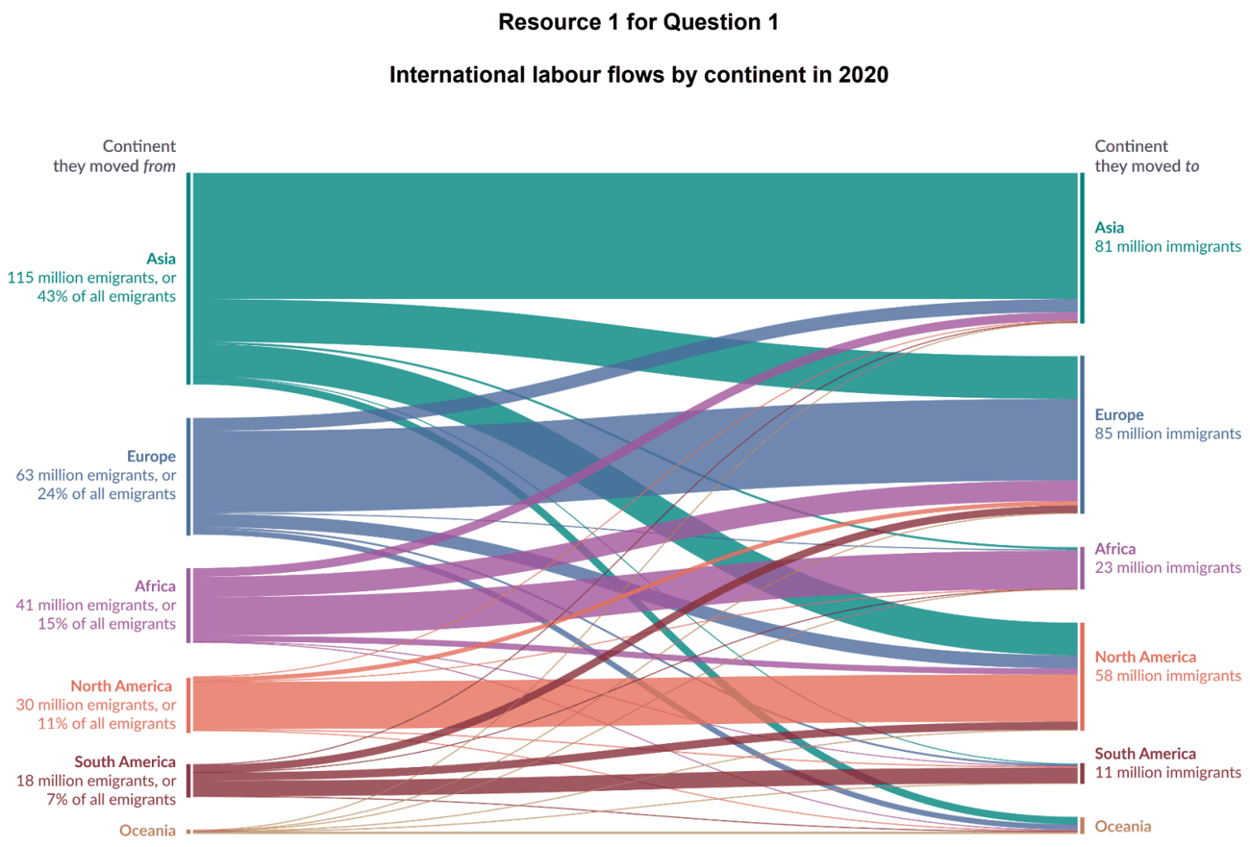

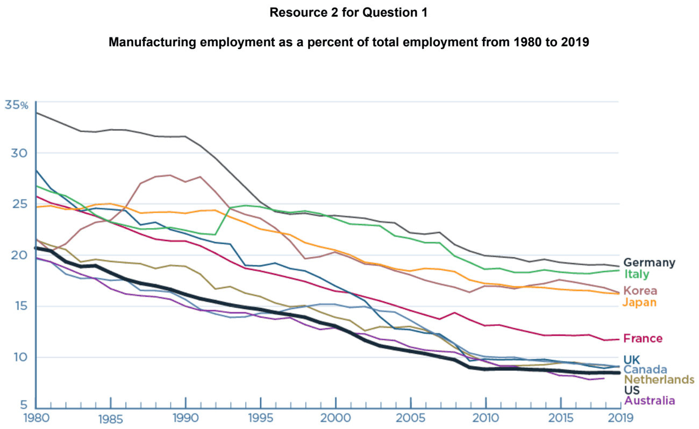

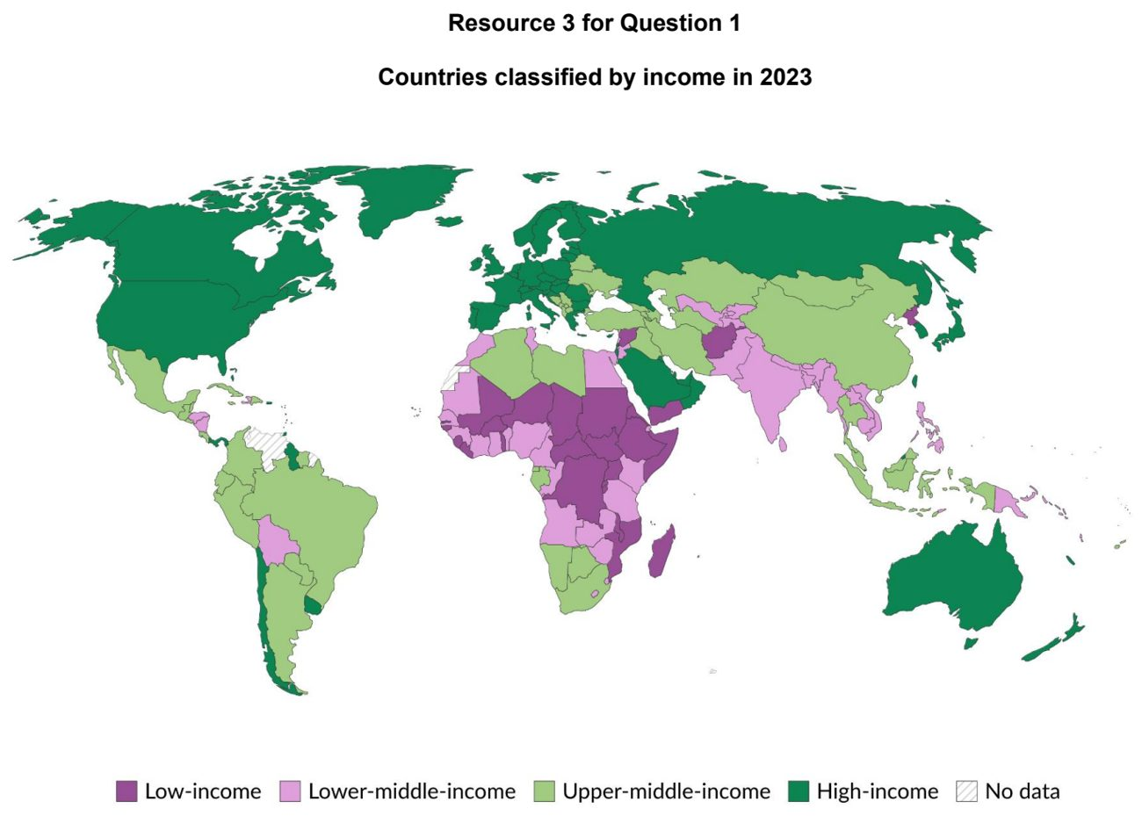

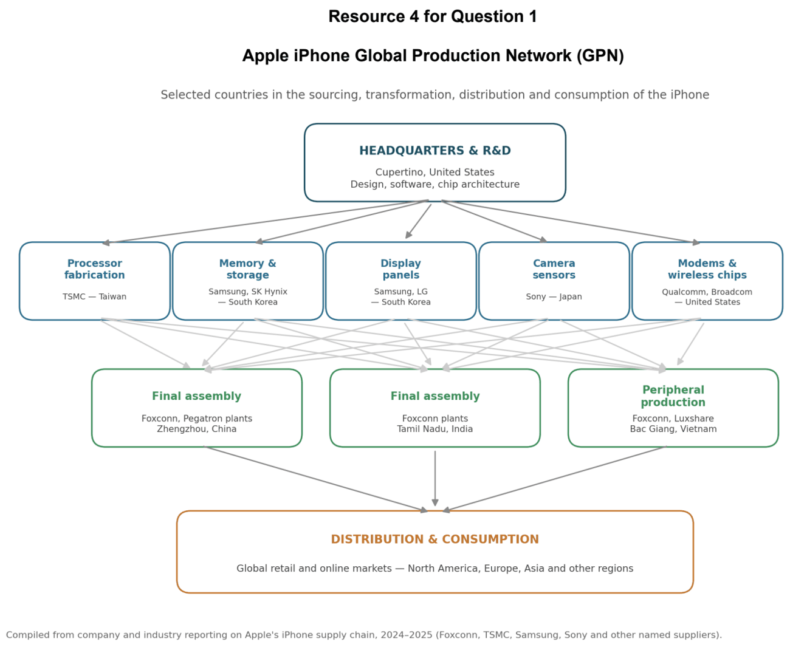

ASRJC 2025 — H2 Paper 1 (9173/01), Q1 [30 marks]
Syllabus: 1.2.2b Geography of the Global Economy and TNCs – GPNs connecting places; 1.2.2c Geography of the Global Economy and TNCs – Impacts of GPNs on home & host; 1.2.3a Relative Influence of Actors in Shaping the Global Economy – States; 1.2.2a Geography of the Global Economy and TNCs – Interconnectedness through flows; 1.1.3c Managing Resources – Extractive industries
Section A — Cluster 1: Global Development and Natural Resources
Tiffany & Co. is a luxury jewellery transnational corporation (TNC) headquartered in the United States of America, with an extensive global production network (GPN). Resource 1 shows the distribution of global diamond supply per Million Carats. Resource 2 shows the distribution of primary sourcing and manufacturing of diamonds and metals of Tiffany & Co. in 2014. Resource 3 shows a factsheet on diamond mining in the Democratic Republic of Congo (DRC). Resource 4 shows an extract on sustainability efforts implemented by Tiffany & Co.
(a) With reference to Resources 1 and 2, compare the spatial pattern of Tiffany & Co.’s primary source of rough diamond with the global diamond supply. [4]
(b) Account for the global distribution of Tiffany & Co. manufacturing plants as seen in Resource 2. [6]
(c) Explain how the GPNs of TNCs like Tiffany & Co. contribute to the interdependence between places in the global economy. [4]
(d) With the help of Resources 1, 2, and 3, describe the characteristics of extractive industries. [4]
(e) With reference to Resource 3 and 4, explain the impacts of the GPN of Tiffany & Co. on host economies. [6]
(f) Suggest how states can influence the operations of TNCs like Tiffany & Co. through their roles as regulators of economic activities. [6]

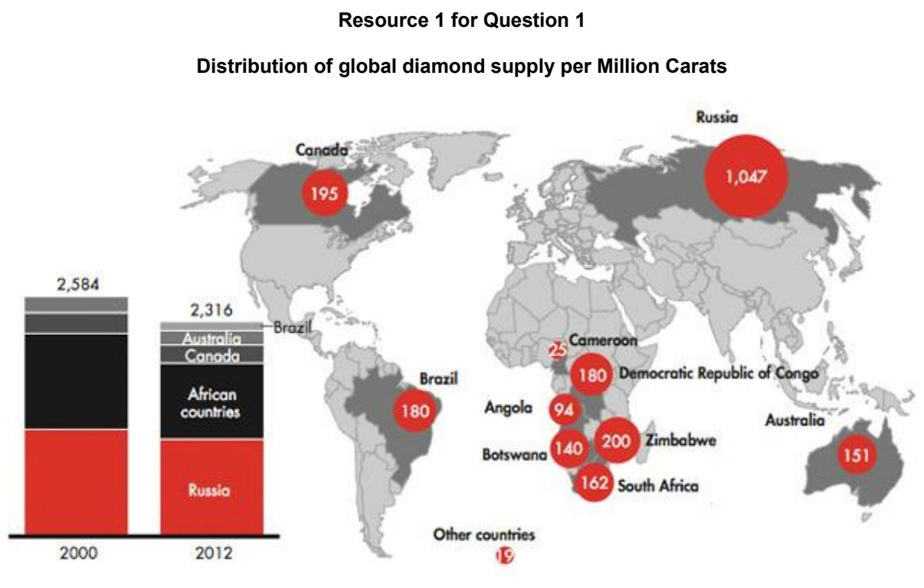

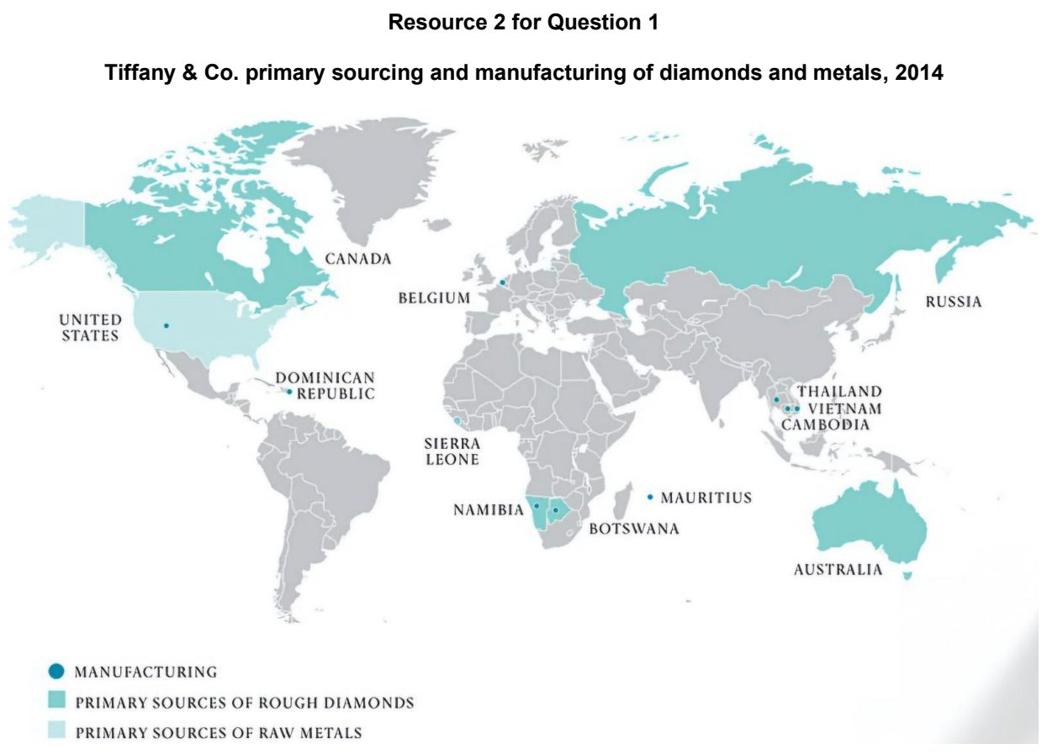

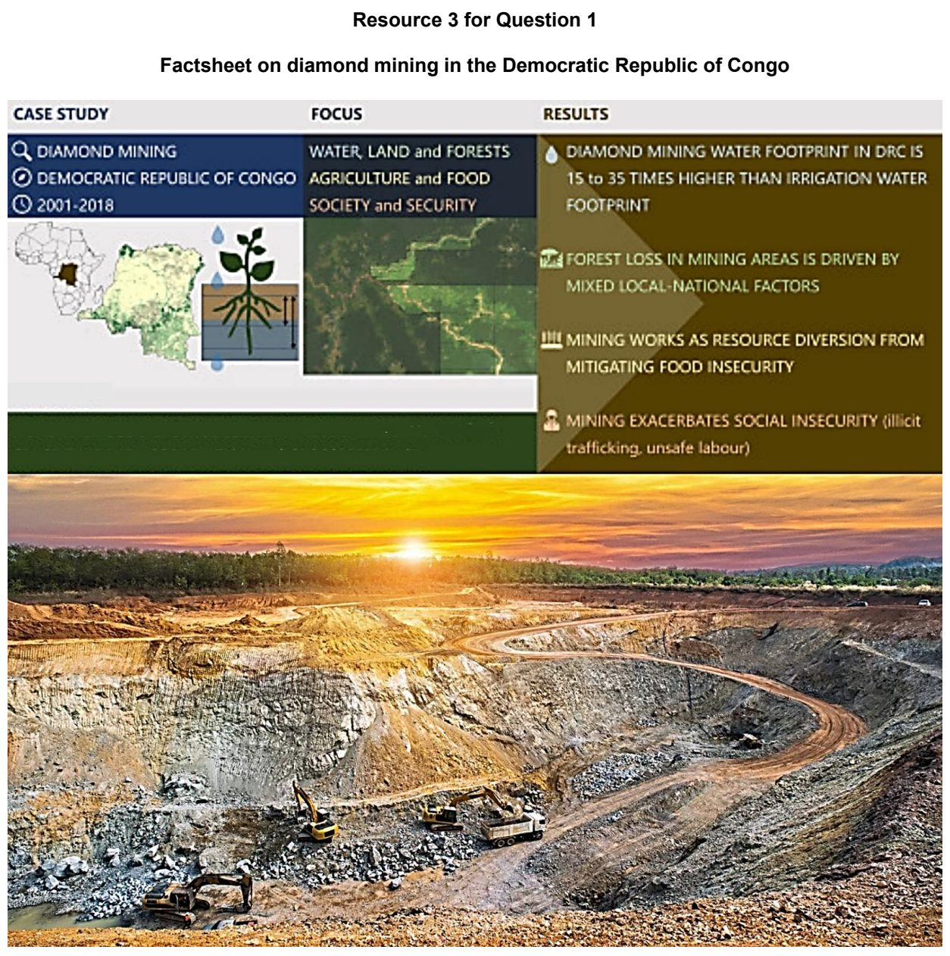

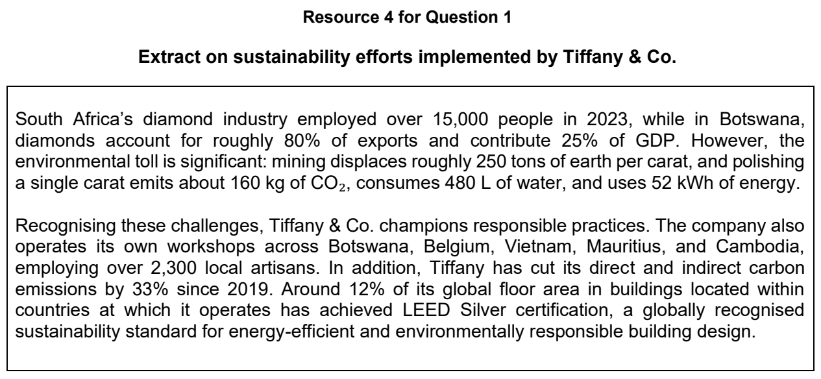

CJC 2025 — H2 Paper 1 (9173/01), Q1 [30 marks]
Syllabus: 1.2.2b Geography of the Global Economy and TNCs – GPNs connecting places; 1.2.3b Relative Influence of Actors in Shaping the Global Economy – Labour; 1.2.3a Relative Influence of Actors in Shaping the Global Economy – States; 1.1.3c Managing Resources – Extractive industries
Section A — Cluster 1: Global Development and Natural Resources
Resource 1 shows a map of BYD Electric Vehicle (EV) production plants around the world and their annual production capacity. Resource 2 shows the EV sales by continent. Resource 3 shows the major Chinese EV and EV battery manufacturing investments in Europe. EV batteries are crucial components in EVs. Resource 4 shows miners at a cobalt cleaning site in the Democratic Republic of the Congo. Cobalt is a crucial component in EV batteries.
(a) Explain the influence of labour characteristics on TNC’s locational decisions. [5]
(b) With reference to Resource 1, describe the location and production capacity of main BYD EV production plants around the world. [5]
(c) With reference to Resources 2 and 3, suggest reasons for the locations of BYD production plants. [6]
(d) With reference to Resource 3, explain how global production networks of transnational corporations (TNCs) connect places across the world. [5]
(e) With reference to Resource 4, explain the impacts of extractive industries. [4]
(f) Explain how states can influence operations of TNCs. [5]

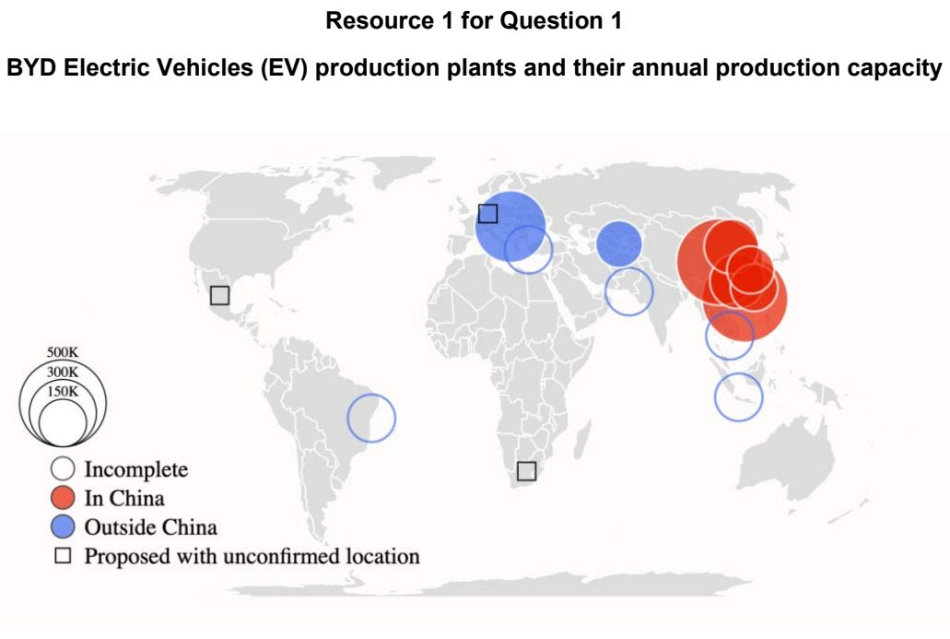

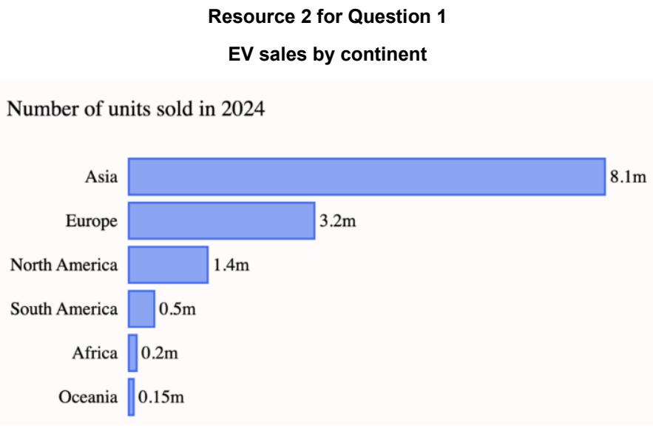

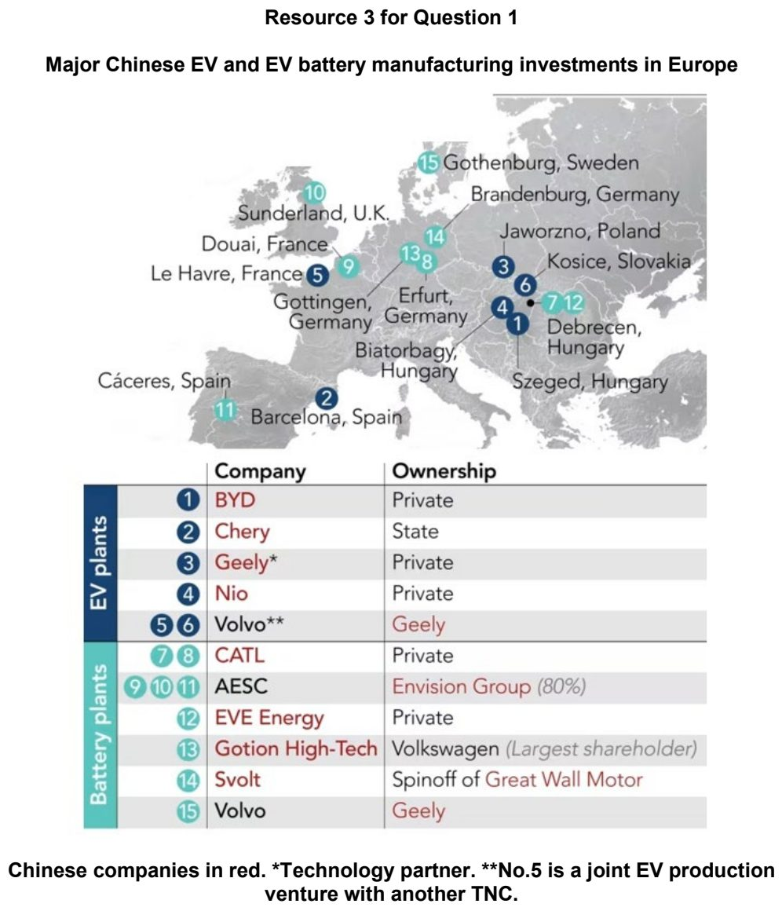

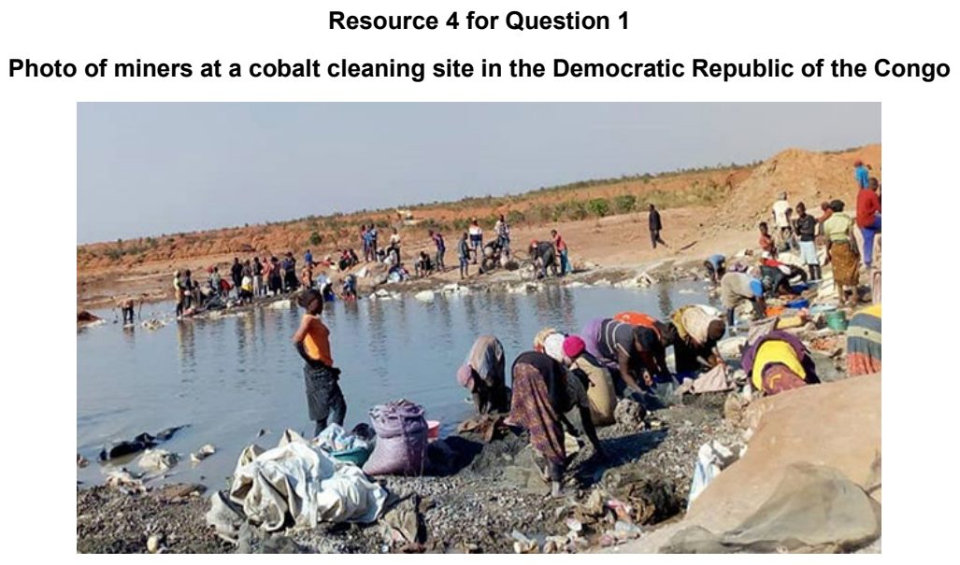

CJC 2026 — H2 Paper 1 (9173/01), Q1 [30 marks]
Syllabus: 1.1.3a Managing Resources – Renewable energy (solar, hydropower); 1.2.1c Development – Shifts in economic structure; 1.2.2c Geography of the Global Economy and TNCs – Impacts of GPNs on home & host; 1.1.1b Understanding Sustainable Development – Measuring progress (SDGs, indicators)
Section A — Cluster 1: Global Development and Natural Resources
Resource 1 shows a map of hydropower generation in 1999 and 2024. Resource 2 shows a map of dams and power plants in the Lancang-Mekong River Basin. Resource 3 shows the power supply structure of countries in the Lancang-Mekong River Basin. Resource 4 shows Vietnam’s exports from 2000 to 2022.
(a) With reference to Resource 1, compare hydropower generation in 1999 and 2024. [5]
(b) With reference to Resources 2 and 3, explain why it is challenging to reduce dependence on fossil fuels as energy sources. [5]
(c) Explain how quantitative targets and indicators can be used to measure progress towards the Sustainable Development Goals (SDGs). [4]
(d) With reference to Resource 4, describe the changes in Vietnam’s exports from 2000 to 2022. [5]
(e) With reference to Resource 4, suggest reasons for the changes in Vietnam’s exports. [5]
(f) Explain how the global production networks (GPNs) of transnational corporations (TNCs) might impact sustainable development. [6]

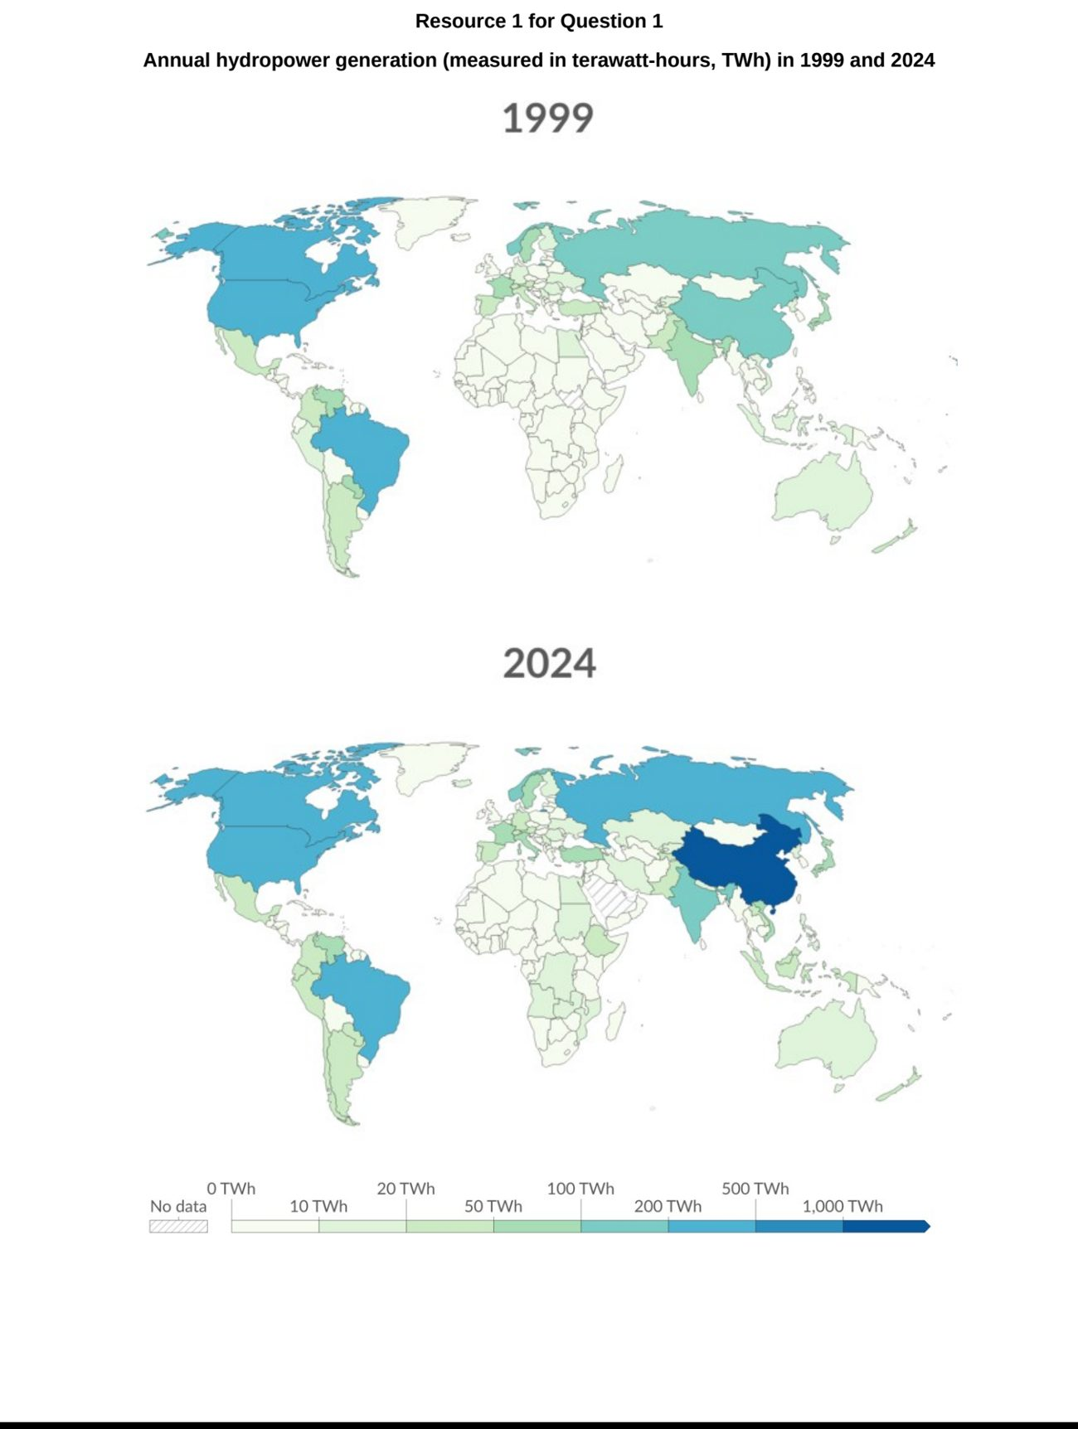

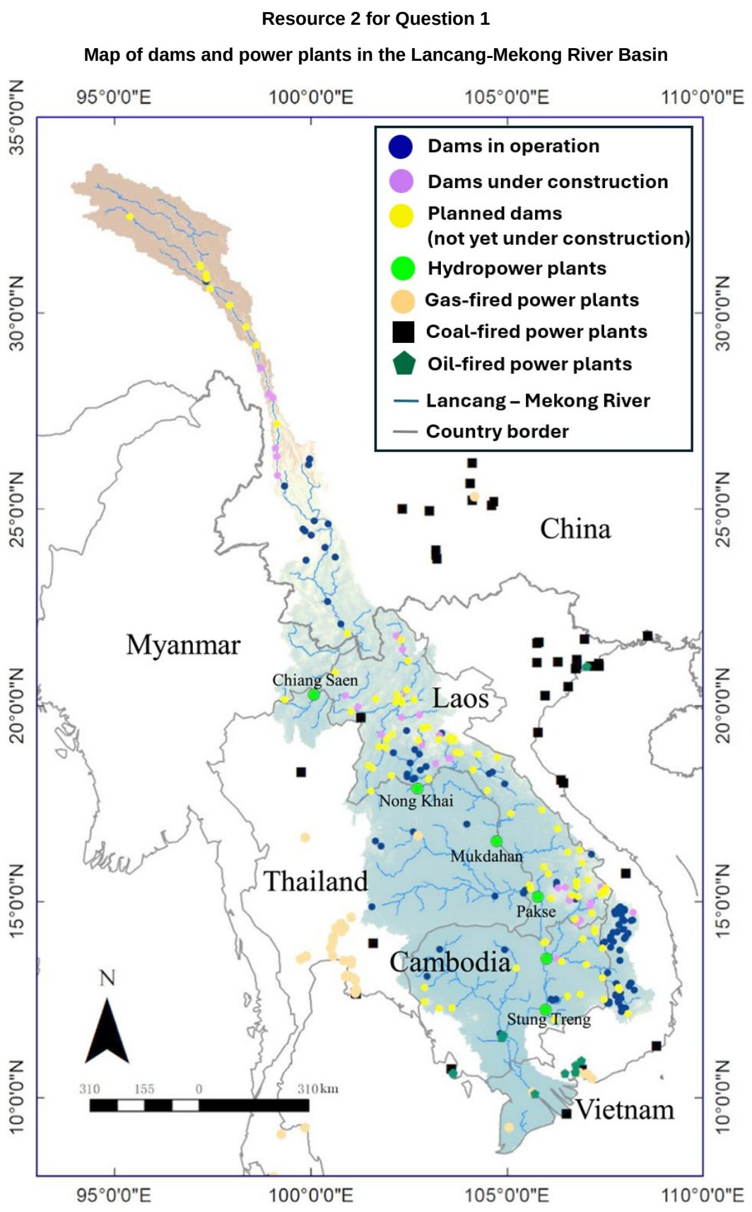

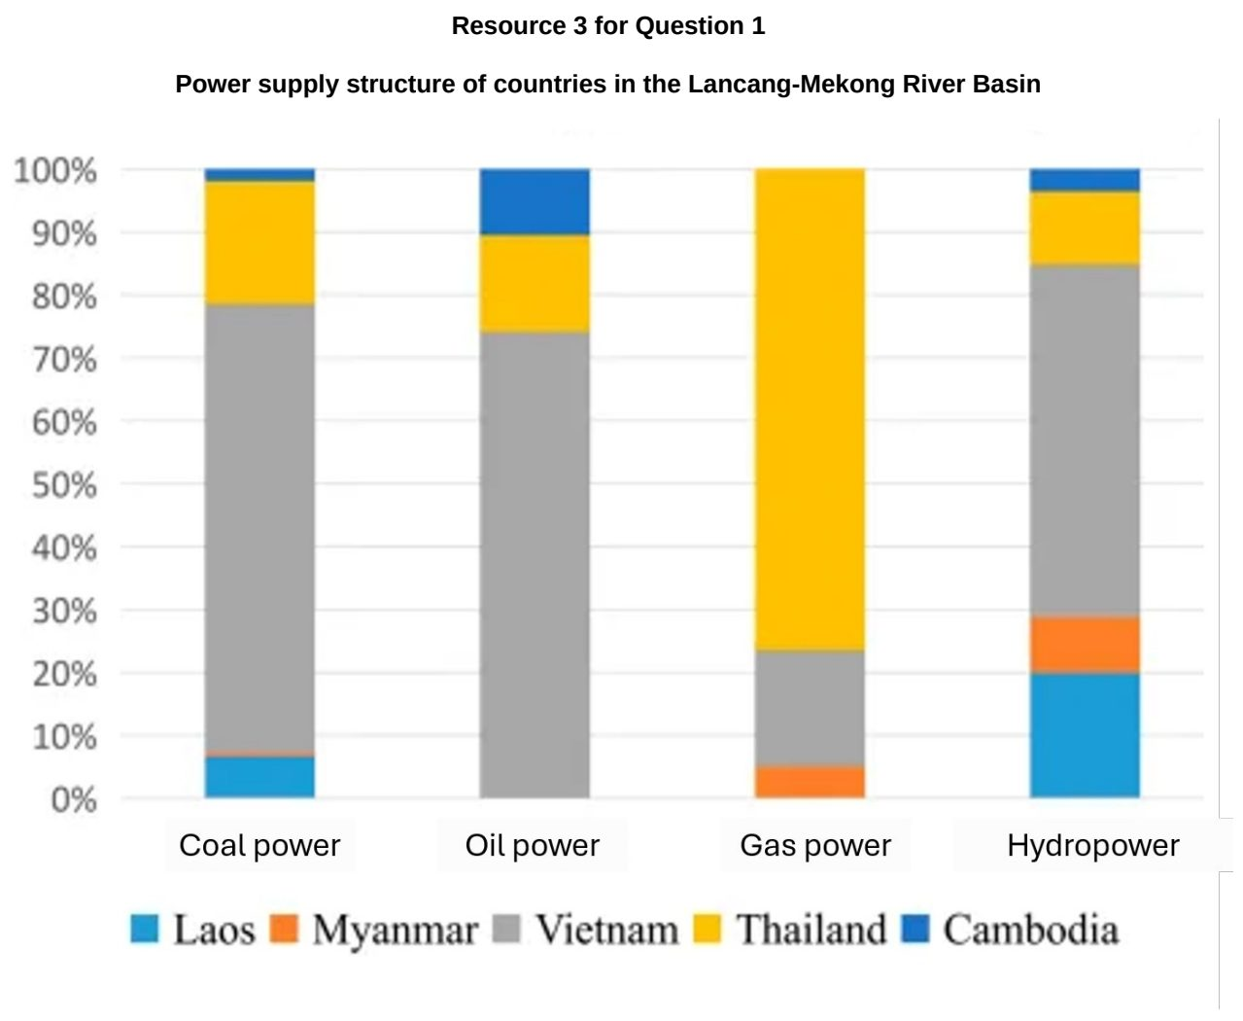

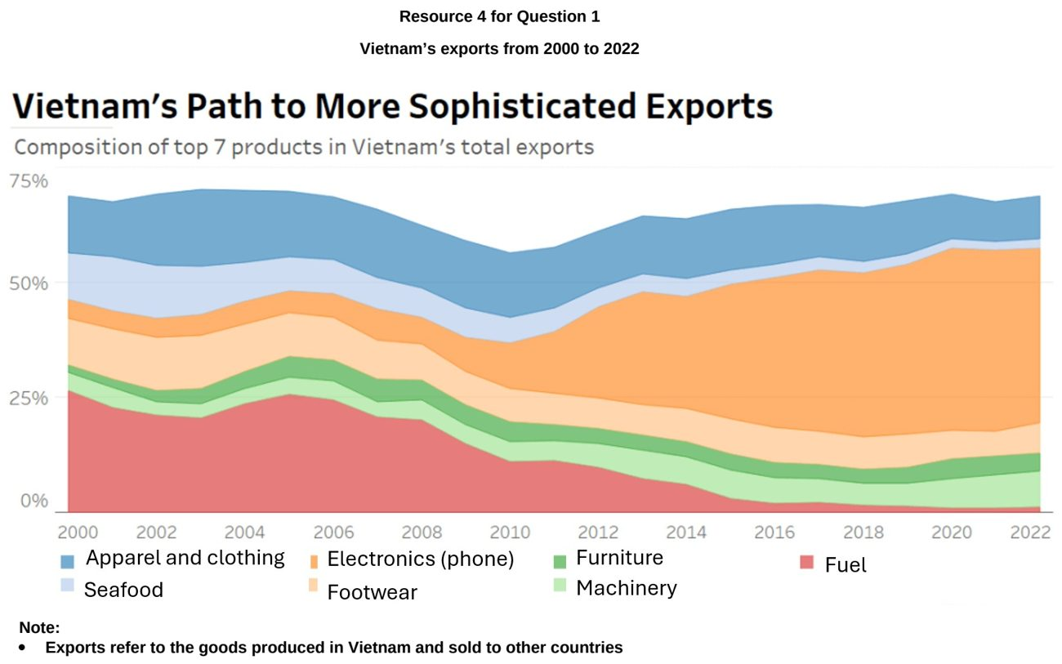

EJC 2025 — H2 Paper 1 (9173/01), Q1 [30 marks]
Syllabus: 1.2.1b Development – Trade, capital & labour flows; 1.2.2c Geography of the Global Economy and TNCs – Impacts of GPNs on home & host; 1.2.1c Development – Shifts in economic structure; 1.2.2a Geography of the Global Economy and TNCs – Interconnectedness through flows; 1.1.1b Understanding Sustainable Development – Measuring progress (SDGs, indicators)
Section A — Cluster 1: Global Development and Natural Resources
Resource 1 shows the inward flows of foreign direct investment (FDI) globally from 2007 to 2019. Resource 2 shows the changes in employment by sector in China from 1952 to 2019. Resource 3 shows Chinese electric vehicle company Build Your Dreams (BYD)’s sales volume and manufacturing plants around the world in 2023.
(a) Describe two ways to measure progress towards sustainable development. [4]
(b) Using Resource 1, describe the changes in inward flows of foreign direct investment (FDI) from 2007 to 2016. [4]
(c) Using Resource 1, account for the distribution in the stocks of foreign direct investments (FDI). [6]
(d) Cite data from Resource 2 to describe the changes in the structure of China’s economy from 1952 to 2019. [5]
(e) Using Resource 3, explain how BYD’s sales and manufacturing plants show interdependence between places in the global economy. [5]
(f) Explain how TNCs can impact progress towards sustainable development in host economies. [6]

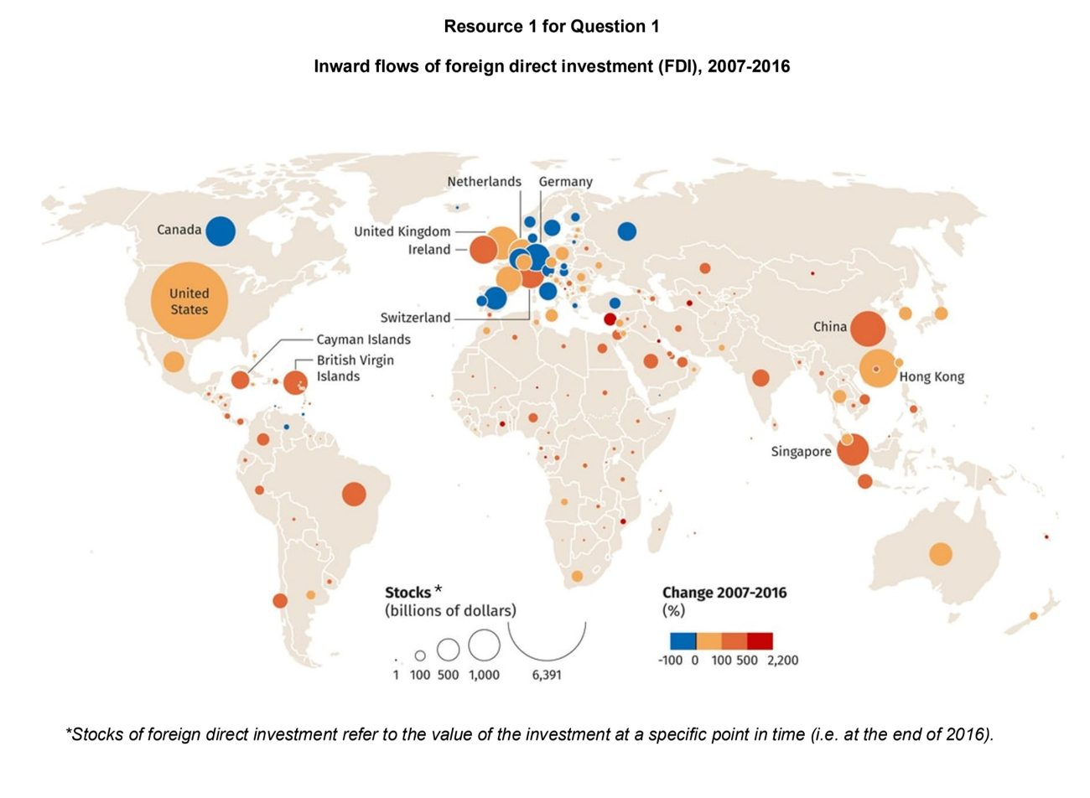

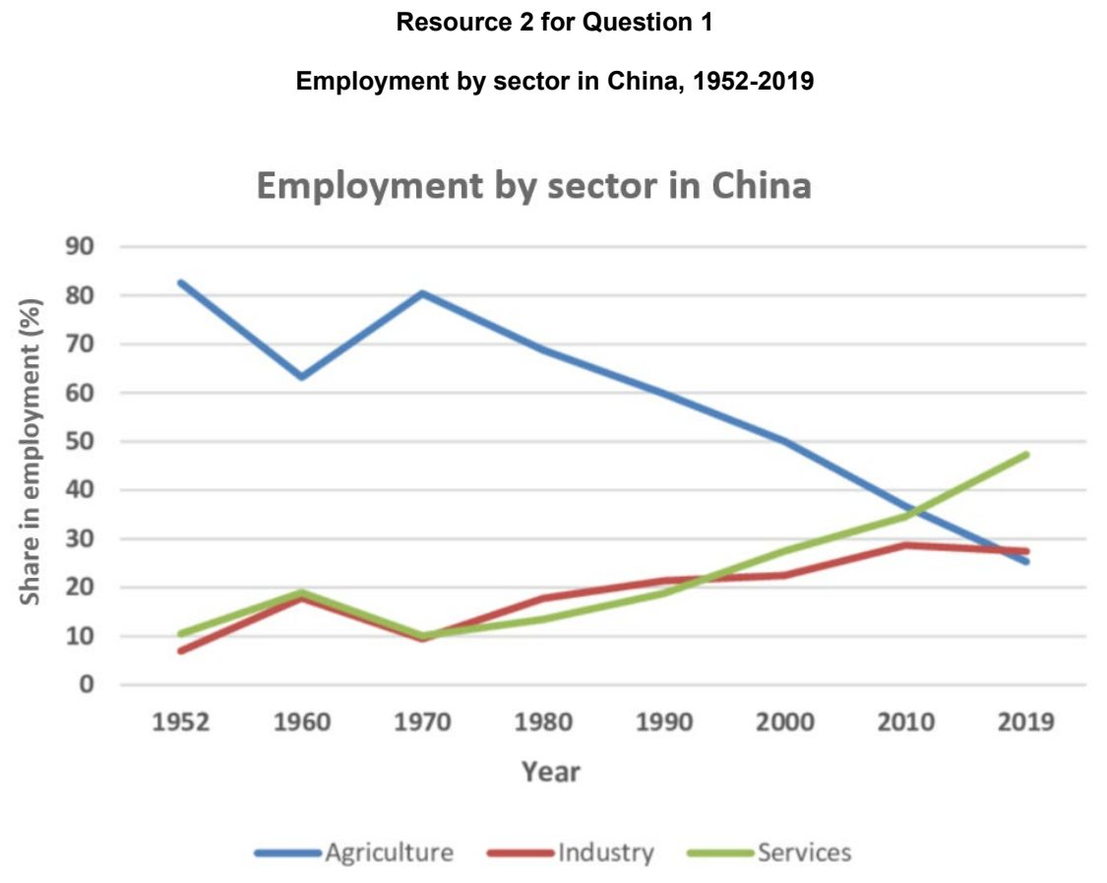

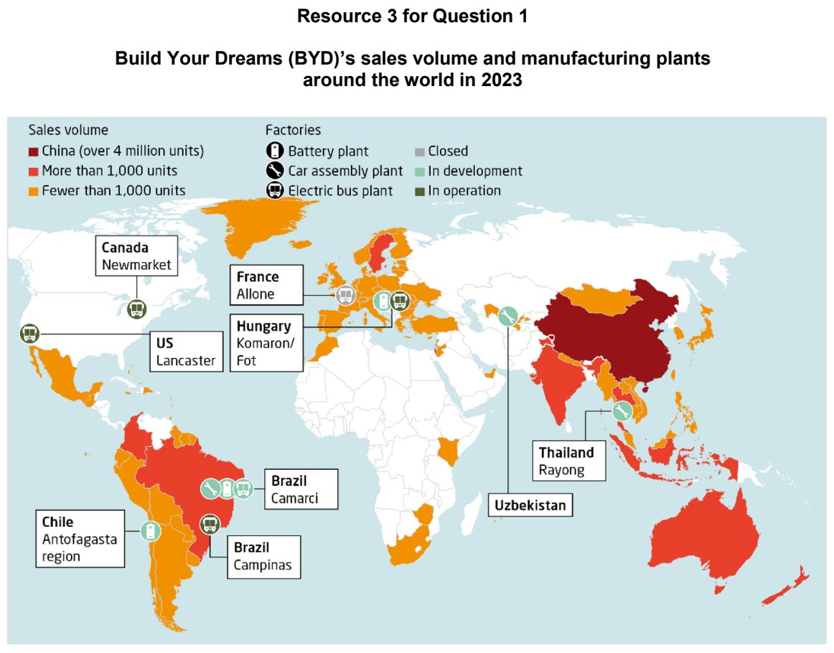

EJC 2026 — H2 Paper 1 (9173/01), Q1 [30 marks]
Syllabus: 1.2.1b Development – Trade, capital & labour flows; 1.2.3a Relative Influence of Actors in Shaping the Global Economy – States; 1.2.2b Geography of the Global Economy and TNCs – GPNs connecting places; 1.2.3c Relative Influence of Actors in Shaping the Global Economy – Multilateral institutions
Section A — Cluster 1: Global Development and Natural Resources
Resource 1 shows the top 5 sources of FDI in ASEAN in 2022 and 2023. Resource 2 shows the ASEAN countries’ trade in services. Resource 3 shows distribution of suppliers in Tesla’s battery supply chain network.
(a) Compare the distribution of the top 5 sources of FDI in ASEAN in 2022 and 2023 as shown in Resource 1. [5]
(b) Explain two ways in which ASEAN can influence economic activities in the global economy. [4]
(c) Using Resource 2, describe the patterns of trade in services among ASEAN countries. [4]
(d) With reference to Resource 2, suggest possible reasons for variations in trade in services between Singapore and Vietnam. [6]
(e) With reference to Resource 3, describe the global distribution of suppliers in Tesla’s battery supply chain network. [5]
(f) Explain how states can influence TNCs’ operations. [6]

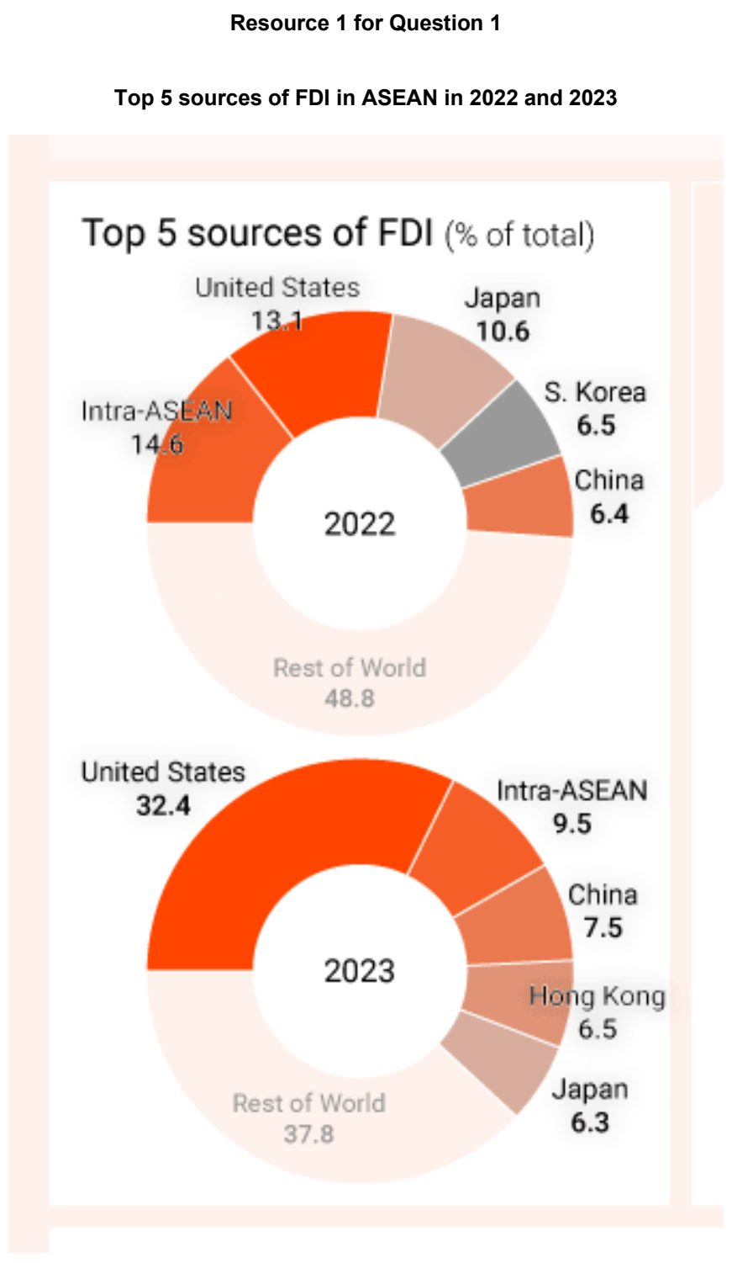

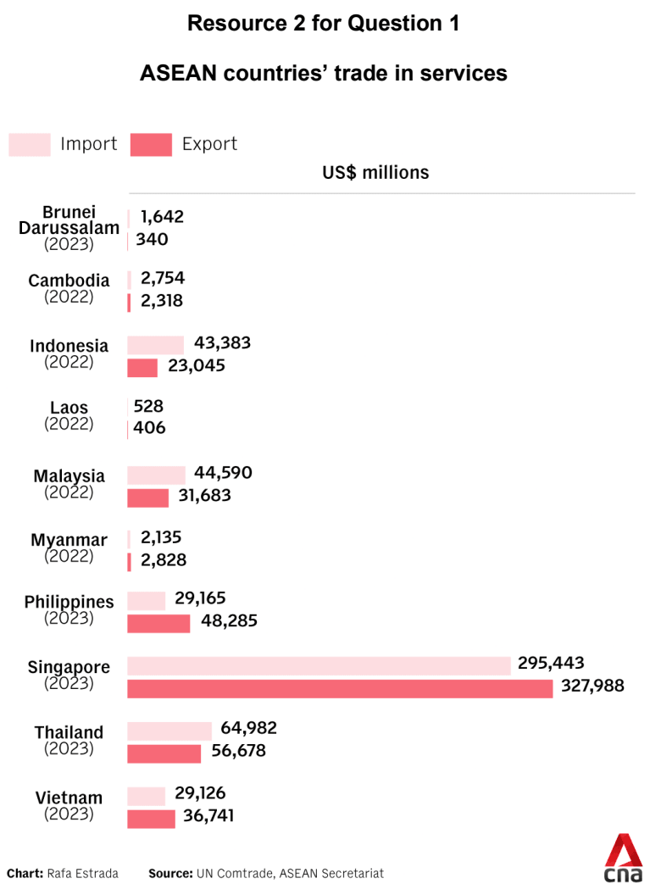

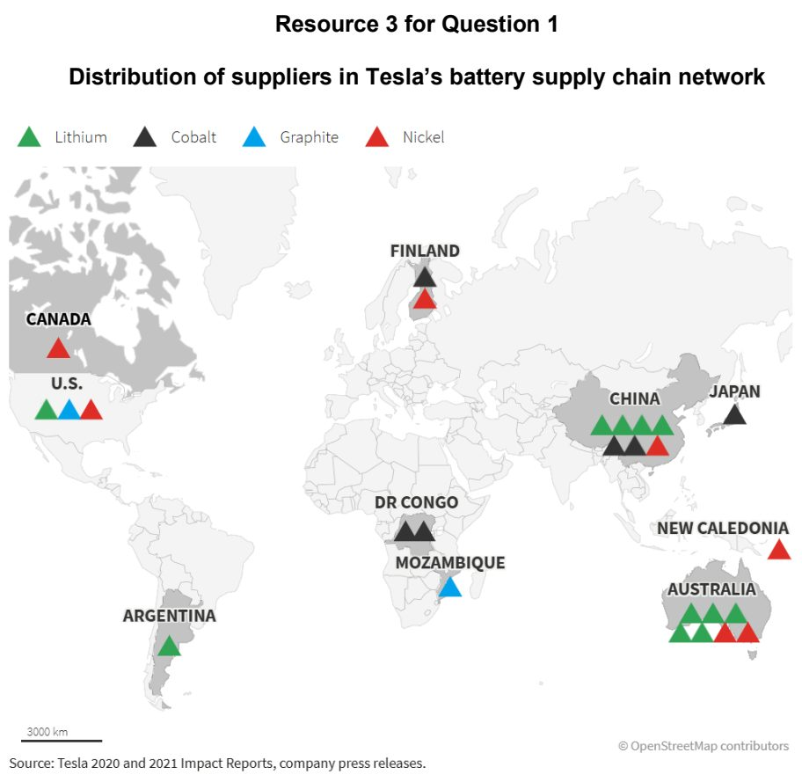

HCI 2024 — H2 Paper 1 (9173/01), Q1 [30 marks]
Syllabus: 1.2.2b Geography of the Global Economy and TNCs – GPNs connecting places; 1.2.3c Relative Influence of Actors in Shaping the Global Economy – Multilateral institutions; 1.2.2c Geography of the Global Economy and TNCs – Impacts of GPNs on home & host
Section A — Cluster 1: Global Development and Natural Resources
Resource 1 shows Apple’s supply chain in 2023 and 2024. Resource 2 shows countries/territories with Apple stores. Resource 3 is an excerpt about the WTO and the Chinese government’s “blacklist”.
(a) Cite data from Resource 1 to describe the changes in the number of Apple’s suppliers in Asia from 2023 to 2024. [3]
(b) With reference to Resource 1, suggest reasons for the changes in Apple’s suppliers in Asia from 2023 to 2024. [5]
(c) Explain the impacts of Global Production Networks (GPNs) of Transnational Corporations (TNCs) like Apple on host economies. [6]
(d) With reference to Resources 1 and 2, explain how GPNs and TNCs contribute to the interdependence between places in the global economy. [6]
(e) With reference to Resource 3, explain the extent of influence the World Trade Organisation (WTO) has on TNCs and states. [6]
(f) Explain the role of Association of Southeast Asian Nations (ASEAN) and World Bank in the global economy. [4]

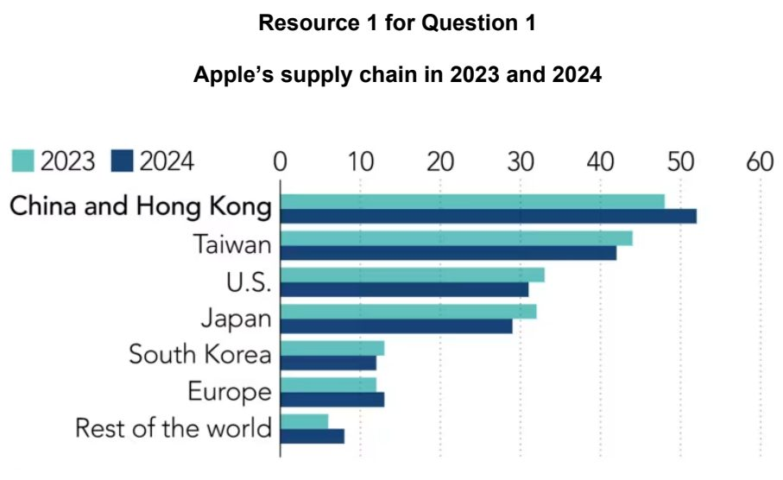

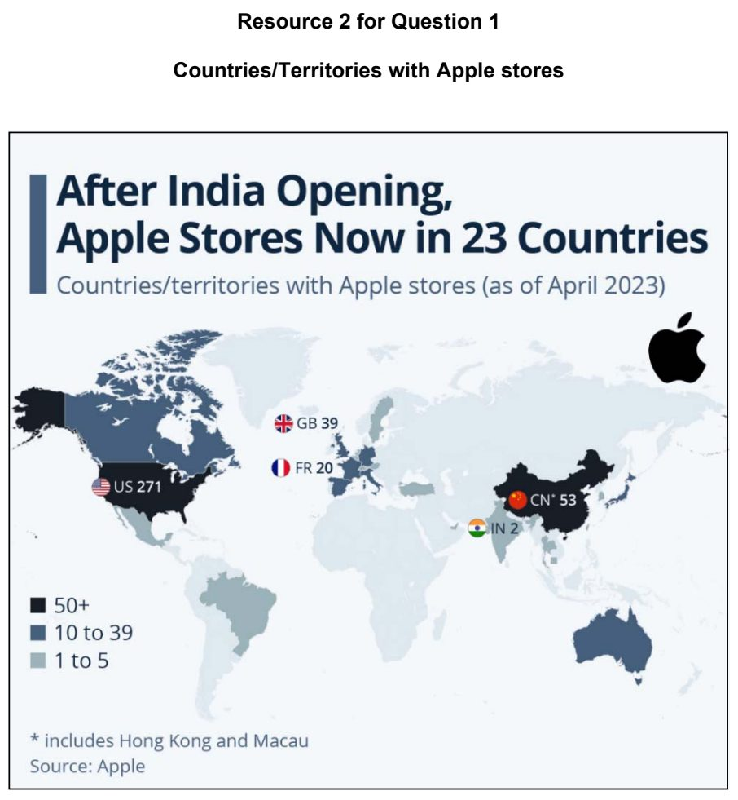

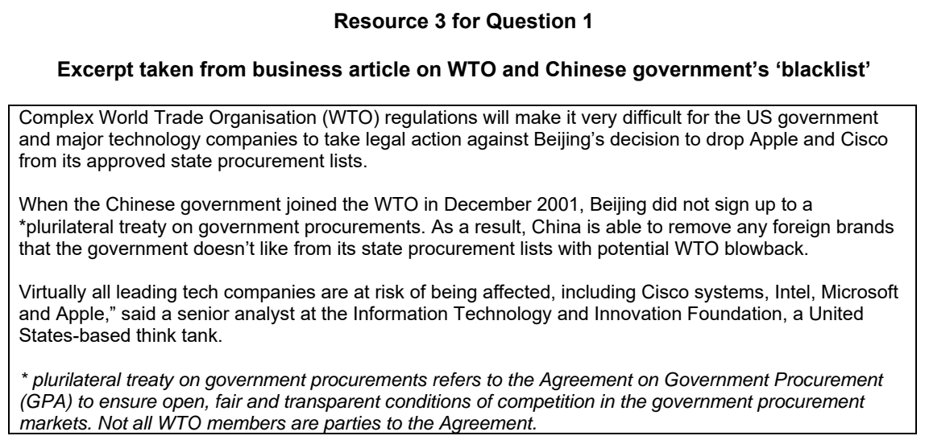

HCI 2026 — H2 Paper 1 (9173/01), Q1 [30 marks]
Syllabus: 1.2.1b Development – Trade, capital & labour flows; 1.2.1c Development – Shifts in economic structure; 1.2.2c Geography of the Global Economy and TNCs – Impacts of GPNs on home & host
Section A — Cluster 1: Global Development and Natural Resources
Resource 1 shows the value of greenfield Chinese manufacturing FDI in ASEAN, by sector. Resource 2 shows export transition for Vietnam and China 2015 – 2024. Resource 3 shows flows of trade between China and Vietnam and Vietnam’s GDP per capita by administrative divisions. Resource 4 shows an extract from an article on Vietnam’s position in the global economy.
(a) Cite data from Resource 1 to describe Chinese manufacturing FDI in ASEAN in 2014 and 2024. [4]
(b) Account for Chinese manufacturing FDI in ASEAN shown in Resource 1. [6]
(c) Compare the value of exports for China and Vietnam shown in Resource 2. [6]
(d) With reference to Resource 3, suggest how flows of trade and capital may influence the level of development in Vietnam. [4]
(e) With reference to Resources 3 and 4, explain why Vietnam’s structure of the economy may change. [6]
(f) Suggest how Vietnam’s economy and environment may be impacted as a host country in the global economy. [4]

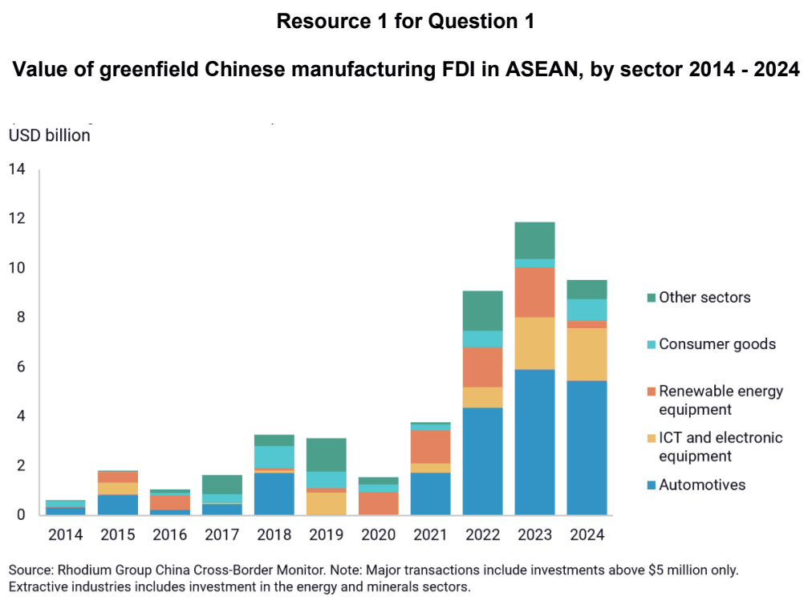

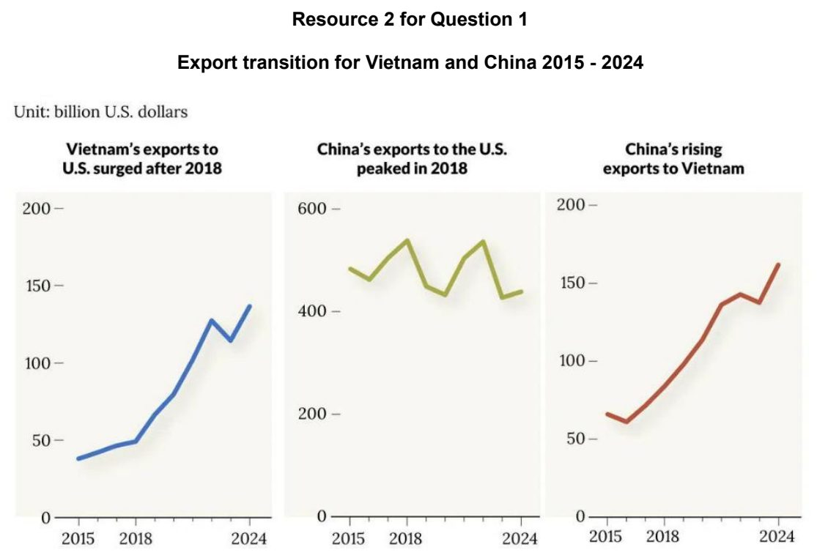

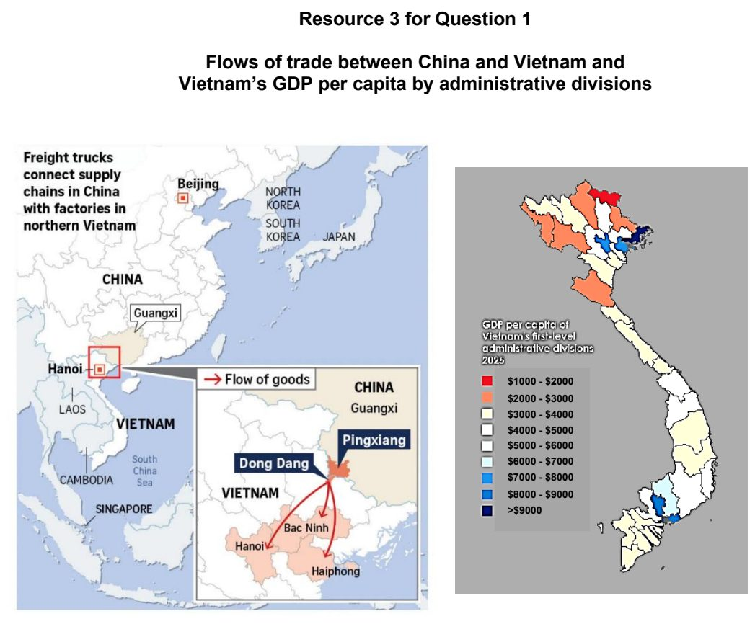

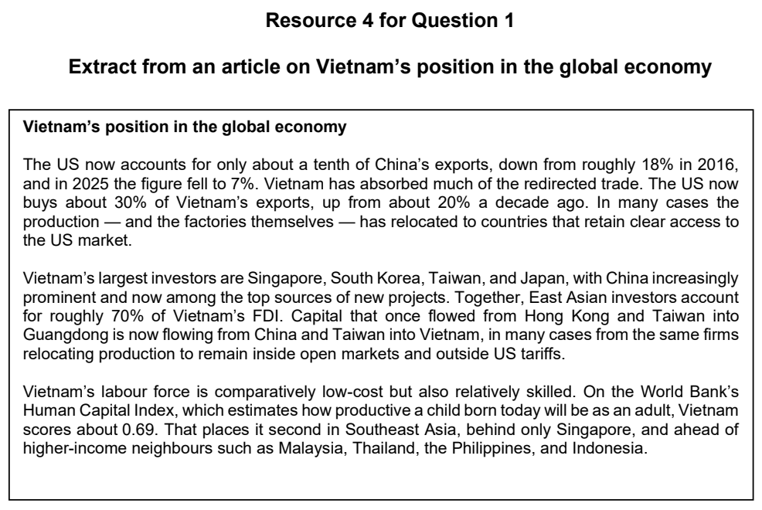

JPJC 2025 — H2 Paper 1 (9173/01), Q1 [30 marks]
Syllabus: 1.2.3c Relative Influence of Actors in Shaping the Global Economy – Multilateral institutions; 1.2.2a Geography of the Global Economy and TNCs – Interconnectedness through flows
Section A — Cluster 1: Global Development and Natural Resources
Resource 1 shows a cartoon depicting inequality at the World Trade Organization (WTO) Talks. Resource 2 shows World Bank lending by region in 2021. Resource 3 shows the WTO membership and global trade share (1995 – 2020).
(a) Suggest reasons for the growing interdependence between places in the global economy. [4]
(b) Describe the criticisms shown in Resource 1 on the role of WTO in the global economy. [4]
(c) Using Resource 2, describe the pattern of World Bank lending in 2021. [5]
(d) With reference to Resource 3, explain why WTO membership and its global trade share have changed from 1995 to 2020. [6]
(e) Using Resources 2 and 3, explain how multilateral institutions can promote economic development. [5]
(f) Explain why multilateral institutions may be more influential than other actors in shaping the global economy. [6]

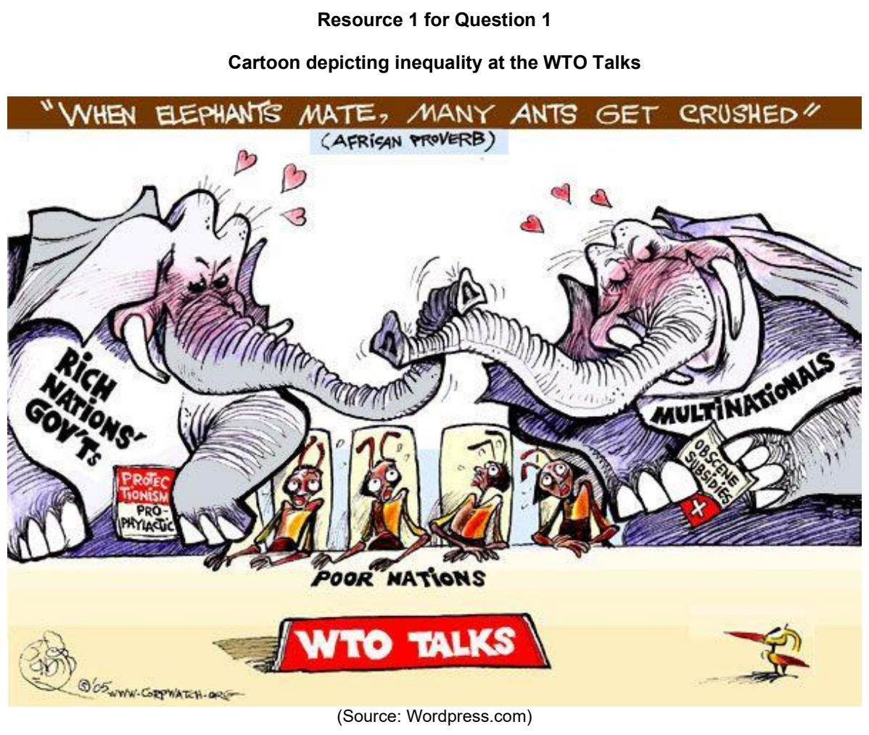

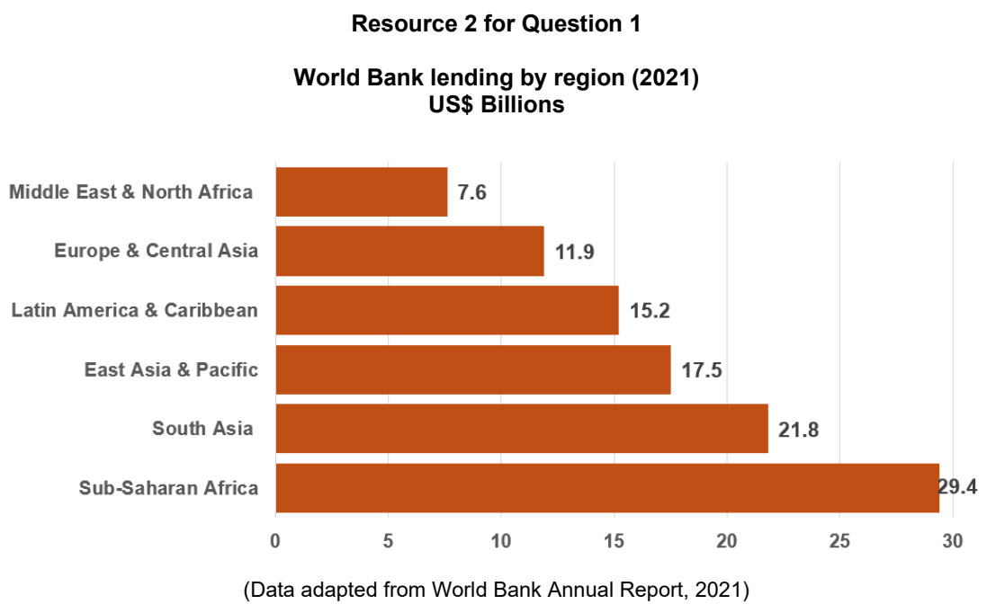

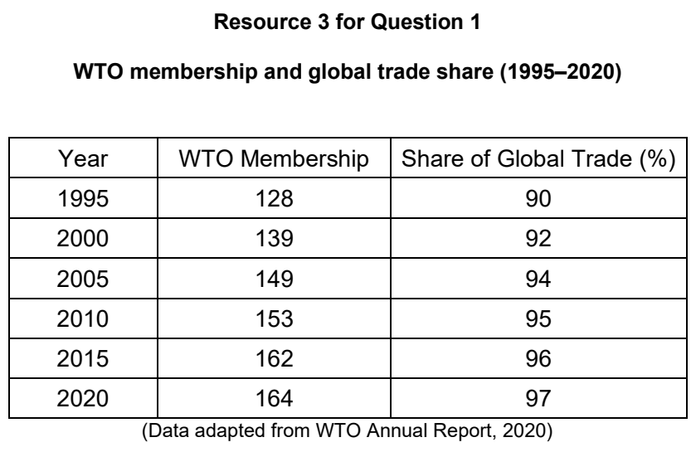

JPJC 2026 — H2 Paper 1 (9173/01), Q1 [30 marks]
Syllabus: 1.2.2c Geography of the Global Economy and TNCs – Impacts of GPNs on home & host; 1.2.1b Development – Trade, capital & labour flows; 1.2.1a Development – Variations in development; 1.2.2b Geography of the Global Economy and TNCs – GPNs connecting places
Section A — Cluster 1: Global Development and Natural Resources
Resource 1 shows the global ranking of capital inflows, as measured by Foreign Direct Investment (FDI), between 2012 and 2022. Resource 2 shows the world’s top cocoa producing countries. Resource 3 shows cocoa bean consumption per person in 2023. Resource 4 shows the share in the sales of an average chocolate bar. Resource 5 shows the top 10 chocolate companies worldwide by chocolate/confectionery sales.
(a) With reference to Resource 1, describe the changes in the global ranking of capital inflows between 2012 and 2022. [4]
(b) Using Resource 1, suggest reasons for the changes in capital inflows into the East Asia & Pacific region between 2012 and 2022. [6]
(c) Explain how the concentration of capital inflows into certain countries might reinforce variations across space in levels of development. [4]
(d) With reference to Resources 2 and 3, compare the locations where inputs are sourced with those where products are consumed in the Global Production Network (GPN) of cocoa. [4]
(e) Using Resources 2, 4, and 5, explain how the GPN of cocoa creates an uneven economic impact across space. [6]
(f) Suggest ways in which the negative impacts of transnational corporations (TNCs) on host economies can be minimised. [6]

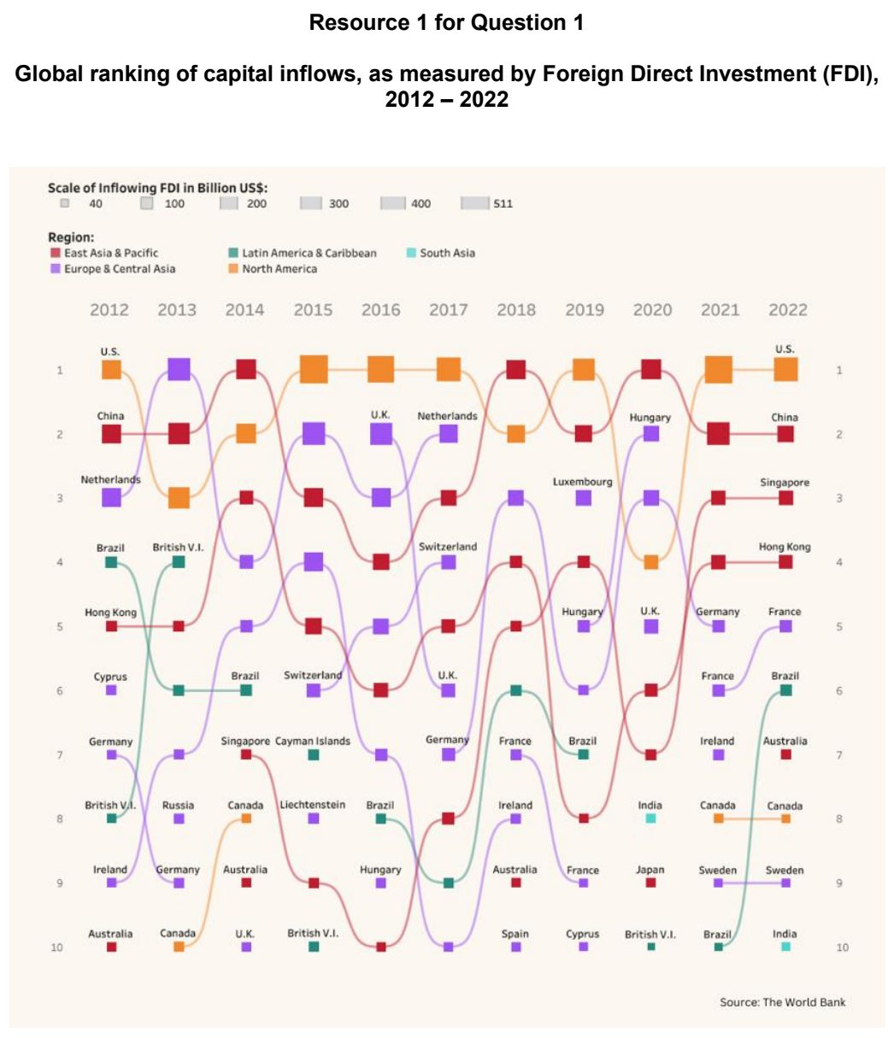

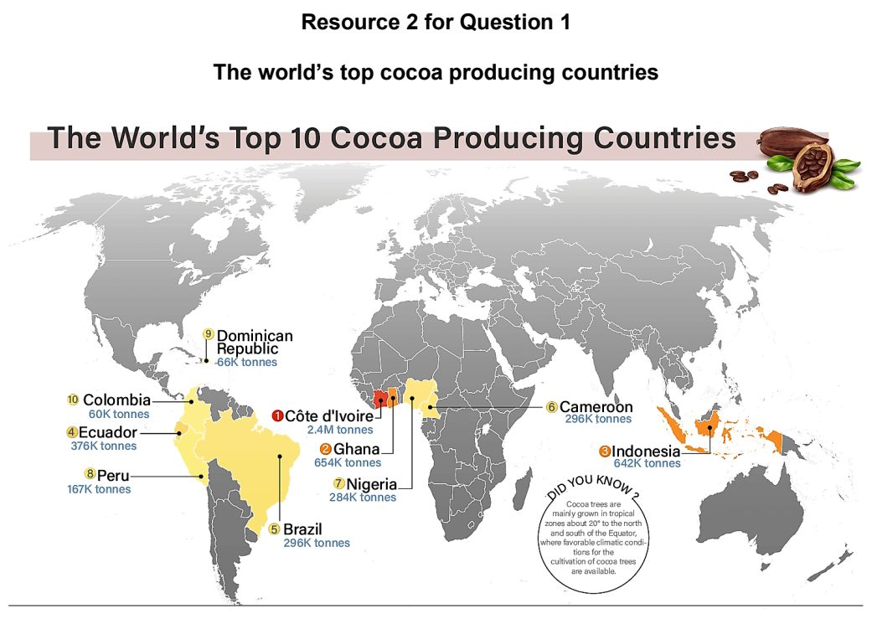

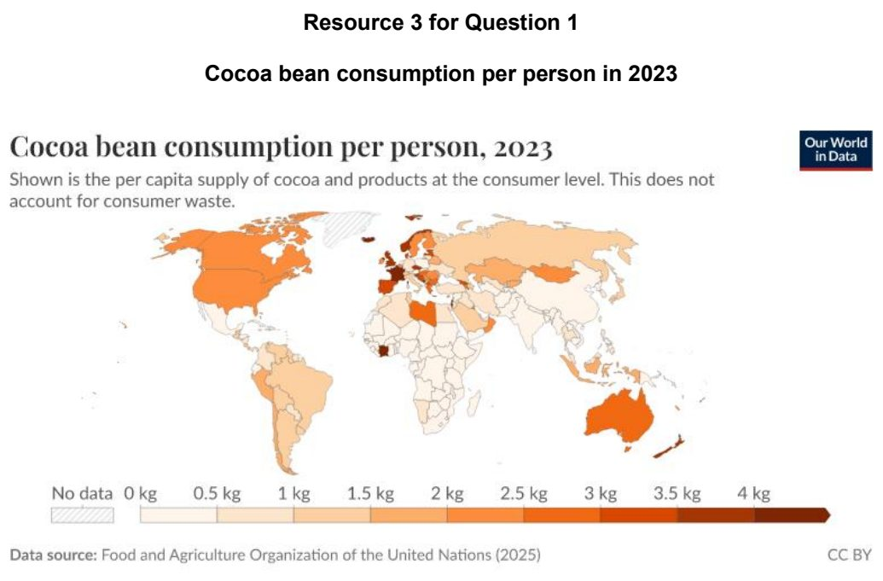

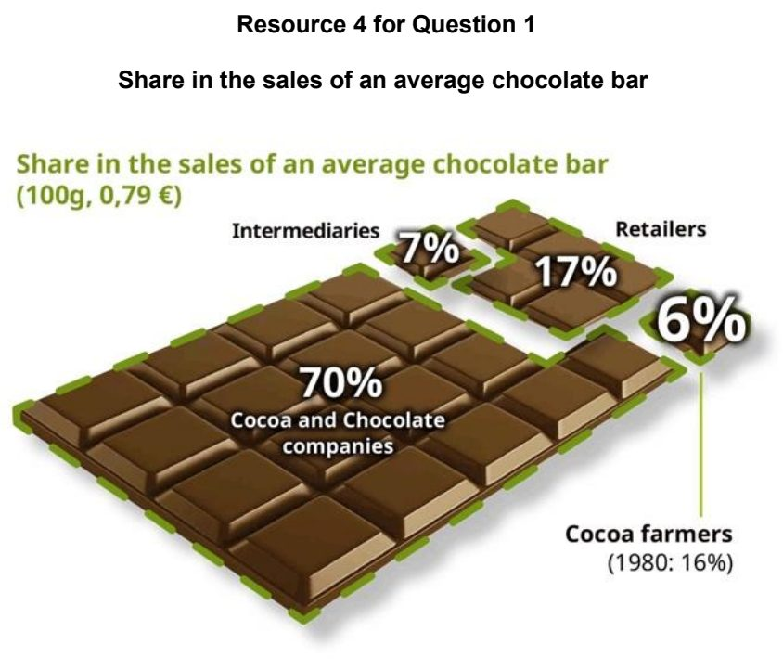

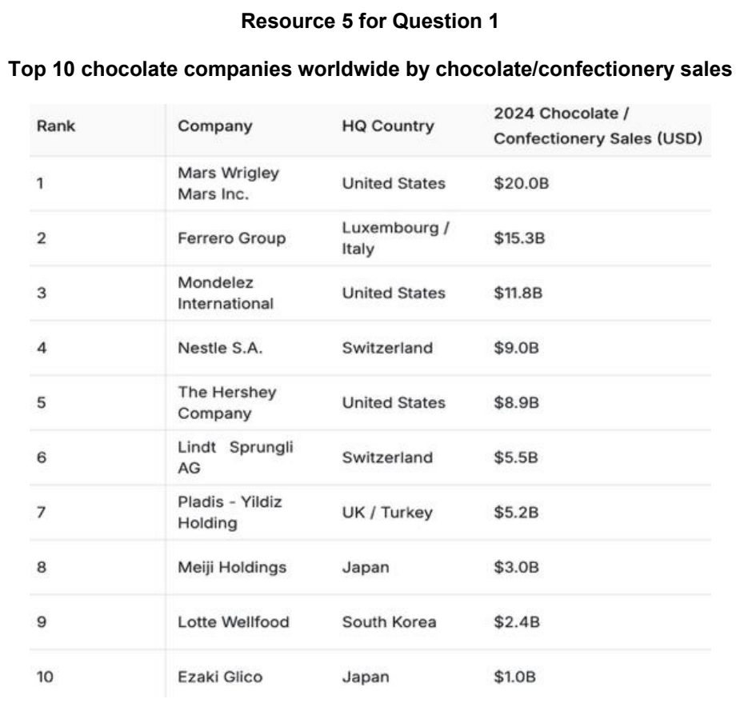

MI 2026 — H2 Paper 1 (9173/01), Q1 [30 marks]
Syllabus: 1.2.2b Geography of the Global Economy and TNCs – GPNs connecting places; 1.2.2c Geography of the Global Economy and TNCs – Impacts of GPNs on home & host; 1.1.3a Managing Resources – Renewable energy (solar, hydropower); 1.1.1c Understanding Sustainable Development – Challenges limiting SD; 1.1.3c Managing Resources – Extractive industries; 1.2.3a Relative Influence of Actors in Shaping the Global Economy – States; 1.2.3c Relative Influence of Actors in Shaping the Global Economy – Multilateral institutions
Section A — Cluster 1: Global Development and Natural Resources
To date, BYD achieved record sales of 8.2 million vehicles globally. Resource 1 shows an BYD’s Global Production Network (GPN) across China, Southeast Asia, Europe and the Americas. Resource 2 shows a photograph of BYD’s Mega Base in Zheng Zhou, China. Resource 3 shows an infographic depicting the additional tariffs applied to newly imported Chinese electric vehicles to the European Union in 2024 by the European Commission. Resource 4 shows the key minerals used in producing an electric vehicle battery. Resource 5 shows an infographic of the world’s largest dams and their impacts.
(a) Explain the challenges limiting the progress towards sustainable development. [4]
(b) Using Resource 1, describe the ways by which BYD’s GPN connects places within the global economy through flows of materials and capital. [6]
(c) With reference to Resources 1 and 2, explain positive and negative impacts that GPNs of TNCs, like BYD, on host economies. [6]
(d) Using Resources 2 and 3, explain the influence of states and multilateral institutions on TNCs’ operations. [4]
(e) With reference to Resource 4, suggest the economic and environmental impacts that extractive industries have on places. [4]
(f) Explain the limitations and trade-offs of alternative energy sources in providing energy security as shown in Resources 5. [6]

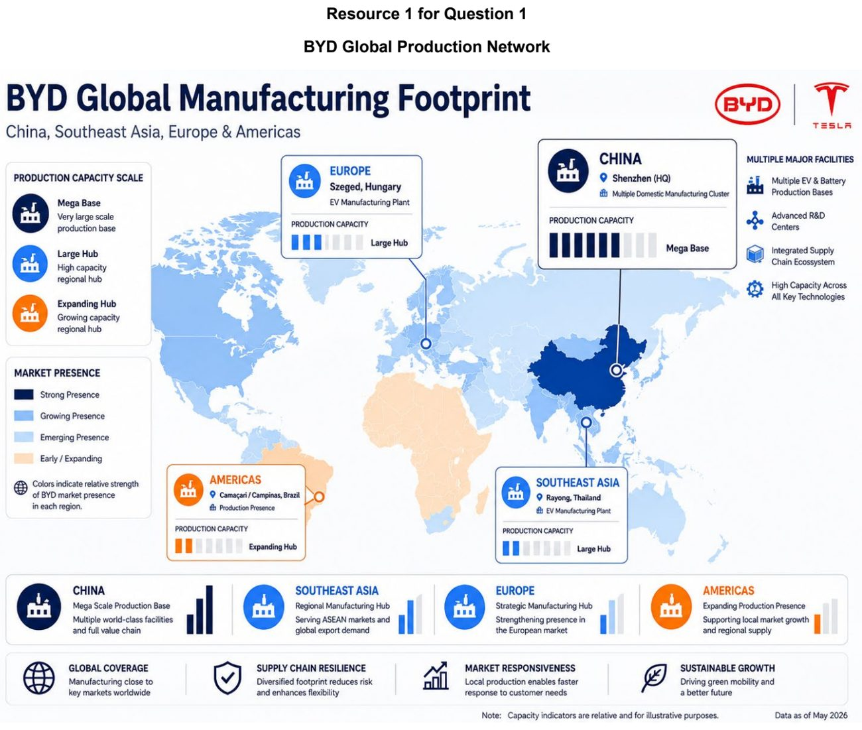

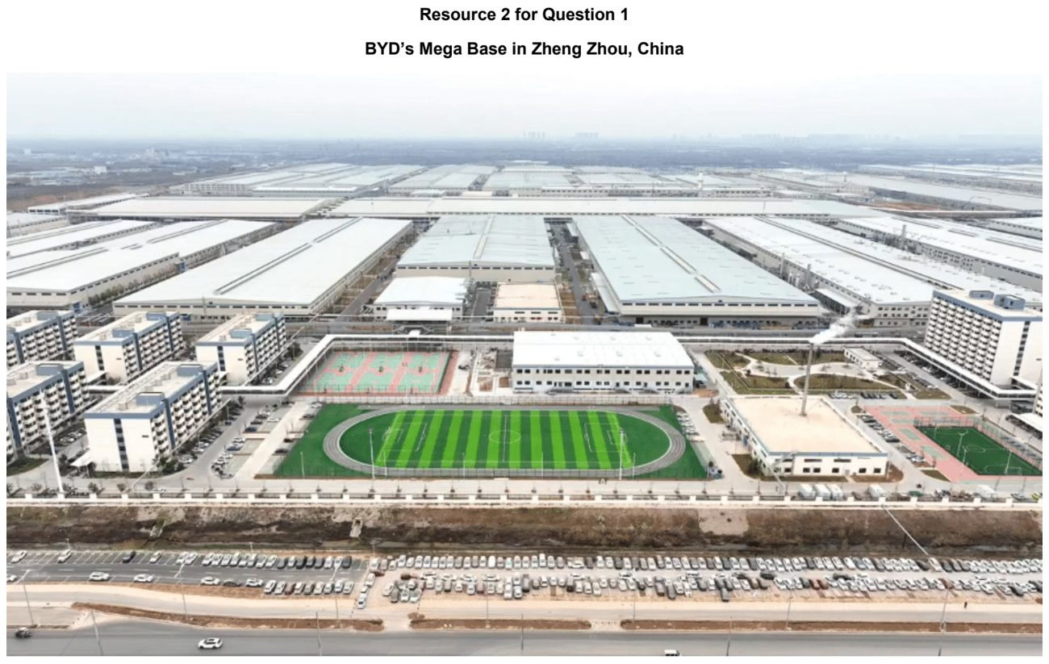

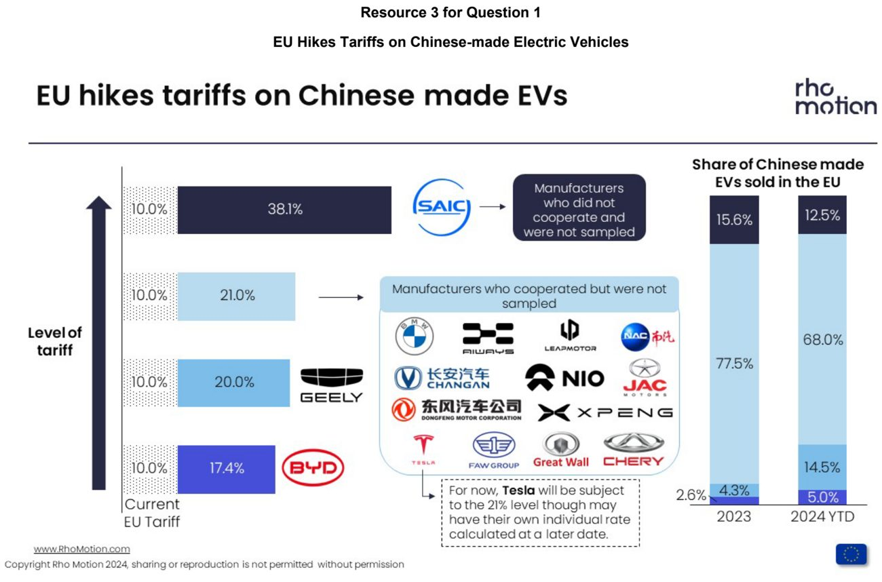

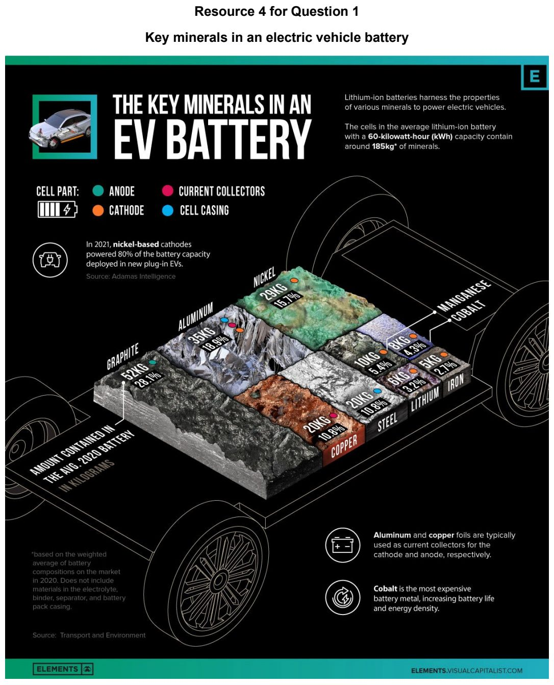

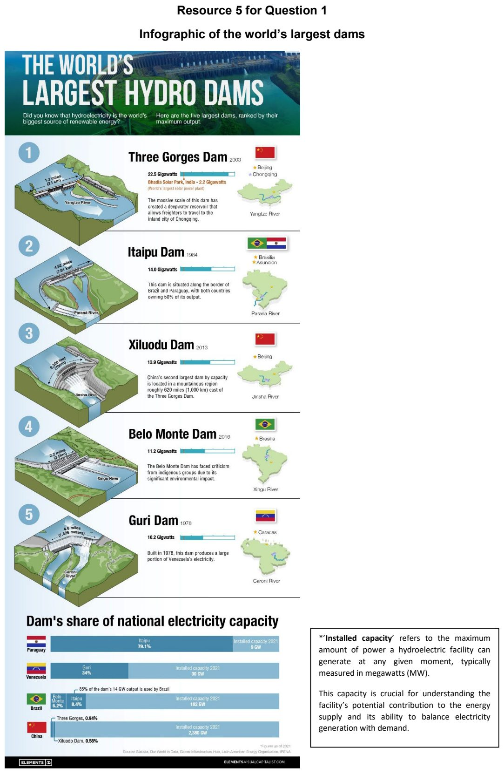

NJC 2026 — H2 Paper 1 (9173/01), Q1 [30 marks]
Syllabus: 1.2.2b Geography of the Global Economy and TNCs – GPNs connecting places; 1.2.2c Geography of the Global Economy and TNCs – Impacts of GPNs on home & host; 1.1.2b Environment and Resources – Supply of provisioning services (reserves); 1.1.3c Managing Resources – Extractive industries; 1.1.1b Understanding Sustainable Development – Measuring progress (SDGs, indicators)
Section A — Cluster 1: Global Development and Natural Resources
Boeing is an aerospace transnational corporation (TNC) based in the USA. It is involved in the design, manufacture and servicing of commercial aircraft. Its operations depend on specialised component suppliers, service locations and access to raw materials such as titanium. Ilmenite is the main ore from which titanium is obtained. Resource 1 shows selected global suppliers of major Boeing aircraft components. Resource 2 shows the locations of selected Boeing operations. Resource 3 shows ilmenite production and reserves in selected countries in 2006. Resource 4 shows the location where 1 million cubic metres of wastewater from ilmenite mining was released from the Rio Tinto QMM mine in southeastern Madagascar on 5 March 2022.
(a) Using Resources 1 and 2, describe Boeing’s global production network. [5]
(b) With reference to Resources 1 and 2, suggest reasons for Boeing’s global production network. [5]
(c) Compare ilmenite production and reserves for the countries shown in Resource 3. [5]
(d) Explain the socio-economic impacts of TNCs’ decisions on labour in host countries. [6]
(e) With reference to Resource 4, suggest possible impacts that the release of mine wastewater could have had in southeastern Madagascar. [5]
(f) Explain the difficulties that some countries may face in measuring progress towards sustainable development. [4]

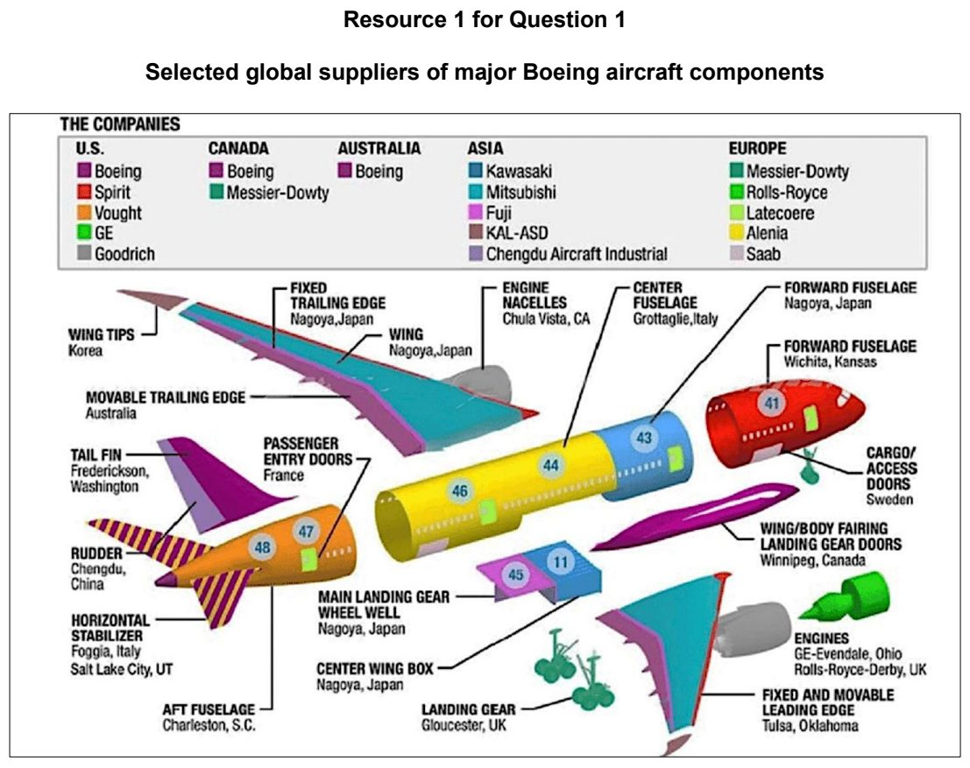

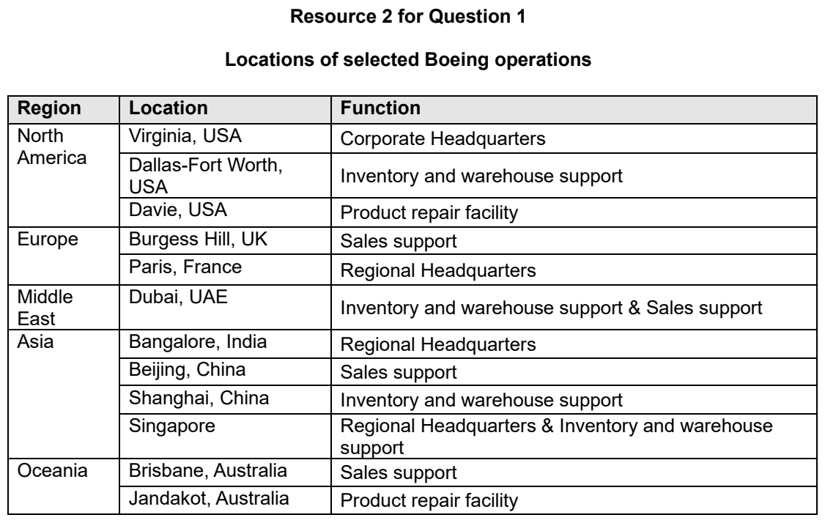

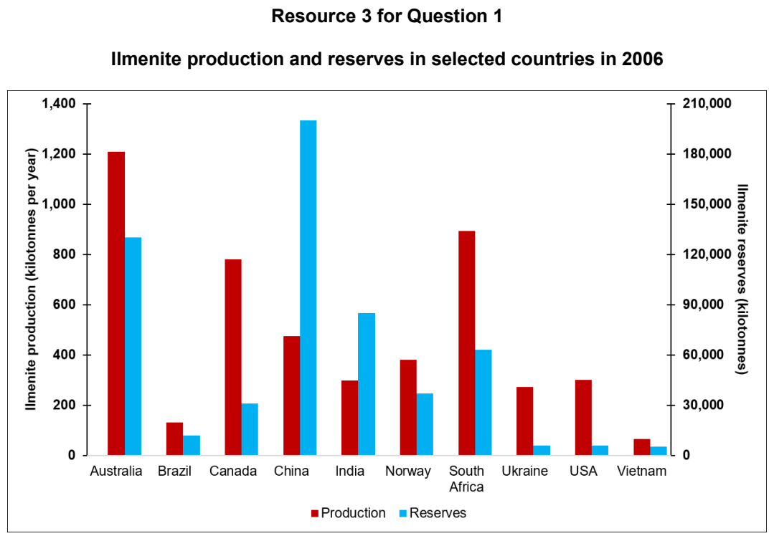

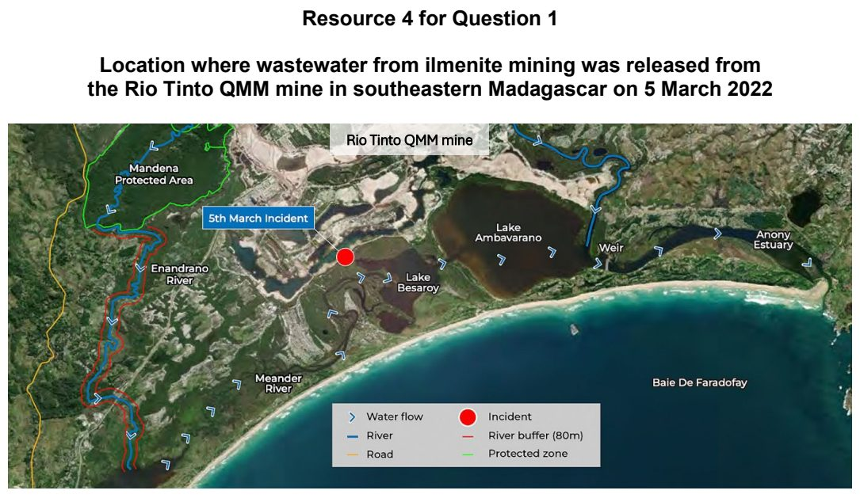

NYJC 2026 — H2 Paper 1 (9173/01), Q1 [30 marks]
Syllabus: 1.2.1a Development – Variations in development; 1.2.1b Development – Trade, capital & labour flows; 1.2.1c Development – Shifts in economic structure
Section A — Cluster 1: Global Development and Natural Resources
Resource 1 shows two photographs depicting the educational infrastructure disparities in ASEAN. Resource 2 shows the employment share by sector in selected ASEAN economies in 1990 and 2022. Resource 3 shows the intra-ASEAN trade flows in USD billions alongside export and import shares. Resource 4 is an excerpt of a news article on poverty reduction and social disparities in ASEAN.
(a) Using Resource 1, describe the differences in the educational environments shown in Photo A and Photo B. [4]
(b) Account for the variations in the educational infrastructure across ASEAN member states. [4]
(c) Using Resource 2, compare the changes in the structural economic composition among the selected ASEAN countries between 1990 and 2022. [5]
(d) Using Resource 3, describe the patterns of trade flows among ASEAN member states. [5]
(e) Using Resource 4, explain how spatial variations in development operate at both the regional scale (between ASEAN countries) and the national scale (within a country). [6]
(f) Explain how uneven flows of capital and labour contribute to spatial variations in levels of development among ASEAN countries. [6]

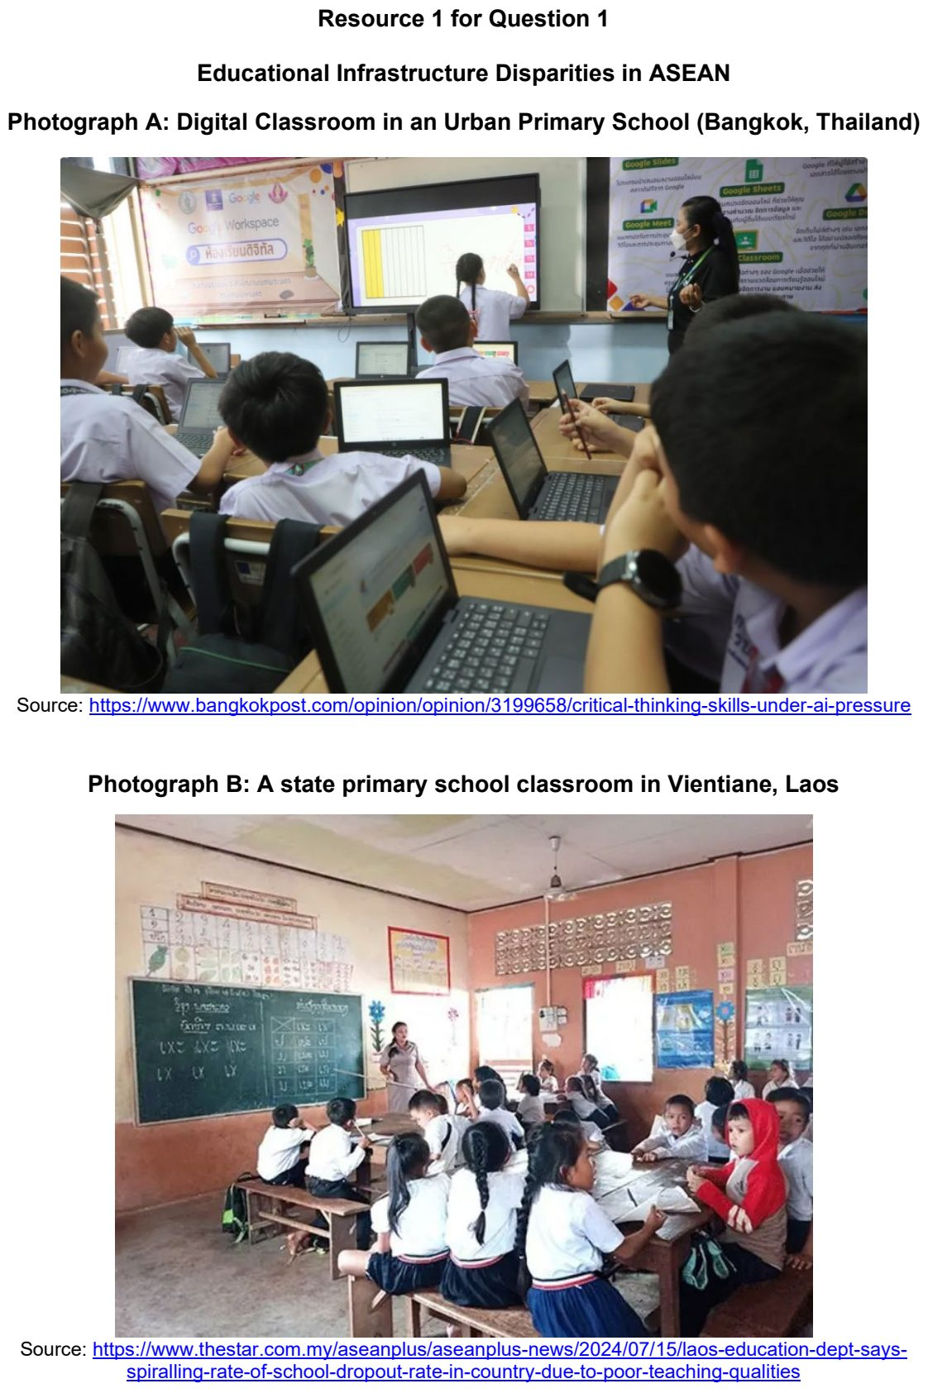

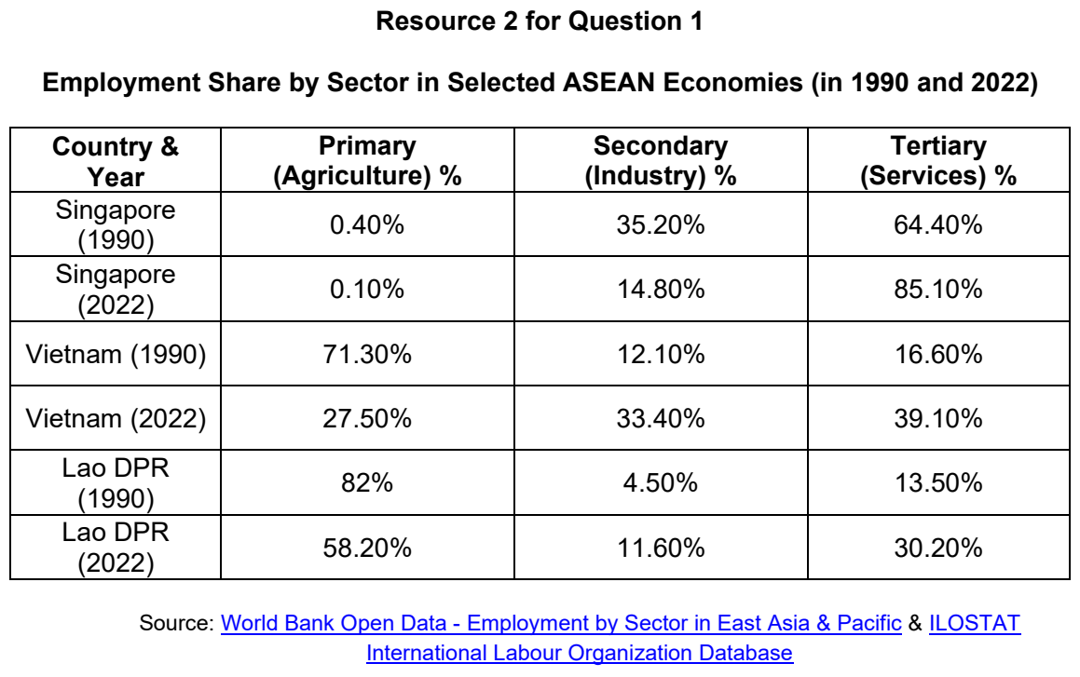

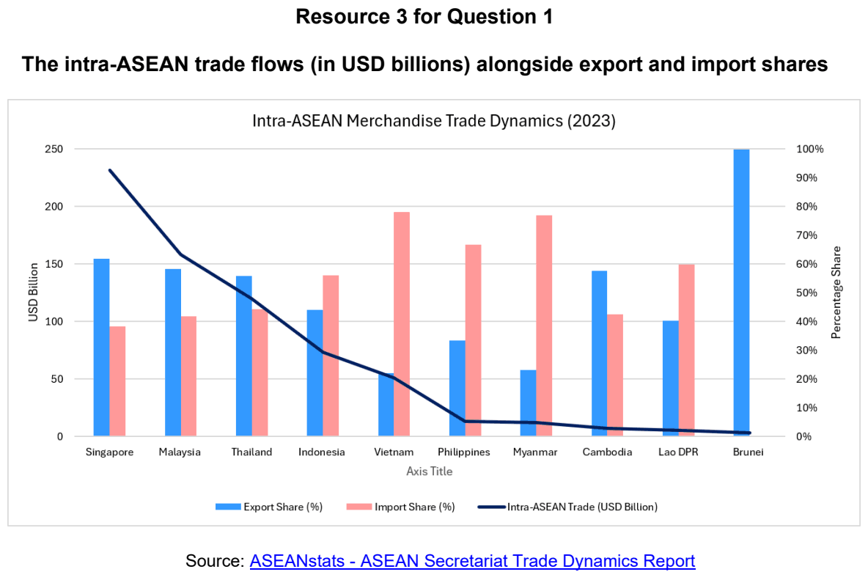

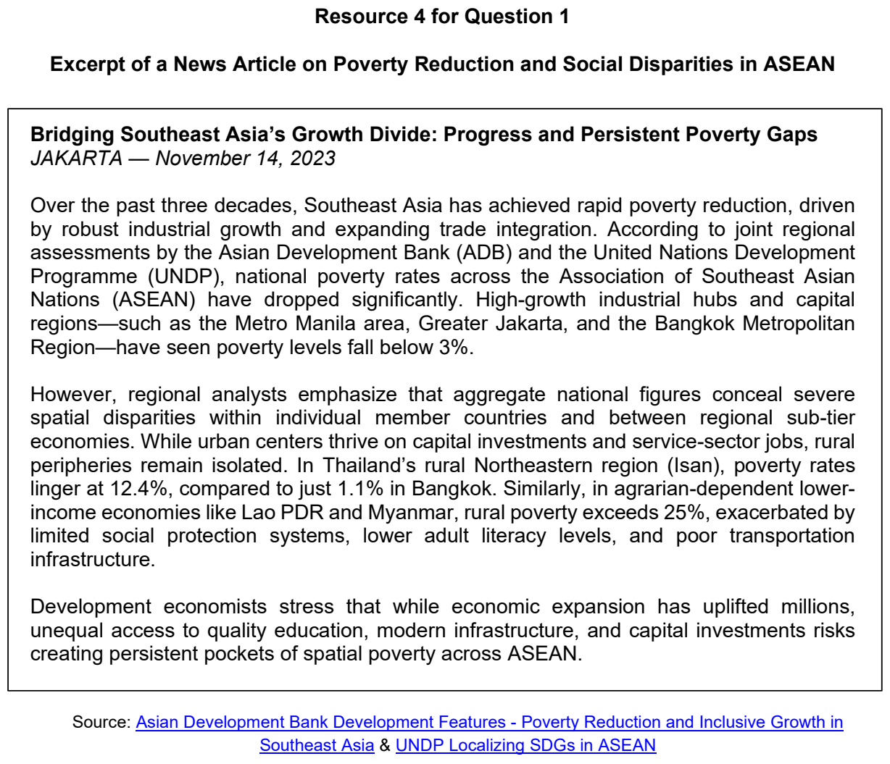

RI 2026 — H2 Paper 1 (9173/01), Q1 [30 marks]
Syllabus: 1.2.1c Development – Shifts in economic structure; 1.2.2b Geography of the Global Economy and TNCs – GPNs connecting places; 1.2.2c Geography of the Global Economy and TNCs – Impacts of GPNs on home & host; 1.1.1c Understanding Sustainable Development – Challenges limiting SD; 1.2.3a Relative Influence of Actors in Shaping the Global Economy – States; 1.1.3b Managing Resources – Transboundary water conflicts
Section A — Cluster 1: Global Development and Natural Resources
Resource 1 shows the changes in economic sectors of More Economically Developed Countries (MEDCs) and Less Economically Developed Countries (LEDC) from 1950 to 2020. Resource 2 shows the spatial distribution of Standard Chartered Bank. Resource 3 shows the map of the Colorado River Basin.
(a) Explain the challenges limiting the progress towards sustainable development for countries at lower levels of development. [4]
(b) Compare the changes in economic sectors of MEDCs and LEDCs from 1950 to 2020 shown in Resource 1. [6]
(c) Describe the spatial distribution of Standard Chartered Bank shown in Resource 2. [6]
(d) Using Resource 2, suggest how role of state may have influenced Standard Chartered Bank’s location of regional headquarters. [4]
(e) Explain the trade-offs in sustainable development of host economies brought upon by transnational corporations like Standard Chartered Bank. [6]
(f) With reference to Resource 3, explain why countries may experience conflict over water resources. [4]

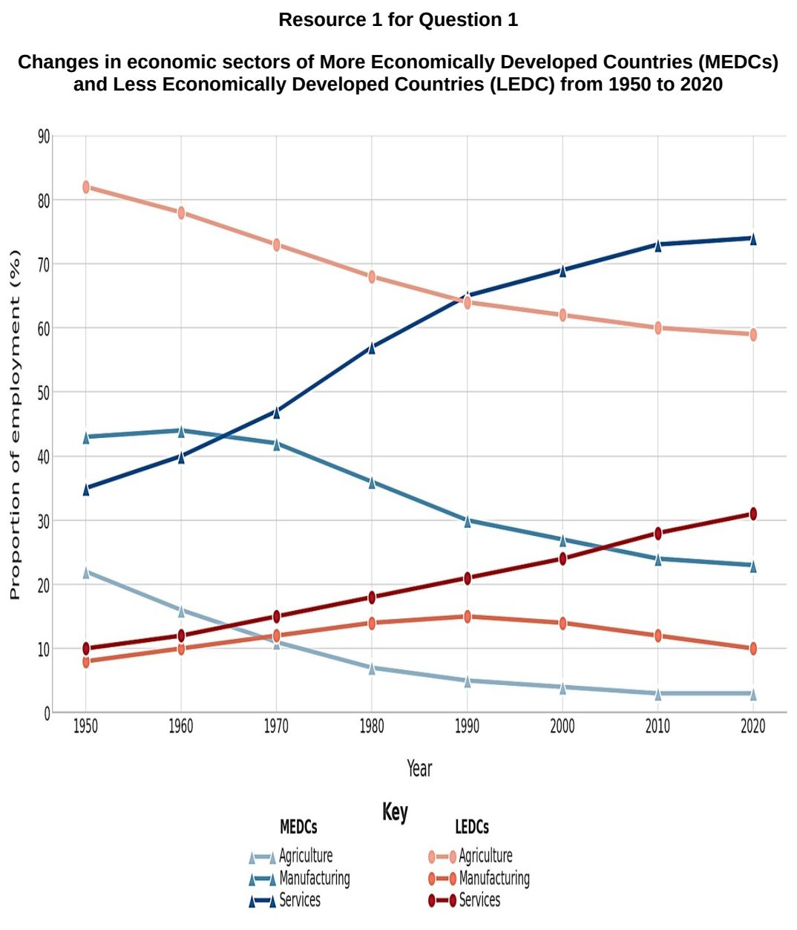

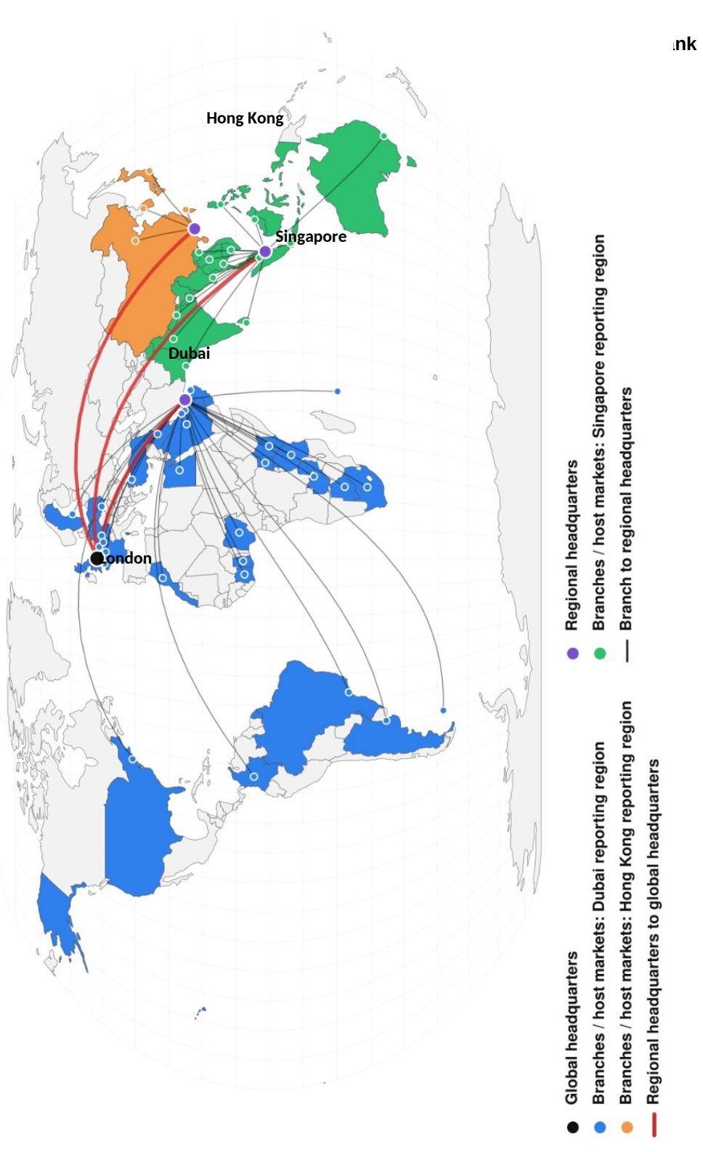

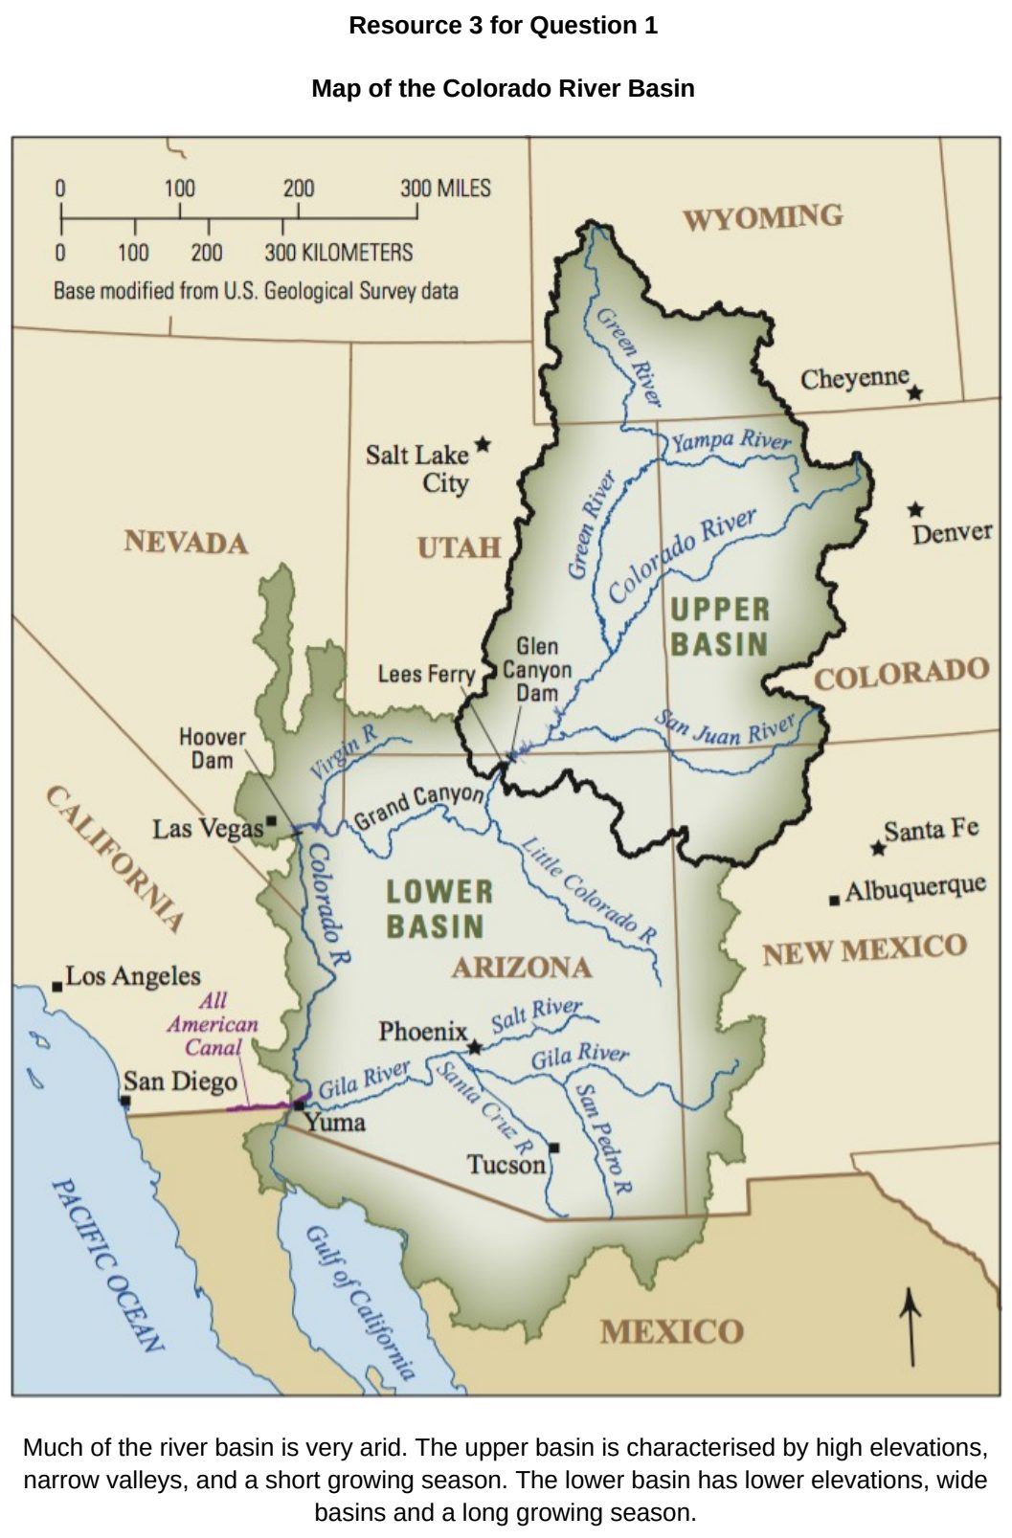

RVHS 2025 — H2 Paper 1 (9173/01), Q1 [30 marks]
Syllabus: 1.2.1a Development – Variations in development; 1.2.1b Development – Trade, capital & labour flows; 1.2.3c Relative Influence of Actors in Shaping the Global Economy – Multilateral institutions; 1.2.2a Geography of the Global Economy and TNCs – Interconnectedness through flows; 1.2.3b Relative Influence of Actors in Shaping the Global Economy – Labour
Section A — Cluster 1: Global Development and Natural Resources
Resource 1 shows GDP* and growth rates of ASEAN member states in 2021. Resource 2 shows service sector employment and mortality* rates of children under 5 for ASEAN member states in 2021. Resource 3 shows the percentage share of total imports and exports of goods by ASEAN member states in 2021. Resource 4 shows the spatial structure of vehicle production, exports and sales by Toyota, a transnational corporation (TNC).
(a) Citing data from Resource 1, compare the ranking of GDP and growth rates shown in the two tables. [4]
(b) Cite data from Resource 2 to describe the levels of development of ASEAN member states. [5]
(c) Cite data from Resource 3 to describe ASEAN member states’ percentage share of total imports and exports of goods. [6]
(d) With reference to Resource 4, explain how Toyota’s spatial structure shows the interconnectedness of the world. [5]
(e) In what ways can multilateral institutions like ASEAN influence the operations and locational decisions of TNCs? [6]
(f) Explain the influence of TNCs on labour. [4]

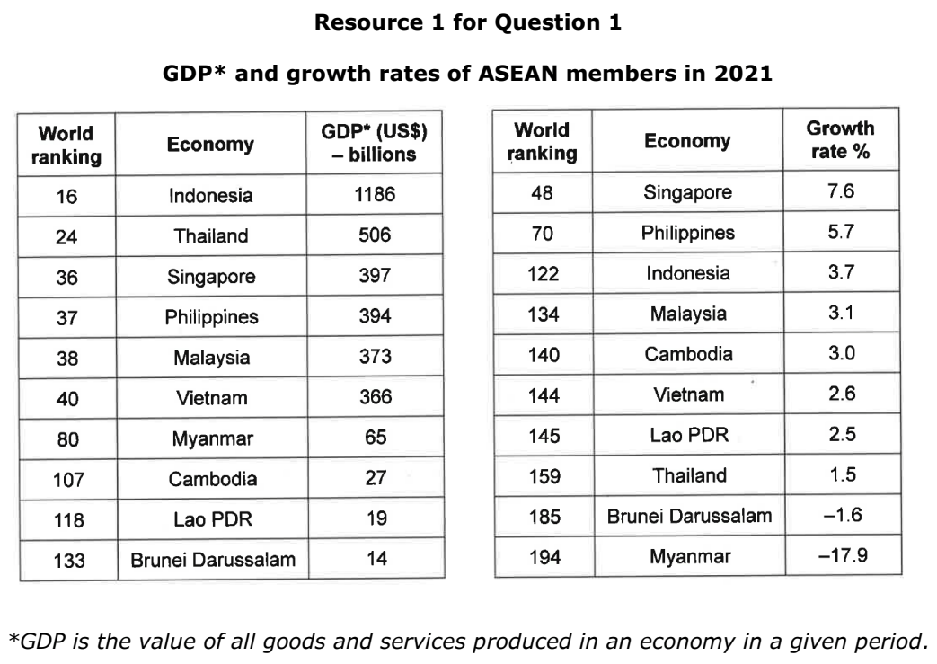

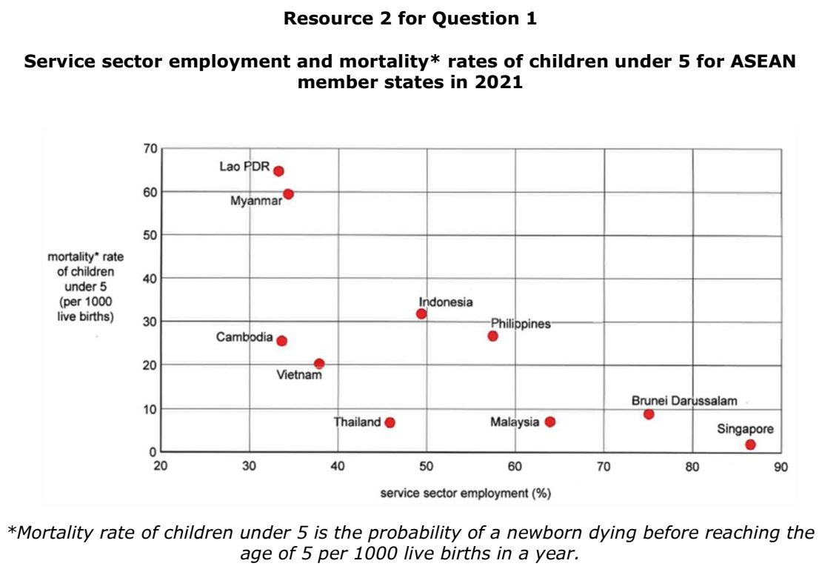

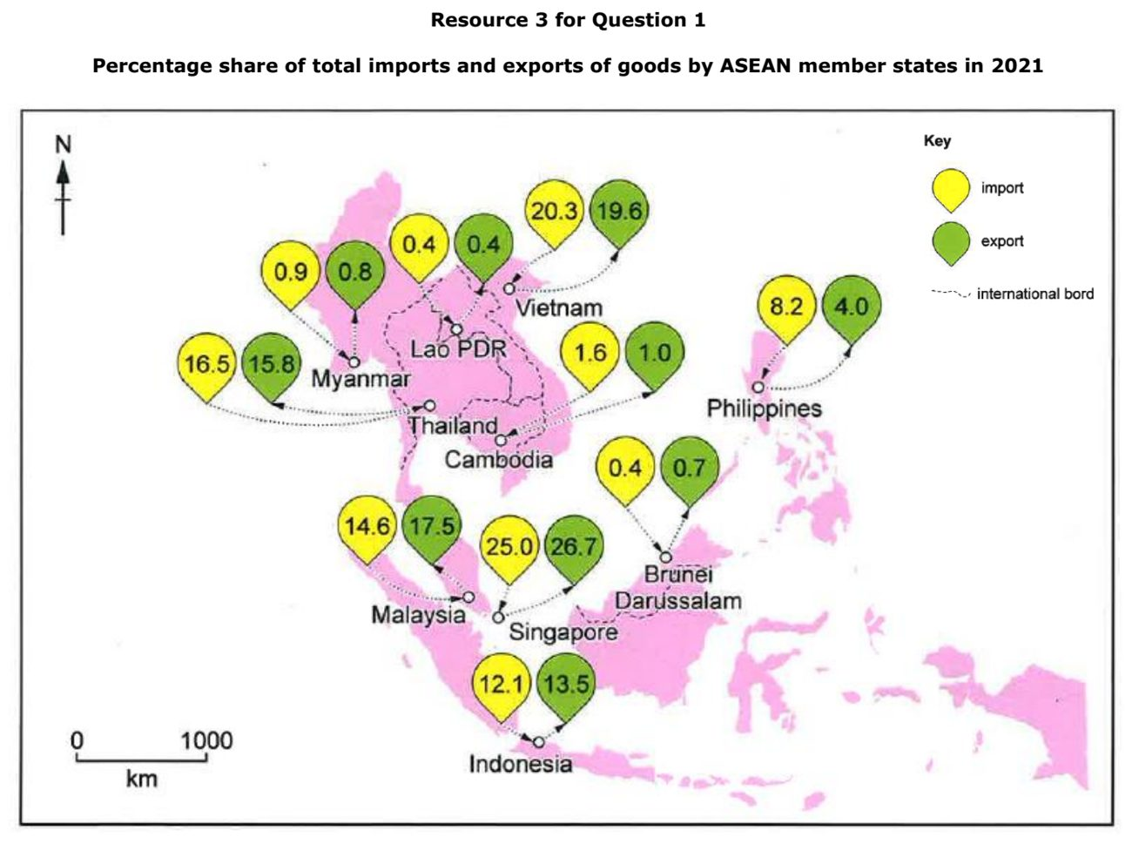

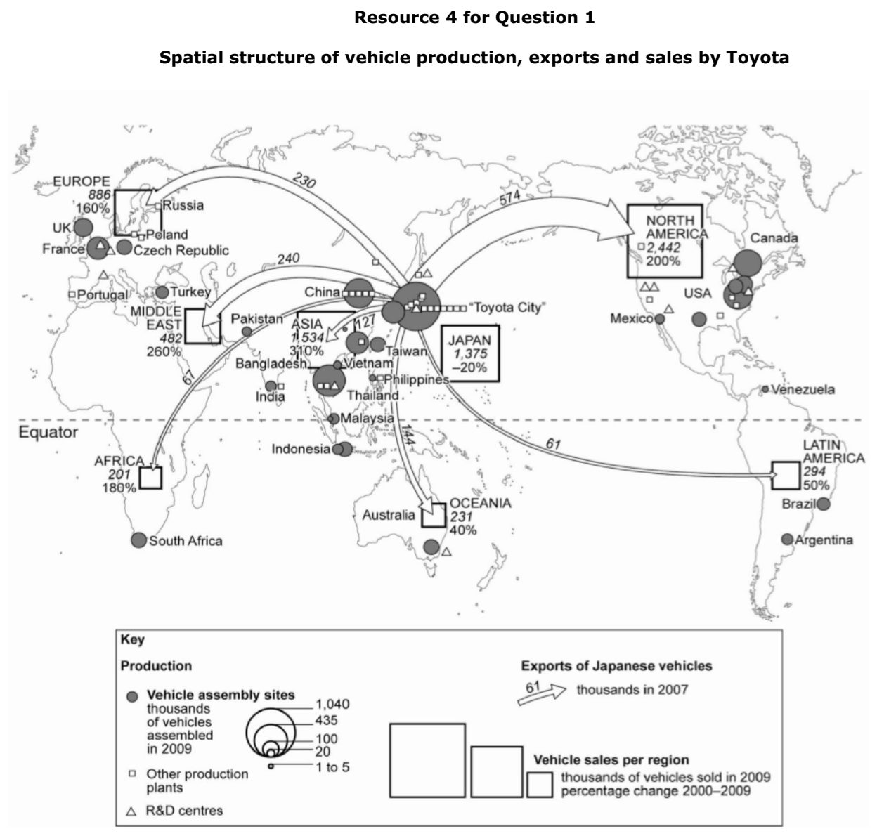

RVHS 2026 — H2 Paper 1 (9173/01), Q1 [30 marks]
Syllabus: 1.2.2c Geography of the Global Economy and TNCs – Impacts of GPNs on home & host; 1.2.2b Geography of the Global Economy and TNCs – GPNs connecting places; 1.2.3a Relative Influence of Actors in Shaping the Global Economy – States; 1.2.2a Geography of the Global Economy and TNCs – Interconnectedness through flows
Section A — Cluster 1: Global Development and Natural Resources
Outsourcing and offshoring of industries and services form part of the wider global shift towards Asia. Bengaluru in southern India has been a popular location for the outsourcing and offshoring of information technology (IT), manufacturing and services by transnational corporations (TNCs) from India, the UK, Europe and the USA for several decades. Resource 1A shows some reasons why IT TNCs have been attracted to Bengaluru, whilst Resource 1B shows some opinions about costs and benefits of offshoring and outsourcing industry to Bengaluru. Resource 2 illustrates the value of international trade per capita (in US$) across selected countries in 2019. Resource 3 shows Apple’s supply chain by number of suppliers across different regions in 2023 and 2024. Resource 4 is a 2026 extract from Apple’s annual accounting of the working and environmental conditions in its supply chain, often in developing nations where enforcement of labour laws and environmental regulations is weak.
(a) Using Resource 1, explain how the IT TNCs have impacted the sustainable development of Bengaluru? [7]
(b) Using Resource 2, explain one strength and one limitation of using international trade per capita to illustrate interconnectedness within the global economy. [4]
(c) Explain how states can influence patterns of international trade. [6]
(d) Cite data from Resource 3 to describe the changes in Apple’s supplier distribution across different regions between 2023 and 2024. [4]
(e) With reference to Resource 3, suggest reasons for the changes in Apple’s suppliers from 2023 to 2024. [4]
(f) Using Resource 4, explain how Apple’s management of its supply chain may affect labour conditions in developing countries. [5]

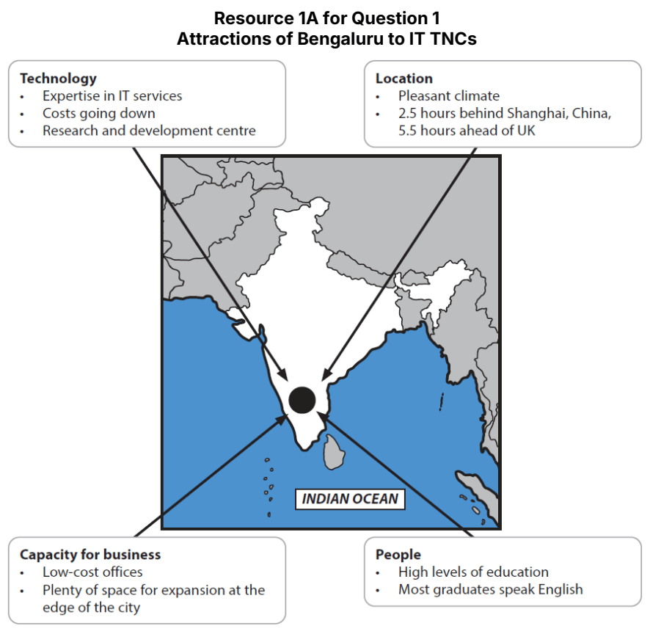

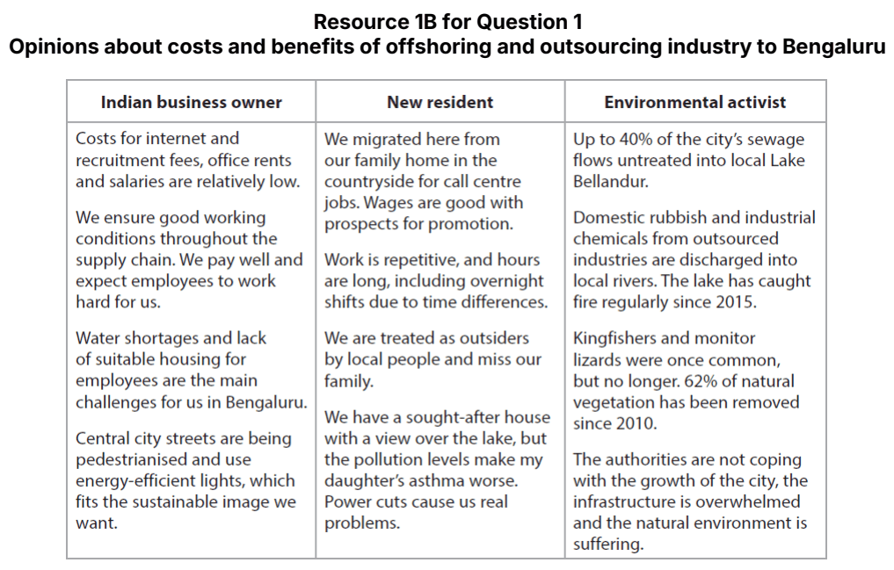

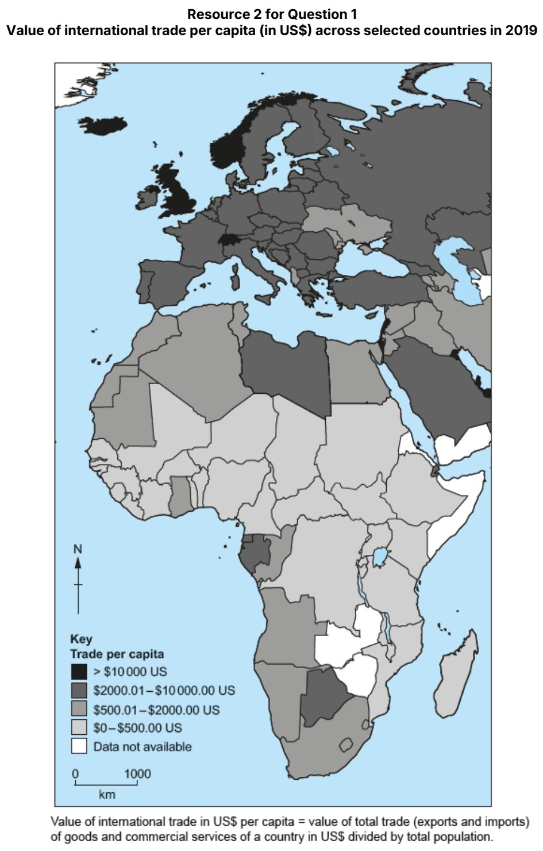

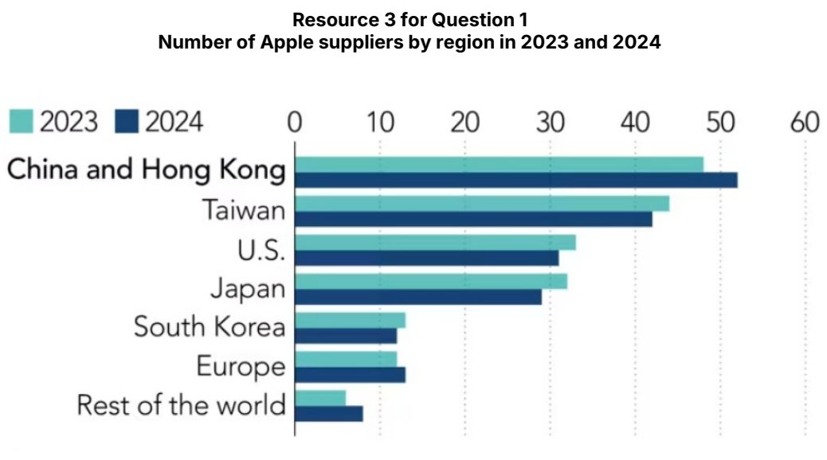

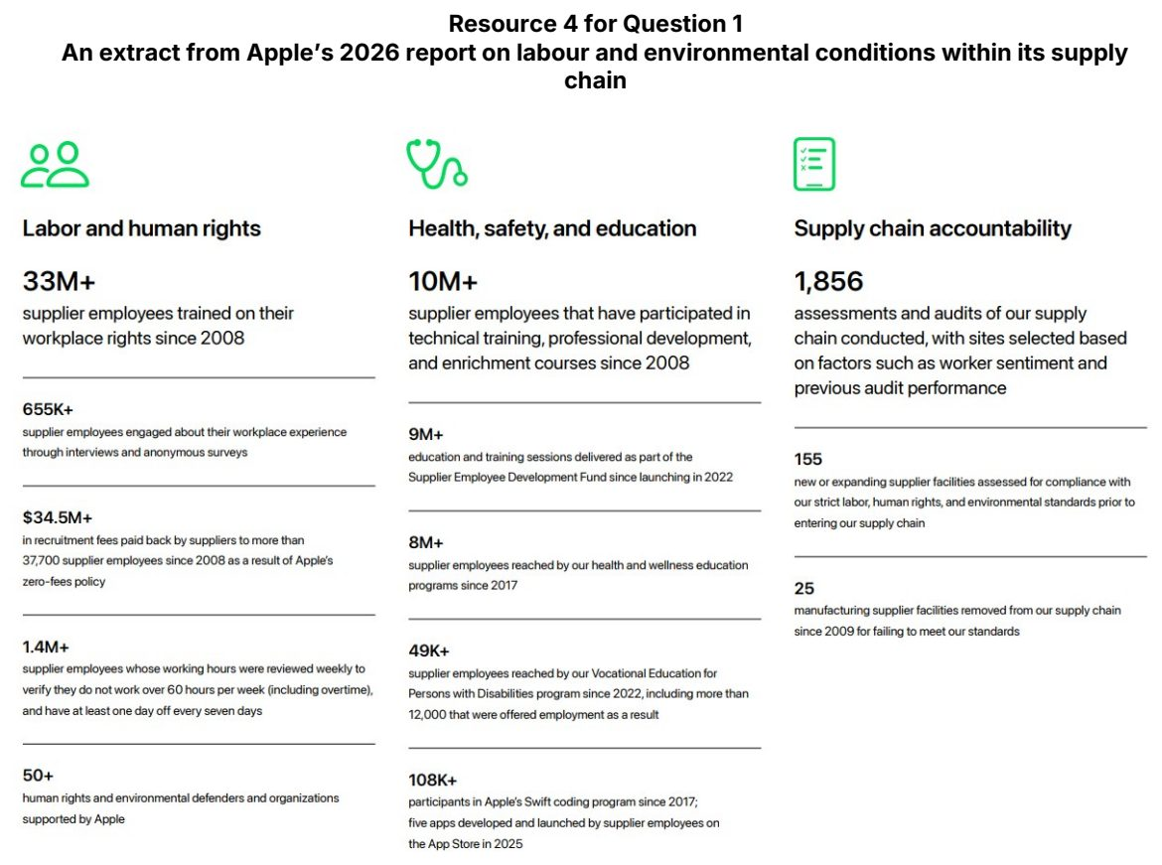

SAJC 2025 — H2 Paper 1 (9173/01), Q1 [30 marks]
Syllabus: 1.2.2a Geography of the Global Economy and TNCs – Interconnectedness through flows; 1.2.2c Geography of the Global Economy and TNCs – Impacts of GPNs on home & host; 1.2.3b Relative Influence of Actors in Shaping the Global Economy – Labour; 1.1.2c Environment and Resources – Population & resources (Malthus, Boserup); 1.1.2a Environment and Resources – Ecosystem services; 1.1.2b Environment and Resources – Supply of provisioning services (reserves)
Section A — Cluster 1: Global Development and Natural Resources
Resource 1 shows the top 5 exporters of cocoa and their total export value. Resource 2 shows information about cocoa cultivation. Resource 3 shows the impact of climate change on cocoa production.
(a) Describe the patterns observed in the import and export of cocoa beans as shown in Resource 1. [6]
(b) Using Resources 1 and 2, explain the impact of the chocolate industry on the places within its supply chain. [6]
(c) Using Resource 2, explain how cocoa cultivation provides support for Boserup’s perspective on the relationship between population and resources. [4]
(d) Explain how labour affects the global economy. [6]
(e) Differentiate between provisioning and cultural ecosystem services. [4]
(f) Using Resources 2 and 3, explain how the renewability of cocoa beans may change over time. [4]

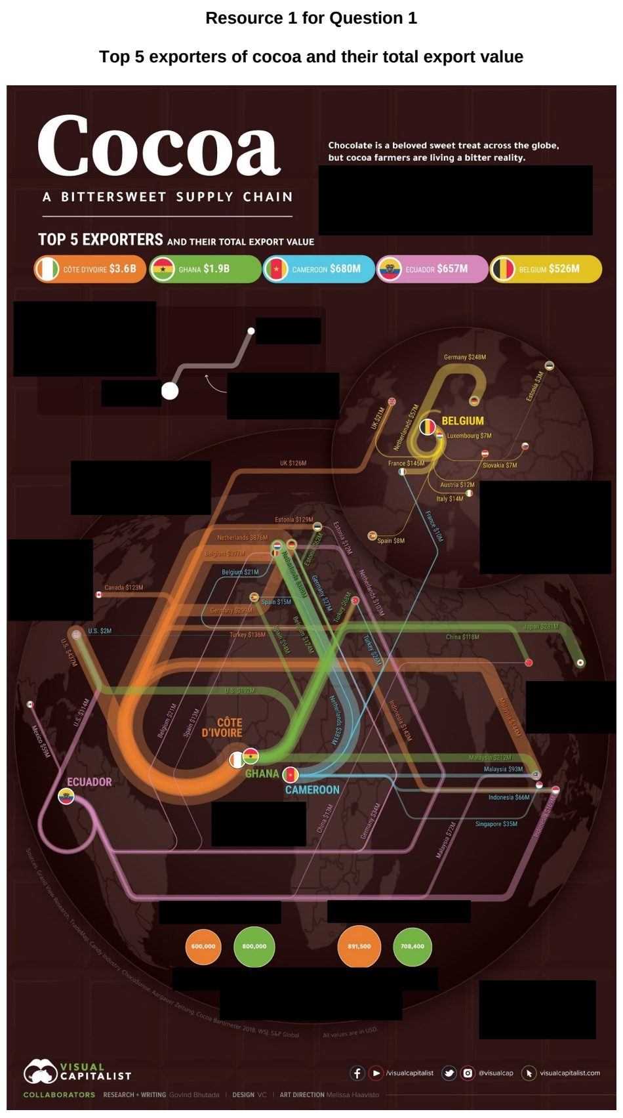

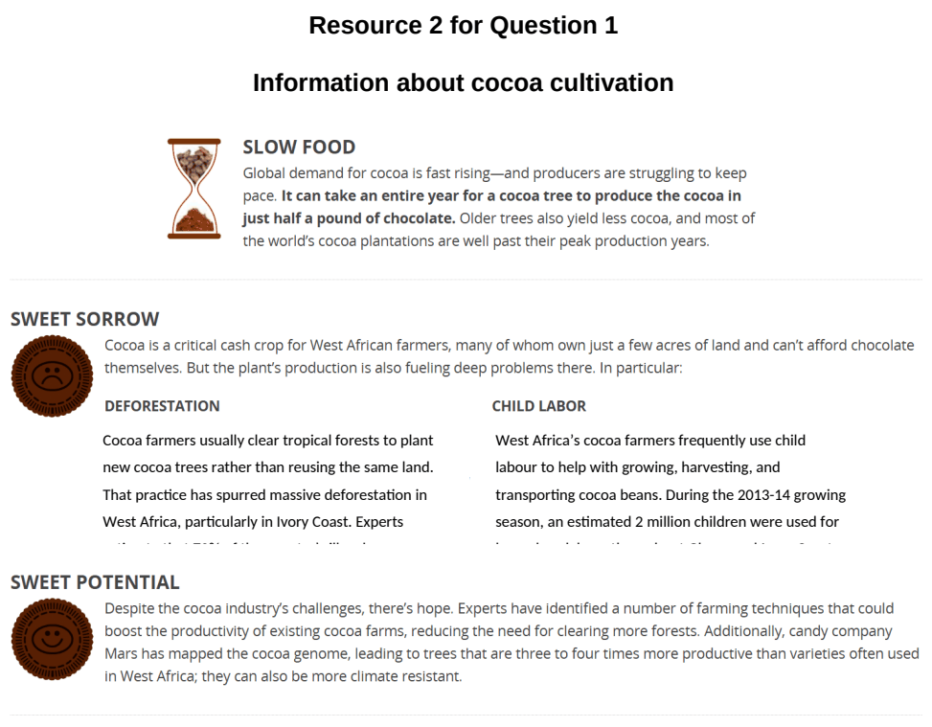

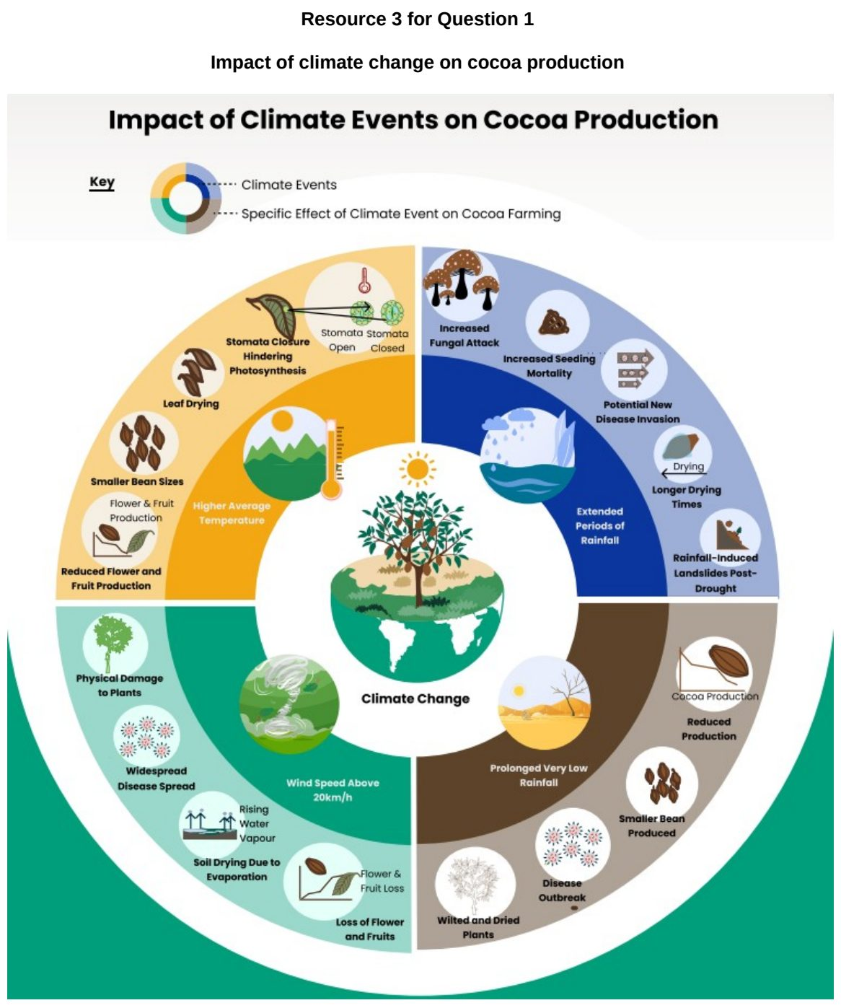

SAJC 2026 — H2 Paper 1 (9173/01), Q1 [30 marks]
Syllabus: 1.2.2b Geography of the Global Economy and TNCs – GPNs connecting places; 1.2.2c Geography of the Global Economy and TNCs – Impacts of GPNs on home & host; 1.2.2a Geography of the Global Economy and TNCs – Interconnectedness through flows; 1.2.3c Relative Influence of Actors in Shaping the Global Economy – Multilateral institutions
Section A — Cluster 1: Global Development and Natural Resources
Resource 1 shows the global distribution of Apple’s suppliers by country in 2023. Resource 2 shows the number of Apple suppliers in Southeast Asia by country from 2020 to 2024. Resource 3 shows the operational structure of Apple’s global production network (GPN). Resource 4 shows an excerpt on Apple’s GPN and host economies.
(a) Using Resource 1, describe the spatial distribution of Apple’s global suppliers in 2023. [4]
(b) Using Resource 2, compare the growth in the number of Apple suppliers in Malaysia and Indonesia between 2020 to 2024. [4]
(c) With reference to Resource 3, explain how the GPN of a TNC such as Apple contributes to the connectedness of places within the global economy. [6]
(d) Suggest reasons for the increasing economic interdependence between places in the global economy. [5]
(e) With reference to Resource 4, explain the impacts of the GPNs of TNCs such as Apple on host economies. [6]
(f) Explain how multilateral institutions can influence the locational decisions and operations of TNCs. [5]

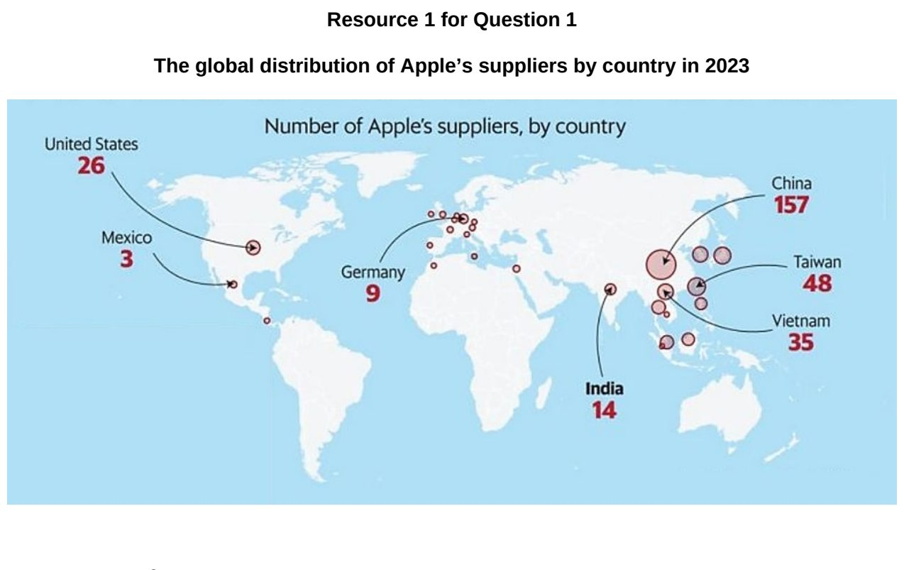

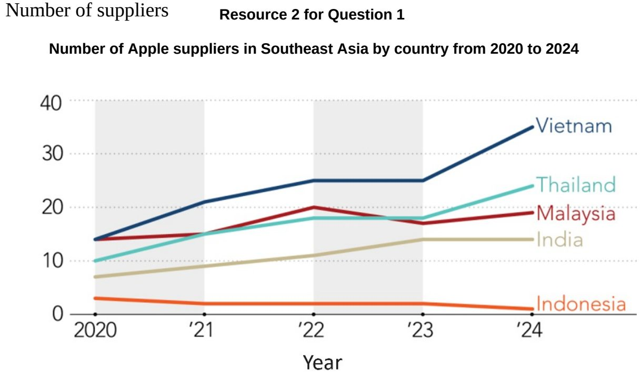

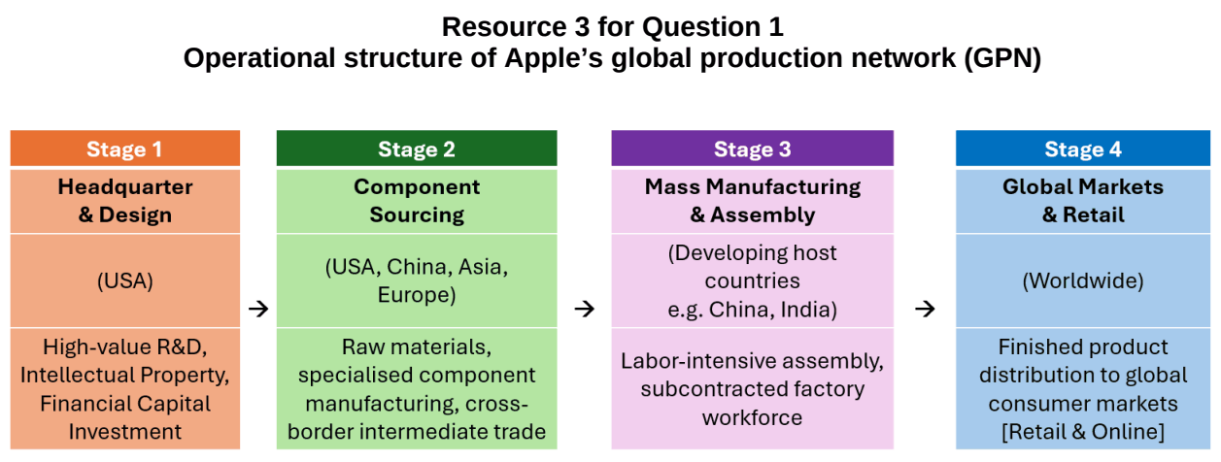

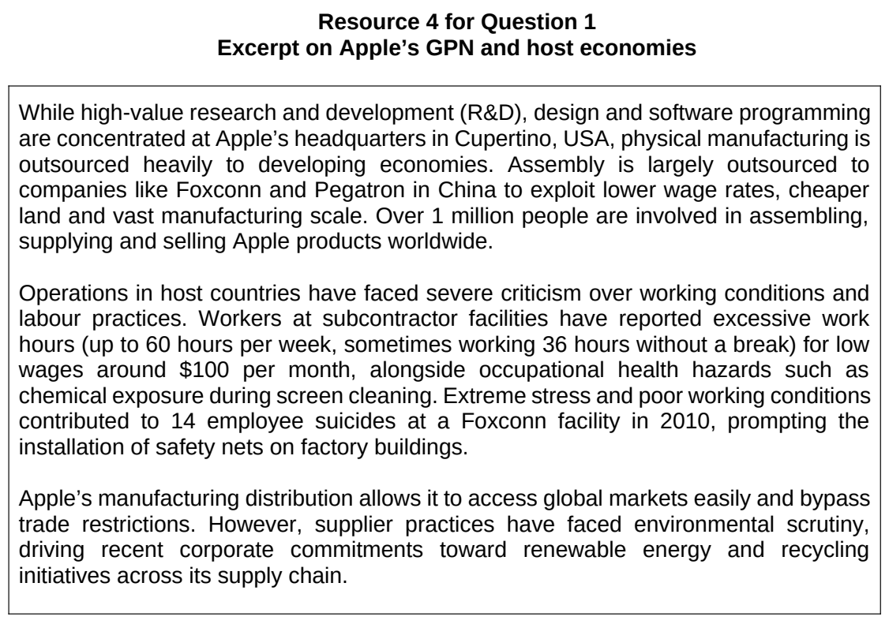

TJC 2026 — H2 Paper 1 (9173/01), Q1 [30 marks]
Syllabus: 1.2.1c Development – Shifts in economic structure; 1.2.2b Geography of the Global Economy and TNCs – GPNs connecting places; 1.2.2a Geography of the Global Economy and TNCs – Interconnectedness through flows; 1.2.1b Development – Trade, capital & labour flows; 1.2.3c Relative Influence of Actors in Shaping the Global Economy – Multilateral institutions
Section A — Cluster 1: Global Development and Natural Resources
Resource 1 shows the flows of waste generated by global production networks (GPNs) in 2016. Resource 2 shows foreign direct investment (FDI) inflows by regions in 1990 and 2025. Resource 3 shows the production network for Apple, a technology transnational corporation headquartered in USA. Resource 4 shows the employment structure for selected countries.
(a) Describe the pattern of waste flows shown in Resource 1. [6]
(b) Explain the shifts in global patterns of manufacturing and services since the 1950s. [6]
(c) Compare the FDI inflow across regions between 1990 and 2025 shown in Resource 2. [5]
(d) Explain how Apple’s production network shown in Resource 3 demonstrates interconnectedness within the global economy. [6]
(e) Using Resource 4, compare the employment structures between developed and developing economies. [3]
(f) Using examples, explain two ways in which the World Trade Organisation (WTO) has benefitted developing economies. [4]

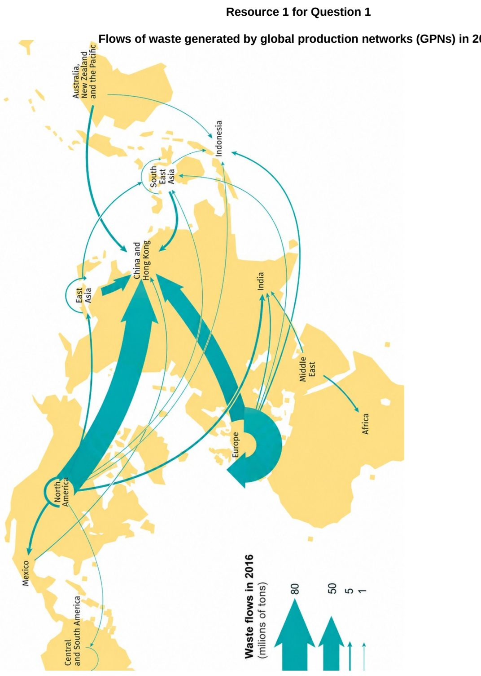

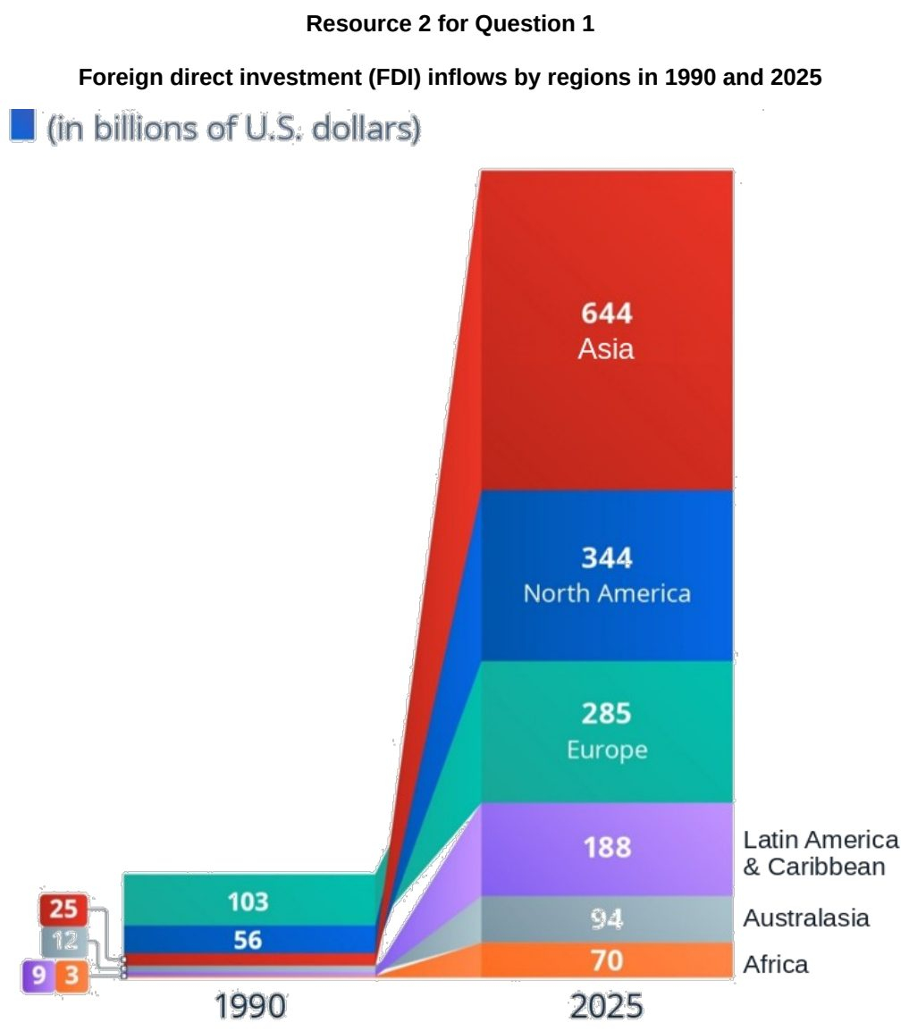

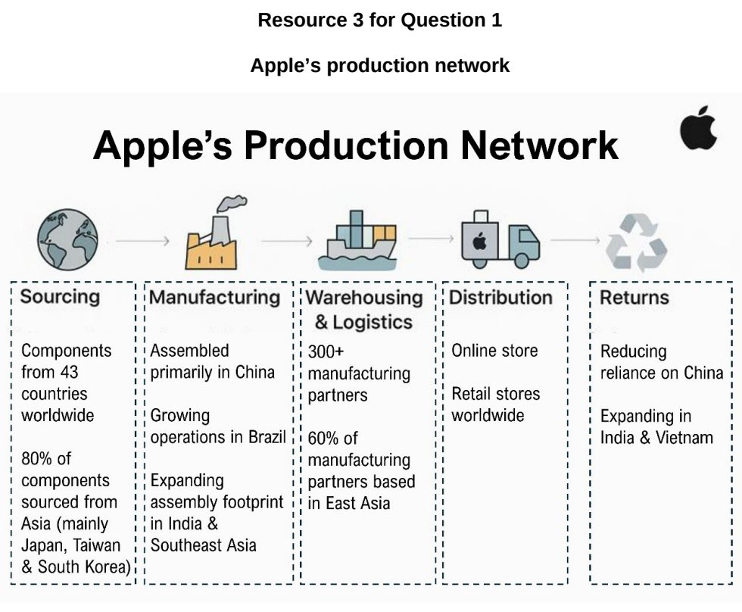

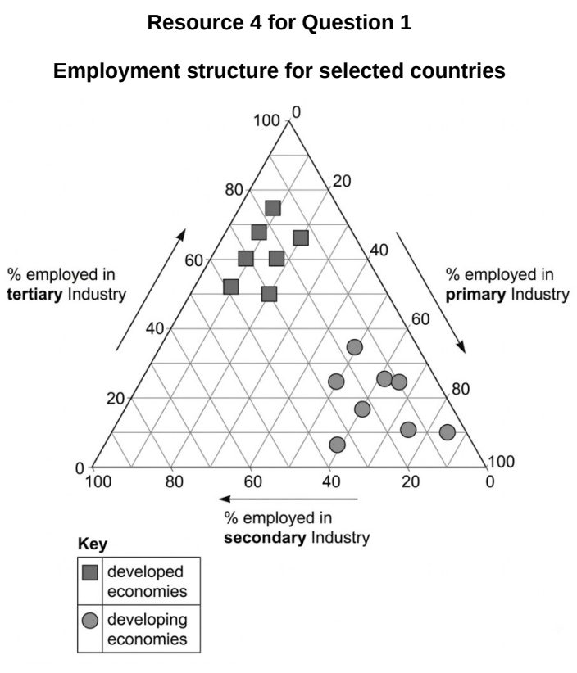

TMJC 2025 — H2 Paper 1 (9173/01), Q1 [30 marks]
Syllabus: 1.2.1a Development – Variations in development; 1.2.1b Development – Trade, capital & labour flows; 1.2.3a Relative Influence of Actors in Shaping the Global Economy – States; 1.1.1c Understanding Sustainable Development – Challenges limiting SD; 1.1.1b Understanding Sustainable Development – Measuring progress (SDGs, indicators)
Section A — Cluster 1: Global Development and Natural Resources
Resource 1 shows the GDP growth of selected ASEAN countries. Resource 2 shows US tariffs on different ASEAN countries, with proposed additional tariffs. Resource 3 shows ASEAN nations’ exports to major destinations. Resource 4 shows 2023 SDG levels and trends for ASEAN countries on selected SDG indicators.
(a) Using Resource 1, describe the changes in GDP growth for all the selected ASEAN countries from 2024 to 2025. [4]
(b) Suggest reasons for the differing changes in GDP growth for the ASEAN countries in Resource 1. [4]
(c) Using Resources 2 and 3, explain how the proposed additional tariffs can have differing impacts on ASEAN countries. [6]
(d) Explain what states can do to mitigate the impact of proposed additional tariffs by US as shown in Resource 2. [6]
(e) Using Resource 4, compare SDG levels and trends for Singapore and Malaysia. [4]
(f) Account for the difference in the SDG trends between Singapore and Malaysia. [6]

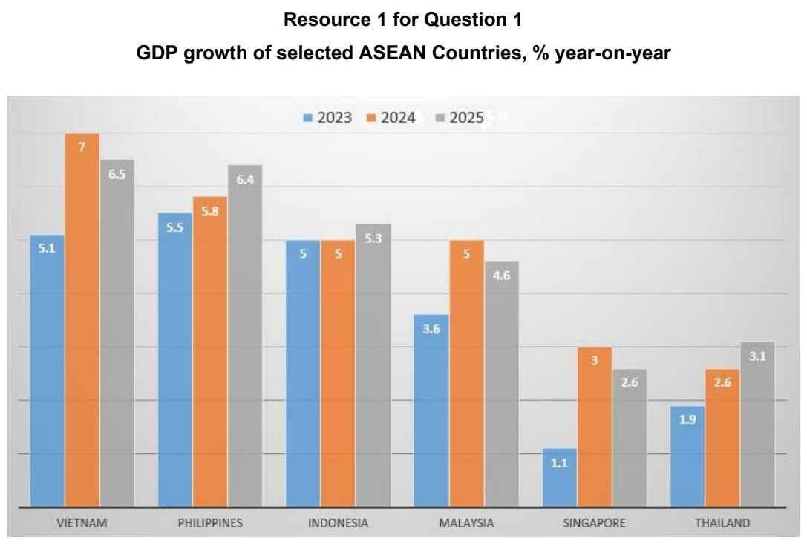

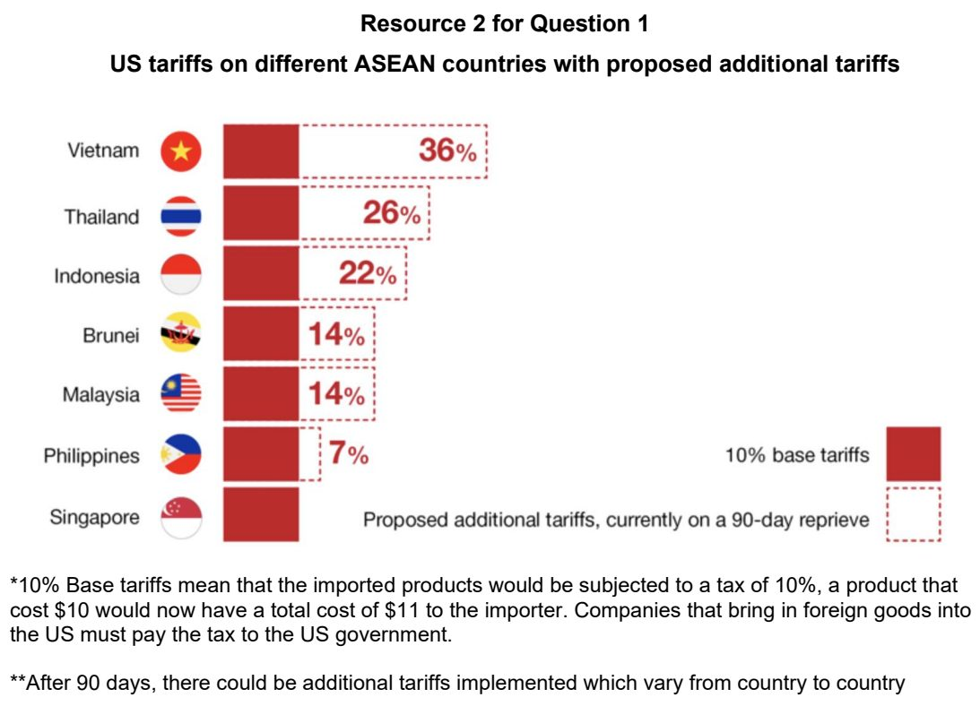

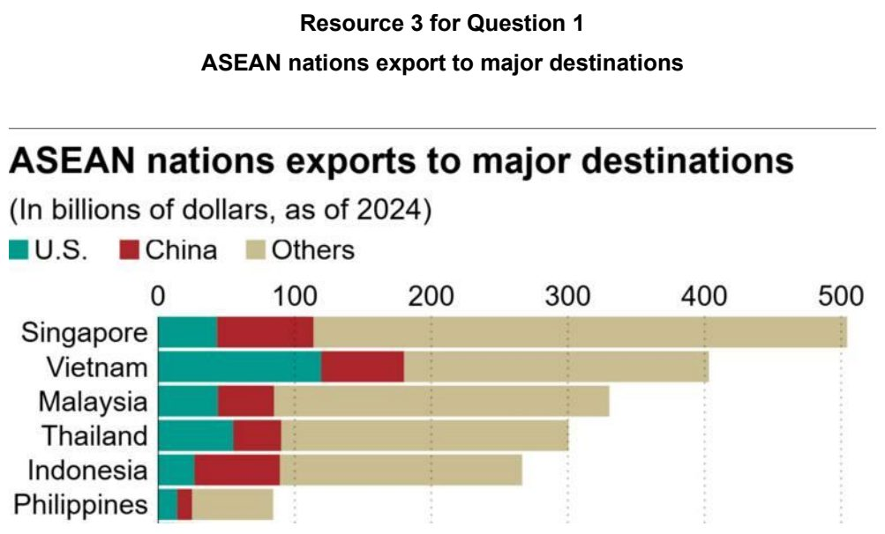

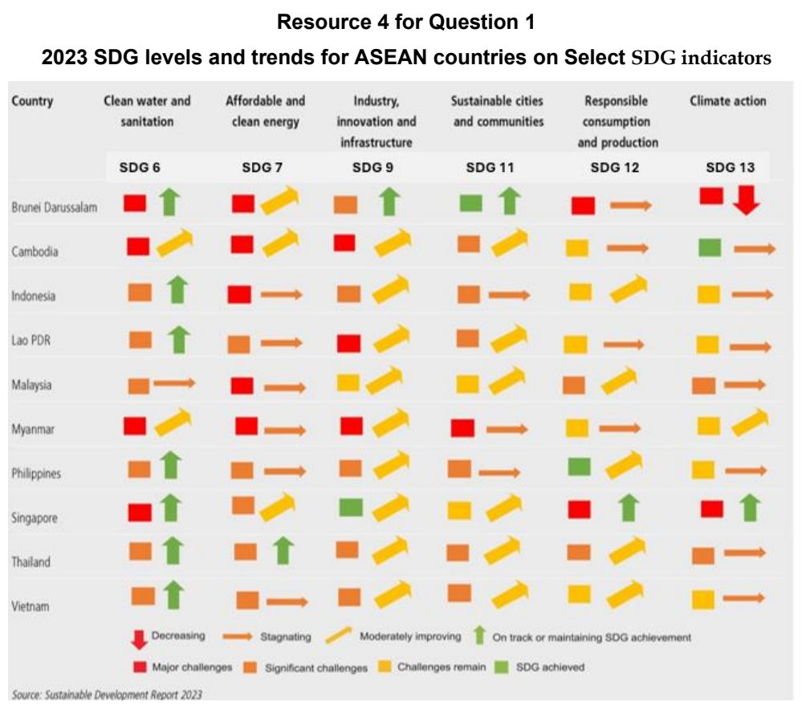

TMJC 2026 — H2 Paper 1 (9173/01), Q1 [30 marks]
Syllabus: 1.2.2b Geography of the Global Economy and TNCs – GPNs connecting places; 1.1.3c Managing Resources – Extractive industries
Section A — Cluster 1: Global Development and Natural Resources
Resource 1 shows Tesla’s operations throughout the world. Resource 2 shows the various component suppliers for Tesla cars. Resource 3 shows the annual battery-electric passenger vehicle sales of Tesla and BYD.
(a) Using Resource 1, describe how Tesla’s operations are distributed around the world. [4]
(b) With reference to Resources 1 and 2, account for the locational distribution of Tesla’s Gigafactories. [6]
(c) Using the help of Resources 1 and 2, explain how Tesla’s operation reflect the presence of a global production network. [6]
(d) Using Resource 3, compare the sales of Tesla and BYD vehicles for 2018 to 2025. [4]
(e) Explain possible reasons for the sales for Tesla and BYD vehicles from 2018 to 2025 as shown in Resource 3. [4]
(f) Explain the strategies that can be used to manage impacts of extractive industries on places. [6]

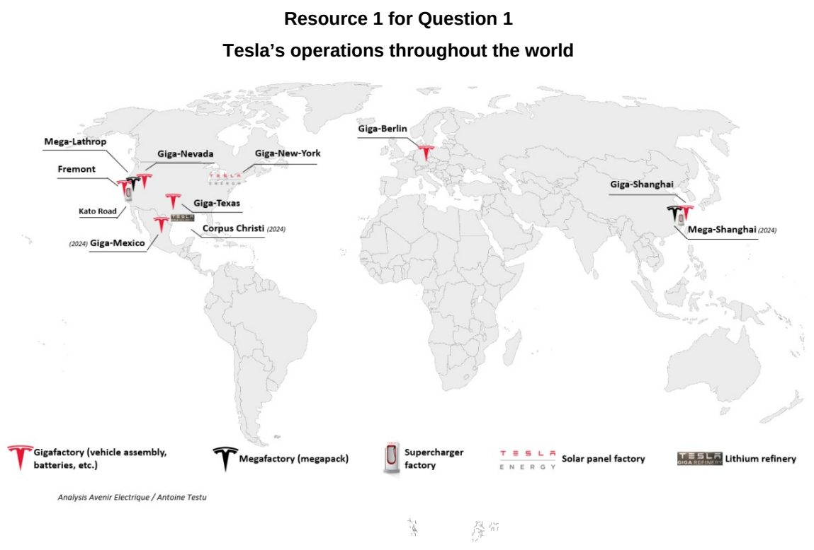

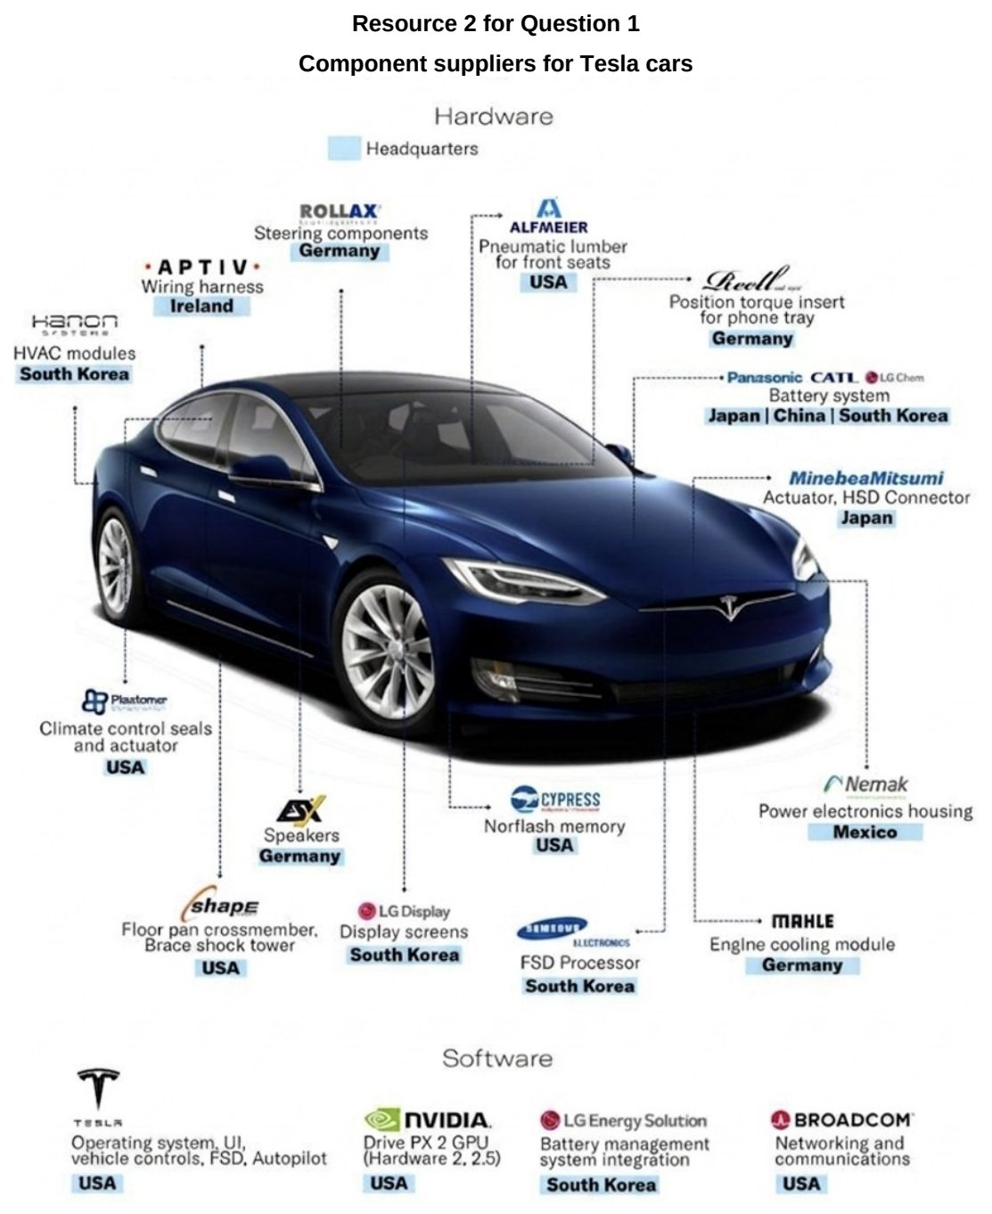

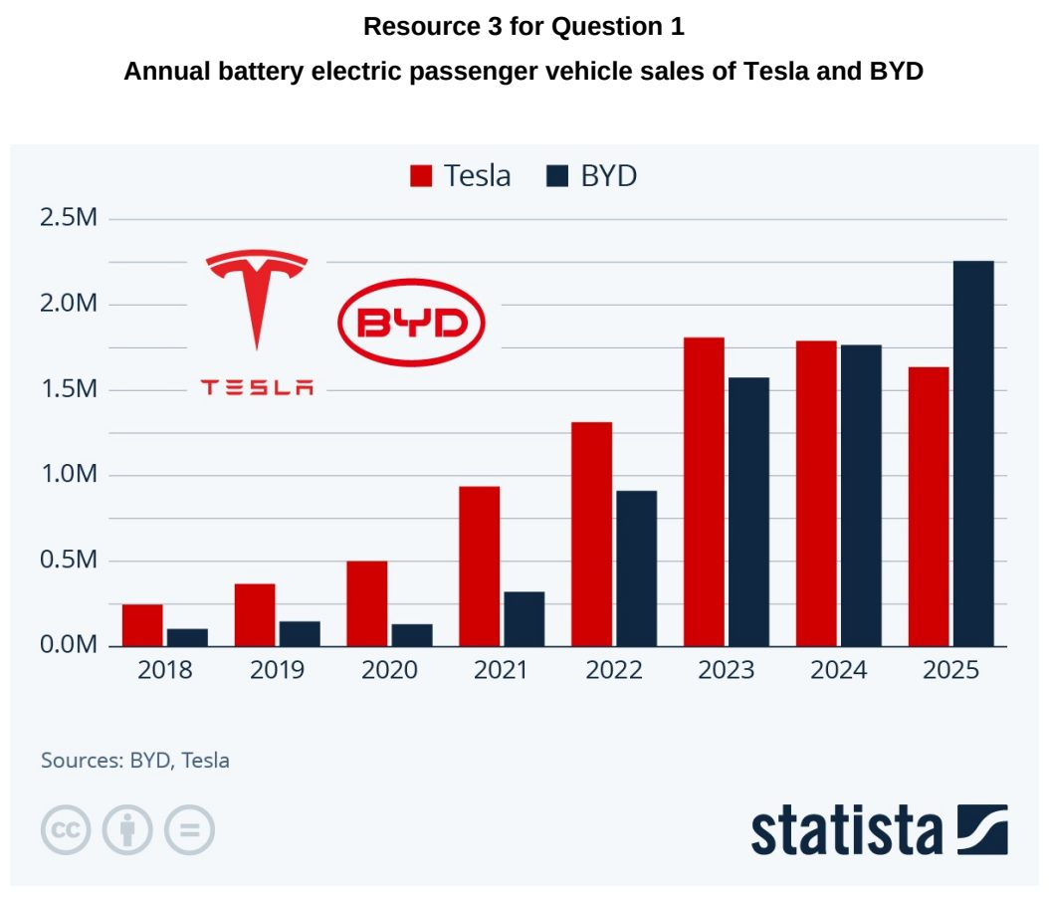

VJC 2024 — H2 Paper 1 (9173/01), Q1 [30 marks]
Syllabus: 1.2.2b Geography of the Global Economy and TNCs – GPNs connecting places; 1.2.2c Geography of the Global Economy and TNCs – Impacts of GPNs on home & host; 1.2.3a Relative Influence of Actors in Shaping the Global Economy – States
Section A — Cluster 1: Global Development and Natural Resources
Ferrero Group is an Italian transnational company with headquarters in Alba, Italy. Ferrero is a manufacturer of branded chocolate and confectionery products, and the second biggest chocolate producer and confectionery company in the world.
Resource 1 shows Ferrero Group’s global supply chain. Resource 2 is an article on the impacts of Ferrero Group’s global supply chain. Resource 3 shows the sales of the top four confectionery companies by region in 2015.
(a) Explain how the Global Production Networks (GPNs) of TNCs like Ferrero Group connect places within the global economy. [5]
(b) Suggest reasons for the spatial distribution of Ferrero Group’s GPN as seen in Resource 1. [5]
(c) With reference to Resource 2, explain the impacts of Ferrero Group’s global production of Nutella. [6]
(d) Suggest how states can mitigate the impacts of Ferrero Group’s global production of Nutella. [5]
(e) Compare the share of sales of Mars Inc and Ferrero Group in 2015 shown in Resource 3. [4]
(f) With reference to Resource 3, account for Ferrero Group’s share of sales in North America and Western Europe. [5]

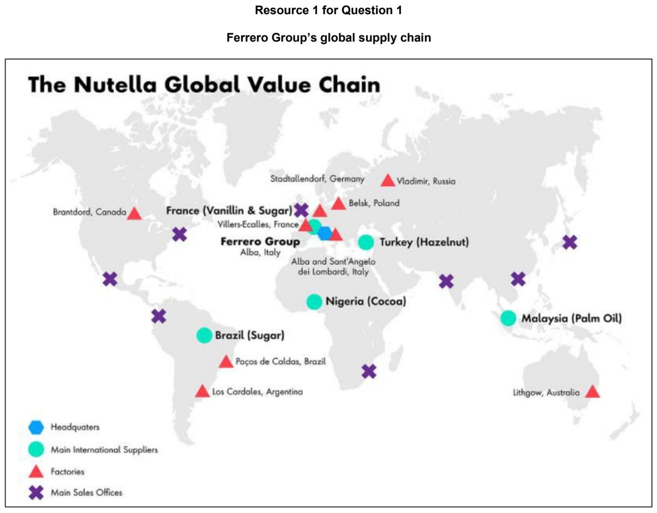

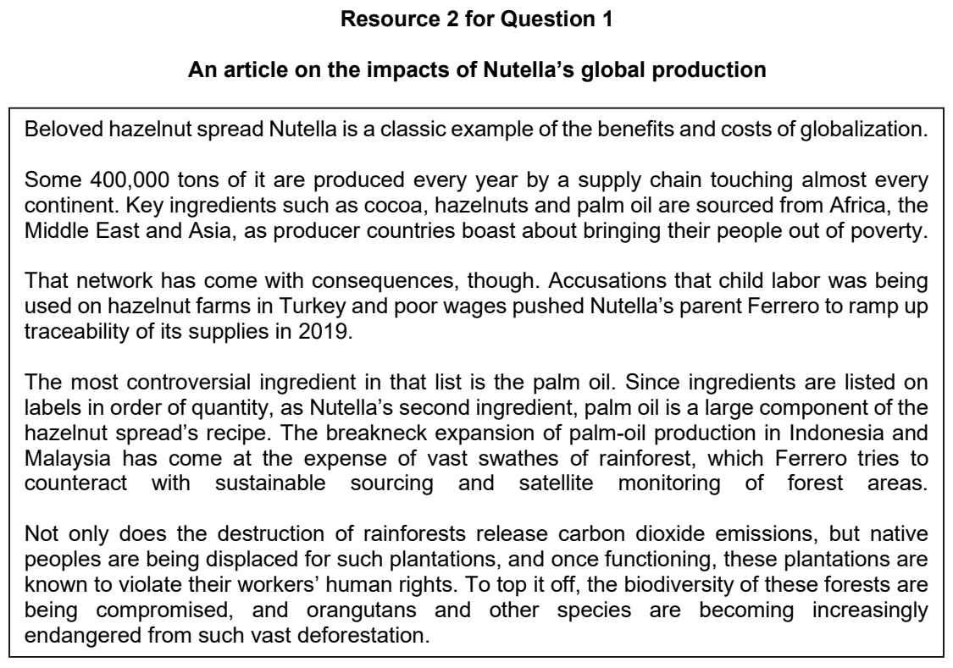

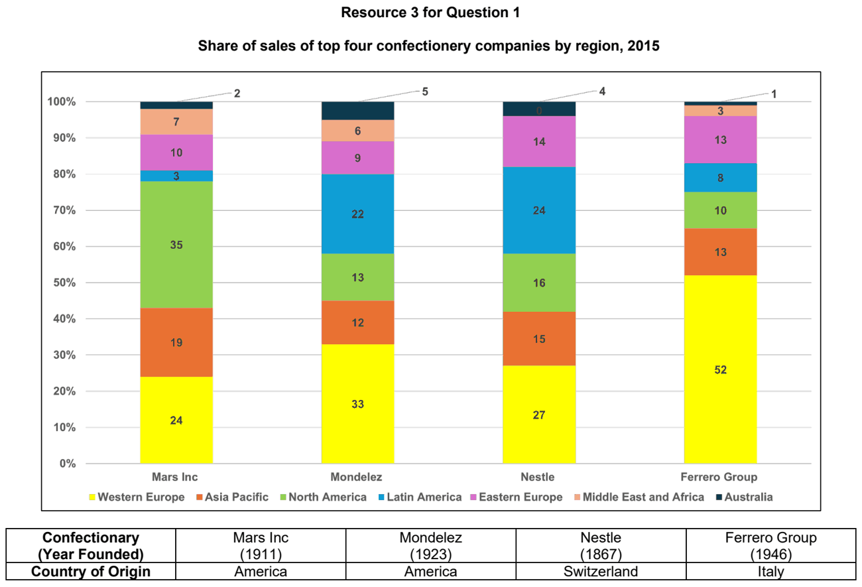

VJC 2026 — H2 Paper 1 (9173/01), Q1 [30 marks]
Syllabus: 1.1.3c Managing Resources – Extractive industries; 1.2.2b Geography of the Global Economy and TNCs – GPNs connecting places; 1.2.2a Geography of the Global Economy and TNCs – Interconnectedness through flows
Section A — Cluster 1: Global Development and Natural Resources
Niger is one of the world's leading uranium producers and an important supplier to the global nuclear energy industry. Orano is a French TNC that sources uranium from Niger and other countries to produce nuclear fuel for international markets.
Resource 1A shows global uranium production in 2018. Resource 1B shows Uranium's contribution to GDP (%) in 2018. Resource 2 shows is an article about uranium production in Niger. Resource 3 shows the spatial organisation of Orano, a French TNC that sources uranium to produce nuclear fuel for international markets.
(a) Describe the global pattern of uranium production among the countries shown in Resource 1A. [4]
(b) With reference to Resources 1A and 1B, suggest reasons why uranium contributes more significantly to GDP in some countries than others. [4]
(c) With reference to Resource 2, explain how the production and trade of uranium create interdependence between Niger and France. [4]
(d) Suggest some impacts of natural resource extraction in less developing countries. [6]
(e) Using Resource 3, describe the spatial organisation of Orano, a French energy TNC that sources uranium from around the world. [6]
(f) Explain the factors that may have contributed to Orano’s spatial organisation. [6]

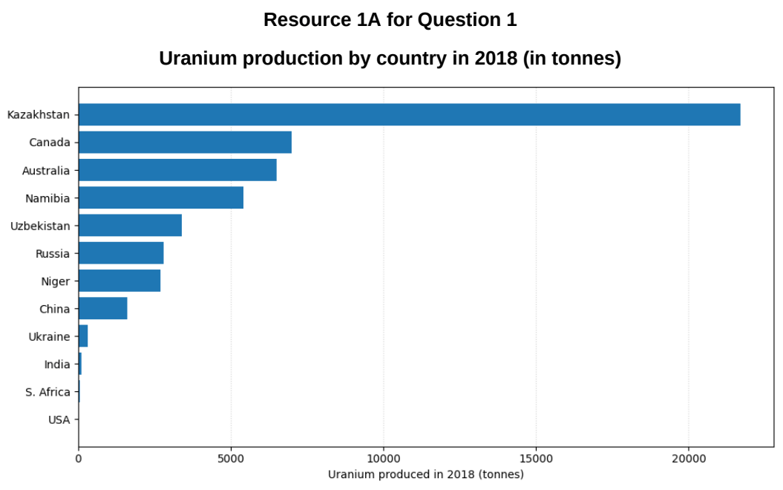

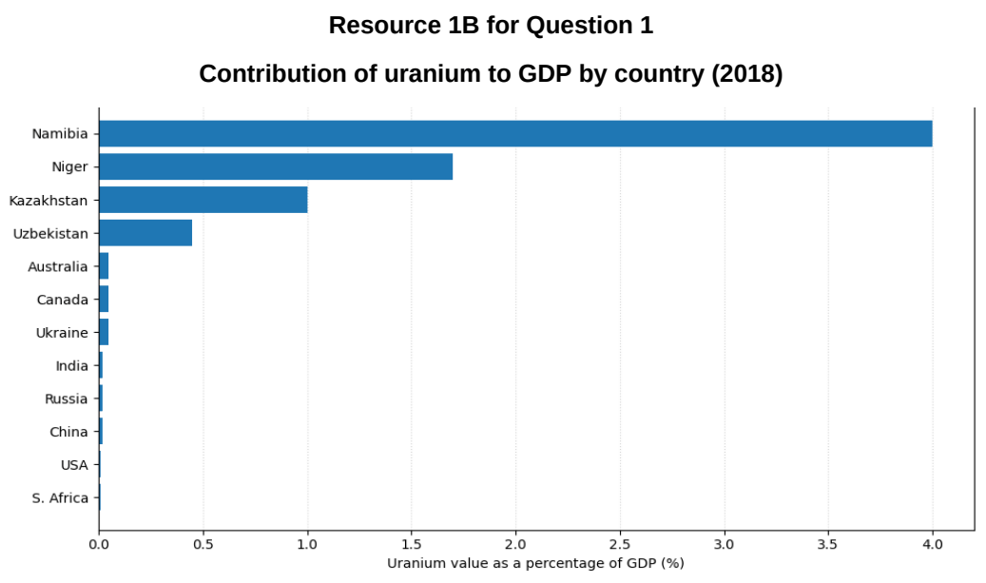

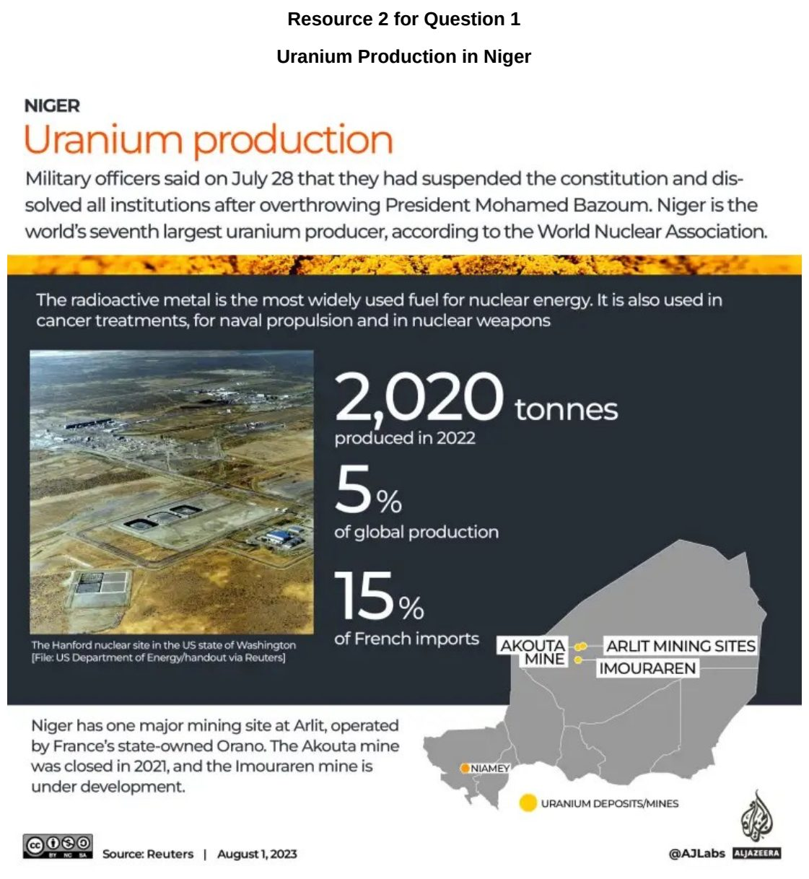

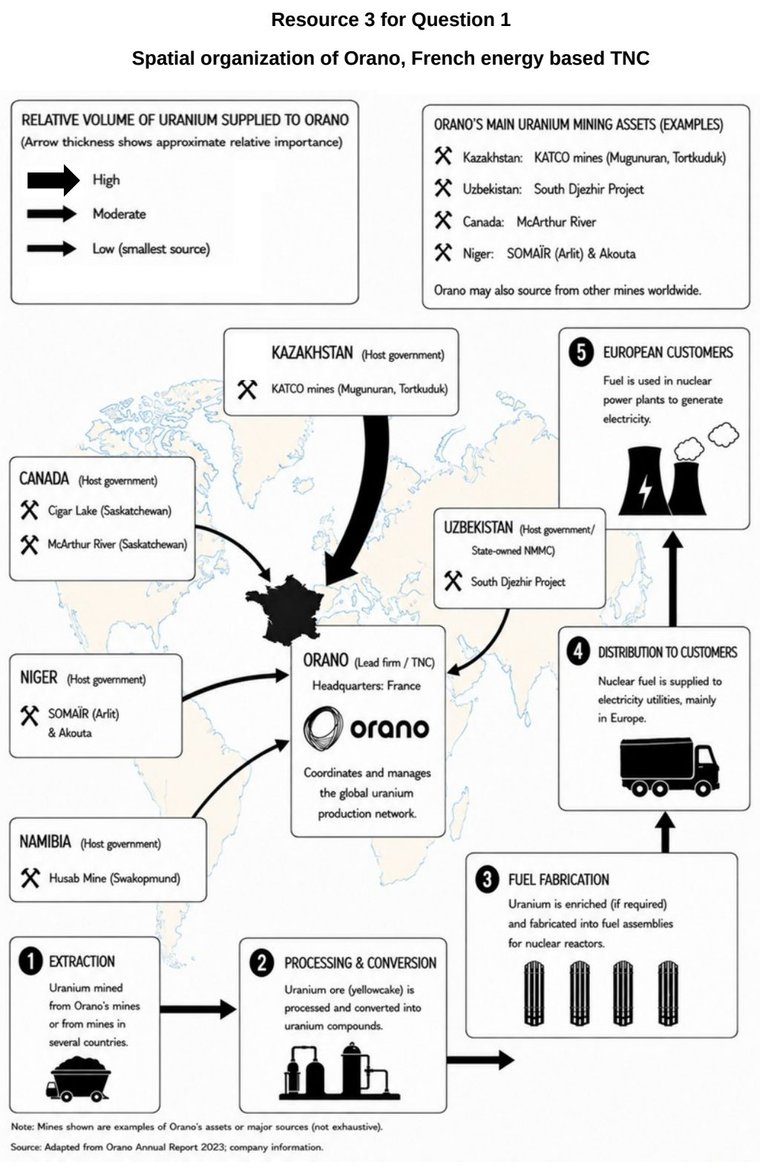

YIJC 2025 — H2 Paper 1 (9173/01), Q1 [30 marks]
Syllabus: 1.2.3a Relative Influence of Actors in Shaping the Global Economy – States; 1.2.2a Geography of the Global Economy and TNCs – Interconnectedness through flows; 1.2.1b Development – Trade, capital & labour flows
Section A — Cluster 1: Global Development and Natural Resources
Resource 1 shows the distribution of international migrant workers (%) by region of destination in 2022. Resource 2 shows major free trade agreements of Singapore. Resource 3 shows a newspaper article on small and medium-sized Enterprises SMEs in Indonesia. Resource 4 shows the share of companies using Artificial Intelligence (AI) in 2021.
(a) Using Resource 1, describe the global distribution of international migrant workers by region of destination in 2022. [4]
(b) Suggest reasons for the global distribution of international migrant workers by region of destination, as seen in Resource 1. [4]
(c) Using Resource 2, explain how free trade agreements can impact a country’s economy, such as that of Singapore’s. [6]
(d) With reference to Resource 3, explain measures the Indonesian government can take to support its Small and Medium-sized Enterprises (SMEs). [5]
(e) Describe the share of companies using Artificial Intelligence (AI) globally in 2021, as seen in Resource 4. [5]
(f) With reference to all the Resources, explain if globalisation has created more problems or benefits for countries like Singapore. [6]

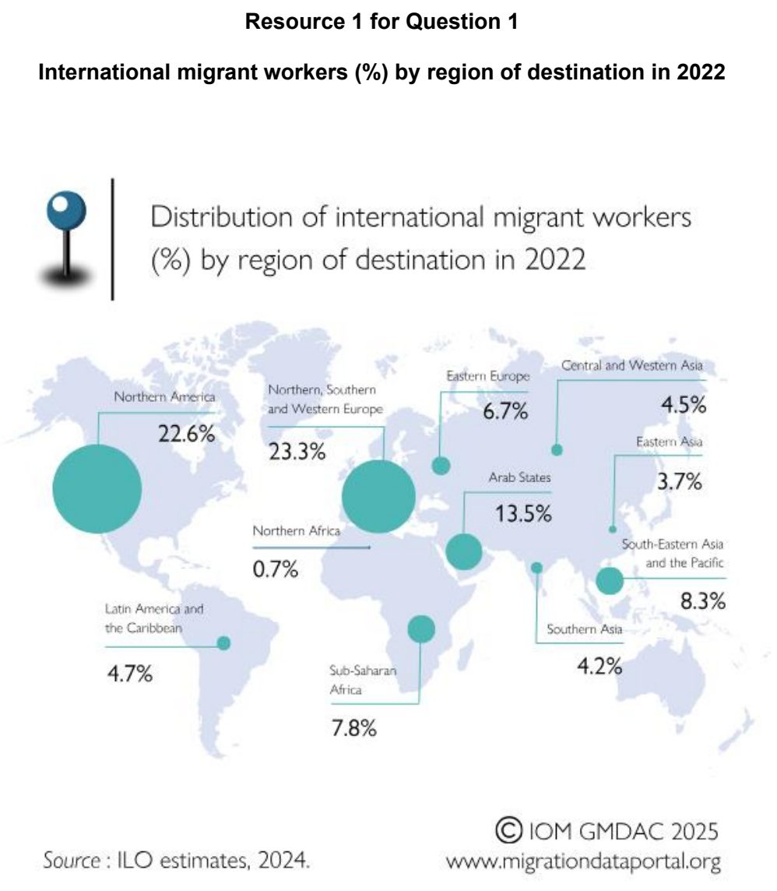

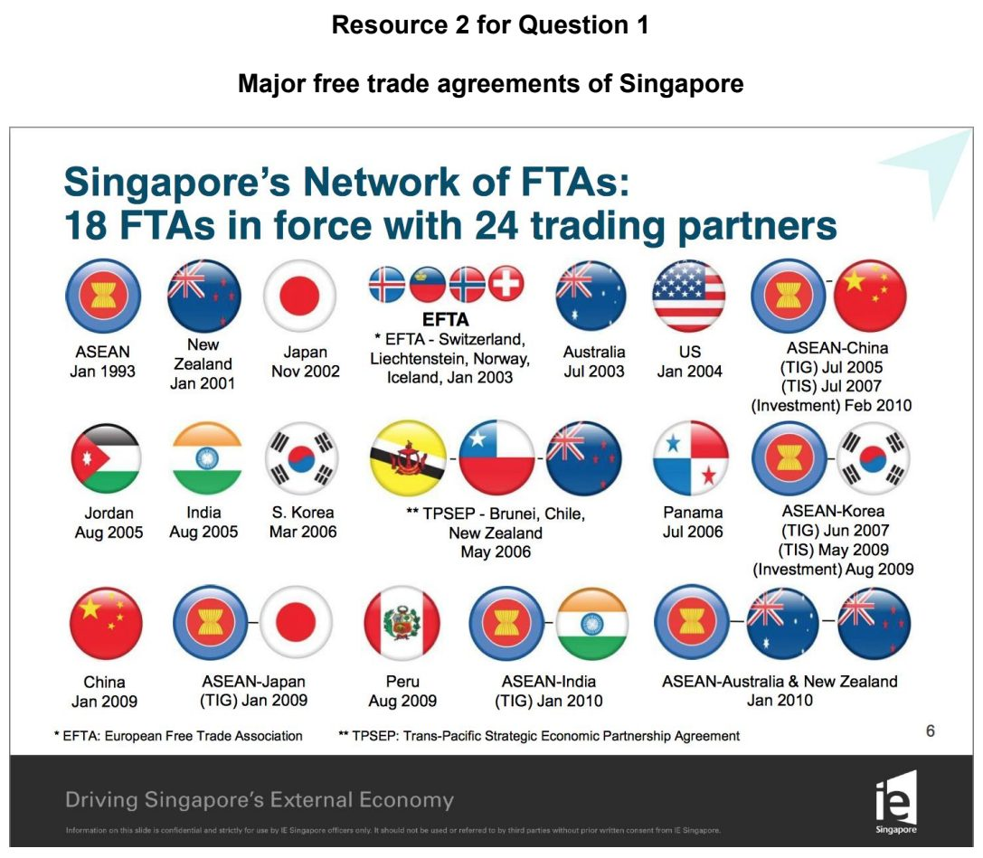

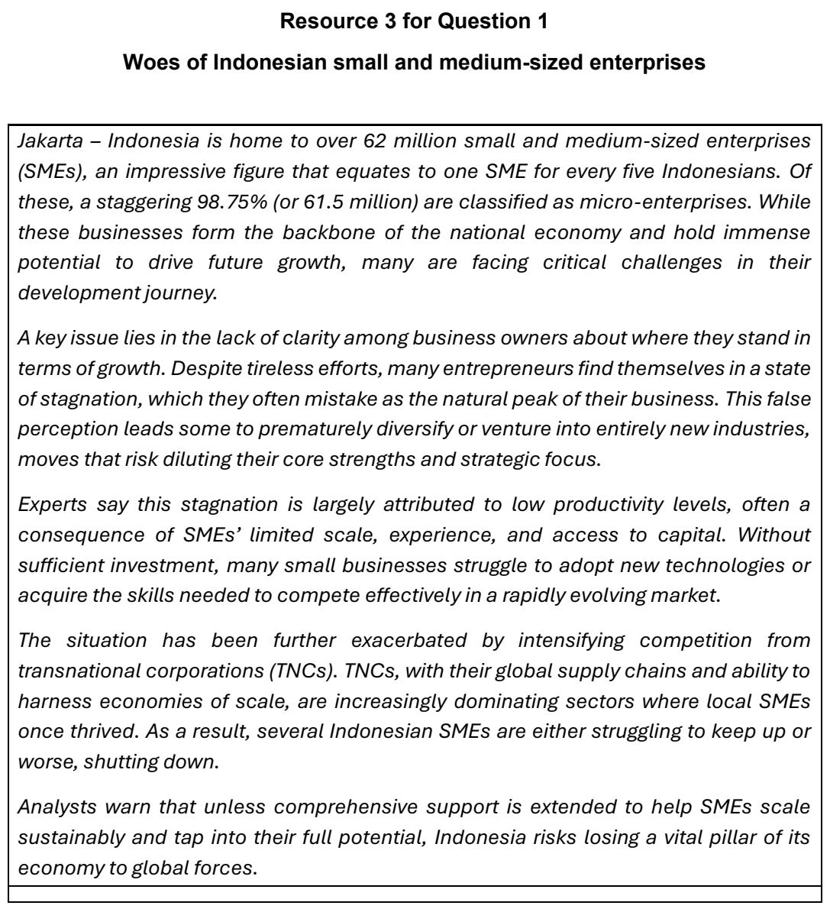

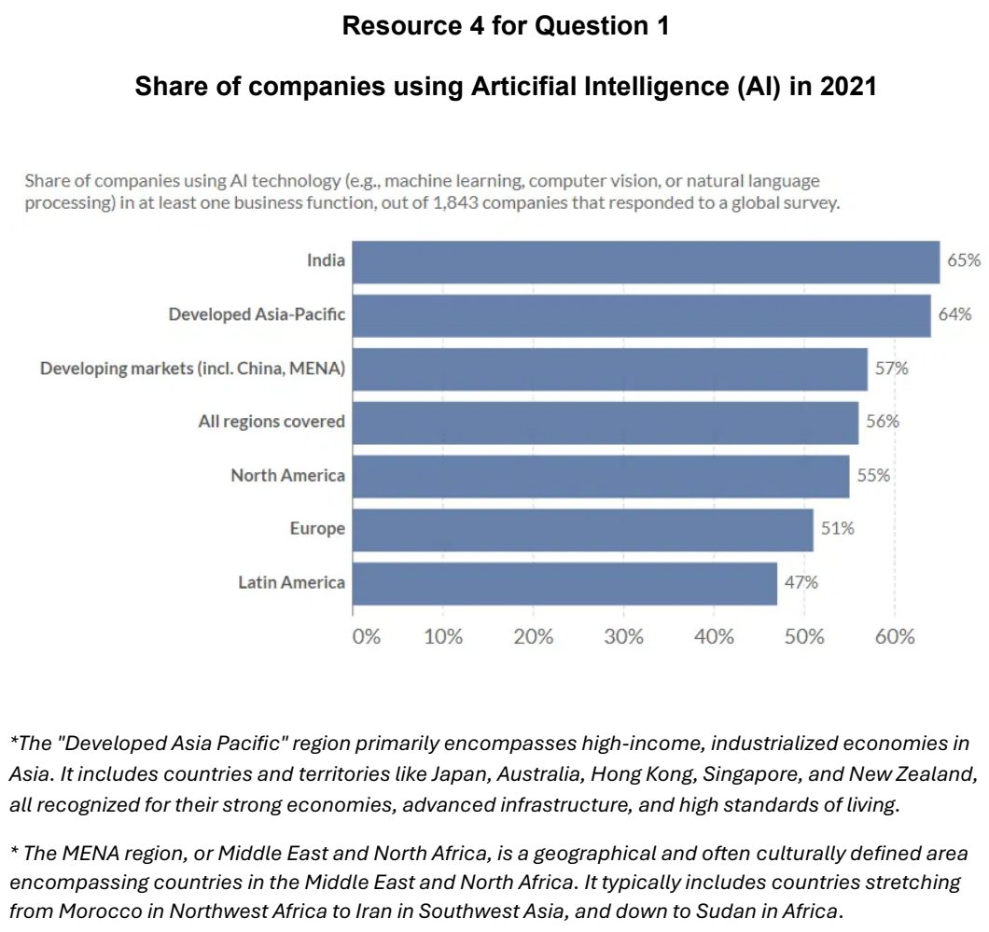

Cluster 2: Tropical Environments

2.1 Tropical Climates and Drainage Basins

ACJC 2025 — H2 Paper 1 (9173/01), Q2 [30 marks]
Syllabus: 2.1.1c Tropical Climates – Synoptic circulation (monsoons, cyclones, ENSO); 2.1.2c Drainage Basin Hydrology – Pathways; 2.2.3b Fluvial Landforms in the Humid Tropics – Formation of fluvial landforms; 2.2.3a Fluvial Landforms in the Humid Tropics – Fluvial landforms & features; 2.2.3c Fluvial Landforms in the Humid Tropics – Delta ecosystem services
Section A — Cluster 2: Tropical Environments
Resource 5 shows the sea surface temperature anomaly during an El Nino event in 2023. Resource 6 shows the spatial and temporal distribution of tropical cyclones. Resource 7 shows a meandering stream in the humid tropics. Resource 8 shows a braided stream located on a glacial outwash plain.
(a) With the aid of Resource 5, describe the oceanic and atmospheric conditions associated with an El Nino event. [4]
(b) Explain the conditions leading to the spatial and temporal distribution of tropical cyclones shown in Resource 6. [6]
(c) Explain how climate and vegetation lead to differences in storm hydrographs of the humid and arid tropics. [6]
(d) Compare the fluvial features of the meandering stream along the cross-section labelled P – Q in Resource 7 with those along the cross-section X – Y of the braided stream shown in Resource 8. [4]
(e) With reference to Resource 8, explain the factors that contribute to the formation of the braiding pattern shown. [6]
(f) Describe four ecosystem services provided by deltas in the humid tropics. [4]

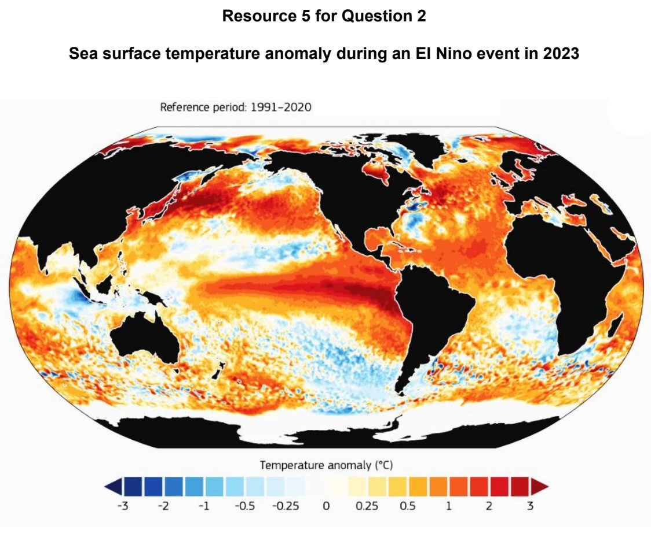

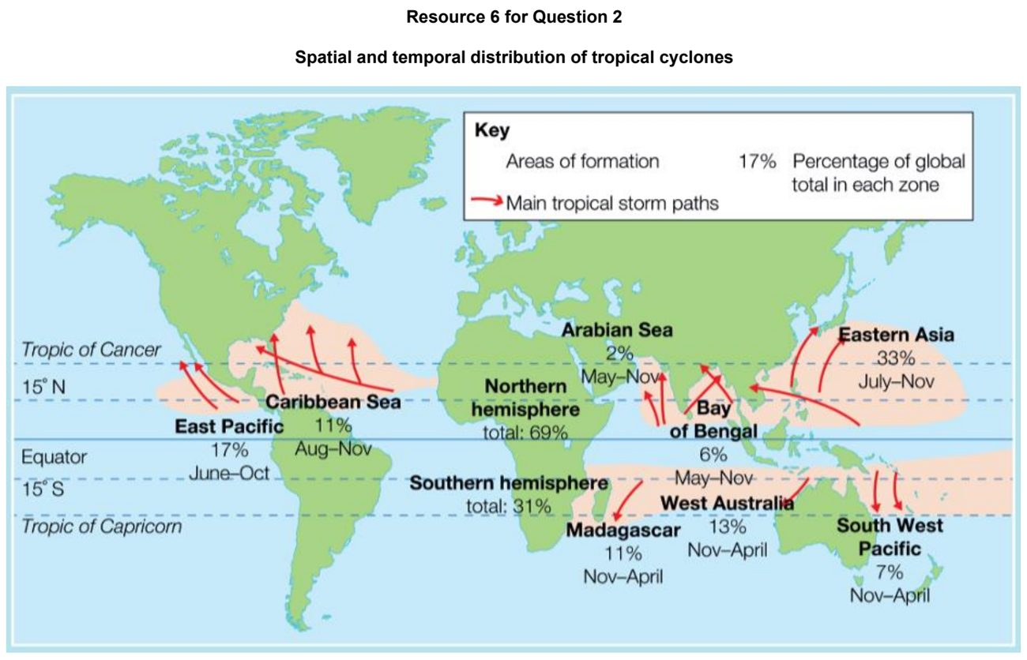

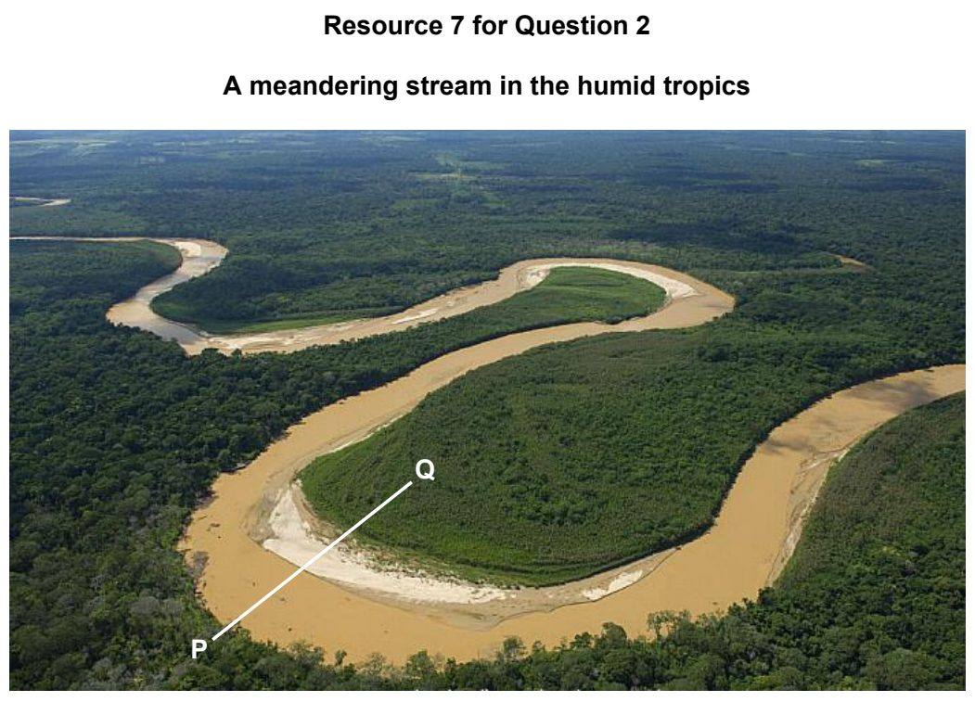

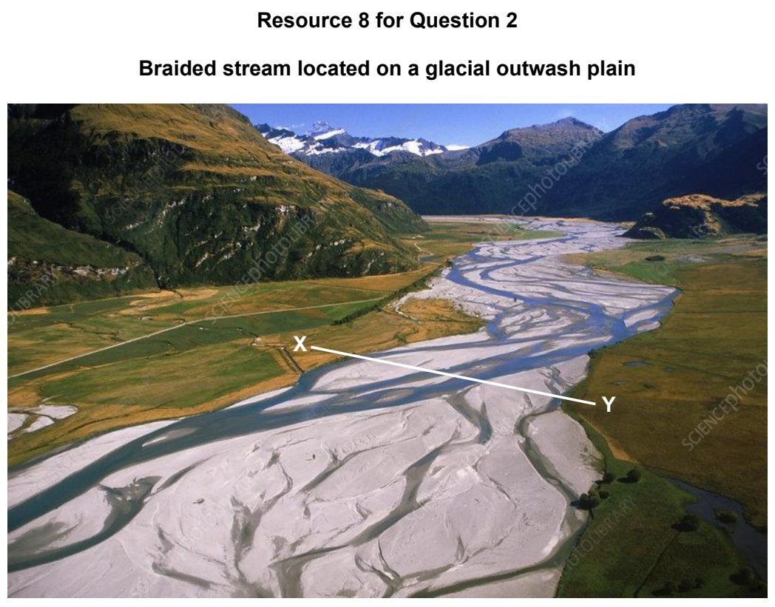

ACJC 2026 — H2 Paper 1 (9173/01), Q2 [30 marks]
Syllabus: 2.1.1c Tropical Climates – Synoptic circulation (monsoons, cyclones, ENSO); 2.1.2c Drainage Basin Hydrology – Pathways; 2.2.3b Fluvial Landforms in the Humid Tropics – Formation of fluvial landforms; 2.1.2a Drainage Basin Hydrology – Input–output balance; 2.2.1b Geomorphic Processes – Mass movement & slope erosion
Section A — Cluster 2: Tropical Environments
Resource 5A shows the climograph of Bandung, Indonesia and Resource 5B shows the locations of Bandung and the Bengawan Solo River Basin. Resource 6 shows the effects of El Niño. Resource 7 shows the water balances of two drainage basins in the tropics. Resource 8 shows a meander bend of the Bengawan Solo River. Resource 9 shows a mudflow in Pasirlangu village, Bandung on 25 January 2026.
(a) Explain the rainfall pattern of Bandung shown in the climograph of Resource 5. [5]
(b) Explain how the atmospheric and oceanic conditions associated with El Niño can alter rainfall patterns in countries in the eastern and western Equatorial Pacific Ocean shown in Resource 6. [4]
(c) Compare the water balances of the two drainage basins shown in Resource 7. [4]
(d) With the aid of Resource 7, provide explanations for the differences in the hydrological pathways of the two drainage basins. [7]
(e) Explain the formation of the main features of the meander bend shown in Resource 8. [6]
(f) With the aid of Resource 5 and citing evidence from Resource 9, suggest factors that contributed to the occurrence of the mudflow shown in Resource 9. [4]

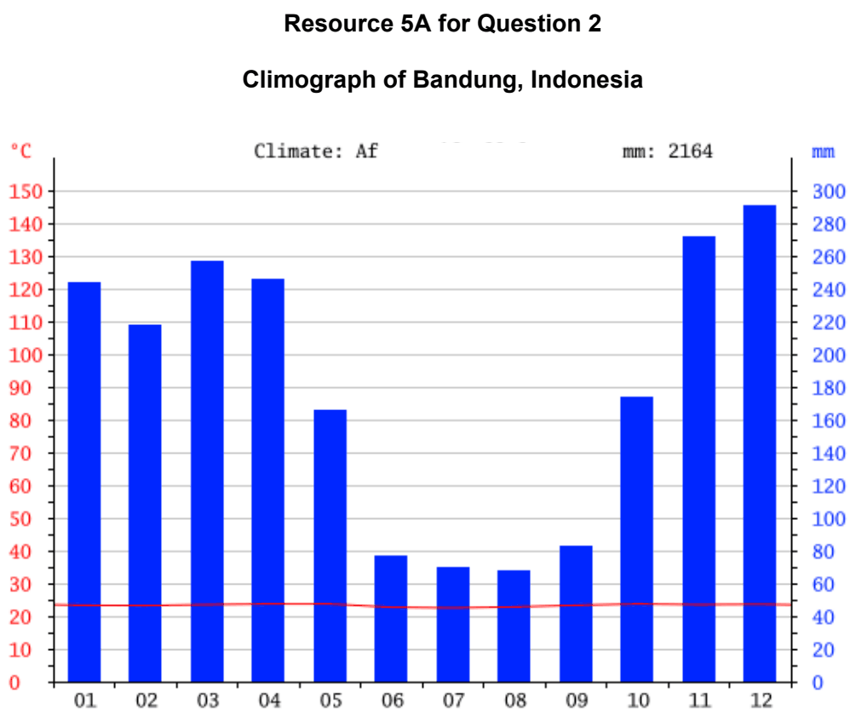

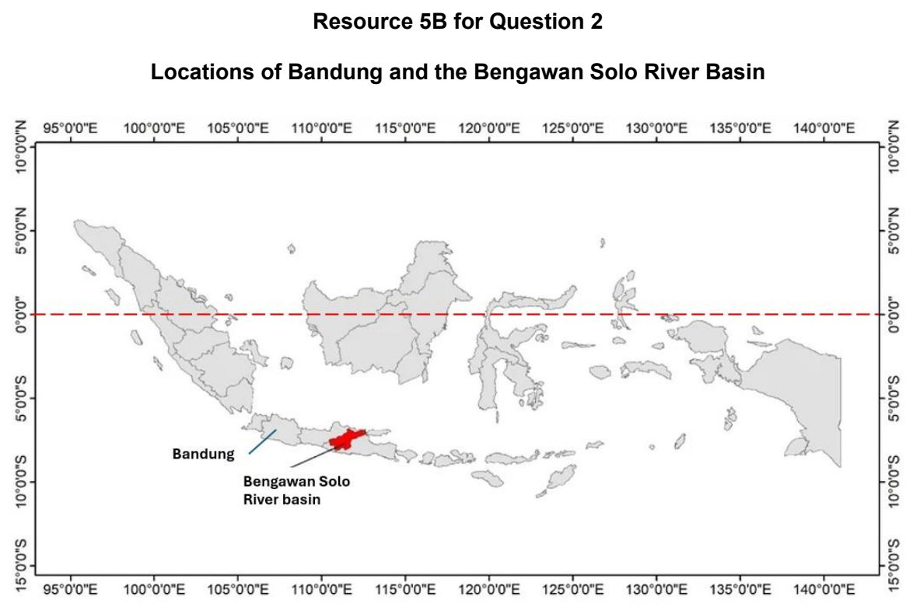

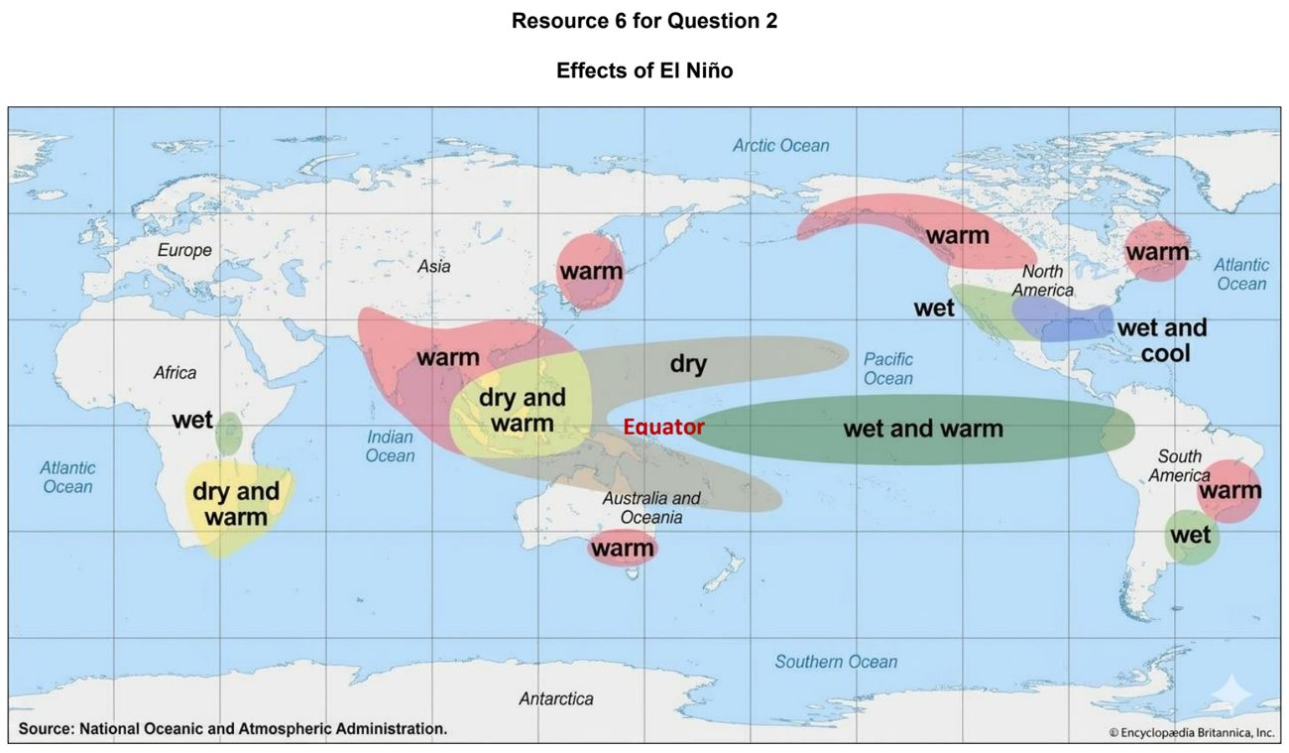

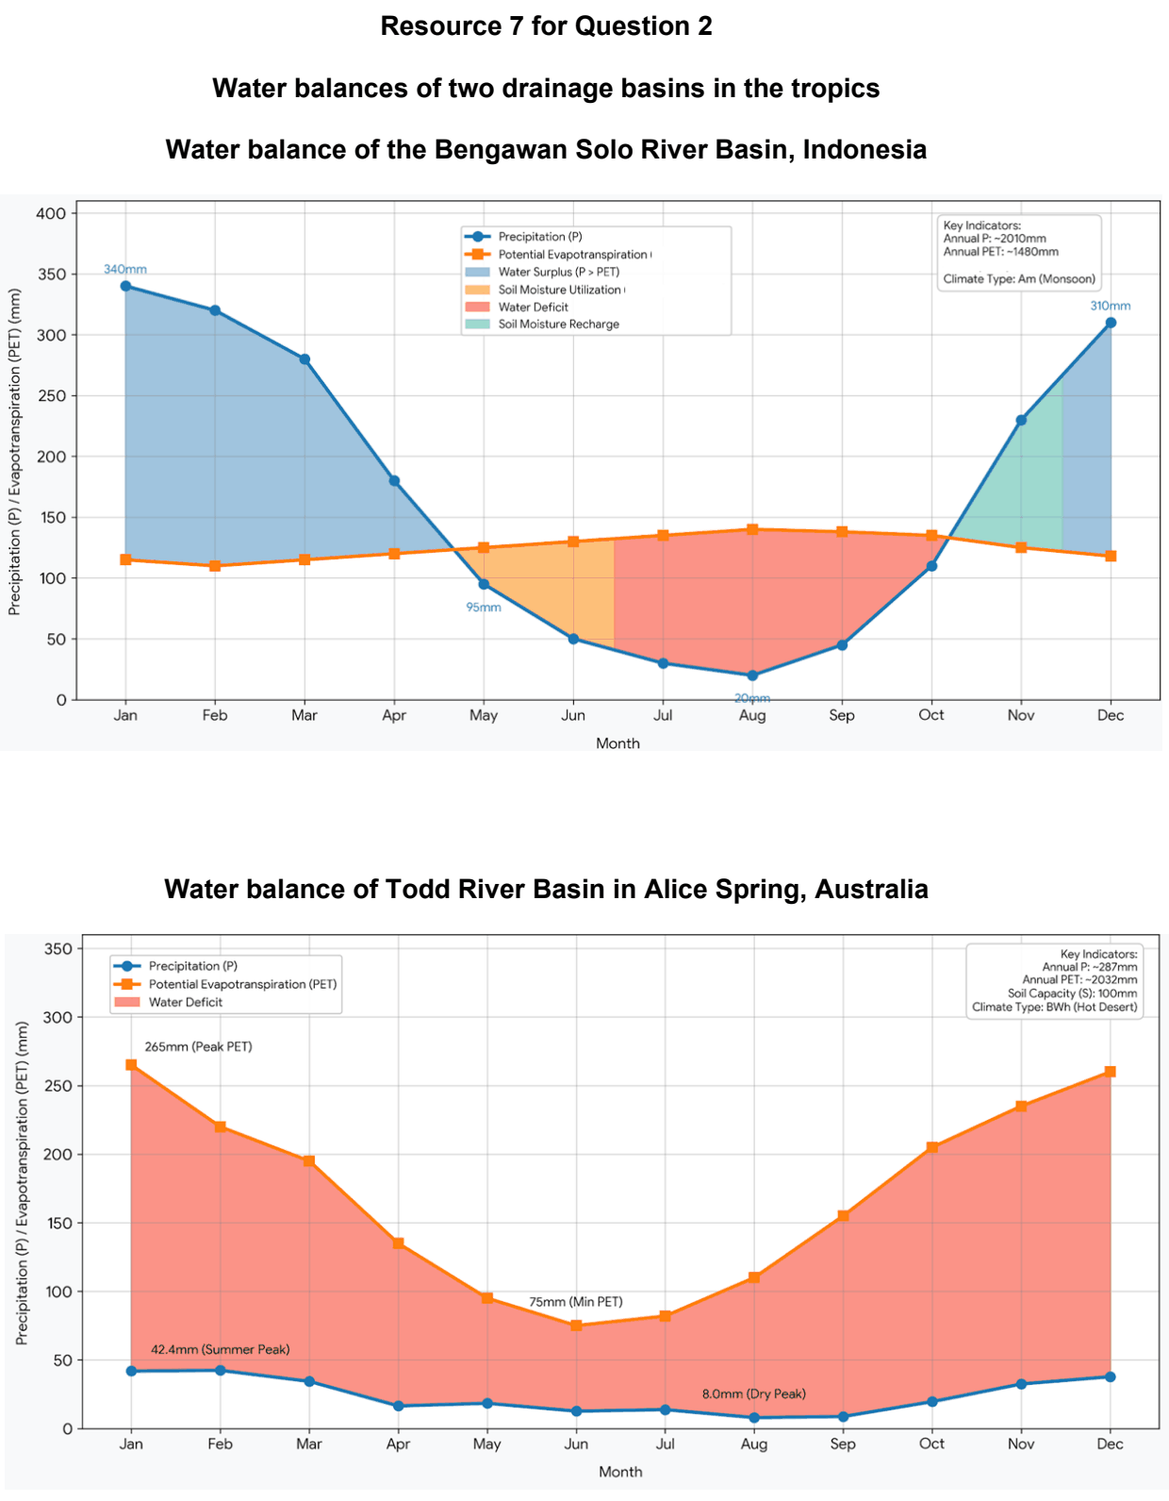

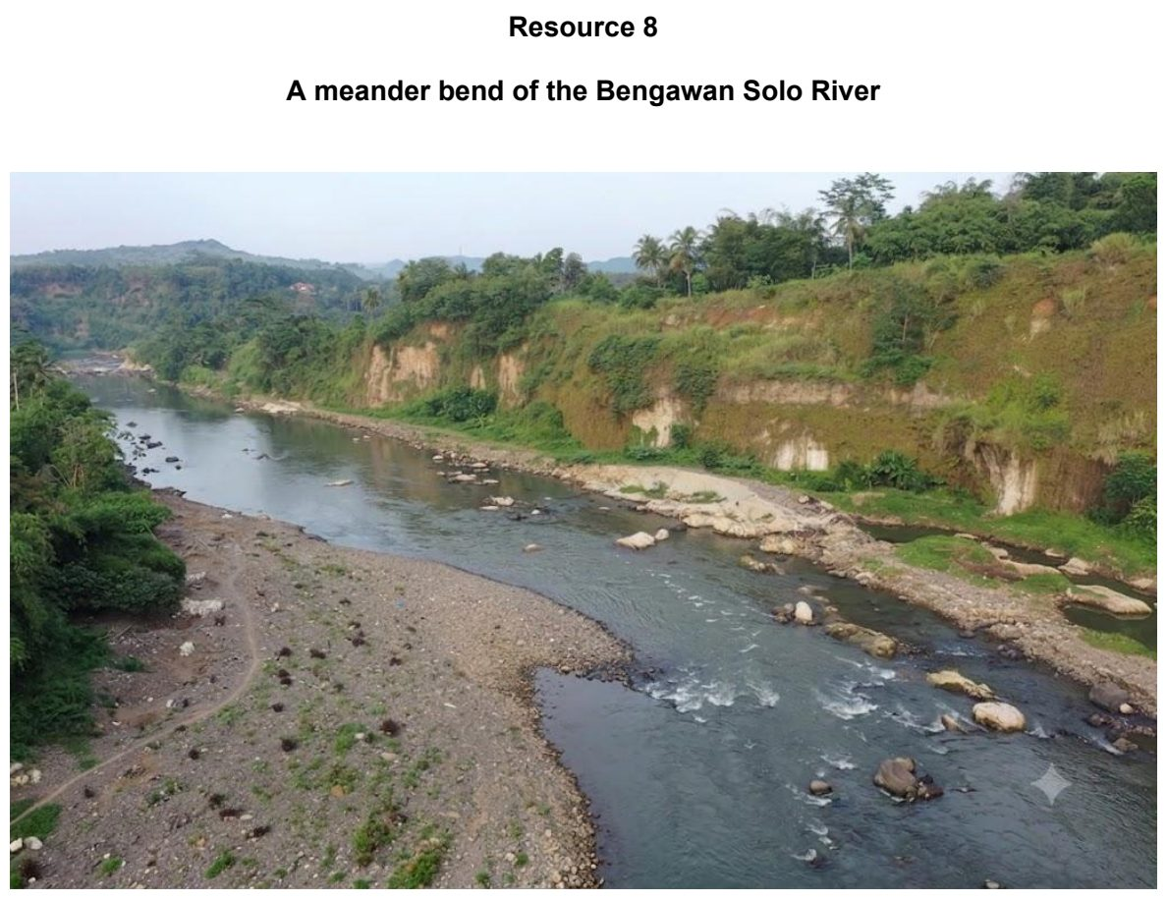

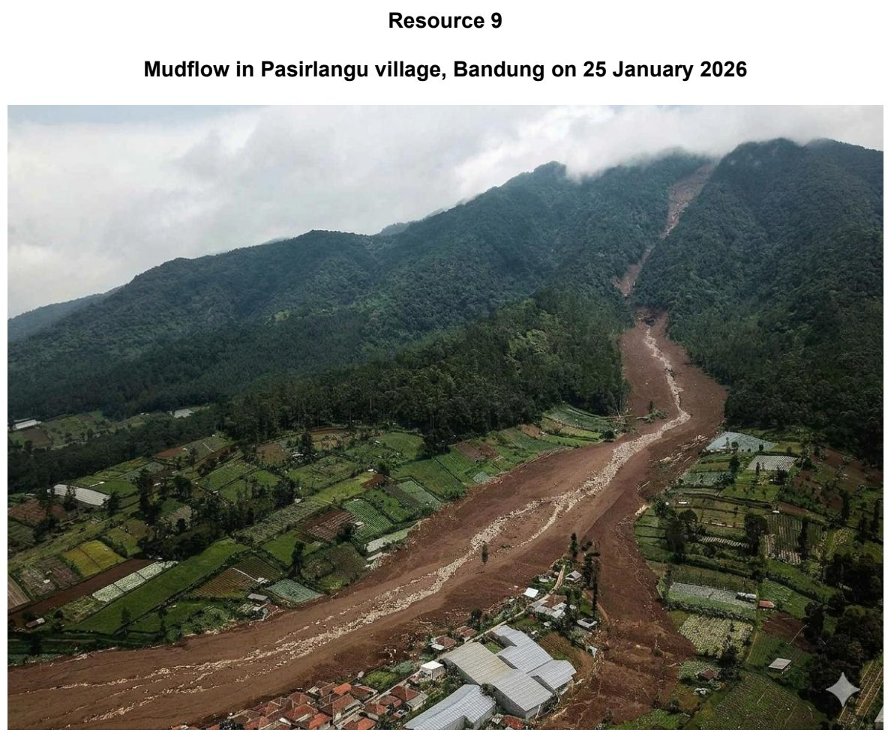

ASRJC 2025 — H2 Paper 1 (9173/01), Q2 [30 marks]
Syllabus: 2.1.1c Tropical Climates – Synoptic circulation (monsoons, cyclones, ENSO); 2.1.3a Floods in the Humid Tropics – Causes of fluvial floods; 2.2.1c Geomorphic Processes – Fluvial processes; 2.1.3c Floods in the Humid Tropics – Flood management; 2.2.3b Fluvial Landforms in the Humid Tropics – Formation of fluvial landforms
Section A — Cluster 2: Tropical Environments
Resource 5 shows the movement of Tropical Storm Washi across the Philippines from 15 December to 19 December 2011. Resource 6 shows fluvial flooding at Cagayan de Oro City and its location in the Cagayan River Basin. Resource 7 shows a flood prevention measure along a stretch of the Cagayan River.
(a) Describe the path and changes in storm intensity of Tropical Storm Washi as it moved across the Philippines, as shown in Resource 5. [4]
(b) With reference to Resource 5, suggest possible reasons for the formation of Tropical Storm Washi. [5]
(c) Using Resources 5 and 6, explain the factors that led to fluvial flooding in Cagayan de Oro City on December 17, 2011. [6]
(d) Describe the circumstances under which deposition may take place within a river. [5]
(e) Explain the benefits and potential limitations of the flood prevention measure along the Cagayan River shown in Resource 7. [5]
(f) Explain the formation of river cliffs and point bars. [5]

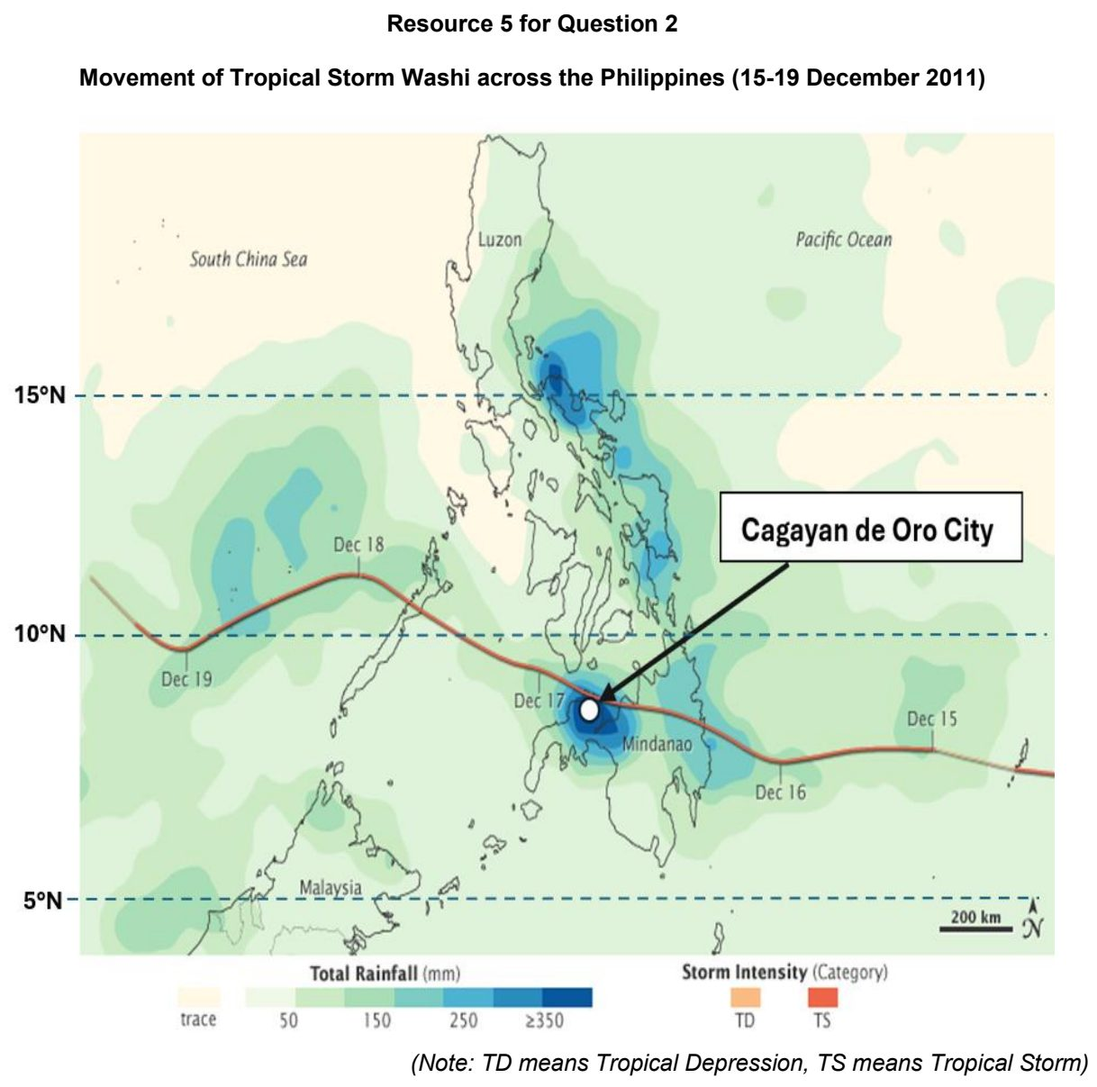

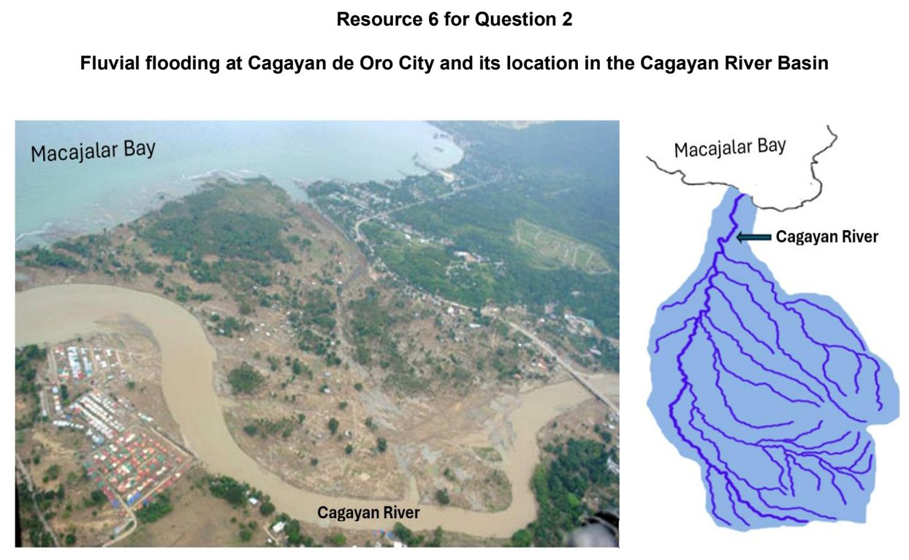

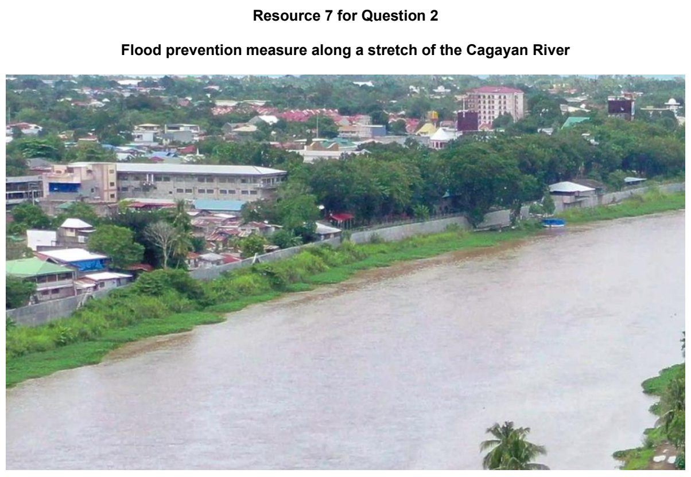

CJC 2026 — H2 Paper 1 (9173/01), Q2 [30 marks]
Syllabus: 2.1.1c Tropical Climates – Synoptic circulation (monsoons, cyclones, ENSO); 2.2.1a Geomorphic Processes – Weathering; 2.1.3c Floods in the Humid Tropics – Flood management; 2.1.1a Tropical Climates – Climate zones (temperature & rainfall); 2.2.1b Geomorphic Processes – Mass movement & slope erosion
Section A — Cluster 2: Tropical Environments
Resource 5 shows the development of Typhoon Odette in December 2021. Resource 6 shows sea surface temperatures over the Pacific Ocean between 29 November and 5 December 2021. Resource 7 shows a slope failure in the Philippines in December 2021. Resource 8 shows a cartoon on fluvial flood management in the Philippines.
(a) Explain why the tropics are characterised by high temperatures. [4]
(b) Explain the natural factors influencing the type and rate of weathering in the tropics. [6]
(c) Describe the development of Typhoon Odette as shown in Resource 5. [5]
(d) With reference to Resources 5 and 6, explain the development of Typhoon Odette. [5]
(e) Cite data from Resources 5 and 7 to explain how Typhoon Odette might have influenced the movement of materials on slopes. [4]
(f) With reference to Resource 8, explain the challenges in managing fluvial floods. [6]

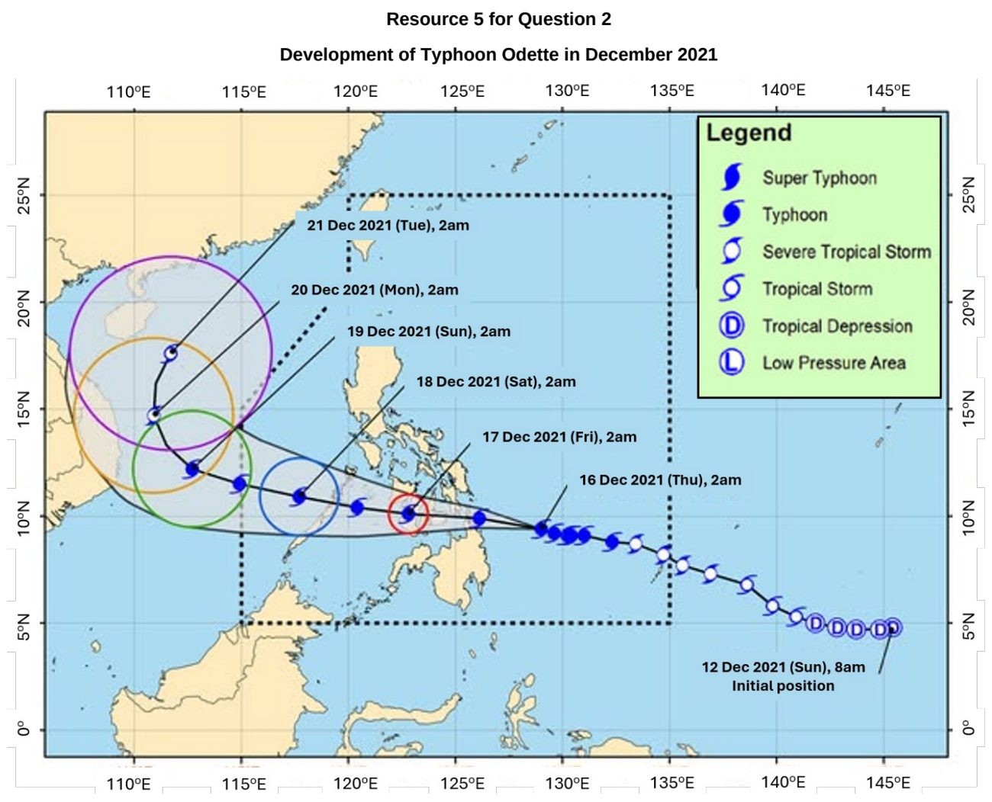

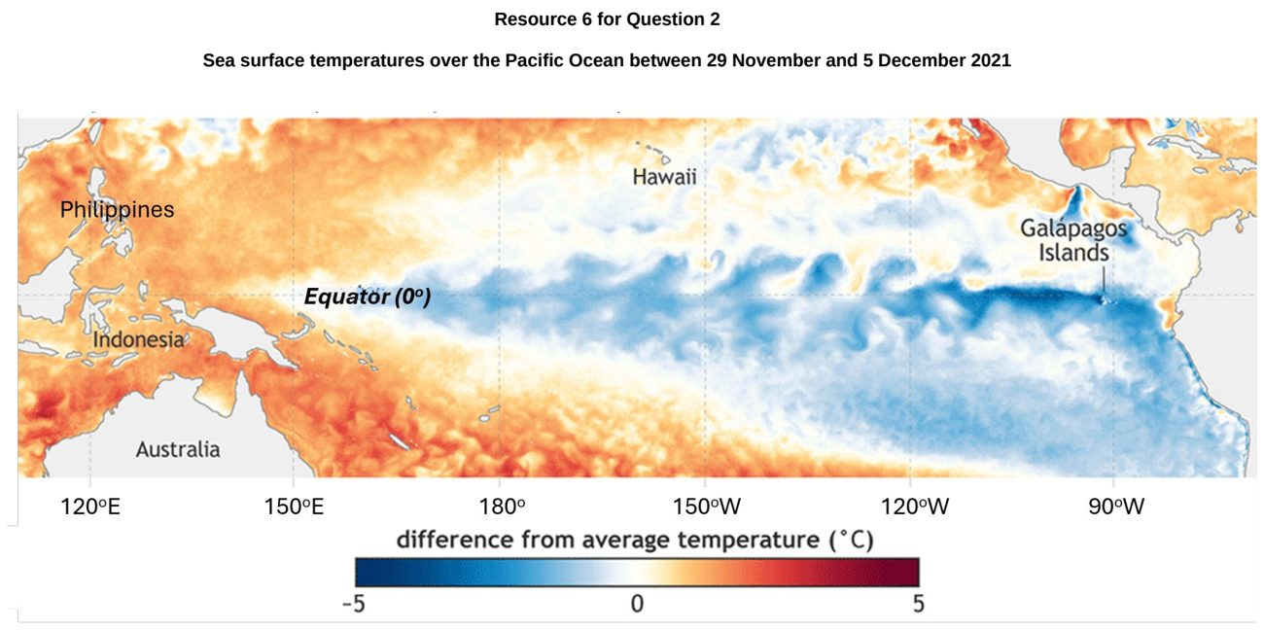

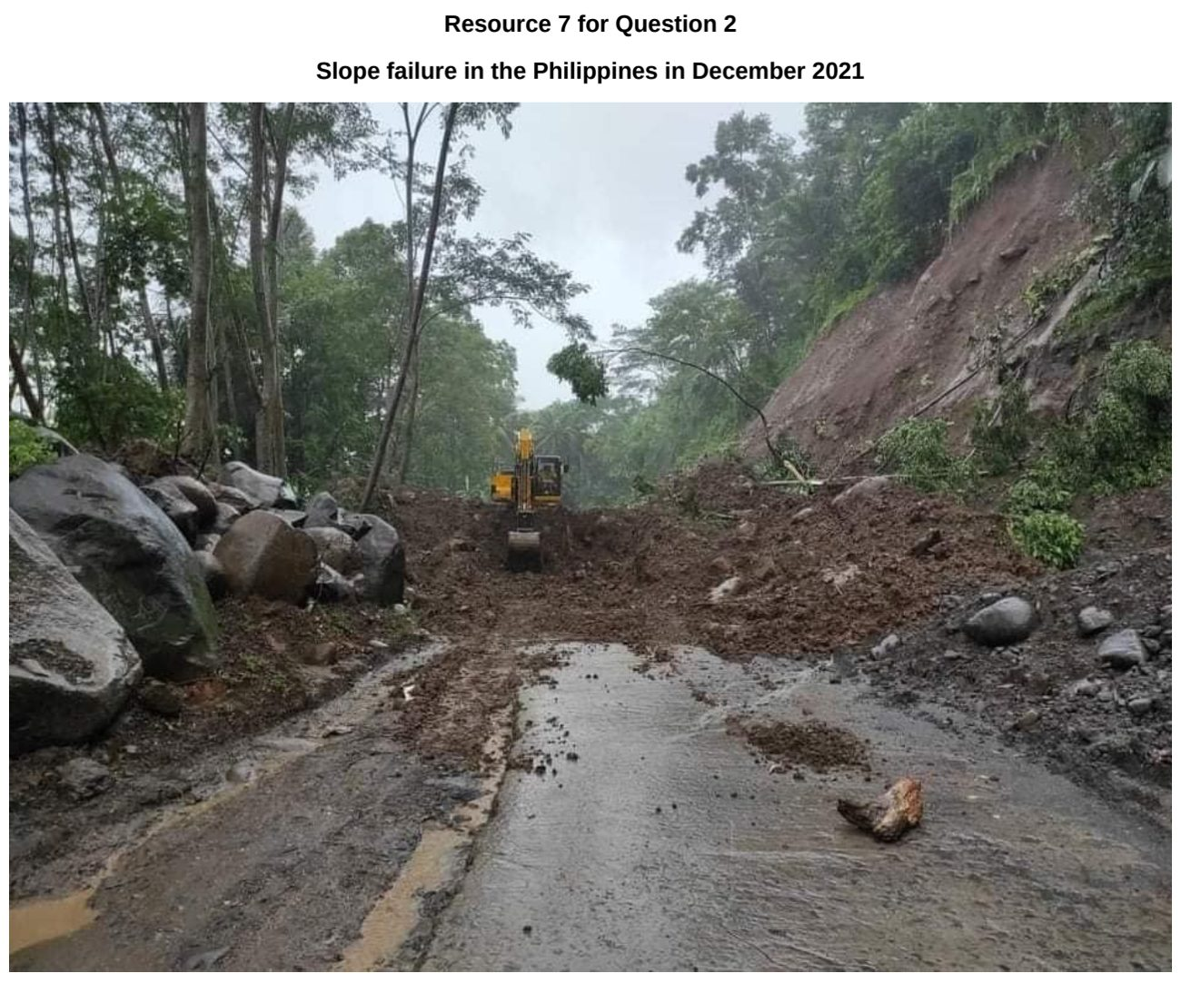

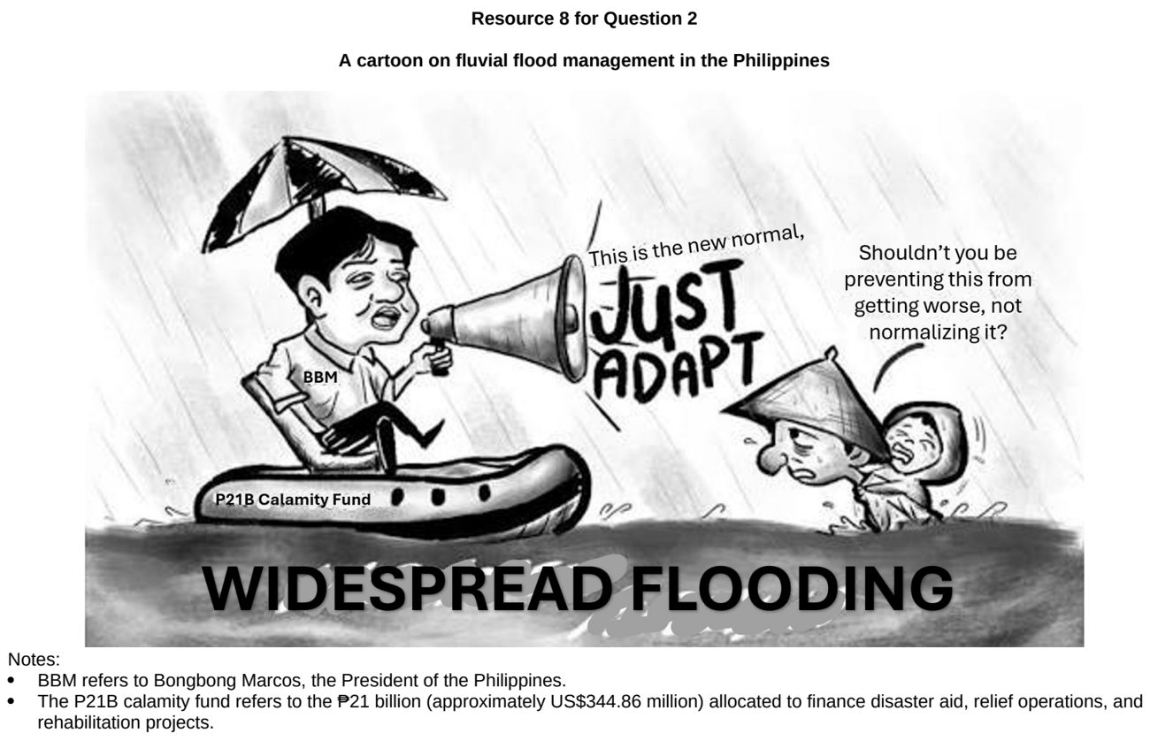

EJC 2024 — H2 Paper 1 (9173/01), Q2 [30 marks]
Syllabus: 2.1.2c Drainage Basin Hydrology – Pathways; 2.1.1c Tropical Climates – Synoptic circulation (monsoons, cyclones, ENSO); 2.2.3b Fluvial Landforms in the Humid Tropics – Formation of fluvial landforms; 2.1.1a Tropical Climates – Climate zones (temperature & rainfall); 2.2.3a Fluvial Landforms in the Humid Tropics – Fluvial landforms & features
Section A — Cluster 2: Tropical Environments
Resources 6A and 6B show the climographs of the two cities of Mumbai, India and Cairo, Egypt respectively. Resource 7 shows the regional wind system over India in June and January. Resource 8 shows a hydrograph of a drainage basin. Resource 9 shows a fluvial landform along the Brahmaputra River in India.
(a) With reference to Resources 6A and 6B, compare the temperature and rainfall characteristics of Mumbai and Cairo. [5]
(b) Using Resource 7, account for the rainfall patterns in Mumbai as shown in Resource 6A. [6]
(c) Contrast between percolation and overland flow in a drainage basin system. [4]
(d) With reference to Resource 8, explain how parts A and B of the hydrograph will change when rainfall intensity increases. [5]
(e) Describe the characteristics of the fluvial landform shown in Resource 9. [4]
(f) Explain the fluvial processes leading to the formation of the fluvial landform shown in Resource 9. [6]

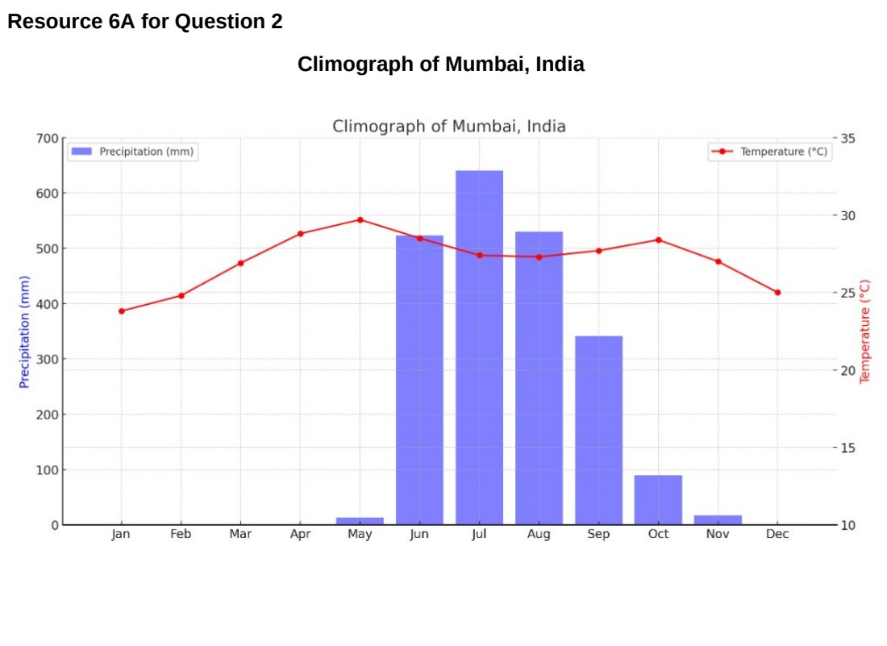

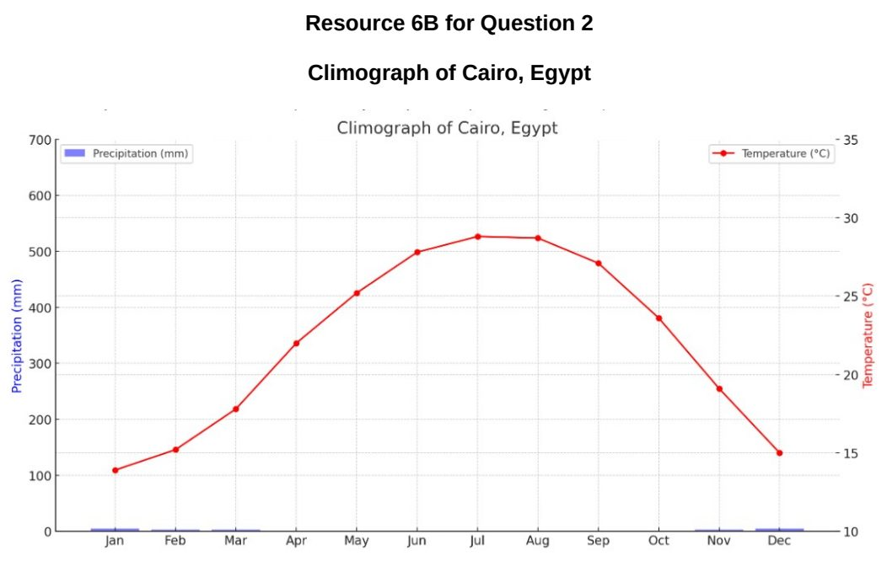

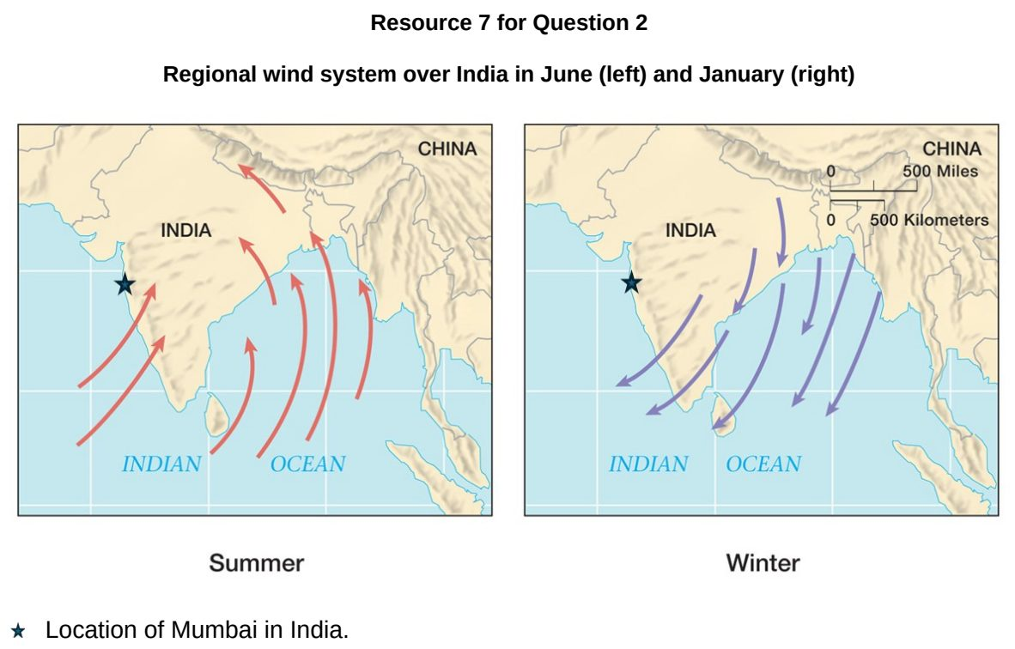

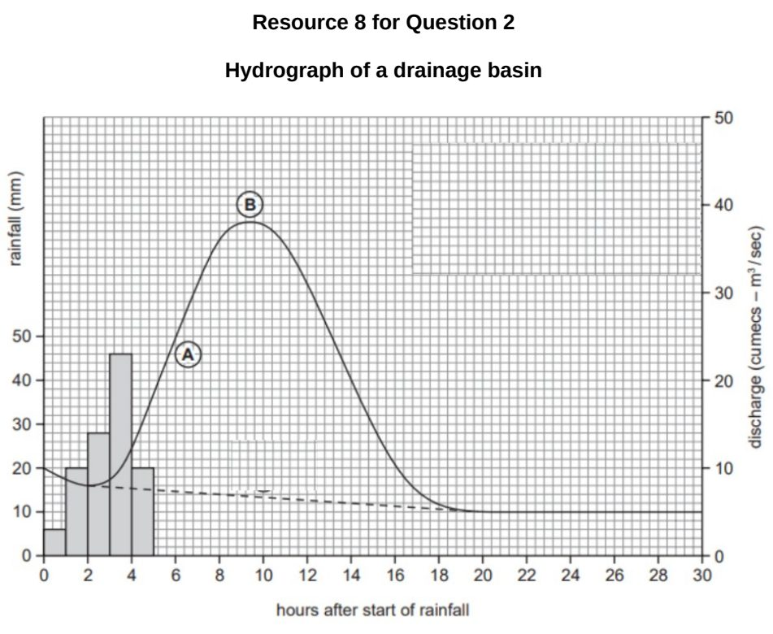

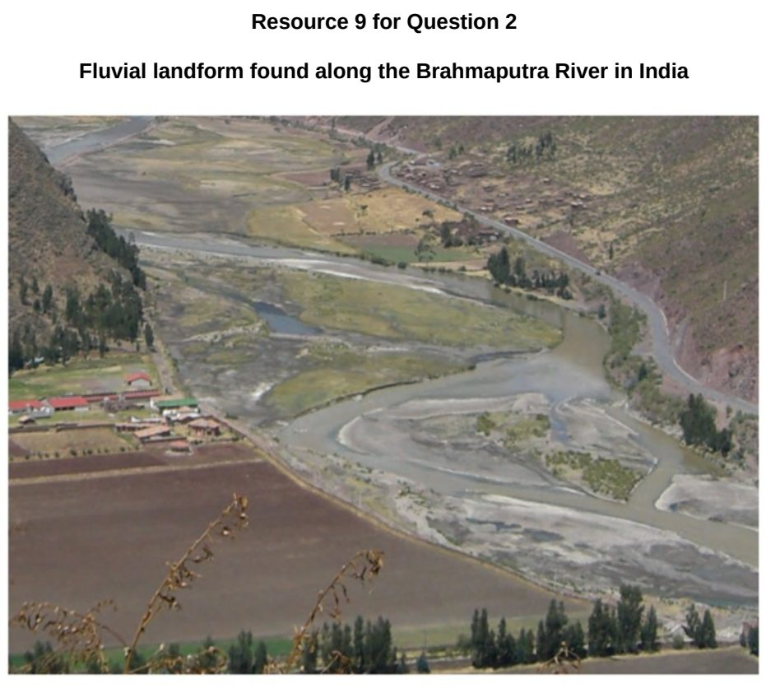

EJC 2025 — H2 Paper 1 (9173/01), Q2 [30 marks]
Syllabus: 2.1.1c Tropical Climates – Synoptic circulation (monsoons, cyclones, ENSO); 2.2.1c Geomorphic Processes – Fluvial processes; 2.1.1a Tropical Climates – Climate zones (temperature & rainfall); 2.1.2c Drainage Basin Hydrology – Pathways; 2.2.3a Fluvial Landforms in the Humid Tropics – Fluvial landforms & features
Section A — Cluster 2: Tropical Environments
Resources 4A and 4B show the climographs of two Indian cities, Mumbai and New Delhi, respectively. Resource 5 shows the rainfall in the Indian subcontinent from May through October. Resource 6 shows a section of the Brahmaputra River.
(a) Using Resources 4A and 4B, compare the climatic characteristics of Mumbai and New Delhi. [5]
(b) Cite data from Resource 5 to describe the rainfall distribution in the Indian subcontinent from May through October. [5]
(c) With reference to Resource 5, explain how the monsoon circulation affects the rainfall patterns in the Indian subcontinent from May through October. [6]
(d) Distinguish between infiltration and throughflow in a drainage basin system. [4]
(e) Describe the channel characteristics of the Brahmaputra River as shown in Resource 6. [4]
(f) Suggest how human factors can influence fluvial processes in rivers. [6]

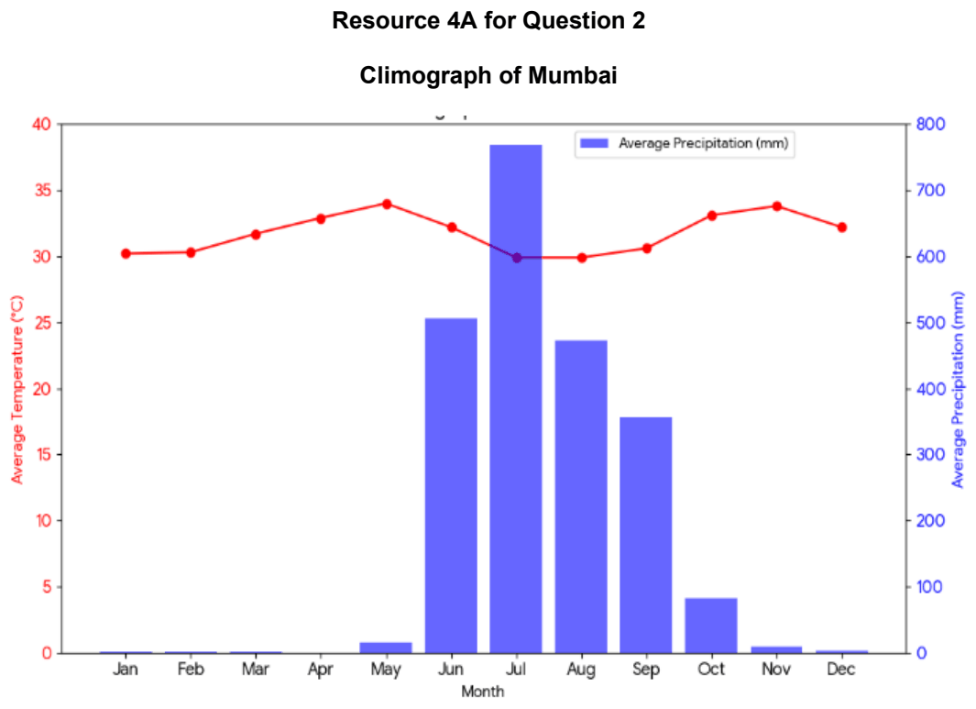

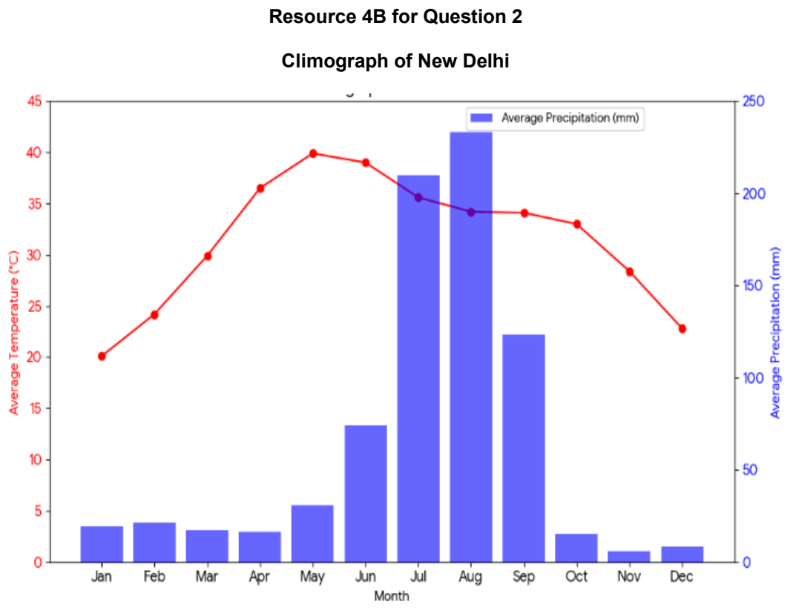

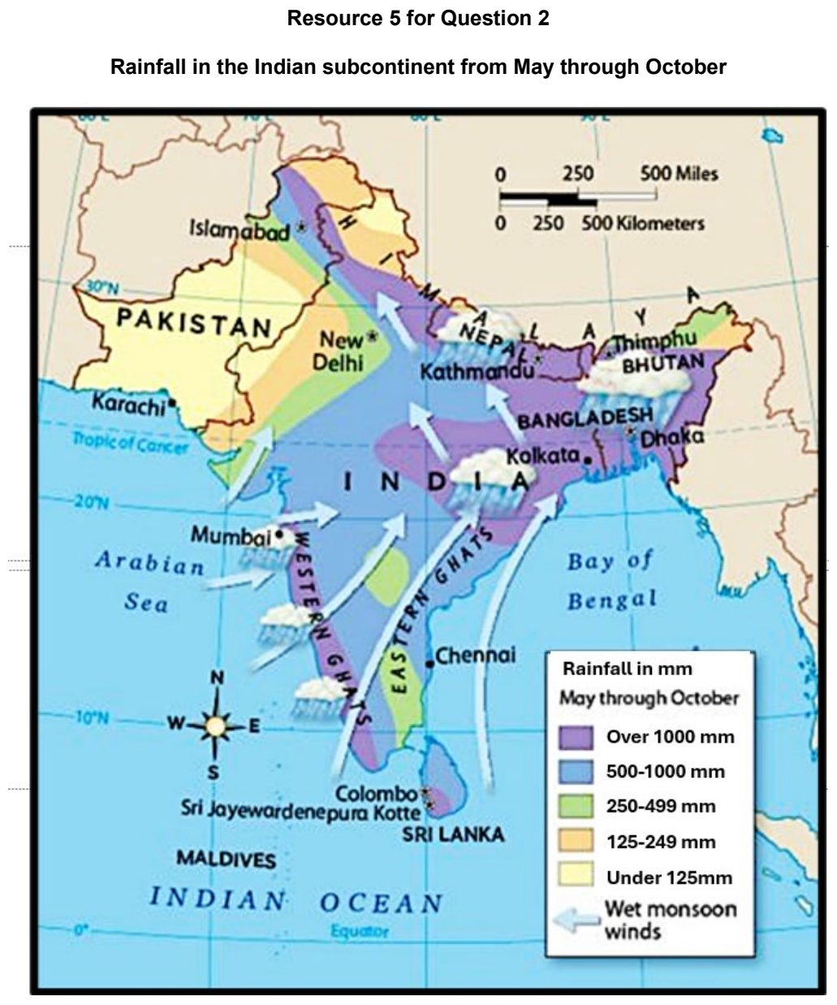

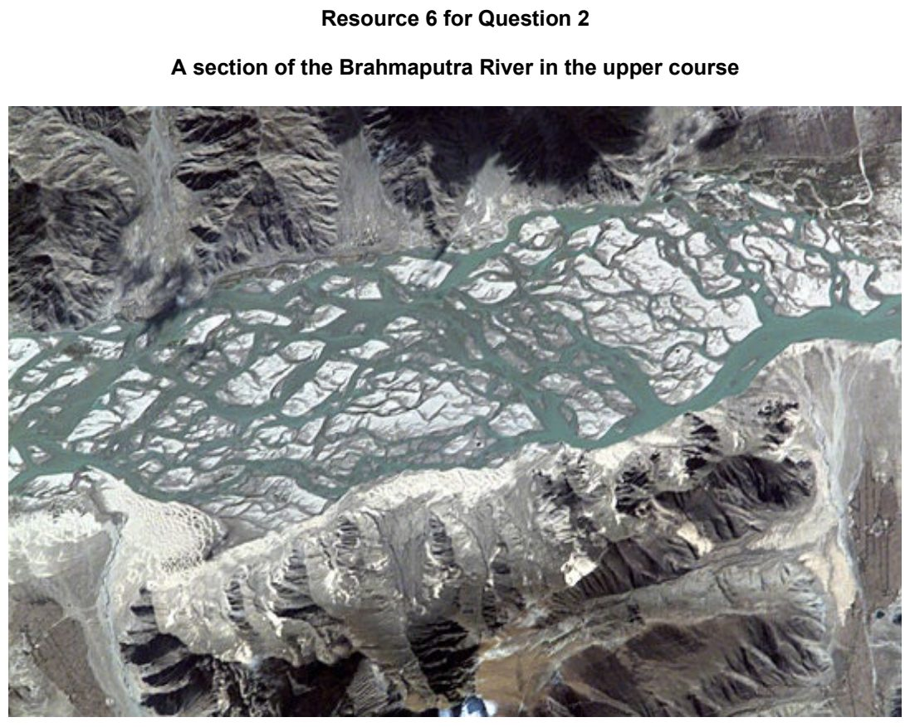

EJC 2026 — H2 Paper 1 (9173/01), Q2 [30 marks]
Syllabus: 2.1.1c Tropical Climates – Synoptic circulation (monsoons, cyclones, ENSO); 2.2.3c Fluvial Landforms in the Humid Tropics – Delta ecosystem services; 2.2.3b Fluvial Landforms in the Humid Tropics – Formation of fluvial landforms
Section A — Cluster 2: Tropical Environments
Resource 4 shows the sea surface temperature deviations as a result of El Nino Southern Oscillation (ENSO). Resource 5 shows global precipitation impact during La Nina. Resource 6 shows precipitation anomalies in the Mekong Basin during El Nino years. Resource 7 shows the landuse map of Mekong Delta.
(a) Describe the patterns in sea surface temperature deviations during ENSO as shown in Resource 4. [5]
(b) Using Resource 5, describe the precipitation impact of La Nina globally. [5]
(c) Explain how the El Nino phase can result in changes in rainfall over tropical Pacific. [5]
(d) With reference to Resource 6 describe the pattern of rainfall anomalies in the Mekong Basin during the El Nino years. [4]
(e) With the aid of Resource 7, suggest how ecosystem services provided by deltas can be impacted by El Nino rainfall anomalies. [6]
(f) Explain the factors influencing the formation of deltas. [5]

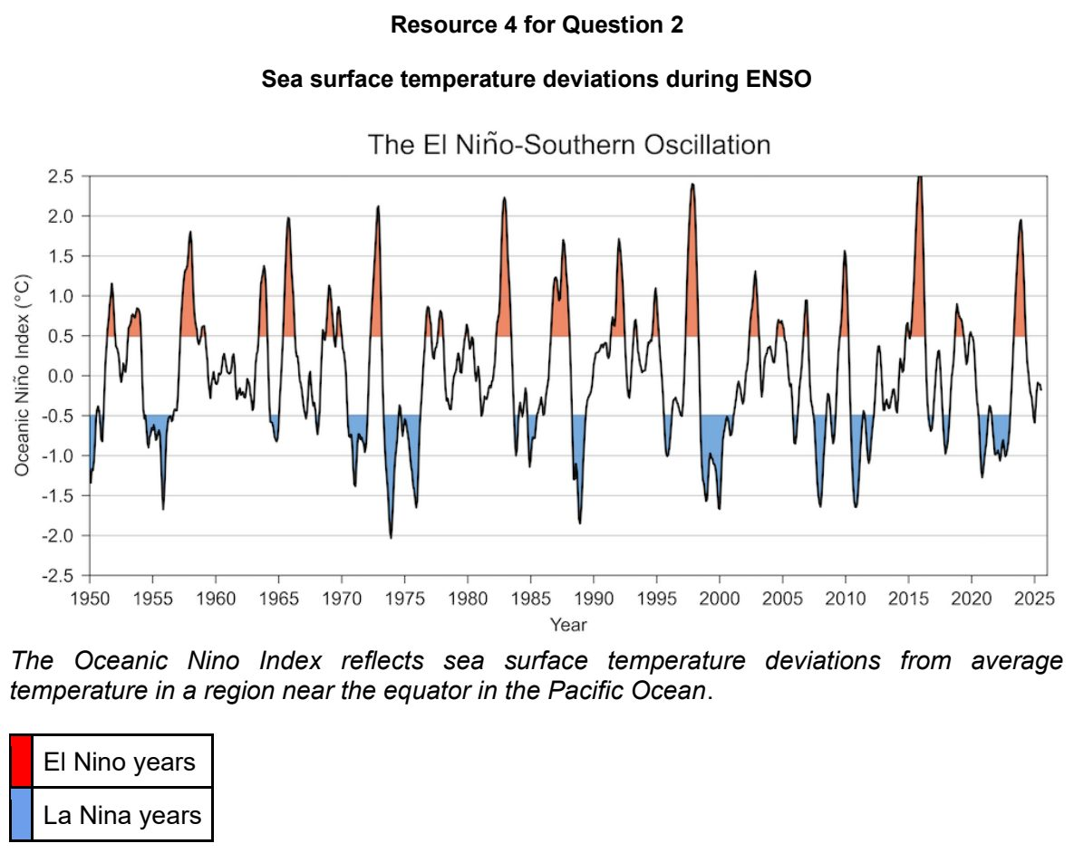

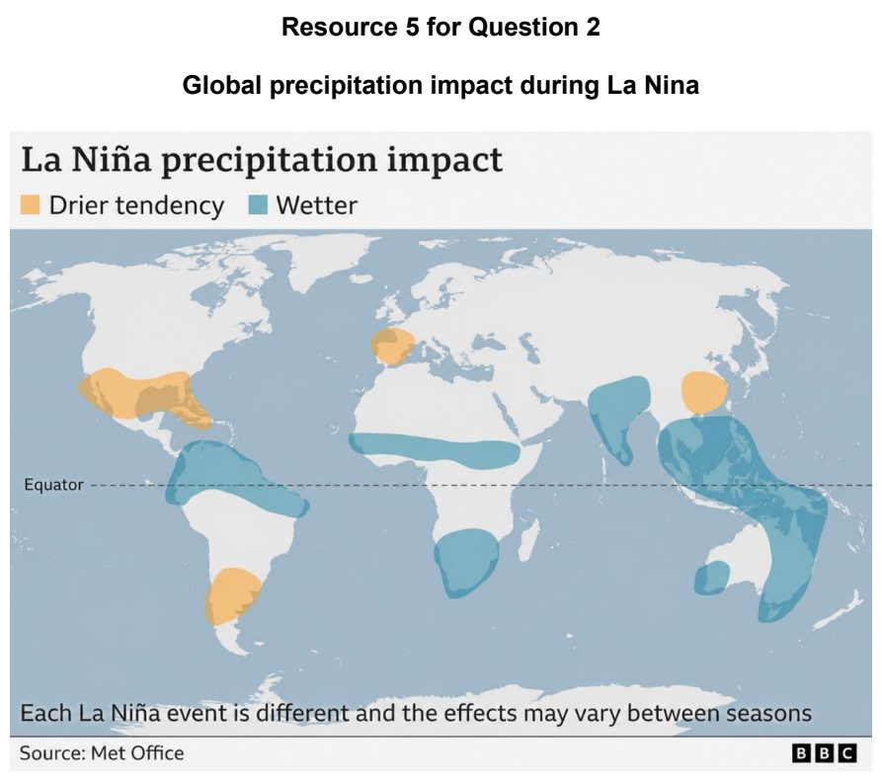

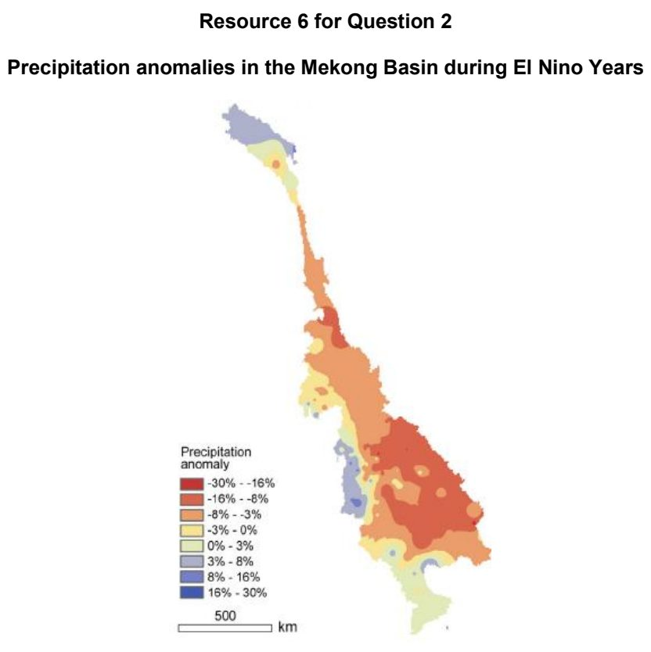

HCI 2025 — H2 Paper 1 (9173/01), Q2 [30 marks]
Syllabus: 2.1.1c Tropical Climates – Synoptic circulation (monsoons, cyclones, ENSO); 2.1.2b Drainage Basin Hydrology – Water storage; 2.1.1a Tropical Climates – Climate zones (temperature & rainfall)
Section A — Cluster 2: Tropical Environments
Resources 4A and 4B show the climographs for Cherrapunji and Mumbai in India. Resource 5 shows monsoon circulation over India in July and January. Resource 6 shows the structural characteristics of a ‘monsoon low’ and tropical cyclone. Resource 7 shows India’s summer monsoon (wet monsoon) rainfall between 1871 and 2023 and El Niño and La Niña years.
(a) Cite data from Resources 4A and 4B to compare the climate characteristics of Cherrapunji and Mumbai. [4]
(b) With reference to Resource 5, suggest reasons for the climate characteristics of Cherrapunji and Mumbai shown in Resources 4A and 4B. [6]
(c) With reference to Resource 6, describe two differences between ‘monsoon lows’ and tropical cyclones. [4]
(d) Explain how tropical cyclones may impact the storages in drainage basin systems. [6]
(e) Describe the relationship between the El Niño and La Niña phases and summer monsoon rainfall in India shown in Resource 7. [5]
(f) Explain the influence of the El Niño Southern Oscillation (ENSO) on rainfall in the tropics. [5]

JPJC 2024 — H2 Paper 1 (9173/01), Q2 [30 marks]
Syllabus: 2.1.3a Floods in the Humid Tropics – Causes of fluvial floods; 2.2.3b Fluvial Landforms in the Humid Tropics – Formation of fluvial landforms; 2.2.3c Fluvial Landforms in the Humid Tropics – Delta ecosystem services; 2.1.3b Floods in the Humid Tropics – Impacts of floods & vulnerability; 2.1.3c Floods in the Humid Tropics – Flood management
Section A — Cluster 2: Tropical Environments
Resource 4 shows a flood risk map of the Niger River in Nigeria, West Africa. Resource 5 shows flood risk at Talle on the Sirba River, a tributary of the Niger River. Resource 6 shows the location of Niger Delta along the Niger River. Resource 7 shows an oil spill in the Niger Delta.
(a) Compare the location and extent of low flood risk and high flood risk areas shown in Resource 4. [4]
(b) Suggest why there could be variations in flood risk across places as shown in Resource 4. [5]
(c) Describe how flooding would impact Talle as shown in Resource 5. [5]
(d) With reference to Resource 5, suggest two possible strategies to mitigate flooding in Talle. [4]
(e) Explain the role of geomorphic processes which has led to the formation of the Niger delta as shown in Resource 6. [6]
(f) With the aid of Resource 7, describe how human activities can negatively impact ecosystem services provided by deltas. [6]

JPJC 2026 — H2 Paper 1 (9173/01), Q2 [30 marks]
Syllabus: 2.1.1c Tropical Climates – Synoptic circulation (monsoons, cyclones, ENSO); 2.2.1b Geomorphic Processes – Mass movement & slope erosion; 2.1.1a Tropical Climates – Climate zones (temperature & rainfall)
Section A — Cluster 2: Tropical Environments
Resource 6 shows the track and intensity of Tropical Cyclone Narelle. Resource 7A shows the sea surface temperature (SST) anomaly in the Eastern Pacific in November 2025. Resource 7B shows the SST anomaly in the Eastern Pacific in May 2026.
(a) Compare the rainfall characteristics of the humid tropics with those of the arid tropics. [4]
(b) With reference to Resource 6, describe the track and changing intensity of Tropical Cyclone Narelle. [5]
(c) Cite data from Resource 6 to explain the surface and atmospheric conditions necessary for the formation of Tropical Cyclone Narelle. [6]
(d) Explain how the rainfall generated by a tropical cyclone can impact geomorphic processes. [6]
(e) With reference to Resources 7A and 7B, contrast the SST anomalies in the eastern equatorial Pacific Ocean between November 2025 and May 2026. [3]
(f) Account for the SST anomalies in the eastern equatorial Pacific Ocean shown in Resources 7A and 7B. [6]

NJC 2024 — H2 Paper 1 (9173/01), Q2 [30 marks]
Syllabus: 2.1.1c Tropical Climates – Synoptic circulation (monsoons, cyclones, ENSO); 2.2.3c Fluvial Landforms in the Humid Tropics – Delta ecosystem services; 2.2.3b Fluvial Landforms in the Humid Tropics – Formation of fluvial landforms; 2.1.1a Tropical Climates – Climate zones (temperature & rainfall)
Section A — Cluster 2: Tropical Environments
Resource 5 shows the climograph of Pathein, a city located within the Irrawaddy Delta in Myanmar. Resource 6 shows summer and winter monsoon circulations in humid tropical Asia. Resource 7 shows the forecast of Tropical Cyclone Mocha in May 2023 by the Myanmar Information Management Unit. Resource 8 shows land cover of the Irrawaddy Delta in 1974 and 2021.
(a) Describe the climatic characteristics of Pathein, Myanmar as seen in Resource 5. [4]
(b) Using Resource 6, account for the climatic characteristics of Pathein, Myanmar as shown in Resource 5. [6]
(c) With reference to Resource 7, describe the development of Tropical Cyclone Mocha. [4]
(d) Explain atmospheric and surface conditions necessary for the development of tropical cyclones, such as the one seen in Resource 7. [5]
(e) With reference to Resource 8, explain how ecosystem services provided by the Irrawaddy Delta could be affected by the changes in land cover. [6]
(f) Explain how deltas are formed. [5]

RI 2026 — H2 Paper 1 (9173/01), Q2 [30 marks]
Syllabus: 2.1.2b Drainage Basin Hydrology – Water storage; 2.1.2a Drainage Basin Hydrology – Input–output balance; 2.1.3b Floods in the Humid Tropics – Impacts of floods & vulnerability; 2.1.3a Floods in the Humid Tropics – Causes of fluvial floods
Section A — Cluster 2: Tropical Environments
Resource 4 shows average annual precipitation levels (m/year) in the USA, 2005 to 2015. Resource 5 shows water withdrawals per day in the USA in 2015. Resource 6 shows trends in population and freshwater withdrawals from drainage basins in the USA, 1950 to 2015. Resource 7 shows predicted percentage change in flood risk 2030 to 2100.
(a) Using Resource 4, describe the pattern of average annual precipitation. [4]
(b) Cite data from Resources 4 and 5 to identify two states that are most likely to suffer from water shortages in the USA. [4]
(c) Compare the patterns in groundwater and surface water withdrawals shown in Resource 6. [4]
(d) Describe the relationship between population change and freshwater withdrawals shown in Resource 6. [5]
(e) Apart from precipitation, suggest three reasons for the change in flood risk in the USA as shown in Resource 7. [6]
(f) With reference to all Resources, explain why the future effects of flooding may vary across the USA. [7]

RVHS 2025 — H2 Paper 1 (9173/01), Q2 [30 marks]
Syllabus: 2.1.1c Tropical Climates – Synoptic circulation (monsoons, cyclones, ENSO); 2.1.1b Tropical Climates – Global circulation (Hadley cells, ITCZ); 2.1.1a Tropical Climates – Climate zones (temperature & rainfall)
Section A — Cluster 2: Tropical Environments
Resource 5 shows the climograph of Hat Yai (7°N), Thailand. Resource 6 shows the mean long-term location of the ITCZ over Thailand. Resource 7 shows a scene in Jeddah (21.5°N), Saudi Arabia. Resource 8A shows the difference from average winter-spring rainfall in Australia for moderate-strong El Nino events. Resource 8B shows a map of Australia.
(a) Citing data from Resource 5, describe the climate characteristics of Hat Yai, Thailand. [4]
(b) With reference to Resource 6, explain the climate characteristics of Hat Yai, Thailand described in (a). [8]
(c) Explain the predominant factor that has led to the development of the landscape shown in Resource 7. [3]
(d) Citing data from Resources 8A and 8B, describe the difference from average winter-spring rainfall in Australia for moderate-strong El Nino events. [4]
(e) Explain how El Nino impacts rainfall in Australia as shown in Resource 8A. [6]
(f) Explain how La Nina affects climatic conditions in Australia. [5]

RVHS 2026 — H2 Paper 1 (9173/01), Q2 [30 marks]
Syllabus: 2.1.2b Drainage Basin Hydrology – Water storage; 2.2.3c Fluvial Landforms in the Humid Tropics – Delta ecosystem services; 2.2.3b Fluvial Landforms in the Humid Tropics – Formation of fluvial landforms; 2.1.2c Drainage Basin Hydrology – Pathways
Section A — Cluster 2: Tropical Environments
Resource 5 shows variation in hydrological outputs and pathways among different tree cover extents. Resource 6 shows the Mekong Delta with indications of the historical coastlines of the delta. Resource 7 shows the changes in mangrove areas and water surfaces for aquaculture in the Mekong Delta between 1950 and 2015. Resource 8 shows the primary environmental pressures on the Vietnamese Mekong Delta
(a) With reference to Resource 5, describe the relationship between tree cover extent and hydrological pathways. [5]
(b) With reference to Resource 5, explain how tree cover affects the storage of water in a drainage basin. [6]
(c) Explain why water storage in a drainage basin might change over time. [4]
(d) Describe the geomorphic processes that have created the landform shown in Resource 6. [6]
(e) Citing data from Resource 7, compare the changes in mangrove area with the area of water surfaces for aquaculture in the Mekong Delta between 1950 and 2015. [4]
(f) With reference to Resources 7 and 8, explain how human activities can impact the ability of deltas to provide ecosystem services. [5]

SAJC 2025 — H2 Paper 1 (9173/01), Q2 [30 marks]
Syllabus: 2.1.1c Tropical Climates – Synoptic circulation (monsoons, cyclones, ENSO); 2.1.3b Floods in the Humid Tropics – Impacts of floods & vulnerability; 2.1.1a Tropical Climates – Climate zones (temperature & rainfall); 2.1.2c Drainage Basin Hydrology – Pathways; 2.1.3a Floods in the Humid Tropics – Causes of fluvial floods
Section A — Cluster 2: Tropical Environments
Resource 4 shows the climograph of Mangalore, India. Resource 5 shows the arrival of monsoon winds in India. Resource 6 shows the seasonal monsoon wind system in India. Resource 7 shows the hydrograph recorded after an intense rainfall event that occurred in June.
(a) Using Resource 4, describe the climatic characteristics of Mangalore. [4]
(b) Describe the arrival of monsoon winds in India, as shown in Resource 5. [5]
(c) With reference to Resources 4 and 6, explain the rainfall pattern of Mangalore. [7]
(d) Describe the characteristics of the hydrograph shown in Resource 7. [4]
(e) Explain two human activities that contribute to the occurrence of fluvial floods. [4]
(f) Using examples, explain how the impacts of fluvial floods can vary between groups of people of different income levels. [6]

SAJC 2026 — H2 Paper 1 (9173/01), Q2 [30 marks]
Syllabus: 2.1.1c Tropical Climates – Synoptic circulation (monsoons, cyclones, ENSO); 2.1.1b Tropical Climates – Global circulation (Hadley cells, ITCZ)
Section A — Cluster 2: Tropical Environments
Resource 5 shows the track and intensity of Super Typhoon Koppu from 13 to 20 October 2015. Resource 6 shows changes in the estimated minimum central pressure and maximum surface wind speed of Koppu. Resource 7 shows typical sea-surface temperature and rainfall anomalies during El Niño and La Niña conditions.
(a) With reference to Resource 5, describe the changes in the location and intensity of Typhoon Koppu from 13 to 20 October 2015. [5]
(b) Compare the changes in estimated minimum central pressure and maximum surface wind speed shown in Resource 6. [5]
(c) Explain the conditions that are necessary for tropical cyclone formation. [5]
(d) Explain the role of surplus heat in driving atmospheric circulation in the Hadley Cells. [5]
(e) Describe the differences between the El Niño and La Niña conditions shown in Resource 7. [4]
(f) With reference to Resource 7, explain how the El Niño and La Niña conditions influence rainfall variations in the tropics. [6]

TJC 2025 — H2 Paper 1 (9173/01), Q2 [30 marks]
Syllabus: 2.1.1c Tropical Climates – Synoptic circulation (monsoons, cyclones, ENSO); 2.2.3a Fluvial Landforms in the Humid Tropics – Fluvial landforms & features; 2.2.3b Fluvial Landforms in the Humid Tropics – Formation of fluvial landforms
Section A — Cluster 2: Tropical Environments
Resource 4 shows the monsoons of Asia and Australia. Resource 5 shows the path of Typhoon Haiyan, a powerful tropical cyclone in the South China Sea in 2013. Resource 6 shows monthly sea surface temperatures in the Pacific Ocean. Resource 7 is a satellite image of part of the Padma (Ganges) delta in Bangladesh.
(a) Using Resource 4, compare the characteristics of the monsoons of Asia and Australia in January and July. [5]
(b) Explain how the summer monsoon circulation affects rainfall patterns in humid tropical Asia. [6]
(c) With reference to Resource 5, explain the conditions which resulted in the development and path of Typhoon Haiyan. [5]
(d) Explain the relationship between sea surface temperatures and the phases of the El Niño Southern Oscillation (ENSO) shown in Resource 6. [6]
(e) Using Resource 7, describe the features of the Padma (Ganges) delta in Bangladesh. [4]
(f) Explain two factors that may influence the formation of deltas. [4]

TJC 2026 — H2 Paper 1 (9173/01), Q2 [30 marks]
Syllabus: 2.1.1c Tropical Climates – Synoptic circulation (monsoons, cyclones, ENSO); 2.1.2a Drainage Basin Hydrology – Input–output balance; 2.1.2b Drainage Basin Hydrology – Water storage; 2.2.1b Geomorphic Processes – Mass movement & slope erosion
Section A — Cluster 2: Tropical Environments
Resource 5 shows a mass movement in the tropics. Resource 6 shows the distribution of areas affected by tropical cyclones. Resource 7 shows the depth of groundwater in southern India in March and September. Resource 8 shows the water balance for a city in southern India.
(a) Using Resource 5, describe the features of the mass movement shown. [4]
(b) Describe the distribution of areas affected by tropical cyclones shown in Resource 6. [5]
(c) Explain why tropical cyclones only affect specific areas around the world. [5]
(d) Using Resource 7, compare the depth of groundwater in southern India between March and September. [5]
(e) Using Resources 7 and 8, suggest reasons for the changes in the depth of groundwater in southern India between March and September. [6]
(f) Explain how the El Niño phase of the El Niño Southern Oscillation (ENSO) affects rainfall over the tropical Pacific. [5]

TMJC 2025 — H2 Paper 1 (9173/01), Q2 [30 marks]
Syllabus: 2.1.1c Tropical Climates – Synoptic circulation (monsoons, cyclones, ENSO); 2.1.3b Floods in the Humid Tropics – Impacts of floods & vulnerability; 2.1.1a Tropical Climates – Climate zones (temperature & rainfall); 2.2.3b Fluvial Landforms in the Humid Tropics – Formation of fluvial landforms
Section A — Cluster 2: Tropical Environments
Resource 5 shows the map and climograph of Dhaka, the capital city of Bangladesh. Resource 6 temporal patterns in river discharge measured at a research station situated at the lower course of the Padma River in Bangladesh. Resource 7 shows the forecast of Tropical Cyclone Remal in May 2024. Resource 8 shows land cover maps of Dhaka metropolitan area from 1989 to 2009.
(a) Describe the climatic characteristics of Dhaka, Bangladesh as seen in Resource 5. [4]
(b) Account for the climatic characteristics of Dhaka, Bangladesh as shown in Resource 5. [6]
(c) Suggest how the river discharge shown in Resource 6 may influence the development of fluvial landform(s). [4]
(d) With reference to Resource 7, describe the track and development of Tropical Cyclone Remal. [4]
(e) Explain how tropical cyclones develop. [6]
(f) With reference to Resource 8, explain how impacts of fluvial floods could have differed between 1989 to 2009. [6]

YIJC 2025 — H2 Paper 1 (9173/01), Q2 [30 marks]
Syllabus: 2.1.1c Tropical Climates – Synoptic circulation (monsoons, cyclones, ENSO); 2.1.3a Floods in the Humid Tropics – Causes of fluvial floods; 2.1.1b Tropical Climates – Global circulation (Hadley cells, ITCZ)
Section A — Cluster 2: Tropical Environments
Resource 5 shows the relationship between the Inter-tropical Convergence Zone (ITCZ) and tropical cyclones. Resource 6 shows the development of Hurricane Gustav. Resource 7 shows the fluctuations of the Indian Summer Monsoon Rainfall from 1871 to 2023. Resource 8 shows the variation in the effect of El Niño in various parts of the Asia-Pacific region.
(a) Using Resource 5, explain the relationship between the Inter-tropical Convergence Zone (ITCZ) and frequency of tropical cyclones. [4]
(b) Using Resource 5 and Resource 6, describe the development of Hurricane Gustav. [4]
(c) Explain how atmospheric and oceanic conditions differ between El Niño and La Nina events. [6]
(d) Describe the variations in the Indian Summer Monsoon Rainfall from 1871 to 2023 as seen in Resource 7. [4]
(e) With reference to Resource 8, account for the variations in the impact of El Niño in various parts of the Asia-Pacific region. [6]
(f) Explain how floods can result from both natural and human factors. [6]

2.2 Landforms in the Tropics

ACJC 2024 — H2 Paper 1 (9173/01), Q2 [30 marks]
Syllabus: 2.2.1a Geomorphic Processes – Weathering; 2.2.1b Geomorphic Processes – Mass movement & slope erosion; 2.2.2a Karst Landforms in the Humid Tropics – Karst landforms & features; 2.2.2c Karst Landforms in the Humid Tropics – Karst ecosystem services; 2.1.1a Tropical Climates – Climate zones (temperature & rainfall); 2.1.1c Tropical Climates – Synoptic circulation (monsoons, cyclones, ENSO)
Section A — Cluster 2: Tropical Environments
Resource 5 shows the climate graph of Phang Nga Bay, Thailand. Resource 6A shows karst landforms in Phang Nga Bay, Thailand in the Tropical Monsoon climate zone. Resource 6B shows weathering on a rock pedestal in Timna Valley, Israel in the Tropical Desert climate zone. Resource 7 shows a rockfall at the Halsema Highway near Bontoc, Philippines in July 2022.
(a) Explain the temperature pattern shown in Resource 5. [4]
(b) Explain the rainfall pattern shown in Resource 5. [6]
(c) Describe the main features of tower karst in Resource 6A. [3]
(d) With reference to Resources 6A and 6B, compare the weathering processes likely to be operating in each of the landscapes. [6]
(e) Describe the ecosystem services provided by the karst landforms in Resource 6A. [6]
(f) Explain the factors likely to have induced the rockfall shown in Resource 7. [5]

ASRJC 2024 — H2 Paper 1 (9173/01), Q2 [30 marks]
Syllabus: 2.2.1b Geomorphic Processes – Mass movement & slope erosion; 2.2.1a Geomorphic Processes – Weathering; 2.2.2b Karst Landforms in the Humid Tropics – Formation of karst
Section A — Cluster 2: Tropical Environments
Resource 6 shows a weathered rock which contains iron. Resource 7 shows a limestone region in Jamaica.
Resource 8 shows the relationship between rainfall characteristics and the occurrence of debris flows. Resource 9 shows a schematic diagram of factors leading to the development of a mass movement.
(a) With reference to Resource 6, account for the likely weathering process that the rock has undergone. [4]
(b) Within reference to Resource 7, explain how the features of the limestone region shown may have developed. [6]
(c) Explain how climatic factors may influence weathering of rocks. [6]
(d) With reference to Resource 8, explain how rainfall characteristics could influence the occurrence of debris flows. [6]
(e) With reference to Resource 9, account for the likely mass movement that might develop. [4]
(f) Explain how human factors may influence mass movements on slopes. [4]

ASRJC 2026 — H2 Paper 1 (9173/01), Q2 [30 marks]
Syllabus: 2.2.1b Geomorphic Processes – Mass movement & slope erosion; 2.2.3b Fluvial Landforms in the Humid Tropics – Formation of fluvial landforms; 2.2.3a Fluvial Landforms in the Humid Tropics – Fluvial landforms & features; 2.2.1c Geomorphic Processes – Fluvial processes
Section A — Cluster 2: Tropical Environments
In April 2024, Jiangwan Town, which lies in the Shaoguan City administrative area of Guangdong Province, China suffered extremely heavy rainfall, triggering mass movements and floods. Resource 5A shows the daily rainfall and cumulative rainfall distribution in Shaoguan in April 2024. Resource 5B shows the distribution of rainfall for the same period in April for the past 30 years in Shaoguan. Resource 6 shows a mass movement in Jiangwan Town on 24 April 2024.
Resource 7 shows the position of the Mississippi River delta lobes over different time periods.
(a) With reference to Resources 5A and 5B, explain why the rainfall events on 19 and 20 April 2024 in Shaoguan were considered “extreme”. [6]
(b) Describe the type of mass movement shown in Resource 6. [4]
(c) With reference to Resources 5 and 6, explain how the mass movement in Jiangwan Town of Shaoguan City may have occurred. [6]
(d) Describe how mass movement events may impact deposition in a river channel. [3]
(e) Explain how meanders may develop along a river. [7]
(f) Describe the changes in the position of the delta lobes shown in Resource 7. [4]

CJC 2024 — H2 Paper 1 (9173/01), Q2 [30 marks]
Syllabus: 2.2.3b Fluvial Landforms in the Humid Tropics – Formation of fluvial landforms; 2.1.1b Tropical Climates – Global circulation (Hadley cells, ITCZ); 2.2.1a Geomorphic Processes – Weathering; 2.2.3a Fluvial Landforms in the Humid Tropics – Fluvial landforms & features; 2.1.1a Tropical Climates – Climate zones (temperature & rainfall)
Section A — Cluster 2: Tropical Environments
Resource 5 is a climograph of a region in North-West Botswana. Resource 6 is a map of Botswana. Resource 7 shows the elevation of the Mekong River delta above sea level.
(a) Citing data from Resource 5, describe the characteristics of Botswana’s climate. [4]
(b) Referring to Resources 5 and 6, explain the climate characteristics of Botswana. [6]
(c) With reference to Resource 5, explain how climate can influence weathering processes in Botswana. [5]
(d) Explain the factors influencing the formation of meanders. [4]
(e) Describe the features of the Mekong River delta as shown in Resource 7. [5]
(f) Explain how a delta forms over time. [6]

CJC 2025 — H2 Paper 1 (9173/01), Q2 [30 marks]
Syllabus: 2.2.3b Fluvial Landforms in the Humid Tropics – Formation of fluvial landforms; 2.2.3c Fluvial Landforms in the Humid Tropics – Delta ecosystem services; 2.2.3a Fluvial Landforms in the Humid Tropics – Fluvial landforms & features; 2.1.3b Floods in the Humid Tropics – Impacts of floods & vulnerability; 2.1.3c Floods in the Humid Tropics – Flood management; 1.1.3b Managing Resources – Transboundary water conflicts
Section A — Cluster 2: Tropical Environments
Resource 5 shows a map of Nile River and its tributaries. Resource 6 shows Nile discharge before and after the Grand Ethiopian Renaissance Dam (GERD) was built. Resource 7 shows the elevation of the Nile River Delta.
(a) Cite data from Resource 6 to compare discharge before and after GERD was built. [4]
(b) With reference to Resources 5 and 6, explain how the construction of GERD may influence the formation of fluvial landforms. [6]
(c) With reference to Resource 6, describe how humans can compromise the ability of deltas to provide ecosystem services. [5]
(d) Describe the features of the Nile River Delta as shown in Resource 7. [5]
(e) Explain the variations in the effects of fluvial floods experienced by different groups of people. [5]
(f) Explain the strengths and limitations of strategies to manage fluvial floods. [5]

DHS 2024 — H2 Paper 1 (9173/01), Q2 [30 marks]
Syllabus: 2.2.3a Fluvial Landforms in the Humid Tropics – Fluvial landforms & features; 2.2.3b Fluvial Landforms in the Humid Tropics – Formation of fluvial landforms; 2.1.1c Tropical Climates – Synoptic circulation (monsoons, cyclones, ENSO); 2.1.1b Tropical Climates – Global circulation (Hadley cells, ITCZ); 2.2.1c Geomorphic Processes – Fluvial processes
Section A — Cluster 2: Tropical Environments
Resource 5 shows the position of the Intertropical Convergence Zone (ITCZ) and wind systems in the tropics in January and July. Resource 6 shows the relief map of the Indian subcontinent and the rainfall received in July at locations A, B and C. Resource 7 shows a developed river channel of the Mekong River that is in flood in Cambodia. Resource 8 is a schematic diagram of the stages in the development of the river channel in Resource 7.
(a) With reference to Resource 5, describe the differences in the features of the ITCZ and wind systems in January and July. [5]
(b) With reference to Resources 5 and 6, explain the difference in the rainfall received in July for locations A, B and C in Resource 6. [6]
(c) Compare the river channel at Stage 1 with the river channel at Stage 3 as shown in Resource 8. [4]
(d) With reference to Resource 8, explain how the fluvial processes operating in the channel in Stages 2 and 3 will result in the developed channel in Resource 7. [7]
(e) Name and describe the feature labelled X and the feature between Y and Z in Resource 7. [4]
(f) With reference to Resource 7, explain how the nature of the channel and the physical processes operating in the channel affect Settlements A and B differently. [4]

DHS 2025 — H2 Paper 1 (9173/01), Q2 [30 marks]
Syllabus: 2.1.1c Tropical Climates – Synoptic circulation (monsoons, cyclones, ENSO); 2.2.3c Fluvial Landforms in the Humid Tropics – Delta ecosystem services; 2.2.1b Geomorphic Processes – Mass movement & slope erosion
Section A — Cluster 2: Tropical Environments
Resource 5 shows the distribution of annual summer monsoon rainfall totals in India from 1901 to 2010. Resource 6 shows a classification of mass movements in the tropics according to water content and velocity. Resource 7 shows land use change in the Indian section of the Ganges-Brahmaputra Delta from 2001-2002 to 2010-2011.
(a) Describe the distribution of annual summer monsoon rainfall totals for India from 1901 to 2010 as shown in Resource 5. [5]
(b) With reference to Resource 5, suggest reasons for the variation in annual summer monsoon rainfall. [6]
(c) Describe the differences in mass movements shown in Resource 6. [4]
(d) Suggest reasons for the range of velocity for debris slide shown in Resource 6. [4]
(e) With reference to Resource 7, describe the land use change in the Indian section of the Ganges-Brahmaputra Delta from 2001-2002 to 2010-2011. [5]
(f) Explain how the land use change shown in Resource 7 may impact ecosystem services provided by the Ganges-Brahmaputra Delta. [6]

DHS 2026 — H2 Paper 1 (9173/01), Q2 [30 marks]
Syllabus: 2.1.1c Tropical Climates – Synoptic circulation (monsoons, cyclones, ENSO); 2.2.3b Fluvial Landforms in the Humid Tropics – Formation of fluvial landforms; 2.2.3c Fluvial Landforms in the Humid Tropics – Delta ecosystem services; 2.2.3a Fluvial Landforms in the Humid Tropics – Fluvial landforms & features
Section A — Cluster 2: Tropical Environments
Resource 5 shows the forecasted likelihood of the three El Niño Southern Oscillation (ENSO) phases - La Niña, Neutral, El Niño, from February to December 2024. Resource 6 shows La Niña climate impacts from December 2023 to February 2024 and from June to August 2024. Resources 7A and 7B show satellite images of the Yellow River Delta in Shandong Province, China, in 1979 and 2000 respectively. Resource 8 shows annual discharge, sediment load and land area of delta of the Yellow River in Shandong Province, China, between 1979 and 2020
(a) Using Resource 5, describe the pattern of the forecasted likelihood of the three ENSO phases in 2024. [3]
(b) Compare the spatial patterns of La Niña climate impacts between December 2023 to February 2024 and June 2024 to August 2024 shown in Resource 6. [5]
(c) Describe the atmospheric and surface conditions necessary for the development of tropical cyclones. [6]
(d) Using Resources 7A and 7B, describe the changes in Yellow River Delta between 1979 and 2000. [4]
(e) With reference to Resources 7A, 7B and 8, suggest reasons for the changes in the Yellow River Delta between 1979 and 2020. [6]
(f) Explain the impact of human activities on ecosystem services provided by deltas. [6]

HCI 2024 — H2 Paper 1 (9173/01), Q2 [30 marks]
Syllabus: 2.2.3c Fluvial Landforms in the Humid Tropics – Delta ecosystem services; 2.2.3a Fluvial Landforms in the Humid Tropics – Fluvial landforms & features; 2.2.3b Fluvial Landforms in the Humid Tropics – Formation of fluvial landforms
Section A — Cluster 2: Tropical Environments
Resource 4 shows the classification of deltas. Resource 5 shows the Niger Delta in Nigeria with ecoregions and land use types. Resource 6 shows land use and land cover impacted by oil spills in the Niger Delta.
(a) Cite data from Resource 4 to describe how deltas can be classified. [4]
(b) Describe the key features of a delta. [5]
(c) With reference to Resource 4, explain the role of geomorphic processes in the formation of deltas. [6]
(d) With reference to Resource 5, suggest the various ecosystem services provided by the Niger Delta. [6]
(e) Compare the distribution of oil spill incidences across the various land uses as seen in Resource 6. [3]
(f) With reference to Resources 5 and 6, suggest the impacts of human activity on the ecosystem services found in the Niger Delta. [6]

HCI 2026 — H2 Paper 1 (9173/01), Q2 [30 marks]
Syllabus: 2.2.1b Geomorphic Processes – Mass movement & slope erosion; 2.2.1a Geomorphic Processes – Weathering; 2.1.1a Tropical Climates – Climate zones (temperature & rainfall)
Section A — Cluster 2: Tropical Environments
Resource 5 shows the climate graph of Bujumbura, Burundi in east-central Africa. Resource 6 shows a mass movement in Bujumbura, Burundi. Resource 7 shows a photograph of a type of mass movement in the Valley of the Kings, Egypt. Resource 8 shows the influence of weathering on intact rock and rock mass properties.
(a) Cite data from Resource 5 to describe the characteristics of Bujumbura’s climate. [4]
(b) With reference to Resources 5 and 6, explain the role of natural factors in contributing to the occurrence of mass movements. [6]
(c) With reference to Resources 6 and 7, compare the characteristics of the mass movements shown in Bujumbura and the Valley of the Kings. [4]
(d) Suggest how human factors may have contributed to the occurrence and nature of the mass movement shown in Resource 7. [4]
(e) Explain the dominance of physical weathering processes over chemical weathering processes in arid environments. [6]
(f) With reference to Resource 8 explain how rock weathering affects slope stability. [6]

JPJC 2025 — H2 Paper 1 (9173/01), Q2 [30 marks]
Syllabus: 2.2.3a Fluvial Landforms in the Humid Tropics – Fluvial landforms & features; 2.1.1c Tropical Climates – Synoptic circulation (monsoons, cyclones, ENSO); 2.2.3c Fluvial Landforms in the Humid Tropics – Delta ecosystem services; 2.2.3b Fluvial Landforms in the Humid Tropics – Formation of fluvial landforms; 2.1.1b Tropical Climates – Global circulation (Hadley cells, ITCZ)
Section A — Cluster 2: Tropical Environments
Resource 4 shows the position of the Intertropical Convergence Zone (ITCZ) and prevailing wind directions in January and July. Resource 5 shows a climate graph of Kolkata, India. Resource 6 shows a satellite image of Ganges Delta with its major rivers. Resource 7 shows a section of Padma River in the Ganges Delta.
(a) With reference to Resource 4, describe the differences in the features of the ITCZ and wind systems in January and July. [4]
(b) With reference to Resources 4, account for the climatic characteristics of Kolkata, India as shown in Resource 5. [6]
(c) Describe the characteristics of the Ganges Delta as shown in Resource 6. [4]
(d) Explain the impacts of human activities on ecosystem services provided by deltas. [6]
(e) Describe the characteristics of the fluvial landform as shown in Resource 7. [4]
(f) Explain the fluvial processes that led to the formation of the landform shown in Resource 7. [6]

MI 2026 — H2 Paper 1 (9173/01), Q2 [30 marks]
Syllabus: 2.1.1a Tropical Climates – Climate zones (temperature & rainfall); 2.1.1c Tropical Climates – Synoptic circulation (monsoons, cyclones, ENSO); 2.2.1b Geomorphic Processes – Mass movement & slope erosion; 2.2.3b Fluvial Landforms in the Humid Tropics – Formation of fluvial landforms; 2.2.1a Geomorphic Processes – Weathering
Section A — Cluster 2: Tropical Environments
Myanmar is a country in the tropical region. Resource 6 shows a climograph of Thaton, Mon State in Myanmar. Resource 7 shows the rainfall patterns recorded at Thaton, Hpa-an and Mawlaymyine between 4 to 9 August 2019. Resource 8 shows an aerial photograph of a mass movement event in Thalphyugone Village at Ma Latt hill, in Paung Township, Mon State on 9 August 2019, located upstream of the Gyaing River. Resource 9 shows a satellite image of the Gyaing River in Mon State, Myanmar.
(a) Cite data from Resource 6 to describe the temperature and rainfall characteristics of Thaton, Mon State, Myanmar. [4]
(b) With reference to Resource 6, account for the seasonal rainfall pattern experienced in location such as Myanmar. [6]
(c) Using Resource 7, compare the rainfall patterns recorded at Thaton, Hpa-an and Mawlamyine between 4 and 9 August 2019. [4]
(d) Using Resources 6, 7 and 8, suggest how various factors may have contributed to the mass movement event as shown in Resource 8. [6]
(e) Using Resources 6 and 8, explain the formation of the fluvial landform as shown in Resource 9. [6]
(f) Explain the differences between physical and chemical weathering processes. [4]

NJC 2025 — H2 Paper 1 (9173/01), Q2 [30 marks]
Syllabus: 2.2.3b Fluvial Landforms in the Humid Tropics – Formation of fluvial landforms; 2.2.3c Fluvial Landforms in the Humid Tropics – Delta ecosystem services; 2.2.3a Fluvial Landforms in the Humid Tropics – Fluvial landforms & features; 2.1.3a Floods in the Humid Tropics – Causes of fluvial floods; 2.2.1c Geomorphic Processes – Fluvial processes; 2.1.3c Floods in the Humid Tropics – Flood management
Section A — Cluster 2: Tropical Environments
Resource 5 shows a schematic map of the Ganga River flowing through the alluvial Ganga Plain and Bengal Plain. Resource 6 shows sediment grain size variation by downstream distance in the Ganga River. Resource 7 shows the changes in fluvial landform morphology of the Ganga River near Munger, Bihar in 1900, 1936 and 1963. Resource 8 shows land cover changes in the Ganga-Brahmaputra-Meghna Delta from 2020 to projected year 2080.
(a) With reference to Resources 5 and 6, account for the relationship between sediment size and downstream distance in the Ganga River. [4]
(b) Using Resource 7, describe how the fluvial landforms of the Ganga River have changed between 1900 and 1963. [5]
(c) With reference to Resources 5, 6 and 7, suggest factors that could influence changes in fluvial landforms of the Ganga River over time. [6]
(d) Using Resource 8, explain how projected changes in the Ganges- Brahmaputra delta from 2020 to 2080 could cause fluvial floods. [5]
(e) With reference to Resource 8, explain how human activities in the Ganga River basin could have an impact on ecosystem services. [6]
(f) Suggest the strengths and limitations of two strategies to manage fluvial floods. [4]

NJC 2026 — H2 Paper 1 (9173/01), Q2 [30 marks]
Syllabus: 2.2.1b Geomorphic Processes – Mass movement & slope erosion; 2.1.2c Drainage Basin Hydrology – Pathways; 2.1.3b Floods in the Humid Tropics – Impacts of floods & vulnerability; 2.2.3b Fluvial Landforms in the Humid Tropics – Formation of fluvial landforms
Section A — Cluster 2: Tropical Environments
Resource 5 shows flood injuries by province in Vietnam. Resource 6 shows land use in Lao Cai province in northern Vietnam in 1987 and 2022. Resource 7 shows a mass movement which affected Khanh village, located in Hoa Binh province in northern Vietnam, on 12 October 2017. Resource 8 shows hourly and cumulative rainfall in Khanh village from 10 to 12 October 2017.
(a) Using Resource 5, describe the distribution of flood injuries in Vietnam. [5]
(b) Using Resource 6, describe the changes in land use in Lao Cai province from 1987 to 2022. [4]
(c) Explain how land use changes may alter the characteristics of a storm hydrograph in a drainage basin. [5]
(d) Using Resource 7, describe the characteristics of the mass movement shown. [5]
(e) With reference to Resources 7 and 8, suggest factors that may have led to the occurrence of the mass movement. [6]
(f) Explain how geomorphic processes may result in the development of a delta. [5]

NYJC 2024 — H2 Paper 1 (9173/01), Q2 [30 marks]
Syllabus: 2.2.2b Karst Landforms in the Humid Tropics – Formation of karst; 2.2.2c Karst Landforms in the Humid Tropics – Karst ecosystem services; 2.2.1a Geomorphic Processes – Weathering; 2.2.2a Karst Landforms in the Humid Tropics – Karst landforms & features
Section A — Cluster 2: Tropical Environments
Resource 4 is a photograph of the karst landscape in Tam Coc National Park, Ninh Binh, Vietnam. Resource 5 shows the climograph of Ninh Binh in Vietnam. Resource 6 is a photograph of Thien Cung Cave, Ha Long Bay, Vietnam.
(a) Describe the characteristics of the karst landform A in Tam Coc National Park, Ninh Binh, Vietnam, shown in Resource 4. [4]
(b) With reference to Resource 5, explain how the karst landform A shown in Resource 4 is formed over time. [6]
(c) With reference to Resource 6, explain how feature B is formed. [4]
(d) With reference to Resources 4 and 6, explain how human activities can accelerate the weathering processes in the karst landscapes in Vietnam. [6]
(e) With reference to Resource 6, suggest the ecosystem services that may be provided by the cave. [4]
(f) Explain how human activities can affect ecosystem services provided by karst landforms. [6]

NYJC 2025 — H2 Paper 1 (9173/01), Q2 [30 marks]
Syllabus: 2.2.1b Geomorphic Processes – Mass movement & slope erosion; 2.2.3b Fluvial Landforms in the Humid Tropics – Formation of fluvial landforms; 2.2.3a Fluvial Landforms in the Humid Tropics – Fluvial landforms & features
Section A — Cluster 2: Tropical Environments
Resource 5 shows a type of mass movement in the humid tropics. Resource 6 shows a type of mass movement in the arid tropics. Resource 7 shows a system of slope processes. Resource 8 shows a satellite image of a fluvial landform in the Amazon, Brazil.
(a) With reference to Resources 5 and 6, compare the characteristics of the two types of mass movements shown. [4]
(b) Using Resource 7, explain the role of climate in contributing to the occurrence of the mass movement shown in Resource 5. [6]
(c) Suggest one physical factor and one human factor that may have contributed to the occurrence of the mass movement shown in Resource 5. [4]
(d) Describe the main characteristics of the fluvial landform as shown in Resource 8. [4]
(e) Using Resource 8 explain how the channel may change over time at sections (X) and (Y). [6]
(f) With reference to Resource 8, explain how human activities may modify the landform. [6]

NYJC 2026 — H2 Paper 1 (9173/01), Q2 [30 marks]
Syllabus: 2.2.3b Fluvial Landforms in the Humid Tropics – Formation of fluvial landforms; 2.2.3c Fluvial Landforms in the Humid Tropics – Delta ecosystem services; 2.1.1a Tropical Climates – Climate zones (temperature & rainfall); 2.2.3a Fluvial Landforms in the Humid Tropics – Fluvial landforms & features
Section A — Cluster 2: Tropical Environments
Resource 5 is a climograph of Vientiane, Laos. Resource 6 shows a satellite map of the Mekong River between Laos and Thailand (upper course of the Mekong River). Resource 7 shows the Mekong Delta in Vietnam. Resource 8 contains excerpts from articles of the state of the Mekong River Basin.
(a) Cite data from Resource 5 to describe the climate of Vientiane, Laos. [4]
(b) Using Resource 6, describe the channel features of the Mekong River. [4]
(c) Explain how the climate of the area shown in Resource 5 influences the channel features identified in (b). [6]
(d) Explain how fluvial and coastal processes influence the fluvial landforms shown in Resource 7. [6]
(e) Describe two ecosystem services provided by tropical deltas. [4]
(f) With reference to Resources 6 and 8, explain how upstream human activities can disrupt the ecosystem services provided by tropical deltas. [6]

RVHS 2024 — H2 Paper 1 (9173/01), Q2 [30 marks]
Syllabus: 2.2.1b Geomorphic Processes – Mass movement & slope erosion; 2.2.3b Fluvial Landforms in the Humid Tropics – Formation of fluvial landforms; 2.2.3c Fluvial Landforms in the Humid Tropics – Delta ecosystem services; 2.2.1a Geomorphic Processes – Weathering
Section A — Cluster 2: Tropical Environments
Resource 5 shows the temporal distribution of reported mass movement events in Western Cape, South Africa. Resource 6A shows the percentage of land that is very highly susceptible to landslides in the districts of Kerala, India. Resource 6B shows the districts of Kerala, India. Resource 7 shows an abstract from a news article on the causes of the 30 July 2024 landslide near Meppadi in Wayanad district, Kerala. Resource 8 shows the land use map of the Mekong Delta in 2015.
(a) Citing data from Resource 5, compare the temporal distribution of flows with the temporal distribution of falls. [4]
(b) Distinguish the processes of mass movement, water erosion and weathering. [4]
(c) Citing data from Resources 6A and 6B, describe the spatial distribution of land that is very highly susceptible to landslides in the districts of Kerala, India. [4]
(d) With reference to Resource 7, suggest reasons for the occurrence of the 30 July landslide near Meppadi in Wayanad district. [6]
(e) Explain the role of geomorphic processes in the formation of deltas. [8]
(f) With reference to Resource 8, explain the ecosystem services provided by deltas. [4]

SAJC 2024 — H2 Paper 1 (9173/01), Q2 [30 marks]
Syllabus: 2.2.1a Geomorphic Processes – Weathering; 2.1.1c Tropical Climates – Synoptic circulation (monsoons, cyclones, ENSO); 2.2.3b Fluvial Landforms in the Humid Tropics – Formation of fluvial landforms; 2.2.3a Fluvial Landforms in the Humid Tropics – Fluvial landforms & features
Section A — Cluster 2: Tropical Environments
Resource 3 shows the neutral phase of the El Niño Southern Oscillation (ENSO) along the equatorial Pacific Ocean. Resource 4 shows the El Niño phase of the El Niño Southern Oscillation (ENSO) along the equatorial Pacific Ocean. Resource 5 shows a section of a fluvial landform. Resource 6 shows the climograph of a tropical desert.
(a) Distinguish between the two phases of the El Niño Southern Oscillation (ENSO) along the equatorial Pacific Ocean in Resources 3 and 4. [4]
(b) Using Resource 4, explain how atmospheric circulation influences rainfall patterns in the tropics. [5]
(c) Draw a cross section along A-B and label the main features of the fluvial landform as shown in Resource 5. [5]
(d) Explain the conditions and processes involved in the formation of the fluvial landform shown in Resource 5. [6]
(e) With reference to Resource 6, explain what makes physical weathering more effective in the arid tropics than the humid tropics. [5]
(f) Explain how rock composition determines the rate of both physical and chemical weathering processes. [5]

TJC 2024 — H2 Paper 1 (9173/01), Q2 [30 marks]
Syllabus: 2.2.2a Karst Landforms in the Humid Tropics – Karst landforms & features; 2.2.1b Geomorphic Processes – Mass movement & slope erosion; 2.2.2b Karst Landforms in the Humid Tropics – Formation of karst; 2.2.2c Karst Landforms in the Humid Tropics – Karst ecosystem services
Section A — Cluster 2: Tropical Environments
Resource 5 shows the distribution of karst in tropical China and Southeast Asia. Resource 6 shows two karst landforms in the humid tropics. Resource 7 shows speleothems in a limestone cave. Resource 8 shows vertical drop and horizontal travel distance of two mass movement processes.
(a) Using Resource 5, describe the distribution of karst in tropical China and Southeast Asia. [4]
(b) Compare the features of the two karst landforms shown in Resource 6. [6]
(c) Explain the formation of the speleothems shown in Resource 7. [6]
(d) Suggest two ways in which human activities can negatively impact ecosystem services provided by karst landforms. [4]
(e) Compare the relationship between vertical drop and horizontal travel distance of the two mass movement processes shown in Resource 8. [4]
(f) Explain how natural factors can result in the occurrence of mass movement in the humid tropics. [6]

TMJC 2024 — H2 Paper 1 (9173/01), Q2 [30 marks]
Syllabus: 2.2.1b Geomorphic Processes – Mass movement & slope erosion; 2.1.1c Tropical Climates – Synoptic circulation (monsoons, cyclones, ENSO); 2.1.1a Tropical Climates – Climate zones (temperature & rainfall); 2.2.3b Fluvial Landforms in the Humid Tropics – Formation of fluvial landforms; 2.2.3a Fluvial Landforms in the Humid Tropics – Fluvial landforms & features
Section A — Cluster 2: Tropical Environments
Resource 4 shows climographs of two different tropical climates in Southeast Asia. Resource 5 shows a picture of the High Country Rivers in New Zealand. Resource 6 shows the landslide potential map of mainland USA.
(a) Compare the two climographs shown in Resource 4. [4]
(b) Using Resource 4, account for the difference in rainfall and temperature of Luang Prabang and Quy Nhon. [6]
(c) Using Resource 5, draw a cross-section sketch of X to Y, label the main features. [3]
(d) Explain how the formation of the river channel shown in Resource 5 is formed. [4]
(e) Describe the distribution of landslides as shown in Resource 6. [4]
(f) Explain why some areas are more prone to landslides than others. [4]
(g) Explain how water erosion can influence movements of materials on slopes. [5]

TMJC 2026 — H2 Paper 1 (9173/01), Q2 [30 marks]
Syllabus: 2.1.1b Tropical Climates – Global circulation (Hadley cells, ITCZ); 2.2.3c Fluvial Landforms in the Humid Tropics – Delta ecosystem services; 2.1.1a Tropical Climates – Climate zones (temperature & rainfall); 2.2.3b Fluvial Landforms in the Humid Tropics – Formation of fluvial landforms; 2.2.1a Geomorphic Processes – Weathering
Section A — Cluster 2: Tropical Environments
Resource 4 shows the climate of In Salah, Algeria in the Sahara Desert and the climate of the Amazon Rainforest, Brazil. Resource 5 shows a section of the Amazon River. Resource 6 shows areas of deforestation in the Amazon Rainforest, South America
(a) Compare the climate characteristics of In Salah, Algeria and the Amazon Rainforest, Brazil. [5]
(b) Using Resource 4, account for difference in climatic characteristics of In Salah and the Amazon Rainforest. [6]
(c) Explain two weathering processes that can occur in In Salah. [4]
(d) Explain how the fluvial landform shown in Resource 5 is formed. [5]
(e) Using Resource 6, describe the location of rainforest deforestation between 1998 to 2006. [4]
(f) Explain how human activities affect ecosystem services provided by deltas. [6]

VJC 2024 — H2 Paper 1 (9173/01), Q2 [30 marks]
Syllabus: 2.2.2c Karst Landforms in the Humid Tropics – Karst ecosystem services; 2.1.1a Tropical Climates – Climate zones (temperature & rainfall); 2.2.1a Geomorphic Processes – Weathering; 2.2.2b Karst Landforms in the Humid Tropics – Formation of karst; 2.2.2a Karst Landforms in the Humid Tropics – Karst landforms & features
Section A — Cluster 2: Tropical Environments
Kampot is a province in southwest Cambodia. It is located at a latitude of 10°N and experiences the Tropical Monsoon (Am) climate. Phnom La’ang is a limestone karst landscape in Kampot covering more than 500 hectares.
Resource 4 is a photograph of tower karsts in Kampot. Resource 5 is a climograph of Kampot, with the line graph showing temperature and the bar graph showing rainfall. Resource 6 is a photograph of Phnom Chhnork, a Hindu temple in a limestone cave in Kampot. Resource 7 is an adapted article excerpt on limestone quarrying in Cambodia.
(a) With the use of an annotated diagram, describe the features of the karst landscape shown in Resource 4. [4]
(b) With reference to Resource 5, account for the temperature characteristics of Kampot, Cambodia. [5]
(c) With reference to Resource 4 and 5, explain why chemical weathering processes are likely to be dominant in this location. [5]
(d) Explain how the limestone cave in Resource 6 was formed. [5]
(e) Describe the ecosystem services offered by karst landscapes in Cambodia as seen in Resource 6 and 7. [6]
(f) With reference to Resource 7, explain how the ecosystem services of karst landscapes in Cambodia can be threatened by limestone quarrying. [5]

VJC 2025 — H2 Paper 1 (9173/01), Q2 [30 marks]
Syllabus: 2.1.1c Tropical Climates – Synoptic circulation (monsoons, cyclones, ENSO); 2.2.3c Fluvial Landforms in the Humid Tropics – Delta ecosystem services; 2.2.3b Fluvial Landforms in the Humid Tropics – Formation of fluvial landforms; 2.2.3a Fluvial Landforms in the Humid Tropics – Fluvial landforms & features
Section A — Cluster 2: Tropical Environments
Resource 4 is a satellite image of the Mekong Delta in southwest Vietnam. Resource 5 shows the location of the Mekong Delta in Vietnam, a Southeast Asian country in the Western Pacific. Resource 6 shows the distribution of mangrove forests on the Mekong Delta. Resource 7 provides information on the Can Gio mangrove forest located south of Ho Chi Minh City.
(a) Describe the characteristics of the Mekong Delta as seen in Resource 4. [4]
(b) Explain why the shape and size of deltas vary across space. [5]
(c) With reference to Resource 5, explain how El Nino would affect rainfall patterns of the Mekong Delta. [5]
(d) Explain three conditions required for tropical cyclones to form. [6]
(e) Describe the distribution of mangrove forests on the Mekong Delta as seen in Resource 6. [4]
(f) With reference to Resource 7, describe the impacts of tropical cyclones on the ecosystem services of the Mekong Delta. [6]

VJC 2026 — H2 Paper 1 (9173/01), Q2 [30 marks]
Syllabus: 2.2.3a Fluvial Landforms in the Humid Tropics – Fluvial landforms & features; 2.1.1c Tropical Climates – Synoptic circulation (monsoons, cyclones, ENSO); 2.2.1b Geomorphic Processes – Mass movement & slope erosion; 2.2.3b Fluvial Landforms in the Humid Tropics – Formation of fluvial landforms; 2.2.3c Fluvial Landforms in the Humid Tropics – Delta ecosystem services
Section A — Cluster 2: Tropical Environments
Typhoon Bavi was a tropical cyclone that battered Guam, the Philippines, Taiwan, Japan and China in July 2026. Resource 4 is a map of Typhoon Bavi’s pathway. Resource 5 is an article excerpt on landslides in Mindanao, Philippines brought about by Typhoon Bavi.
Resource 6A and Resource 6B is a map and satellite image respectively of the Yangtze River Delta in China. The Yangtze River Delta is located where the Yangtze River enters the East China Sea. Many flights and railway services in the delta region were cancelled when Typhoon Bavi made landfall.
(a) With reference to Resource 4, explain the conditions that led to the development and path of Typhoon Bavi. [6]
(b) With reference to Resource 5, describe the natural and human factors that led to the mass movement. [6]
(c) Contrast the characteristics of meandering and braided rivers. [4]
(d) With the use of an annotated diagram, explain why meander bends have asymmetrical cross-sectional profiles. [5]
(e) With reference to Resource 6A and 6B, describe the characteristics of the Yangtze River Delta. [5]
(f) Explain the possible impacts Typhoon Bavi could have had on the ecosystem services of the Yangtze River Delta. [4]

YIJC 2024 — H2 Paper 1 (9173/01), Q2 [30 marks]
Syllabus: 2.2.3a Fluvial Landforms in the Humid Tropics – Fluvial landforms & features; 2.2.3b Fluvial Landforms in the Humid Tropics – Formation of fluvial landforms; 2.1.3c Floods in the Humid Tropics – Flood management; 2.2.3c Fluvial Landforms in the Humid Tropics – Delta ecosystem services; 2.1.1a Tropical Climates – Climate zones (temperature & rainfall)
Section A — Cluster 2: Tropical Environments
Resource 5 shows the climate graph of Dhaka, Bangladesh. Resource 6 is a photograph of a part of the Brahmaputra River in the middle course of the river. Resource 7A and 7B show photographs of Dhaka during a flood. Resource 8 shows the map of the Ganges Brahmaputra Delta in Bangladesh.
(a) Cite data from Resource 5 to describe the temperature and rainfall characteristics of Dhaka, Bangladesh. [4]
(b) Sketch and annotate the features of the Brahmaputra River shown in Resource 6. [4]
(c) Account for the formation of the Brahmaputra River using Resources 5 and 6. [6]
(d) With reference to Resources 7A and 7B, explain the challenges of implementing appropriate flood management strategies in Dhaka, Bangladesh. [6]
(e) Describe the characteristics of the Ganges Brahmaputra Delta shown in Resource 8. [4]
(f) Using Resource 8, explain the impact of human activities on the ecosystem services provided by the Ganges Brahmaputra Delta. [6]

YIJC 2026 — H2 Paper 1 (9173/01), Q2 [30 marks]
Syllabus: 2.2.1c Geomorphic Processes – Fluvial processes; 2.2.3b Fluvial Landforms in the Humid Tropics – Formation of fluvial landforms; 2.1.1b Tropical Climates – Global circulation (Hadley cells, ITCZ); 2.2.1a Geomorphic Processes – Weathering; 2.1.3b Floods in the Humid Tropics – Impacts of floods & vulnerability; 2.2.3c Fluvial Landforms in the Humid Tropics – Delta ecosystem services
Section A — Cluster 2: Tropical Environments
Resource 3 shows the location of Tindouf, Algeria and its climate graph. Resource 4 is a feature frequently seen in the humid tropics. Resource 5 is River Itachi before and after restoration.
(a) With reference to Resource 3, account for the climate of Tindouf, Algeria (X). [5]
(b) Explain the positive impacts of fluvial floods on places. [4]
(c) Using Resource 4, account for its formation. [5]
(d) With the use of the Resource 5, explain how channelisation and subsequent dechannelisation may affect fluvial processes. [6]
(e) Explain how a delta forms over time. [6]
(f) Account for how human activities have impacted the ecosystem services provided by deltas. [4]

Cluster 3: Sustainable Future and Climate Change

3.1 Cities in a Sustainable Future

ACJC 2025 — H2 Paper 2 (9173/02), Q2 [30 marks]
Syllabus: 3.1.3a Liveable Cities – SUD & liveability; 3.1.1b Sustainable Urban Development – Urban population trends; 3.1.3c Liveable Cities – Liveable cities for women
Section B — Cluster 3
Resource 5 shows the annual growth rates for the urban core and suburbs in large metro areas from 2010-2022. Resource 6 shows the city liveability index in 2024. Resource 7 shows the four main themes the United Nations has identified to improve cities for women.
(a) Compare the changes in the annual growth rates between the urban core and suburbs seen in Resource 5. [4]
(b) Explain the impacts of urban population loss in the urban core as seen in Resource 5 on progress towards sustainable development. [6]
(c) Describe the global distribution of the most and least liveable cities as seen in Resource 6. [5]
(d) Describe two ways to measure urban liveability. [4]
(e) With reference to Resource 7, explain the issues that women living in the city face. [6]
(f) Using examples, explain the tension between sustainable urban development and liveability. [5]

ASRJC 2024 — H2 Paper 2 (9173/02), Q2 [30 marks]
Syllabus: 3.1.2a Sustainable Cities – Waste management; 3.1.1b Sustainable Urban Development – Urban population trends; 3.1.1c Sustainable Urban Development – Demand on natural environments
Section B — Cluster 3
Resource 5 shows an infographic showing projections of the world’s fastest growing cities in 2018. Resource 6 shows waste generation rates in selected Ethiopian cities. Resource 7 shows the population size and poverty rate of selected Ethiopian cities, expressed as a percentage of the population whose expenditure on food and non-food items falls below the official national poverty line. Resource 8 is an article on the the Koshe landfill in Addis Ababa, Ethiopia. Resource 9 provides information on the Reppie waste-to-energy incineration plant in Addis Ababa, Ethiopia and how it compares with the recycling chain involving the informal waste sector.
(a) With reference to Resource 5, describe the distribution of the projections of the world’s fastest growing cities in 2018. [4]
(b) With reference to Resource 5, explain why countries like China may be experiencing slowing urban population growth. [4]
(c) Describe the differences in problems associated with with non-hazardous solid waste in urban areas of developed and less developed countries. [6]
(d) With reference to Resource 7, suggest reasons for the difference in waste generation rate for Addis Ababa compared to other Ethiopian cities as shown in Resource 6. [6]
(e) With reference to Resource 8, explain how the Koshe landfill could both hinder and contribute to sustainable urban development in Addis Ababa. [5]
(f) With reference to Resource 9, explain why waste-to-energy incineration plants may not be fully sustainable. [5]

ASRJC 2025 — H2 Paper 2 (9173/02), Q2 [30 marks]
Syllabus: 3.1.2a Sustainable Cities – Waste management; 3.1.1c Sustainable Urban Development – Demand on natural environments; 3.1.1b Sustainable Urban Development – Urban population trends; 3.1.1a Sustainable Urban Development – Measuring SUD
Section B — Cluster 3
Resource 5 shows the spatial variations in ecological footprint across the world. Resource 6 shows waste generation and Gross Domestic Product (GDP) by country. Resource 7A shows the types of non-hazardous solid waste produced by income level. Resource 7B shows waste disposal methods by income level. Resource 8 shows a cartoon about a strategy to manage non-hazardous solid waste.
(a) Describe the spatial variations in ecological footprint across the world as seen in Resource 5. [4]
(b) Explain the difficulties faced when measuring sustainable urban development. [4]
(c) Account for the pattern of waste generation shown in Resource 6. [5]
(d) Contrast the types of non-hazardous solid waste produced and disposal methods between high- and low-income countries as seen in Resources 7A and 7B. [6]
(e) Using Resource 8, suggest how the strategy to manage non-hazardous solid waste shown can impact sustainable urban development. [5]
(f) Explain how urban population trends can hinder progress towards sustainable urban development. [6]

ASRJC 2026 — H2 Paper 2 (9173/02), Q2 [30 marks]
Syllabus: 3.1.2c Sustainable Cities – Urban reimaging; 3.1.3b Liveable Cities – Liveable cities for the elderly; 3.1.1b Sustainable Urban Development – Urban population trends; 3.1.3a Liveable Cities – SUD & liveability
Section B — Cluster 3
Seoul, South Korea, unveiled its new brand slogan “Seoul, My Soul,” in August 2023. Resource 5A is an article on the challenges of city branding efforts in Seoul, South Korea. Resource 5B provides information on the related initiatives of the “Seoul, My Soul” city branding campaign.
Resource 6 shows the living arrangements for seniors (65 years old and above) in resident households in 2015 and 2025. Resource 7 shows responses of Singaporeans to a survey in 2018 on the importance of four sectors in bearing responsibility for eldercare.
(a) Explain how urban population trends in both developing and developed countries challenge progress towards sustainable development. [6]
(b) Explain how efforts to achieve sustainable urban development and enhance liveability of cities may be complementary. [4]
(c) With reference to Resources 5A and 5B, suggest how Seoul’s new city branding campaign and its related initiatives can help the city progress towards sustainable urban development. [6]
(d) With reference to Resource 5A, explain why city branding efforts in Seoul may limit its progress towards sustainable urban development. [4]
(e) With reference to Resource 6, describe how the living arrangements for seniors in Singapore have changed from 2015 to 2025. [5]
(f) With reference to Resources 6 and 7, explain why it might be challenging to meet the needs of the elderly in Singapore. • [5]

DHS 2024 — H2 Paper 2 (9173/02), Q2 [30 marks]
Syllabus: 3.1.1c Sustainable Urban Development – Demand on natural environments; 3.1.1a Sustainable Urban Development – Measuring SUD; 3.1.2b Sustainable Cities – Slum management; 3.2.1c The Science of Climate Change – Human influence
Section B — Cluster 3
Resource 4 shows the National Ecological footprint, Human Development Index (HDI) and urbanisation level for selected countries. Resources 5A and 5B show schematic diagrams of urban metabolic flows. Resource 6 shows the City Development Index (CDI) and its component sub-indices for selected cities in 2010.
(a) Describe the relationships between the National Ecological footprint, Human Development Index and level of urbanisation shown in Resource 4. [5]
(b) Suggest reasons for the relationship between level of urbanisation and national ecological footprint observed in Resource 4. [6]
(c) With reference to Resources 5A and 5B, explain how cities can reduce their ecological footprint and achieve sustainable urban development. [4]
(d) With reference to Resource 6, explain the usefulness and limitations of the City Development Index (CDI) in monitoring sustainable urban development. [5]
(e) Explain the impact of multiple deprivations, experienced by slum dwellers, on sustainable urban development. [5]
(f) Explain the role of human activities and associated feedback mechanisms in influencing global warming. [5]

DHS 2025 — H2 Paper 2 (9173/02), Q2 [30 marks]
Syllabus: 3.1.2b Sustainable Cities – Slum management; 3.2.3a Responses to Climate Change – Mitigation & adaptation; 3.1.1a Sustainable Urban Development – Measuring SUD; 3.2.2a Possible Effects of Climate Change – Impacts on ecosystems & humans; 3.1.1c Sustainable Urban Development – Demand on natural environments
Section B — Cluster 3
Resource 5 shows the classification of countries by the Human Development Index (HDI) of countries in 2022 and the sustainability indicators: world biocapacity in 1961 and 2022 and the Ecological Footprint of countries in 2022. Resources 6A, 6B and 6C show the performance of three indicators of the slum deprivation index: sanitation, waste disposal and dwellings of slum settlements in the Lagos metropolis, Nigeria. Resource 7 shows a typical slum in two settlements, Oko-Baba and Abule-Nla, in the Lagos metropolis. Resource 8 shows the mean annual global sea level change from 1992 to 2010. Resource 9 shows strategies that have been proposed to manage sea level rise in the low-lying South Pacific islands. The South Pacific islands are low-income countries and located in the southern Pacific Ocean.
(a) Describe the relationship between HDI and sustainability of the countries shown in Resource 5. [4]
(b) With reference to Resource 5, explain the possible challenges for the countries, with very high HDI and low HDI, in achieving sustainable urban development. [5]
(c) With reference to Resources 6A, 6B and 6C, describe the performance of the slum settlements as shown by the indicators of the slum deprivation index. [4]
(d) With reference to Resource 7, explain the issues of deprivation faced by the slum residents of Oko-Baba and Abule-Nla. [6]
(e) Describe the distribution of mean annual global sea level change shown in Resource 8. [5]
(f) With reference to Resource 9, explain the suitability of the proposed strategies to manage sea level rise in the South Pacific islands. [6]

EJC 2026 — H2 Paper 2 (9173/02), Q2 [30 marks]
Syllabus: 3.1.2a Sustainable Cities – Waste management; 3.1.3a Liveable Cities – SUD & liveability; 3.2.3a Responses to Climate Change – Mitigation & adaptation; 3.1.1c Sustainable Urban Development – Demand on natural environments
Section B — Cluster 3
Resource 5 shows the distribution of Waste-to-Energy (WtE) plants across China in 2020. Resource 6 shows the benefits of Waste-to-Energy (WtE) plants over landfills. Resource 7 shows the types of food waste and GHG emissions across different age groups. Resource 8 is an infographic on “Growing Green and Resilient Cities”.
(a) Describe the distribution of Waste-to-Energy (WtE) plants across China in 2020 as shown in Resource 5. [5]
(b) With reference to Resource 6, account for the benefits of Waste-to-Energy (WtE) plants over landfills. [4]
(c) Compare the problems associated with non-hazardous solid waste in urban areas of countries at different levels of development. [6]
(d) With reference to Resource 7, describe how food waste and GHG emissions change across the different age groups. [4]
(e) Suggest ways in which elderly residents can respond to contemporary climate change. [5]
(f) Using Resource 8, explain how green and resilient cities can contribute to the social well-being and economic vitality of urban areas. [6]

HCI 2024 — H2 Paper 2 (9173/02), Q2 [30 marks]
Syllabus: 3.1.2a Sustainable Cities – Waste management; 3.1.1b Sustainable Urban Development – Urban population trends; 3.1.1c Sustainable Urban Development – Demand on natural environments
Section B — Cluster 3
Resource 4 shows urban growth in selected cities. Resource 5 shows urban population annual growth rates in primary cities and suburbs in New York and Boston metropolitan areas 2010 – 2020. Resource 6 shows some details of the Deonar dumping ground fire in Mumbai, India and its location within the Mumbai Metropolitan Region. Resource 7 shows solid waste production in Mumbai and Sweden and solid waste management by Tekniska Verken in Sweden.
(a) Cite data to compare urban growth in selected cities shown in Resource 4. [4]
(b) With reference to Resource 4, explain how demand may be placed on natural environments in Lagos and Mumbai. [5]
(c) With reference to Resource 5, suggest the possible challenges faced by New York and Boston in progressing towards sustainable urban development. [6]
(d) With reference to Resource 6, explain the limitations of landfills as a waste management strategy. [6]
(e) Suggest how economic vitality and environmental integrity may be affected by the fire in the Deonar dumping ground in Resource 6. [4]
(f) With reference to Resource 7, suggest how less demand is placed on the environment when waste is viewed as a potential resource. [5]

HCI 2025 — H2 Paper 2 (9173/02), Q2 [30 marks]
Syllabus: 3.1.2b Sustainable Cities – Slum management; 3.1.1b Sustainable Urban Development – Urban population trends; 3.1.1c Sustainable Urban Development – Demand on natural environments
Section B — Cluster 3
Resource 4 shows share of urban population in total (%) in Africa. Resource 5 shows the population pyramid of Ethiopia in 2021. Resource 6A shows the Setegn Meda slum in Addis Ababa, Ethiopia. Resource 6B shows the Integrated Housing Development Programme (IHDP) housing – Jemo condominium - in Addis Ababa, Ethiopia. Resource 7 shows perceptions of residents on comfort and positive characteristics of IDHP housing in three cities in Ethiopia.
(a) Cite data from Resource 4 to describe the changes in urban population across Africa between 1950 and 2010. [4]
(b) Suggest how population characteristics shown in Resource 5 may influence urbanisation rates in Ethiopia. [6]
(c) Compare the conditions of the two housing areas in Addis Ababa, Ethiopia shown in Resources 6A and 6B. [4]
(d) Explain the impact of multiple deprivations experienced by slum dwellers living in Addis Ababa, Ethiopia on sustainable urban development. [4]
(e) With reference to Resources 6B and 7, suggest why the Integrated Housing Development Programme (IHDP) in Ethiopia may have limited success. [6]
(f) Explain the ecological footprint of large cities in less developed countries. [6]

HCI 2026 — H2 Paper 2 (9173/02), Q2 [30 marks]
Syllabus: 3.1.3c Liveable Cities – Liveable cities for women; 3.1.2c Sustainable Cities – Urban reimaging; 3.1.3a Liveable Cities – SUD & liveability
Section B — Cluster 3
Resource 4A shows different mobility patterns between women and men in Vienna. Resource 4B shows different activities of the unpaid reproductive work performed by women and men in Vienna. Resource 5 shows the level of satisfaction of women living in Vienna with their living situation in 2022. Resource 6 shows goals for mobility and transport for the Smart City Strategy in Vienna. Resource 7 shows Vienna’s measures for a 15-minute city.
(a) Describe the distribution of mobility patterns and activities of unpaid reproductive work between women and men shown in Resources 4A and 4B. [4]
(b) With reference to Resource 5, cite data to compare the level of satisfaction of women living in Vienna with the aspects of their living situation. [4]
(c) With reference to Resource 6, explain the complementarity between sustainable urban development and liveability. [4]
(d) Explain how gender equality contributes to progress towards liveable cities. [6]
(e) Suggest how the concept of a 15-minute city and micromobility shown in Resource 7 may address the needs of women in Vienna shown in Resources 4A, 4B and 5. [6]
(f) Explain why the success in urban reimaging strategies may vary across places. [6]

JPJC 2025 — H2 Paper 2 (9173/02), Q2 [30 marks]
Syllabus: 3.1.2b Sustainable Cities – Slum management; 3.1.1b Sustainable Urban Development – Urban population trends; 3.1.1a Sustainable Urban Development – Measuring SUD
Section B — Cluster 3
Resource 4 shows the number of slum population in Mumbai district, India in 2020. Resource 5 shows access to basic amenities in urban and rural India in 2024. Resource 6 shows a slum housing site in Mumbai, India.
(a) Suggest two relevant indicators to monitor sustainable urban development. [4]
(b) Describe the distribution of slum population in Mumbai District as shown in Resource 4. [4]
(c) Compare the access to basic amenities in urban India and rural India, as shown in Resource 5. [5]
(d) Citing data from Resource 5, explain why rural populations continue to move into urban areas in countries at low level of development. [5]
(e) With reference to Resource 6, explain how the multiple deprivations experienced by slum dwellers in Mumbai can impact sustainable urban development. [6]
(f) Explain why slums may also develop in urban areas of countries at higher level of development. [6]

NJC 2024 — H2 Paper 2 (9173/02), Q2 [30 marks]
Syllabus: 3.1.2b Sustainable Cities – Slum management; 3.1.3c Liveable Cities – Liveable cities for women; 3.2.2b Possible Effects of Climate Change – Uneven impacts across places & people; 3.2.3c Responses to Climate Change – Success & challenges of responses; 3.2.1a The Science of Climate Change – Past climate variability
Section B — Cluster 3
Resource 5 shows the percentage of urban slum population in developing regions in the world from 1990 to 2014. Resource 6 shows an excerpt on women’s lives in slums. Resource 7 shows oxygen isotope data in ocean cores for the last 500,000 years. Resource 8 shows a cartoon on responses to climate change.
(a) With reference to Resource 5, compare the percentage of urban slum population across developing regions in the world from 1990 to 2014. [5]
(b) Using Resource 6, explain the issues that are more prevalently faced by women living in urban slums. [6]
(c) Describe strategies implemented by cities to improve the lives of slum dwellers. [4]
(d) Using Resource 7, explain how the study of ocean cores provides evidence of past climate variability. [4]
(e) Describe how the impacts of contemporary climate change vary. [6]
(f) With reference to Resource 8, explain the challenges in responses to climate change. [5]

NJC 2025 — H2 Paper 2 (9173/02), Q2 [30 marks]
Syllabus: 3.1.1a Sustainable Urban Development – Measuring SUD; 3.1.1b Sustainable Urban Development – Urban population trends; 3.2.2b Possible Effects of Climate Change – Uneven impacts across places & people
Section B — Cluster 3
The Arcadis Sustainable Cities Index (SCI) 2024 provides an in-depth analysis of urban sustainability across 100 cities worldwide. It evaluates their performance across four core pillars: Planet, People, Profit, and the newly introduced Progress pillar, to assess how cities are advancing towards sustainable future.
Resource 6 shows the ranking of Top 3 Cities based on the SCI in 2024. Resource 7 shows a photograph of Kinshasa, the capital of Democratic Republic of Congo. Resource 8 is a fact file on Democratic Republic of Congo.
(a) Define sustainable urban development. [2]
(b) Describe how the indicator of Sustainable Cities Index can be used to measure sustainable urban development. [5]
(c) Compare the ranking of the cities shown in Resource 6. [6]
(d) Suggest reasons for the ranking described in (c). [5]
(e) With reference to Resources 7 and 8, explain the possible challenges in progressing towards sustainable urban development in Kinshasa. [7]
(f) Explain how the vulnerability of different groups of people may result in varied impacts of climate change. [5]

NJC 2026 — H2 Paper 2 (9173/02), Q2 [30 marks]
Syllabus: 3.1.3b Liveable Cities – Liveable cities for the elderly; 3.1.1b Sustainable Urban Development – Urban population trends; 3.2.2b Possible Effects of Climate Change – Uneven impacts across places & people; 3.1.3a Liveable Cities – SUD & liveability
Section B — Cluster 3
Resource 5 is an infographic showing Japan’s population data. Resource 6 shows Japan’s population by age group in 2022. Resource 7 shows the estimated rate of increase in elderly single-person households by prefecture in Japan in 2050 as compared to 2020. Resource 8 shows the cost of living index comparison by prefecture in Japan in 2024.
(a) Using Resources 5 and 6, describe the population characteristics of Japan. [5]
(b) Using Resource 7, describe how the estimated rate of increase in elderly single- person households varies across Japan. [4]
(c) With reference to Resources 5, 6, 7 and 8, suggest possible issues faced by the elderly living in urban areas of Japan. [6]
(d) Suggest possible strategies to address the issues faced by the elderly living in urban areas of Japan. [6]
(e) Explain two social factors that influence the liveability of a city. [4]
(f) Explain how climate change might impact the elderly. [5]

NYJC 2025 — H2 Paper 2 (9173/02), Q2 [30 marks]
Syllabus: 3.1.1b Sustainable Urban Development – Urban population trends; 3.1.3b Liveable Cities – Liveable cities for the elderly
Section B — Cluster 3
Resource 5 shows the spatial distribution of Singapore’s aged population (above 65) in 2010 and 2018. Resource 6 is an infographic on ageing in Seoul and Singapore. Resource 7 is a photograph showing the facilities in Shinnae Medical Housing in Seoul.
(a) Using Resource 5, describe the changes in the spatial distribution of the aged population (above 65) in Singapore between 2010 and 2018. [4]
(b) Explain the changes in the spatial distribution of the aged population (above 65) in Singapore between 2010 and 2018 shown in Resource 5. [5]
(c) Using Resource 6, compare the ageing trends in Seoul and Singapore. [6]
(d) Explain the challenges faced by the elderly in Seoul as shown in Resource 6. [6]
(e) Using Resource 7, explain how the different facilities help to meet the social and psychological needs of the elderly residents. [5]
(f) With reference to Resource 7, propose ways in which Shinnae Medical Housing in Seoul can help meet the economic needs of its elderly residents. [4]

NYJC 2026 — H2 Paper 2 (9173/02), Q2 [30 marks]
Syllabus: 3.1.1c Sustainable Urban Development – Demand on natural environments; 3.1.2a Sustainable Cities – Waste management; 3.1.1b Sustainable Urban Development – Urban population trends
Section B — Cluster 3
Resource 5 shows a choropleth map of the global distribution of ecological footprint per person (in global hectares). Resource 6 shows a table of Municipal Solid Waste (MSW) generation, recycling, and disposal by key material categories for the United States (based on 2018 EPA data). Resource 7 is an excerpt from the United Nations report "The Weight of Cities: Resource Requirements of Future Urbanisation". Resource 8 is an aerial photograph showing the scale of the Bantar Gebang landfill in Indonesia and its proximity to surrounding infrastructure and waterways.
(a) Describe the global spatial distribution of ecological footprint per person shown in Resource 5. [4]
(b) Account for the variations in the global spatial distribution of ecological footprint per person shown in Resource 5. [6]
(c) With reference to Resource 6, describe the patterns of municipal solid waste generation, recycling, and disposal across the different material categories. [5]
(d) With reference to Resource 7, explain how projected urban trends drive the escalation of material consumption by cities. [4]
(e) Using Resource 8, explain the environmental hazards and liveability risks associated with the accumulation of solid waste in urban peripheries. [5]
(f) Explain why reducing an urban area’s ecological footprint presents trade-offs between the economic and environmental dimensions of sustainable development. [6]

RVHS 2025 — H2 Paper 2 (9173/02), Q2 [30 marks]
Syllabus: 3.1.2b Sustainable Cities – Slum management; 3.1.1b Sustainable Urban Development – Urban population trends; 3.1.2c Sustainable Cities – Urban reimaging
Section B — Cluster 3
Resource 5 shows the trends in the urban area and population of Dhaka, Bangladesh during the period projected from 1989 to 2030. Resource 6 shows the distribution of multiple deprivation in Rangpur City, Bangladesh. Resource 7 shows the contribution of indicators to overall poverty in Bangladeshi cities among children aged 6 to 17 years. Resource 8 shows an excerpt from a BBC article dated 1 July 2015.
(a) Citing data from Resource 5, compare the trends in the urban area and population of Dhaka, Bangladesh during the period 1989 to 2030. [4]
(b) Cite data from Resource 6 to describe the distribution of multiple deprivation in Rangpur City, Bangladesh. [5]
(c) Citing data from Resource 7, compare the contribution of indicators to overall poverty in Chittagong and Rangpur. [4]
(d) With reference to Resource 7, explain how the main indicators contributing to overall poverty in Rangpur can impede Rangpur from attaining sustainable urban development. [6]
(e) Using Resource 8, explain how the strategies implemented improve the lives of slum dwellers. [7]
(f) Explain why the development of slums may motivate cities to engage in urban reimaging. [4]

SAJC 2024 — H2 Paper 2 (9173/02), Q2 [30 marks]
Syllabus: 3.1.1b Sustainable Urban Development – Urban population trends; 3.1.2c Sustainable Cities – Urban reimaging; 3.1.3a Liveable Cities – SUD & liveability; 3.1.1a Sustainable Urban Development – Measuring SUD
Section B — Cluster 3
Resource 4 shows the number of persons added to selected urban areas per hour. Resource 5 shows the photos of a street in Tianzifang, a district in Shanghai, before and after it went through urban reimaging. Resource 6 shows Shanghai’s rankings in two urban liveability indicators in 2016.
(a) Citing data, describe the variations in the number of persons added per hour to the urban areas shown in Resource 4. [4]
(b) Explain the possible reasons that can account for the variations in the number of persons added per hour to the urban areas shown in Resource 4. [6]
(c) Explain the possible challenges in progressing towards sustainable urban development in cities currently experiencing high urbanisation rates and rapid urban growth. [6]
(d) Explain the challenges faced in measuring sustainable urban development [4]
(e) Compare the characteristics of Tianzifang before and after urban reimaging in Resource 5. [5]
(f) Using Resource 6, explain the difference in Shanghai’s liveability rankings as reflected by the two indicators. [5]

SAJC 2026 — H2 Paper 2 (9173/02), Q2 [30 marks]
Syllabus: 3.1.2b Sustainable Cities – Slum management; 3.2.2c Possible Effects of Climate Change – Uncertainty over impacts; 3.1.3a Liveable Cities – SUD & liveability; 3.2.1a The Science of Climate Change – Past climate variability; 3.1.1b Sustainable Urban Development – Urban population trends; 3.2.1b The Science of Climate Change – Natural factors
Section B — Cluster 3
Resource 4 is a graph showing the urban population living in slums between 2000 and 2018. Resource 5 is a photograph showing a slum settlement before and after an upgrading project. Resource 6 shows the extent of summer ice cover in the Northern Hemisphere, 18,000 years ago and present day. Resource 7 shows the influence of high and low clouds on heat energy trapped in the atmosphere
(a) Explain how the goals of urban liveability and sustainable urban development can both complement and be in tension with one another. [5]
(b) Describe the trends in the number of people living in slums between 2000 and 2018 as shown in Resource 4. [4]
(c) With reference to Resource 5, explain how infrastructural improvements contribute to sustainable urban development in slum settlements. [6]
(d) With reference to Resource 6, compare the distribution and extent of summer ice cover in the Northern Hemisphere from 18,000 years ago to the present day. [5]
(e) Explain how the shrinking of global ice cover can amplify the rate of global climate change. [4]
(f) With reference to Resource 7, explain how uncertainty over the amount of high and low clouds in the atmosphere leads to uncertainty in the future impacts of contemporary climate change. [6]

TJC 2024 — H2 Paper 2 (9173/02), Q2 [30 marks]
Syllabus: 3.1.3c Liveable Cities – Liveable cities for women; 3.1.3a Liveable Cities – SUD & liveability; 3.2.2b Possible Effects of Climate Change – Uneven impacts across places & people
Section B — Cluster 3
Resource 5 shows the change in urban liveability scores. Resource 6 shows an aerial photograph of Vienna’s suburbs. Resource 7 shows regional variations in gender disparity in completing school education in India. Resource 8 shows perceived seriousness towards climate change between men and women and GDP per person.
(a) Using Resource 5, describe the main patterns of change in urban liveability scores of cities in the world. [5]
(b) With reference to Resource 6, suggest why Vienna has high urban liveability. [4]
(c) Using Resource 7, describe the regional variations in gender disparity in completing school education in India. [5]
(d) Explain the importance of gender equality in progressing towards liveable cities. [4]
(e) Explain why strategies to manage the well-being of women living in cities are not always successful. [6]
(f) Suggest reasons to account for the differences in perceived seriousness towards climate change shown in Resource 8. [6]

TJC 2025 — H2 Paper 2 (9173/02), Q2 [30 marks]
Syllabus: 3.2.3a Responses to Climate Change – Mitigation & adaptation; 3.1.2a Sustainable Cities – Waste management; 3.1.1c Sustainable Urban Development – Demand on natural environments; 3.2.2b Possible Effects of Climate Change – Uneven impacts across places & people; 3.1.2c Sustainable Cities – Urban reimaging; 3.1.1b Sustainable Urban Development – Urban population trends
Section B — Cluster 3
Resource 5 shows the number of cities in Africa with a population of over 1 million in 1990 and 2018. Resource 6 shows the municipal solid waste destinations for selected macro-regions in 2020. Resource 7 shows a cartoon on the effects of climate change. Resource 8 shows Bosco Verticale, vertical forest apartment and buildings in Milan, Italy.
(a) Using Resource 5, describe the changes in the distribution of cities in Africa with a population of over 1 million in 1990 and 2018. [4]
(b) Compare the municipal solid waste destinations among the macro-regions in 2020 as shown in Resource 6. [5]
(c) Explain how recycling could affect the demand placed on natural environments. [5]
(d) With reference to Resource 7, explain why the impacts of climate change might differ across countries. [5]
(e) Using examples, explain the economic reasons for urban reimaging efforts. [5]
(f) Using Resource 8, explain how the urban development shown serves as both a mitigation and adaptation strategy in response to climate change. [6]

TJC 2026 — H2 Paper 2 (9173/02), Q2 [30 marks]
Syllabus: 3.1.1a Sustainable Urban Development – Measuring SUD; 3.2.3a Responses to Climate Change – Mitigation & adaptation; 3.1.2c Sustainable Cities – Urban reimaging; 3.2.2c Possible Effects of Climate Change – Uncertainty over impacts
Section B — Cluster 3
Resource 6 shows the transformation of King’s Cross, a former industrial area in London, UK, before and after urban reimaging. Resource 7 shows the Sustainable Development Goals (SDG) scores of Oslo, Norway and Athens, Greece. Resource 8 shows the projected global carbon dioxide emissions by source, 2020–2100.
(a) Using Resource 6, describe the changes shown in King’s Cross following urban reimaging. [5]
(b) Compare the SDG scores of the two cities shown in Resource 7. [5]
(c) Explain the difficulties faced when measuring sustainable urban development using measures such as the Sustainable Development Goals (SDG) scores shown in Resource 7. [5]
(d) Using Resource 8, compare the projected changes in global carbon dioxide emissions from energy and land between 2020 and 2100. [5]
(e) With reference to Resource 8, suggest reasons for the projected changes in carbon dioxide emissions from 2040 onwards. [5]
(f) Explain the reasons for uncertainty over present and future impacts of contemporary climate change. [5]

TMJC 2024 — H2 Paper 2 (9173/02), Q2 [30 marks]
Syllabus: 3.1.1b Sustainable Urban Development – Urban population trends; 3.1.2c Sustainable Cities – Urban reimaging; 3.1.3a Liveable Cities – SUD & liveability
Section B — Cluster 3
Resource 5 shows the population growth of the world’s 8 largest cities. Resource 6 shows the changes in Marina Bay Area, Singapore. Resource 7 shows the liveability city ranking for selected cities.
(a) Using Resource 5, describe the change in urban population growth for the world’s 8 largest cities from 1950 to 2035 [4]
(b) With reference to Resource 5, explain the forecasted UN Projection of the world’s 8 largest cities in 2035. [6]
(c) Using Resource 6, describe the changes shown in the Marina Bay area. [4]
(d) Explain the economic reasons for cities to engage in urban reimaging efforts. [6]
(e) Using Resource 7, describe the change in liveability ranking for selected cities from 2013 to 2023. [4]
(f) Explain the factors that could have led to a change in the liveability rankings for the cities shown in Resource 7. [6]

VJC 2024 — H2 Paper 2 (9173/02), Q2 [30 marks]
Syllabus: 3.1.3a Liveable Cities – SUD & liveability; 3.2.1c The Science of Climate Change – Human influence; 3.2.3a Responses to Climate Change – Mitigation & adaptation; 3.1.3b Liveable Cities – Liveable cities for the elderly; 3.1.3c Liveable Cities – Liveable cities for women
Section B — Cluster 3
The City Liveability Index developed by the Economist Intelligence Unit rates living conditions in 173 cities across five categories: stability, healthcare, culture and environment, education, and infrastructure. Vienna, Austria has been consistently ranking top or near the top for many years. The city is also known for its sustainability efforts and inclusive urban planning.
Resource 6 is a map of cities ranked by the City Liveability Index in 2024. Resource 7 shows the location of green spaces and metro (train) stations in Vienna. Resource 8 is an adapted article excerpt on climate protection areas in Vienna. Resource 9 shows inclusive urban designs in Vienna.
(a) With reference to Resource 6, describe the distribution of the world’s cities based on their liveability. [4]
(b) Explain what makes a city liveable. [4]
(c) Describe the strengths and limitations of tools such as the City Liveability Index in measuring urban liveability. [6]
(d) Explain how anthropogenic factors have contributed to contemporary climate change. [6]
(e) With reference to Resource 7 and 8, describe how Vienna has successfully improved urban liveability while also mitigating climate change. [6]
(f) With reference to Resource 9, describe how Vienna’s urban design meets the needs of different social groups within the city. [4]

VJC 2026 — H2 Paper 2 (9173/02), Q2 [30 marks]
Syllabus: 3.1.1c Sustainable Urban Development – Demand on natural environments; 3.1.2a Sustainable Cities – Waste management; 3.1.2b Sustainable Cities – Slum management; 3.1.2c Sustainable Cities – Urban reimaging
Section B — Cluster 3
Resource 4 shows the trends of the Global Fast Fashion Market. Resource 5 shows an infographic on Manshiyat Naser, Cairo, which is also commonly referred to as the ‘Garbage City’. Resource 6 shows the streets of Manshiyat Naser (‘Garbage City’). Resource 7 shows an excerpt of community actions taken to improve the image of ‘Garbage City’.
(a) Using Resource 4, describe the trends of the Global Fast Fashion Market. [6]
(b) With reference to Resource 4, suggest how these trends might influence sustainable development. [4]
(c) Describe two differences between a linear and circular economy. [4]
(d) With reference to Resource 5, explain how the ‘Garbage City’ acts as a solution to Cairo’s urban waste problems. [6]
(e) Using Resource 6, describe the living conditions of ‘Garbage City’. [5]
(f) With reference to Resource 7, suggest how community actions can enhance the image of cities. [5]

YIJC 2024 — H2 Paper 2 (9173/02), Q2 [30 marks]
Syllabus: 3.1.3c Liveable Cities – Liveable cities for women; 3.1.3a Liveable Cities – SUD & liveability; 3.1.1a Sustainable Urban Development – Measuring SUD
Section B — Cluster 3
Resource 5 shows the most and least green countries in the world. Resource 6 shows the most liveable cities of China by expatriates. Resource 7 shows the most liveable cities of India. Resource 8A and 8B show the sexual harassment of women in the EU.
(a) Cite data from Resource 5 to describe the variation of green countries in the world. [4]
(b) Using Resources 5, 6 and 7, explain the tension between sustainable urban development and liveability. [5]
(c) Explain the subjective nature of liveability using Resources 6 and 7. [5]
(d) Account for why there is a need to focus on gender equality for progress towards liveable cities. [5]
(e) Using all Resources, explain whether creating liveable cities for women is achievable. [6]
(f) Account for the varying success of strategies to address the issues faced by women living in cities. [5]

YIJC 2025 — H2 Paper 2 (9173/02), Q2 [30 marks]
Syllabus: 3.1.2a Sustainable Cities – Waste management; 3.1.2c Sustainable Cities – Urban reimaging; 3.1.3a Liveable Cities – SUD & liveability; 3.2.1c The Science of Climate Change – Human influence
Section B — Cluster 3
Resource 5 shows the countries’ waste performance score on the Yale Environmental Performance Index in 2024. Resource 6 shows waste issues in an urban area in India. Resource 7A and 7B show the existing and proposed solid waste management in Ahmedabad, India. Resource 8 shows the before and after pictures of the Seoul Cheonggyecheon Restoration Project in South Korea. The Seoul government redeveloped an 18-lane elevated highway into a revitalized stream with green public space.
(a) Using Resource 5, describe the pattern of countries’ waste performance score on the Yale Environmental Performance Index in 2024. [3]
(b) With reference to Resource 6, explain the impact of problems associated with non-hazardous solid waste in urban areas on sustainable urban development. [6]
(c) Using Resource 7A and Resource 7B, describe the changes observed between the existing and proposed solid waste situation in Ahmedabad, India. [5]
(d) Explain two ways in which waste issues can contribute to climate change. [4]
(e) Explain three economic reasons why urban areas choose to engage in urban reimaging projects like those shown in Resource 8. [6]
(f) With reference to Resource 8, explain how urban reimaging projects could affect urban liveability for different groups of people. [6]

YIJC 2026 — H2 Paper 2 (9173/02), Q2 [30 marks]
Syllabus: 3.1.2c Sustainable Cities – Urban reimaging; 3.1.3a Liveable Cities – SUD & liveability; 3.1.3c Liveable Cities – Liveable cities for women
Section B — Cluster 3
Resource 5 shows the stages of reimaging in selected Melbourne suburbs. Resource 6 shows the indicators of reimaging in selected suburbs in Melbourne. Resource 7 Footscray before and after urban renewal. Resource 8 is an Australian newspaper report on gentrification in Melbourne.
(a) Using Resource 5, describe the spatial pattern of urban reimaging in Melbourne. [5]
(b) Using Resource 6, explain how the demographic and housing data provide evidence that urban reimaging has occurred in the suburbs. [4]
(c) Using Resource 7, describe the physical changes that have taken place following urban reimaging in Footscray. [4]
(d) Using Resource 8, explain how urban reimaging can affect community identity in Footscray. [5]
(e) Explain how urban reimaging can create both complementarity and tensions between sustainable urban development and liveability. [6]
(f) Explain how government can make Footscray more liveable for the women. [6]

3.2 The Future with Climate Change

ACJC 2024 — H2 Paper 2 (9173/02), Q2 [30 marks]
Syllabus: 3.2.2a Possible Effects of Climate Change – Impacts on ecosystems & humans; 3.2.2b Possible Effects of Climate Change – Uneven impacts across places & people; 3.2.3a Responses to Climate Change – Mitigation & adaptation; 3.2.1c The Science of Climate Change – Human influence
Section B — Cluster 3
Resource 5 shows the distribution of the Small Island Developing States (SIDS). Resource 6 shows the temperature anomaly versus sea level rise. Resource 7 shows the impacts of climate change on aquatic and terrestrial ecosystems. Resource 8 shows an infographic about the impacts of climate change on SIDS.
(a) Using Resource 5, describe the locations of the SIDS in the world. [4]
(b) Explain the role of human activities in accelerating warming through positive feedbacks. [4]
(c) Using Resource 6, describe the relationship between temperature anomaly and sea level rise. [4]
(d) Using Resources 6 and 7, explain the impacts of climate change on aquatic and terrestrial ecosystems. [6]
(e) Explain why there are variations in negative impacts of contemporary climate change due to uneven changes in temperature and precipitation across places. [6]
(f) Using Resource 8, explain how countries can respond to contemporary climate change. [6]

ACJC 2026 — H2 Paper 2 (9173/02), Q2 [30 marks]
Syllabus: 3.2.2b Possible Effects of Climate Change – Uneven impacts across places & people; 3.2.2c Possible Effects of Climate Change – Uncertainty over impacts; 3.2.1c The Science of Climate Change – Human influence; 3.2.2a Possible Effects of Climate Change – Impacts on ecosystems & humans; 3.2.1b The Science of Climate Change – Natural factors; 3.1.2b Sustainable Cities – Slum management
Section B — Cluster 3
Resource 5 shows the consumption-based CO2 emissions versus gross domestic product (GDP) per capita in 2023. Resource 6 shows temperature changes in the Arctic and the tropics between 1980–2025 compared to the reference average temperature of 1990–2020. Resource 7 shows an infographic on climate change impacts.
(a) With reference to Resource 5, explain two anthropogenic causes of contemporary climate change. [5]
(b) Compare the temperature changes in the Arctic and the tropics between 2000 and 2025 shown in Resource 6. [4]
(c) Describe two climate feedback mechanisms that contribute to the observed patterns of temperature changes shown in Resource 6. [4]
(d) Explain the challenges faced when making predictions of future impacts of contemporary climate change. [6]
(e) With reference to Resource 7, explain how climate change impacts vary across different groups of people. [7]
(f) Suggest two strategies that cities can use to improve the lives of slum dwellers. [4]

CJC 2024 — H2 Paper 2 (9173/02), Q2 [30 marks]
Syllabus: 3.2.3b Responses to Climate Change – Key actors (firms, NGOs, state); 3.2.2a Possible Effects of Climate Change – Impacts on ecosystems & humans; 3.2.2c Possible Effects of Climate Change – Uncertainty over impacts; 3.2.2b Possible Effects of Climate Change – Uneven impacts across places & people; 3.2.3c Responses to Climate Change – Success & challenges of responses
Section B — Cluster 3
Resources 4a and 4b show 2 projections of climate change impact on terrestrial ecosystems. Resource 5 shows the share of global emissions and climate technology investment by sector. Resource 6 shows survey responses from the private sector about who they felt should be responsible for funding climate resilience. Resource 7 shows a cartoon about what might happen in the future with climate change.
(a) Explain how changes in precipitation and temperature can lead to varied outcomes on populations. [4]
(b) With reference to Resource 4, compare the projections of climate change impact on terrestrial ecosystems. [6]
(c) Cite data from Resource 5 to describe the share of global emissions and climate technology investment. [5]
(d) With reference to Resource 6, describe the survey responses from the private sector. [5]
(e) Explain reasons for uncertainty over the present and future impacts of contemporary climate change. [6]
(f) With reference to Resource 7, describe the challenges in implementing strategies to respond to contemporary climate change. [4]

CJC 2025 — H2 Paper 2 (9173/02), Q2 [30 marks]
Syllabus: 3.2.2b Possible Effects of Climate Change – Uneven impacts across places & people; 3.2.1c The Science of Climate Change – Human influence; 3.1.1c Sustainable Urban Development – Demand on natural environments; 3.1.1a Sustainable Urban Development – Measuring SUD; 3.2.3b Responses to Climate Change – Key actors (firms, NGOs, state)
Section B — Cluster 3
Resource 5 shows the gross domestic product (GDP) loss due to climate change in 2050. Resource 6 shows the sources of climate financing from 2013 to 2022. Resource 7 shows an infographic on climate change and cities. Resource 8 shows the ecological footprint of selected countries and cities.
(a) Describe the GDP loss due to climate change in 2050 shown in Resource 5. [5]
(b) Describe the changes in the sources of climate financing from 2013 to 2022 shown in Resource 6. [4]
(c) Explain the role of human activities in accelerating and suppressing warming through feedback mechanisms. [5]
(d) Cite data from Resource 7 to explain how climate change might impact vulnerable groups living in cities. [6]
(e) With reference to Resource 8, explain the demand placed on the natural environment by urban areas. [5]
(f) Explain how sustainable urban development can be monitored using relevant indicators. [5]

CJC 2026 — H2 Paper 2 (9173/02), Q2 [30 marks]
Syllabus: 3.2.2b Possible Effects of Climate Change – Uneven impacts across places & people; 3.1.2b Sustainable Cities – Slum management; 3.1.1c Sustainable Urban Development – Demand on natural environments; 3.2.1b The Science of Climate Change – Natural factors; 3.2.2a Possible Effects of Climate Change – Impacts on ecosystems & humans
Section B — Cluster 3
Resource 5 shows a photograph of a slum in Asia. Resource 6 shows a map of major cities affected by changing climate in the next 50 years. Resource 7 shows global cities and their environmental risk.
(a) With reference to Resource 5, describe how slums can reduce liveability for residents. [5]
(b) Explain the reasons for variations in demand placed on natural environments by urban areas. [5]
(c) Explain the natural factors influencing temperature variability in the Quaternary period. [5]
(d) Describe the impacts of changing climate on major cities shown in Resource 6. [5]
(e) Cite data from Resources 5 and 6 to explain the challenges faced by cities in achieving sustainable development. [5]
(f) Describe the environmental risk faced by global cities as shown in Resource 7. [5]

DHS 2026 — H2 Paper 2 (9173/02), Q2 [30 marks]
Syllabus: 3.2.1c The Science of Climate Change – Human influence; 3.2.2c Possible Effects of Climate Change – Uncertainty over impacts; 3.2.1a The Science of Climate Change – Past climate variability; 3.2.2b Possible Effects of Climate Change – Uneven impacts across places & people; 3.1.2b Sustainable Cities – Slum management
Section B — Cluster 3
Resource 4 shows the maximum continental and sea ice cover in the Northern Hemisphere during the Last Glacial Maximum and today. Resource 5 shows a map of countries with ocean pH monitoring equipment. Resource 6 shows a slum in Delhi, India. Resource 7 shows the percentage of slum houses with selected features before and after redevelopment in Delhi, India.
(a) Using Resource 4, compare the maximum continental and sea ice cover in the Northern Hemisphere during the Last Glacial Maximum with that of today. [5]
(b) Explain the role of human activities in accelerating the warming of the atmosphere through positive feedbacks. [5]
(c) With reference to Resource 5, suggest reasons for the uncertainties over the present and future effects of climate change. [6]
(d) Explain how cities with a large demand on the environment contribute to contemporary climate change. [4]
(e) Using Resource 6, explain how the characteristics of the slum increases its residents’ vulnerability to climate change. [5]
(f) Using Resource 7, explain how slum redevelopment has improved the social well-being of slum residents in Delhi. [5]

EJC 2024 — H2 Paper 2 (9173/02), Q2 [30 marks]
Syllabus: 3.2.1c The Science of Climate Change – Human influence; 3.2.2a Possible Effects of Climate Change – Impacts on ecosystems & humans; 3.2.3a Responses to Climate Change – Mitigation & adaptation; 3.2.2c Possible Effects of Climate Change – Uncertainty over impacts
Section B — Cluster 3
Resource 5 shows the changes in carbon emissions in various world regions from 1990 to 2012. Resource 6 shows the changes in surface temperatures in China from 1951 to 2011. Resource 7 shows an excerpt on the effects of contemporary climate change on cities in China. Resource 8 shows an infographic on features in Tianjin Eco-City, China.
(a) Cite data from Resource 5 to describe the changes in carbon emissions in various world regions from 1990 to 2012. [5]
(b) Suggest reasons for the changes in Asia’s carbon emissions from 1990 to 2012 shown in Resource 5. [5]
(c) Using Resource 6, describe the spatial variations in temperature changes in China from 1951 to 2011. [4]
(d) With reference to Resources 6 and 7, suggest how climate change might affect urban liveability in China. [5]
(e) Explain why there are uncertainties over the future impacts of climate change. [5]
(f) With reference to Resource 8, explain how Tianjin Eco-City has been designed to respond to climate change. [6]

EJC 2025 — H2 Paper 2 (9173/02), Q2 [30 marks]
Syllabus: 3.2.2b Possible Effects of Climate Change – Uneven impacts across places & people; 3.1.1a Sustainable Urban Development – Measuring SUD; 3.1.2b Sustainable Cities – Slum management; 3.2.2a Possible Effects of Climate Change – Impacts on ecosystems & humans; 3.2.3c Responses to Climate Change – Success & challenges of responses
Section B — Cluster 3
Resource 5A shows the various world regions and Resource 5B shows the share of urban populations living in slums in 2022. Resource 6 shows an infographic on the projected changes in exposure to heatwaves across different socioeconomic clusters from the 2030s to 2090s. Resource 7 shows a photograph of a slum dweller and her home.
(a) Explain the difficulties faced when measuring sustainable urban development. [5]
(b) Describe the variation in the share of urban population living in slums in world regions in 2022 as shown in Resources 5A and 5B. [5]
(c) Using Resource 6, compare the projected changes in exposure to heatwaves across different socioeconomic clusters from the 2030s to 2090s. [4]
(d) Explain the impacts of contemporary climate change on terrestrial ecosystems. [5]
(e) With reference to Resource 7, explain how slum conditions may worsen the effects of extreme heat on slum dwellers. [6]
(f) With reference to Resources 6 and 7, explain the challenges in implementing strategies to respond to climate change in cities. [5]

JPJC 2024 — H2 Paper 2 (9173/02), Q2 [30 marks]
Syllabus: 3.2.1c The Science of Climate Change – Human influence; 3.2.2a Possible Effects of Climate Change – Impacts on ecosystems & humans; 3.2.1b The Science of Climate Change – Natural factors
Section B — Cluster 3
Resource 5 shows the changes in mean temperature in the United Kingdom (UK) (oC), between 1884 to 2020. Resource 6 shows UK’s changes in energy use over time. Resource 7 shows the annual percentage change in global carbon (CO2) emissions in 2022.
(a) Describe one natural factor that influences temperature variability in the Quaternary period. [4]
(b) Describe the changes in mean temperature in UK as shown in Resource 5. [4]
(c) Explain how the changes shown in Resource 5 can impact on aquatic and terrestrial ecosystems in UK. [6]
(d) Using Resource 6, describe the changes in UK’s energy consumption. [5]
(e) Describe the patterns in global CO2 emissions as shown in Resource 7. [5]
(f) Using Resource 7, suggest reasons for the variations in global CO2 emissions. [6]

JPJC 2026 — H2 Paper 2 (9173/02), Q2 [30 marks]
Syllabus: 3.2.2a Possible Effects of Climate Change – Impacts on ecosystems & humans; 3.1.3c Liveable Cities – Liveable cities for women; 3.2.1c The Science of Climate Change – Human influence
Section B — Cluster 3
Resource 5 shows global surface temperature changes in 2017. Resource 6 shows the condition of coral reefs in Mexico from 2018 to 2022. Resource 7A shows women employed in road jobs in Dhaka, Bangladesh. Resource 7B shows the women-only train carriage in Tokyo, Japan.
(a) With reference to Resource 5, describe the global surface temperature changes in 2017. [4]
(b) Explain possible reasons for the global surface temperature changes shown in Resource 5. [6]
(c) With reference to Resource 6, describe the changes in the condition of coral reefs in Mexico from 2018 to 2022. [4]
(d) Explain how changes in aquatic ecosystems as a result of contemporary climate change may impact humans. [6]
(e) Explain why gender equality is important for achieving liveable cities. [4]
(f) Using Resources 7A and 7B, explain the issues faced by women living in cities. [6]

MI 2026 — H2 Paper 2 (9173/02), Q2 [30 marks]
Syllabus: 3.1.2a Sustainable Cities – Waste management; 3.1.2b Sustainable Cities – Slum management; 3.2.2a Possible Effects of Climate Change – Impacts on ecosystems & humans; 3.2.1c The Science of Climate Change – Human influence; 3.2.2c Possible Effects of Climate Change – Uncertainty over impacts; 3.2.2b Possible Effects of Climate Change – Uneven impacts across places & people
Section B — Cluster 3
Resource 6 shows the average carbon dioxide emissions per capita across the world in 2019. Resource 7 shows the share of plastic waste management methods of Europe and Asia in 2019. Resource 8 shows a graph of atmospheric CO2 (parts per million, NOAA) and Global Temperature Anomaly (°C, GISS) from 1964 to 2008. Resource 9 is a photograph of an aerial view of the Bengal Delta in Bangladesh in April 1991.
(a) Using Resource 6, suggest reasons for the variations in the methods of plastic waste management between Europe and Asia in 2019. [6]
(b) Using Resource 7, explain the impact of multiple deprivations experienced by slum dwellers on sustainable urban development. [6]
(c) Citing data from Resource 8, describe the relationship between changes in atmospheric CO₂ concentration and global temperature anomaly over time. [4]
(d) Explain reasons for uncertainty over the present and future impacts of contemporary climate change. [4]
(e) Using Resource 9, explain the impacts of coastal flooding on different groups of people and the environment in Bangladesh. [4]
(f) With the use of examples, explain the impacts of changes in aquatic ecosystems brought about by climate change on humans. [6]

NYJC 2024 — H2 Paper 2 (9173/02), Q2 [30 marks]
Syllabus: 3.2.2a Possible Effects of Climate Change – Impacts on ecosystems & humans; 3.1.3a Liveable Cities – SUD & liveability; 3.2.3a Responses to Climate Change – Mitigation & adaptation
Section B — Cluster 3
Resource 4 shows the distribution of urban liveability of Chinese cities. Resource 5 shows the frequency of hot days in Chinese cities. Resource 6 is a photograph of a farmer using a hose to water plants near a dying chilli pepper plant at his farm in Longquan village in south-western China's Chongqing municipality on Aug 20, 2022.
(a) Describe the distribution of urban liveability of Chinese cities as shown in Resource 4. [4]
(b) Suggest reasons why urban liveability is very high in the selected cities shown in Resource 4. [6]
(c) Describe the distribution of hot days in Chinese cities as shown in Resource 5. [4]
(d) Explain how the urban liveability of cities in Central and East China may be affected by the number of hot days as shown in Resource 5. [6]
(e) With reference to Resource 6, describe the impact of climate change on agricultural ecosystems in China. [4]
(f) Suggest adaptation strategies that China can implement to cope with the impact of climate change on agricultural ecosystems. [6]

RI 2026 — H2 Paper 2 (9173/02), Q2 [30 marks]
Syllabus: 3.2.1c The Science of Climate Change – Human influence; 3.2.3a Responses to Climate Change – Mitigation & adaptation; 3.1.2c Sustainable Cities – Urban reimaging; 3.1.3c Liveable Cities – Liveable cities for women; 3.2.1a The Science of Climate Change – Past climate variability
Section B — Cluster 3
Resource 5 shows the ranking of selected cities on 2023 Dell Women Entrepreneur Cities and 2023 Mercer Quality of Living indices. Resource 6A shows the Stratford waterfront area in London, UK before the redevelopment project. Resource 6B shows the Stratford waterfront area in London, UK after the redevelopment project. Resource 7 shows the projected plan for Long Island in Singapore. Resource 8 shows CO 2 concentrations and Antarctic temperature for the last 800,000 years. Resource 9 shows the feedback mechanism triggered by deforestation.
(a) Using Resource 5, describe the relationship between cities’ support of women entrepreneurship and urban liveability. [4]
(b) Using Resources 6A and 6B, describe the changes to the Stratford waterfront area in London, UK. [5]
(c) Using Resource 7, explain how strategies for climate change adaptation impact sustainable urban development. [6]
(d) Cite relevant data from Resource 8 to explain how changes in atmospheric CO2 concentration provide evidence of climate variability. [4]
(e) With reference to Resource 8, explain the effects of current CO 2 concentration on the natural greenhouse effect. [6]
(f) Explain how deforestation affects global temperature through the feedback mechanism shown in Resource 9. [5]

RVHS 2024 — H2 Paper 2 (9173/02), Q2 [30 marks]
Syllabus: 3.1.1c Sustainable Urban Development – Demand on natural environments; 3.2.1c The Science of Climate Change – Human influence; 3.2.2a Possible Effects of Climate Change – Impacts on ecosystems & humans
Section B — Cluster 3
Resource 5 shows the global temperatures since 1880 as compared to the average global temperature for the mid-20th century years of 1951-1980. Resource 6 shows a simplified schematic representation of the greenhouse effect. Resource 7 shows information about the ecological footprint, Human Development Index (HDI) and Happy Planet Index in selected countries for 2016. Resource 8 is a table showing information about the ecological footprint, population and GNI per person data for selected groups of countries.
(a) With reference to Resource 5, explain the possible effects of global temperature changes on aquatic and terrestrial ecosystems. [8]
(b) Explain the limitations of Resource 6 as a source of information about the greenhouse effect. [3]
(c) Explain how human activities have accelerated global temperature changes through positive feedbacks. [6]
(d) Cite data from Resource 7 to describe the relationships shown. [5]
(e) Cite data from Resource 8 to describe the variations in ecological footprints between the groups of countries shown. [4]
(f) With reference to Resources 7 and 8, explain why the ecological footprint differs across countries and regions. [4]

RVHS 2026 — H2 Paper 2 (9173/02), Q2 [30 marks]
Syllabus: 3.2.3a Responses to Climate Change – Mitigation & adaptation; 3.2.1c The Science of Climate Change – Human influence; 3.2.2a Possible Effects of Climate Change – Impacts on ecosystems & humans
Section B — Cluster 3
Resource 5 shows the share of energy from fossil fuels from 1965 to 2021 for selected countries. Resource 6 shows the projected impacts of contemporary climate change on global plant diversity. Resource 7 presents data on global climate finance between 2013 and 2019.
(a) Citing data from Resource 5, compare the countries’ share of energy from fossil fuels between 1965 and 2021. [6]
(b) Explain how human activities contribute to the enhanced greenhouse effect. [4]
(c) Using Resource 6, describe the projected impacts of contemporary climate change on global plant diversity. [4]
(d) Explain how changes in plant diversity caused by contemporary climate change may affect human societies. [4]
(e) Citing data from Resource 7, describe the trends shown in climate finance from 2013 to 2019. [5]
(f) On 11 February 2026, Senior Minister of State for Sustainability and the Environment Janil Puthucheary stated that countries need to place greater emphasis on adapting to climate impacts as efforts to reduce carbon emissions become increasingly challenging. Explain why countries such as Singapore are placing greater emphasis on adaptation strategies in responding to contemporary climate change. [7]

SAJC 2025 — H2 Paper 2 (9173/02), Q2 [30 marks]
Syllabus: 3.1.3a Liveable Cities – SUD & liveability; 3.2.3b Responses to Climate Change – Key actors (firms, NGOs, state); 3.2.1a The Science of Climate Change – Past climate variability; 3.2.2b Possible Effects of Climate Change – Uneven impacts across places & people; 3.2.3a Responses to Climate Change – Mitigation & adaptation; 3.2.2c Possible Effects of Climate Change – Uncertainty over impacts
Section B — Cluster 3
Resource 7 shows the impact of climate change on the urban environment. Resource 8 shows strategies to respond to climate change in New Washington, Aklan (Philippines) and Hartlepool Dock (United Kingdom). Resource 9 shows the role of states, non-governmental organisations and firms in India’s response to climate change across six partnership dimensions.
(a) With reference to Resource 7, explain why it may be inaccurate in depicting the impact of contemporary climate change on different cities. [4]
(b) With reference to Resource 7, explain how contemporary climate change could affect urban liveability. [6]
(c) Suggest how strategies such as those shown in resource 8, can help cities like New Washington, Aklan (Philippines) and Hartlepool (UK) to respond to climate change. [4]
(d) Using Resource 9, explain the potential weaknesses in the partnership of states, non-government organisations and firms in India’s response to climate change. [6]
(e) Describe the evidence of past climates that can be obtained from ice cores. [6]
(f) Describe how the impacts of climate change on coastal communities may be uncertain. [4]

TMJC 2025 — H2 Paper 2 (9173/02), Q2 [30 marks]
Syllabus: 3.1.3a Liveable Cities – SUD & liveability; 3.2.1c The Science of Climate Change – Human influence; 3.2.1a The Science of Climate Change – Past climate variability
Section B — Cluster 3
Resource 5 shows the atmospheric carbon dioxide concentrations in parts per million from 800000 years ago till present. Resource 6 shows the world’s top eight greenhouse gas emitting countries in 2023. Resource 7 shows the night time cityscape of Guangzhou, China’s most liveable city, in 2024.
(a) Describe the trend in atmospheric carbon dioxide concentrations shown in Resource 5. [3]
(b) Explain how proxy indicators such as ice and ocean cores can provide evidence of past climate variability. [5]
(c) Account for the trend in carbon dioxide concentrations shown in Resource 5 after 1900. [6]
(d) With the use of suitable examples, explain why the term “urban liveability” is a subjective one. [4]
(e) Describe the global pattern of greenhouse gas emissions shown in Resource 6. [4]
(f) Using Resources 6 and 7, explain whether liveable cities like Guangzhou are also sustainable cities. [8]

TMJC 2026 — H2 Paper 2 (9173/02), Q2 [30 marks]
Syllabus: 3.2.1c The Science of Climate Change – Human influence; 3.1.2b Sustainable Cities – Slum management; 3.2.2b Possible Effects of Climate Change – Uneven impacts across places & people; 3.1.2c Sustainable Cities – Urban reimaging
Section B — Cluster 3
Resource 5 shows the carbon dioxide (CO2) emissions per capita of selected countries. Resource 6 shows a cartoon portraying the impact of climate change. Resource 7 shows an urban slum in Manila, Philippines.
(a) Using Resource 5, describe the changes in carbon dioxide (CO2) emissions per capita from 1960 to 2024. [4]
(b) Account for the changes in carbon dioxide (CO2) emissions per capita for different countries shown in Resource 5. [6]
(c) With reference to Resource 6, suggest reasons why the impact of climate change varies between wealthy and poor nations. [6]
(d) Using Resource 7, describe the characteristics of the slum dwelling in Manila, Philippines. [4]
(e) With reference to Resource 7, suggest how the presence of slums would affect sustainable urban development in Manila, Philippines. [6]
(f) Explain two economic reasons why cities engage in urban reimaging efforts. [4]

VJC 2025 — H2 Paper 2 (9173/02), Q2 [30 marks]
Syllabus: 3.2.1c The Science of Climate Change – Human influence; 3.1.2a Sustainable Cities – Waste management; 3.1.3c Liveable Cities – Liveable cities for women; 3.2.2a Possible Effects of Climate Change – Impacts on ecosystems & humans; 3.2.3c Responses to Climate Change – Success & challenges of responses
Section B — Cluster 3
Resource 6 shows the changes in sources of carbon emissions and carbon emissions absorbed by carbon stores between 1900 and 2017. Resource 7 shows a cartoon about challenges related to implementing strategies to respond to climate change. Resource 8 shows a PepsiCo India’s Special Mobile Van that collects post-consumer plastic waste from local establishments as part of its Tidy Trails program in New Delhi.
(a) With reference to Resource 6, describe the changes in sources of carbon emissions and carbon emissions absorbed by carbon stores, between 1900 to 2017. [6]
(b) Explain two reasons for the increased carbon emissions seen in Resource 6. [4]
(c) Explain how the absorption of carbon by ocean carbon sinks and the atmosphere seen in Resource 6 could impact aquatic ecosystems. [4]
(d) With reference to Resource 7, explain the two challenges in implementing strategies to respond to climate change. [4]
(e) With reference to Resource 8, explain the potential of achieving sustainable urban development in New Delhi. [6]
(f) Explain why women may face issues relating to their social well-being in cities. [6]

